Additional file 1
Table 1: Image calibration factors for GE-OSEM, Q.Clear and Q.ClearRDP for 96 updates and different number of iterations and subsets.
Algorithm | Image calibration factor [cps/MBq]
Algorithm | 96i1s | 48i2s | 24i4s | 12i8s | 6i16s
GE-OSEM | 94.0 | 94.1 | 93.6 | 93.5 | 93.3
Q.Clear | 93.9 | 93.9 | 93.8 | 93.5 | 93.3
Q.ClearRDP | 94.0 | 94.1 | 94.0 | 93.8 | 93.5

Table 2: Error in the quantification of the activity in VOI_outside and activity concentration in VOI_inside for the cylinder phantom scan reconstructed with GE-OSEM, Q.Clear and Q.ClearRDP for 96 updates and different number of iterations and subsets.
Algorithm | Metric | 96i1s | 48i2s | 24i4s | 12i8s | 6i16s
GE-OSEM | Error VOI_outside [%] | -1.0 | -1.0 | -0.6 | -0.6 | -1.3
GE-OSEM | Error VOI_inside [%] | -9.0 | -8.5 | -8.2 | -8.2 | -8.6
Q.Clear | Error VOI_outside [%] | -1.4 | -1.2 | -0.9 | -0.6 | -0.8
Q.Clear | Error VOI_inside [%] | -8.8 | -8.8 | -8.6 | -8.2 | -8.2
Q.ClearRDP | Error VOI_outside [%] | -1.6 | -1.5 | -1.2 | -1.0 | -1.1
Q.ClearRDP | Error VOI_inside [%] | -8.9 | -9.1 | -8.8 | -8.6 | -8.5
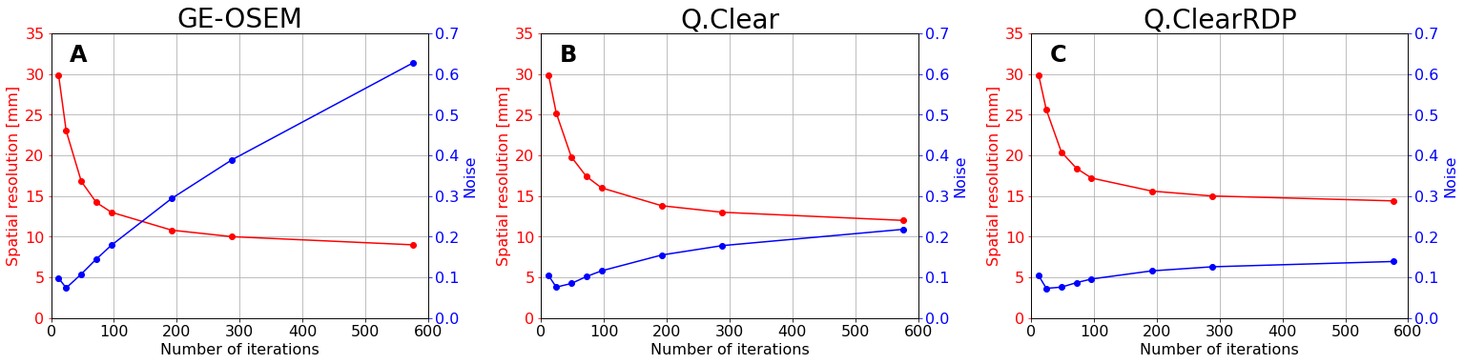
Fig. 1: Spatial resolution (red), computed on the NEMA phantom filled with hot background, and noise (blue) as function of the number of updates (1 subset) for GE-OSEM (A), Q.Clear (B) and Q.ClearRDP (C). For the factory protocol, spatial resolution and noise were found equal to 13.6 mm and 0.15, respectively.

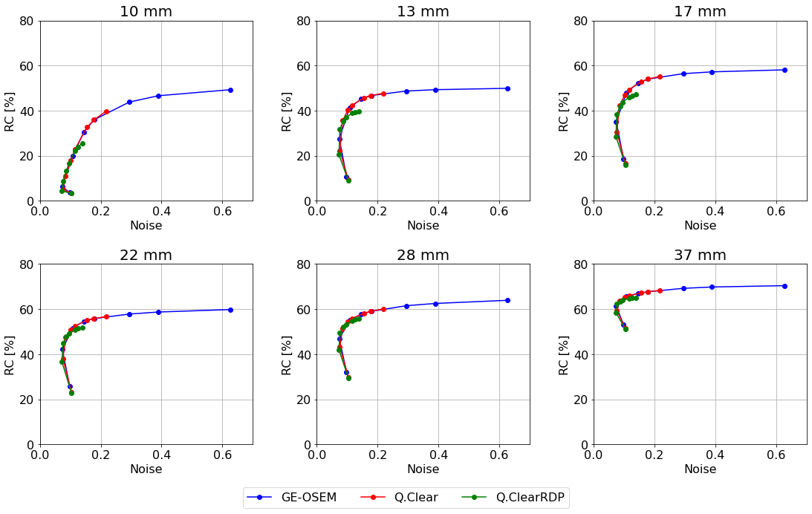
Fig. 2: Recovery Coefficients for the spherical inserts of the NEMA phantom with cold background as function of the noise for GE-OSEM, Q.Clear and Q.ClearRDP. Each data point corresponds to a specific number of iterations, namely 12, 24, 48, 72, 96, 192, 288, and 576 (1 subset), arranged from left to right.
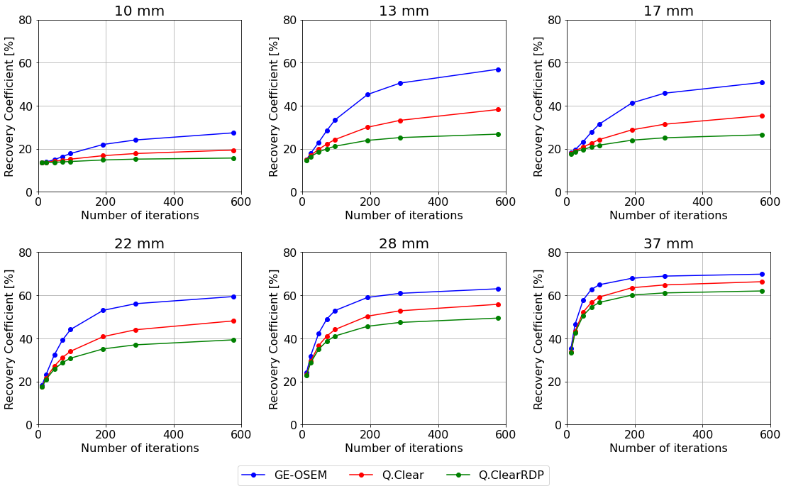
Fig. 3:Recovery Coefficients for the spherical inserts of the NEMA phantom with hot background as function of the number of iterations (1 subset) for GE-OSEM, Q.Clear and Q.ClearRDP. For the factory protocol, RCs with hot background were found equal to 16%, 29%, 30%, 44%, 53%, 63% for the 10 mm, 13 mm, 17 mm, 22 mm, 28 mm and 37 mm sphere, respectively.

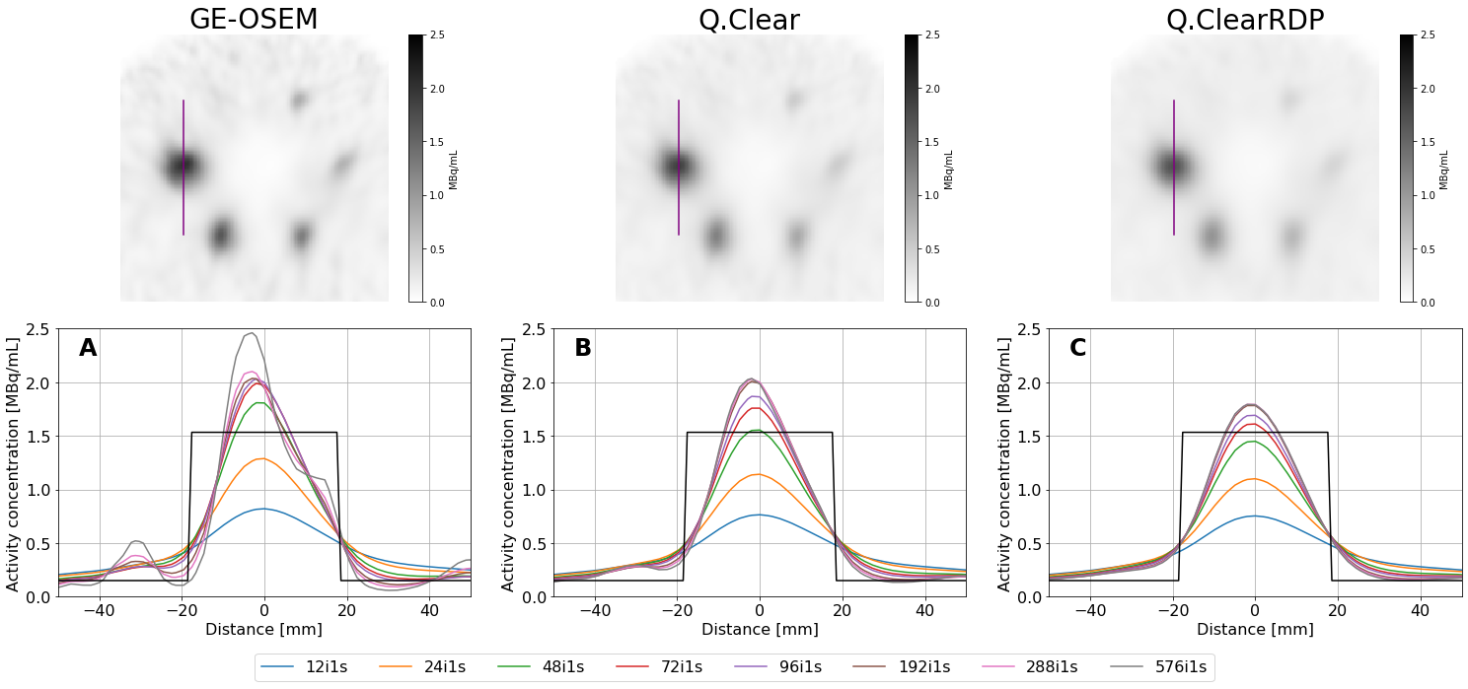
Fig. 4: Top panel - Axial views of the NEMA phantom with hot background reconstructed using GE-OSEM, Q.Clear and Q.ClearRDP (96i1s). The purple line through the biggest sphere defines the cross-section presented in the bottom panel. Bottom panel - cross-section through the largest sphere for GE-OSEM (A), Q.Clear (B) and Q.ClearRDP (C) for different number of iterations and 1 subset. The black rectangular function represents the ideal profile.
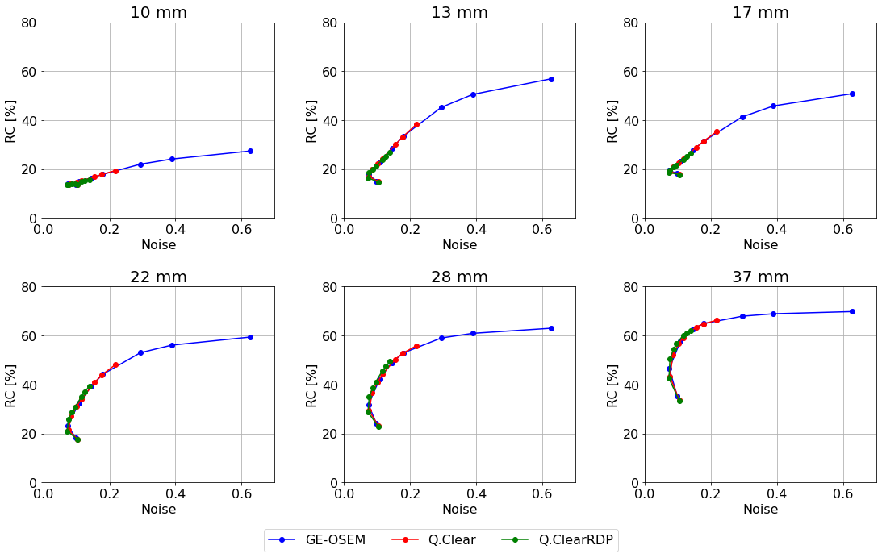
Fig. 5: Recovery Coefficients for the spherical inserts of the NEMA phantom with hot background as function of the noise for GE-OSEM, Q.Clear and Q.ClearRDP. Each data point corresponds to a specific number of iterations, namely 12, 24, 48, 72, 96, 192, 288, and 576 (1 subset), arranged from left to right.

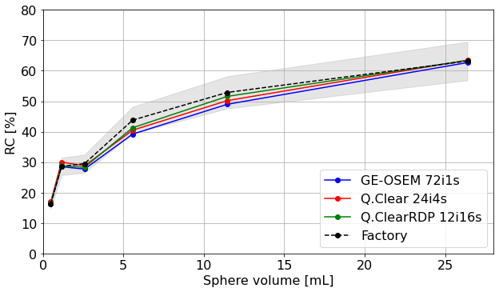
Fig. 6: Recovery Coefficients for the NEMA phantom filled with hot background reconstructed with GE-OSEM 72i1s, Q.Clear 24i4s and Q.ClearRDP 12i16s and factory protocol as a function of the sphere volume. Shaded regions correspond to ±10% the RCs computed on the factory protocol reconstruction.

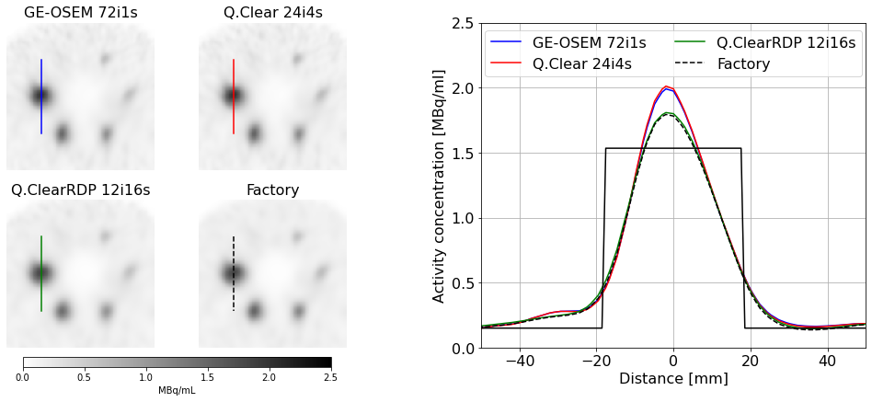
Fig. 7: Left panel- Axial views of the NEMA phantom with hot background reconstructed using GE-OSEM 72i1s, Q.Clear 24i4s and Q.ClearRDP 12i16s and factory protocol. The line through the biggest sphere defines the cross-section presented in the right panel. Right panel - cross-section through the largest sphere for GE-OSEM 72i1s, Q.Clear 24i4s and Q.ClearRDP 12i16s and factory protocol. The black rectangular function represents the ideal profile.

