Effect of Kilovoltage and Quality Reference mAs on CT-Based Attenuation Correction in 177Lu SPECT/CT Imaging: a phantom
Author Names and Degrees:
Dr. Maikol Salas-Ramirez¹*,
MSc. Julian Leube¹,
Prof. Dr. Michael Lassmann¹,
Dr. Johannes Tran-Gia¹
Affiliations:
¹Department of Nuclear Medicine, University Hospital Würzburg, Würzburg, Germany

DERIVATION OF EQUATION 1
The change in ¹⁷⁷Lu activity quantification ($∆A[\%]$) is defined as:
$\text{∆A}\left({}_{}^{\text{177}}{\text{Lu}}\right)\text{[\%]=}\left(\frac{{\text{A}}_{\text{measured}}}{{\text{A}}_{\text{theoretical}}}\text{-1}\right)\text{∙100\%}$ [S1]
Here, ${\text{A}}_{\text{measured}}$ is the activity measured using μ_{measured}-map. ${\text{A}}_{\text{theoretical}}$ is the activity measured using μ_{theoretical}-map.
Next, the non-attenuated activity (${\text{A}}_{\text{0}}$, true activity) is introduced:
$\text{∆A}\left({}_{}^{\text{177}}{\text{Lu}}\right)\text{[\%]=}\left(\frac{\frac{{\text{A}}_{\text{measeured}}}{{\text{A}}_{\text{0}}}}{\frac{{\text{A}}_{\text{theoretical}}}{{\text{A}}_{\text{0}}}}\text{-1}\right)\text{∙100\%}$ [S2]
By definition ${\text{ACF}}_{\text{measured}}\text{=}\frac{{\text{A}}_{\text{0}}}{{\text{A}}_{\text{measured}}}$ and ${\text{ACF}}_{\text{theoretical}}\text{=}\frac{{\text{A}}_{\text{0}}}{{\text{A}}_{\text{theoretical}}}$. Therefore, the equation 2 takes the form:
$\text{∆A}\left({}_{}^{\text{177}}{\text{Lu}}\right)\text{[\%]=}\left(\frac{\frac{\text{1}}{{\text{ACF}}_{\text{measured}}}}{\frac{\text{1}}{{\text{ACF}}_{\text{theoretical}}}}\text{-1}\right)\text{∙100\%}$ [S3]
Lastly, the equation 1 in the manuscript is obtained:
$\text{∆A}\left({}_{}^{\text{177}}{\text{Lu}}\right)\text{[\%]=}\left(\frac{{\text{ACF}}_{\text{theoretical}}}{{\text{ACF}}_{\text{measured}}}\text{-1}\right)\text{∙100\%}$ [S4]

SUPPLEMENTAL TABLES
Supplemental table 1. Nominal activities inside of the syringes
Source geometry  (Syringe volume, mL) | Attenuation  material | Nominal activity (kBq)
1 | PS | 146
1 | PTFE | 162
1 | PP | 168
1 | PA | 155
10 | PS | 1587
10 | PTFE | 1524
10 | PP | 1443
10 | PA | 1505

SUPPLEMENTAL FIGURES
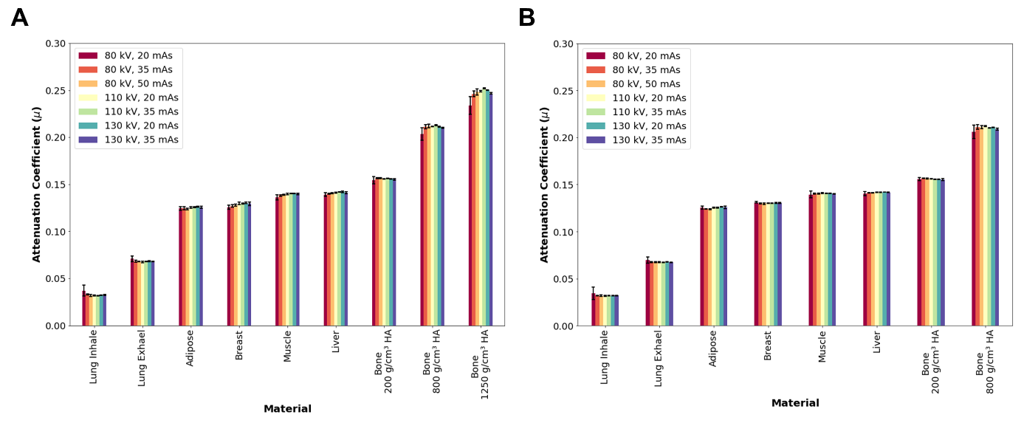
Supplemental Figure 1. Measured attenuation coefficient (µ_{measured}) of the ¹⁷⁷Lu µ-map for the seven studied combinations of kVp and QRM: A) Inner inserts. B) Outer inserts.
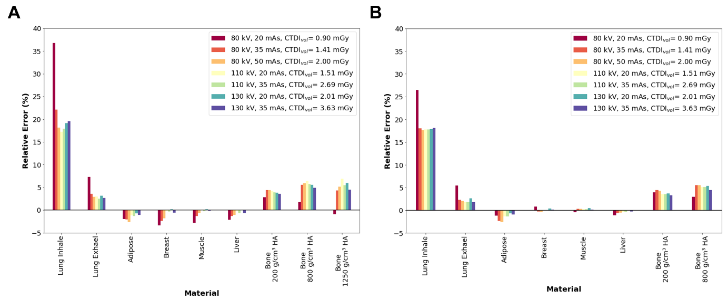
Supplemental Figure 2. Relative errors between measured (µ_{measured}) and theoretical (µ_{theoretical}) attenuation coefficients of ¹⁷⁷Lu µ-map for the seven studied combinations of kVp and QRM: A) Inner inserts. B) Outer inserts.
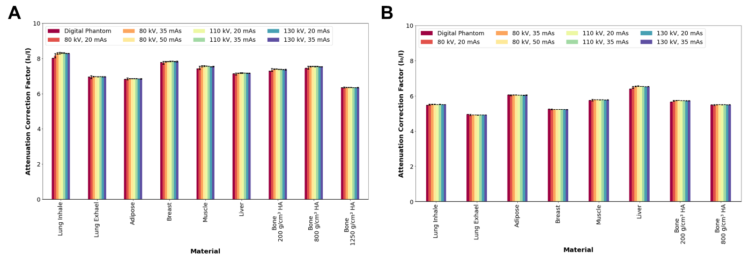
Supplemental Figure 3. Measured and theoretical ACF values: A) Intern inserts. B) Extern inserts. $I_{0}$ is the image with attenuation correction and $I$ is the image without attenuation correction. Theoretical ACF values are represented by the digital phantom.

