Supplementary materials

Title: Bone marrow dosimetry in low volume mHSPC patients receiving Lu-177-PSMA therapy using SPECT/CT

Authors: Dagmar Grob¹, Bastiaan M. Privé^{1,2}, Constantijn H.J. Muselaers⁴, Niven Mehra⁵, James Nagarajah¹, Mark W. Konijnenberg^{1,3}, Steffie M.B. Peters¹
¹: Department of Medical Imaging, Radboud university medical center, Nijmegen, The Netherlands
²: Department of Radiation Oncology, Erasmus Medical Center, Rotterdam, The Netherlands
³: Department of Radiology and Nuclear Medicine, Erasmus Medical Center, Rotterdam, The Netherlands
⁴: Department of Urology, Radboud university medical center, Nijmegen, The Netherlands
⁵: Department of Medical Oncology, Radboud university medical center, Nijmegen, The Netherlands

Corresponding author:
Steffie M.B. Peters (ORCID: 0000-0002-0752-7134)
Radboud university medical center
Department of Medical Imaging
P.O. Box 9101
6500 HB Nijmegen, The Netherlands
T: +31 (6) 11621752
E: steffie.peters@radboudumc.nl

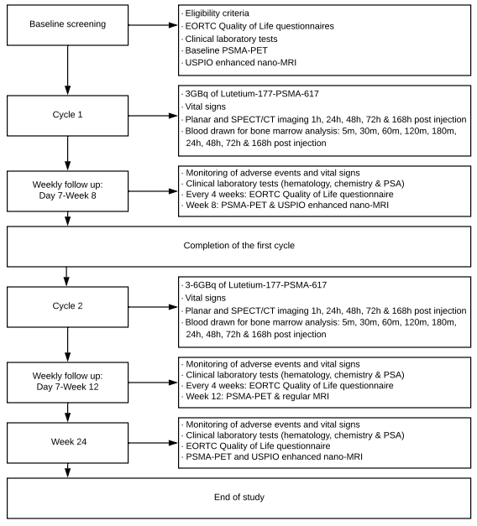
Online Resource 1: Study flowchart

Online Resource 2: Acquisition and reconstruction parameters of the imaging protocols
SPECT/CT and planar imaging was performed at 1, 24, 48, 72 and 168 hours after administration of [¹⁷⁷Lu]Lu-PSMA on either a Symbia T16 or Symbia Intevo Bold system (Siemens Healthineers, Erlangen, Germany). SPECT/CT scans were acquired at three body regions: the pelvis, abdomen, and head-neck region (64 projections per detector, time per projection of 14 s, a 20% photon energy window at 208 keV, and dual-energy window for Compton scattering. SPECT data were reconstructed using OSEM reconstruction (Flash 3D with collimator detector response) using 4 iterations and 8 subsets, matrix size of 128 (resulting in a cuboid-shape voxel size of 4.8 mm³) and a smoothing Gaussian filter of 8.4 mm. The estimated reconstructed SPECT spatial resolution was 15 mm (FWHM). A low dose CT was performed (average DLP of 130 mGy·cm ) and the data were reconstructed using B31s kernel and 3.0 mm slice thickness resulting in a voxel size of 1.0 x 1.0 x 3.0 mm³. Of note, the SPECT image reconstruction approach takes into account corrections for scatter, CT-based attenuation, and dead-time.

Online Resource 3: Uncertainty analysis flowchart
- Error in SPECT camera specific calibration factor for ¹⁷⁷Lu: 5% [Peters, 2020]
CF = 10.6 ± 0.5 cps/MBq low count statistics at late time points was accounted for by Poisson distribution.
- Data collection:
  - Quantitative SPECT at 5 time-points, within 45 minute scan-time
  - Activity concentration in blood samples at 9 time points; error: 5%
- Drawing of VOIs in SPECT data over organs and tumor lesions to determine counts:
  - Fixed size spherical VOI over central region of vertebrae; error: 10%
  - CT based VOI over organs; error 5%
- Determination of lesion and organ volume:
  - Lesion volume based on PET/CT and diagnostic CT [Jentzen, 2015];
Voxelisation and resolution error volume with lesion diameter d and voxel size a: ${\left[\frac{δV}{V}\right]}^{2}=9 {\left[\frac{δd}{d}\right]}^{2}=1.5{\left(\frac{a}{d}\right)}^{2}$ [Gear, 2018]
  - Organ volumes set at fixed ICRP-89 male phantom values; error 10%
  - Bone marrow volume relative to red marrow content in vertebrae and total volume, systematic uncertainty in patients due to age, health status and prior therapy; e.g. 16% difference between S-values by Olinda (with 1170 g0 and IDAC-dose (1394 g), hence a 20% uncertainty in the S-value.
- Fit to Time-Activity Curve
  - Mono-exponential fit SPECT TAC when R² > 0.7, determine covariance matrix
  - Actual SPECT when R² < 0.7 with exponential decay from last time-point
  - Three-exponential curve fit of blood data, determine covariance matrix
- Integration over time of the TAC, to determine the time-integrated activity Ã
  - Mono-exponential integration, error in TIA or Ã:
$${\left[\frac{δ\tilde{A}}{\tilde{A}}\right]}^{2}={\left[\frac{δA_{0}}{A_{0}}\right]}^{2}+{\left[\frac{δλ_{eff}}{λ_{eff}}\right]}^{2}-\frac{2 Cov\left(A_{0},λ_{eff}\right)}{A_{0}λ_{eff}}$$
  - Trapezoid integration method; error:
$${\left[\frac{δ\tilde{A}}{\tilde{A}}\right]}^{2}=\sum_{i}{{\left[\frac{δA(t_{i})}{A(t_{i})}\right]}^{2}}$$
  - Three-exponential integration of blood concentration TAC, error in TIA or Ã:
$${\left[\frac{δ\tilde{A}}{\tilde{A}}\right]}^{2}={\left[\frac{δA_{0}}{A_{0}}\right]}^{2}+{{\left[\frac{δP}{P}\right]}^{2}+{\left[\frac{δ\%Fast}{\%Fast}\right]}^{2}+\left[\frac{δλ_{Fast}}{λ_{Fast}+λ_{p}}\right]}^{2}+{\left[\frac{δ\%Slow}{\%Slow}\right]}^{2}+\left[\frac{δλ_{Slow}}{λ_{Slow}+λ_{p}}\right]+\left[\frac{δλ_{Medium}}{λ_{Medium}+λ_{p}}\right]-\sum{covariances}$$
- Absorbed dose calculation with MIRD equation $D=\tilde{A}×S$; error:
$${\left[\frac{δD}{D}\right]}^{2}={{\left[\frac{δ\tilde{A}}{\tilde{A}}\right]}^{2}+\left[\frac{δS}{S}\right]}^{2}$$

Online Resource 4: Blood measurements for blood and bone marrow toxicity. Each coloured line represents a patient. Dotted vertical lines indicate the first and second therapeutic cycle with ¹⁷⁷Lu-PSMA-617. (a): hemoglobin, (b): white blood cells and (c): thrombocytes

