Supplement

Improvements of 177Lu SPECT Images from Sparsely Acquired Projections by Reconstruction with Deep-Learning-Generated Synthetic Projections
Emma Wikberg*^{1,4}, Martijn van Essen³, Tobias Rydén⁴, Johanna Svensson⁵, Peter Gjertsson^{2,3}, Peter Bernhardt^{1,4}.
¹Department of Medical Radiation Sciences, Institute of Clinical Sciences, Sahlgrenska Academy, University of Gothenburg, Gothenburg, Sweden
²Department of Molecular and Clinical Medicine, Institute of Medicine, Sahlgrenska Academy, University of Gothenburg, Gothenburg, Sweden
³Department of Clinical Physiology, Sahlgrenska University Hospital, 413 45, Gothenburg, Sweden
⁴Medical Physics and Medical Bioengineering, Sahlgrenska University Hospital, 413 45, Gothenburg, Sweden
⁵Department of Oncology, Institute of Clinical Sciences, Sahlgrenska Academy, University of Gothenburg, Gothenburg, Sweden
*Corresponding author:
Emma Wikberg, Gula Stråket 2B plan 3, 413 45 Gothenburg, Sweden, telephone: +46709136581, emma.wikberg@vgregion.se, ORCID: 0000-0002-9441-1059

Methods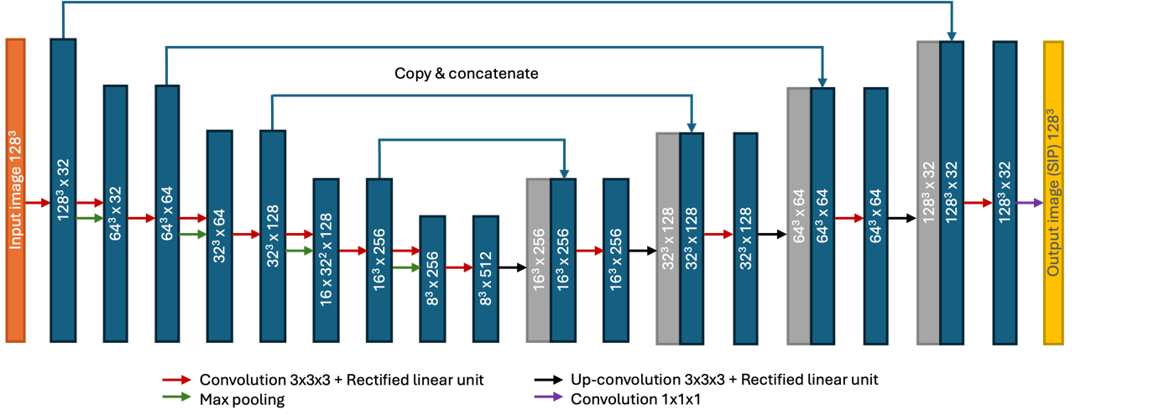
Fig. S1 Schematic illustration of the network structure of CUSIP. Numbers are image size and number of features.

Results
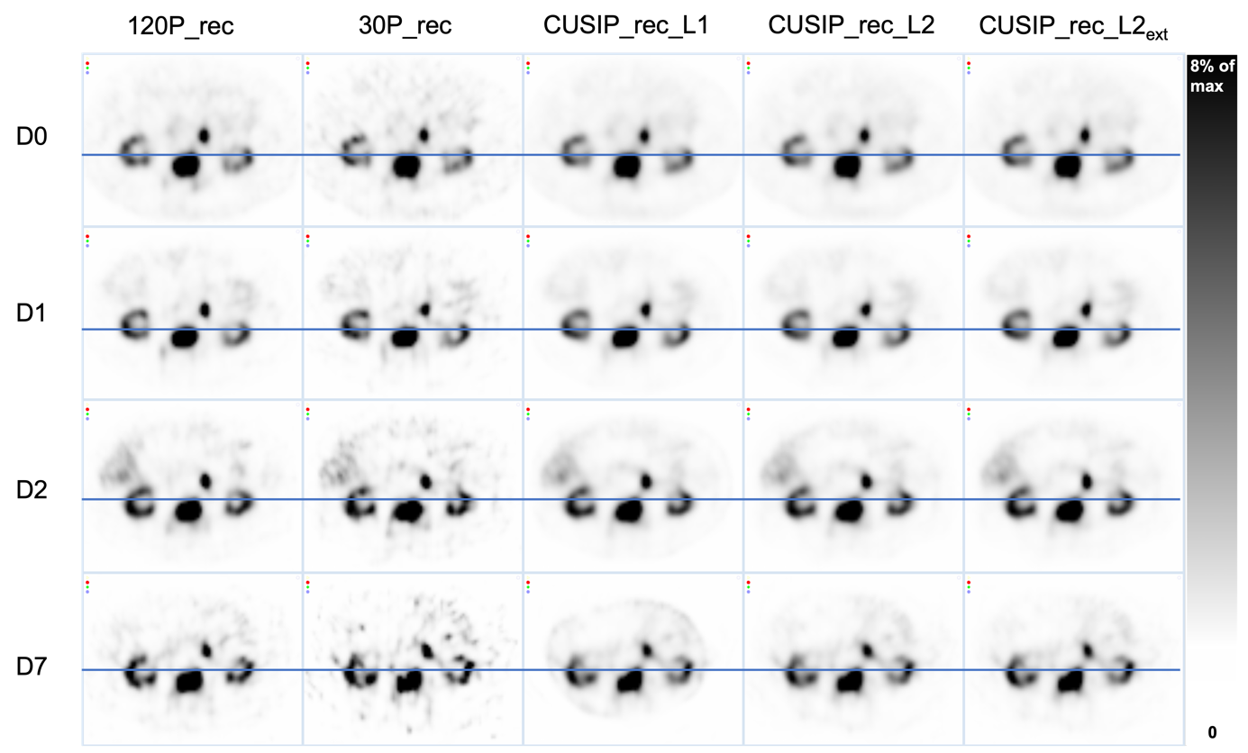
Fig. S2 SPECT images of the abdomen for all reconstruction sets and imaging time points: day (D) 0, D1, D2, and D7 post-administration. Blue lines represent the positions of the line profiles shown in Fig. S3
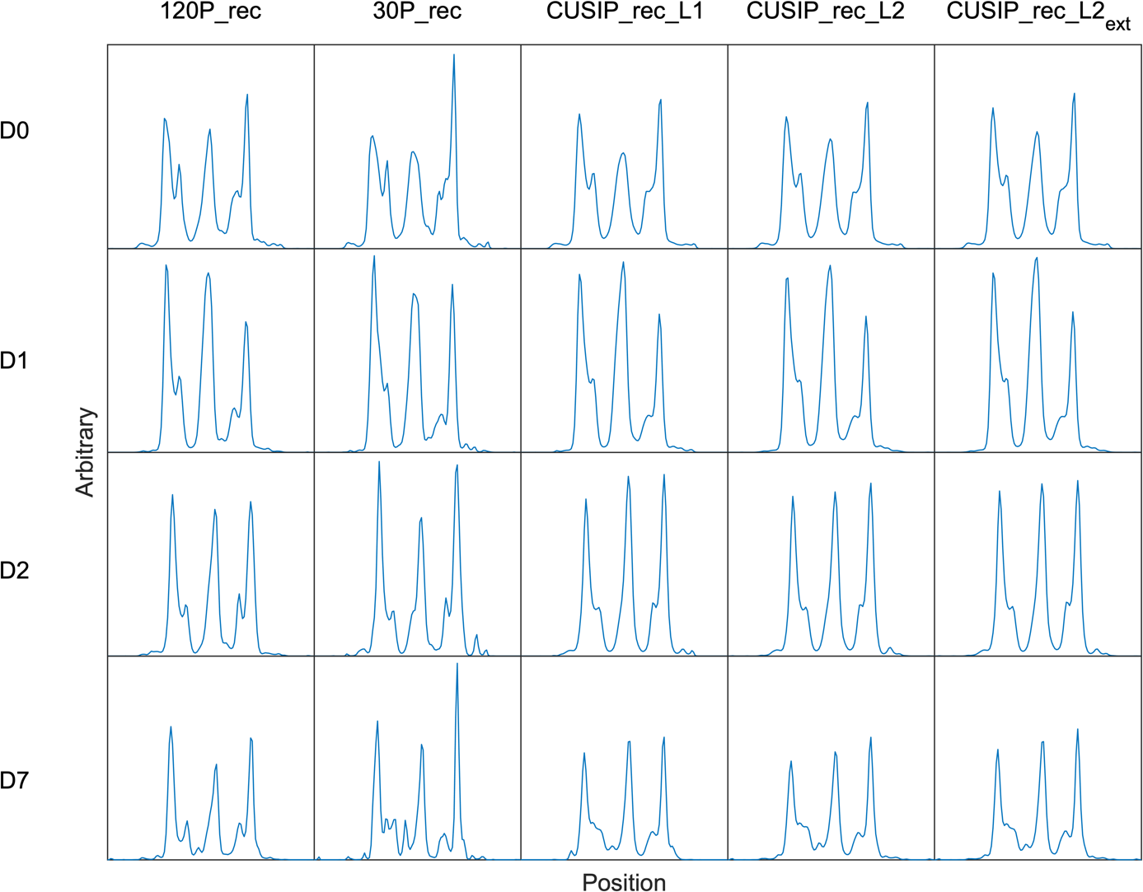
Fig. S3 Corresponding line profiles for the SPECT images in Fig. S2. The line profiles go through the right kidney (first peak), a tumor (second peak), and left kidney (third peak). The y-axis is constant between the reconstruction sets for each day, respectively

