Supplementary material

Design and fabrication of the anthropomorphic inserts
A physical phantom consisting of tumor-free lumbar vertebrae (L1–L2), a metastatic L3 vertebra, and kidneys was fabricated based on the ICRP 145 computational model (1).
Stereolithography files for the cortical bone and spongiosa of the vertebrae and the cortex and medulla of the kidneys were imported into Autodesk Netfabb Premium 2025.0. Cortical bone structures were hollowed out using Boolean operations to create fillable compartments, and only the vertebral bodies were hollowed (i.e. the vertebral arches were solid). For the metastatic L3 vertebra, a wall was inserted into the compartment that separates the healthy spongiosa from the metastatic compartment, at a ratio of 0.75.
Simplified kidney models were generated by combining the cortex and medulla into a single shell with a uniform wall thickness of 1.5 mm. The vertebrae were mechanically linked to the kidney compartments via rectangular connectors, enabling the vertebrae to be removed using a snap-fit joint. Mounting cylinders were incorporated into the superior aspect of L1 and the inferior aspect of L3 to enable secure fixation to a NEMA IEC PET Body Phantom.
The phantom components and the holders were fabricated using a Formlabs 3+ stereolithography printer with Clear V4 resin (density: 1.09 g cm⁻³ (2); Hounsfield units: 121 HU (3)).

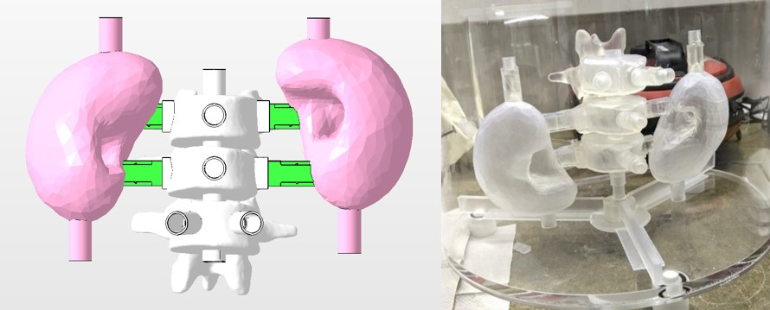
Supplementary Figure 1: CAD model of the anthropomorphic insert (left) and photograph of the NEMA phantom with the insert in place (right).

Additional supplementary figures and tables
Supplementary Table 1: RNC-based activities and activity concentrations within the Deluxe phantom at acquisition, and related errors in the SPECT-based measurement using the StarGuideTM and the NM/CT 870 DR.
 | StarGuideTM |  |  | NM/CT 870 DR
RNC-based  activity (MBq) | RCN-based activity concentration (kBq/ml) | Error (%) | RNC-based  activity (MBq) | RCN-based activity concentration (kBq/ml) | Error (%)
5347 | 921 | 0.6 | - | - | -
2104 | 362 | 0.9 | 2114 | 364 | -5.3
1240 | 214 | 0.2 | 1247 | 215 | -3.1
541 | 93 | 0.9 | 540 | 93 | -1.4
235 | 40 | 0.2 | 235 | 41 | -0.7
117 | 20 | -0.8 | 113 | 20 | -0.6
55 | 9 | -3.4 | - | - | -
27 | 5 | -5.4 | 26 | 5 | 0.1
13 | 2 | -12.4 | 13 | 2 | 0.9
Supplementary Table 2: RCs for the six spheres of the NEMA_noBG phantom. For StarGuideTM, data are reported as mean (CV) across all eight reconstructions.
Sphere diameter | StarGuide | NM/CT 870 DR
60 mm | 0.73 (0.006) | 0.88
37 mm | 0.66 (0.011) | 0.75
28 mm | 0.62 (0.009) | 0.70
22 mm | 0.56 (0.044) | 0.62
17 mm | 0.48 (0.059) | 0.52
13 mm | 0.19 (0.219) | 0.37
Supplementary Table 3: Accuracy and precision – reported as mean error (CV) – of volume and activity concentration estimations using the StarGuideTM and the NM/CT 870 DR for the tumour inserts of the NEMA_anthro phantom segmented with PET Edge+, PET Edge and % peak threshold.
Segmentation | VOI | Volume |  | Activity concentration before PVC |  | Activity concentration after PVC
Segmentation | VOI | StarGuide | NM/CT 870 DR | StarGuide | NM/CT 870 DR | StarGuide | NM/CT 870 DR
PET Edge+ | L1 | -22% (7%) | -15% (3%) | -27% (3%) | -27% (2%) | 13% (4%) | -3% (2%)
PET Edge+ | L3II | -11% (5%) | 3% (3%) | -32% (2%) | -37% (2%) | 11% (2%) | -14% (2%)
PET Edge+ | S1 | -42% (41%) | -7% (35%) | -35% (19%) | -44% (16%) | 30% (27%) | -6% (22%)
PET Edge+ | S2 | -46% (5%) | -40% (11%) | -36% (11%) | -40% (9%) | 41% (12%) | 31% (12%)
PET Edge | L1 | 2% (5%) | -7% (2%) | -36% (3%) | -31% (2%) | -3% (3%) | -10% (2%)
PET Edge | L3II | -6% (12%) | 1% (9%) | -35% (6%) | -38% (5%) | 5% (7%) | -14% (7%)
PET Edge | S1 | -62% (21%) | -45% (6%) | -26% (7%) | -31% (2%) | 53% (10%) | 27% (4%)
PET Edge | S2 | -60% (15%) | -58% (16%) | -29% (15%) | -32% (12%) | 64% (18%) | 63% (16%)
% peak threshold | L1 | -2% (7%) | -10% (1%) | -34% (3%) | -28% (1%) | 1% (4%) | -6% (1%)
% peak threshold | L3II | -5% (4%) | 1% (2%) | -34% (2%) | -37% (1%) | 7% (2%) | -13% (2%)
% peak threshold | S1 | -2% (13%) | -12% (5%) | -48% (4%) | -43% (3%) | -6% (6%) | -4% (4%)
% peak threshold | S2 | 18% (12%) | 23% (6%) | -54% (12%) | -56% (5%) | -9% (14%) | -20% (7%)
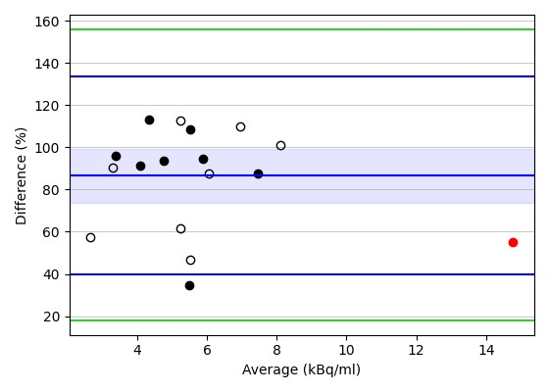
Supplementary Figure 2: Bland-Altman plots showing the percentage differences in the activity concentration in the remainder of the body. Filled dots indicate VOIs in the right gluteus, and open dots indicate VOIs in the left gluteus. The red marker represents the measurement for the background VOI of the NEMA_Anthro phantom, which was excluded from the Bland-Altman analysis and is shown for comparison only. Blue lines represent the bias and limits of agreement (LoAs), while green lines represent the upper and lower 95% confidence interval for the upper and lower LoA, respectively. Shaded area indicate the 95% confidence interval for the bias.
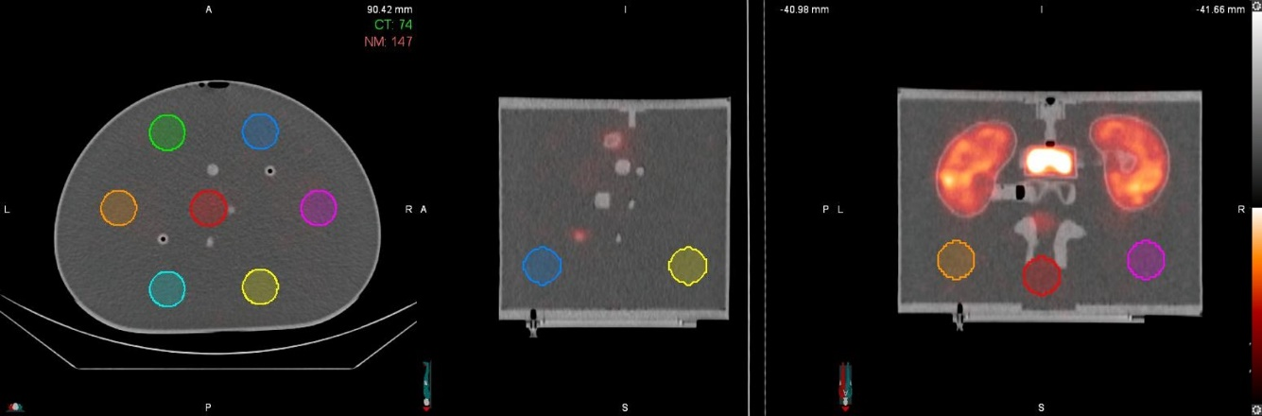
Supplementary Figure 3: Axial (left), sagittal (centre) and coronal (right) views of a fused SPECT/CT scan of the NEMA_Anthro phantom. Seven spherical VOI with a diameter of 35 mm were placed in the background compartment to estimate the activity concentration.
Supplementary Table 4: Accuracy and precision – reported as mean error (CV) – in the estimation of the activity concentration within the VOIs shown in Supplementary Figure 4. All VOIs had a volume of approximately 22 ml. VOIs placed along the z-direction in correspondence with the kidney or tumour inserts (red, magenta and orange) exhibited mean errors exceeding 200%, while those not aligned with hot inserts (blue, green, light blue and yellow) exhibited mean errors below 25%. For the same VOIs, mean errors for the NM/CT 870 DR varied between -19% and 8%.
 | VOI | StarGuide | NM/CT 870 DR
1 | Red | 249% (15%) | 7% (11%)
2 | Magenta | 235% (17%) | -19% (10%)
3 | Blue | 21% (5%) | 8% (2%)
4 | Green | 9% (23%) | -6% (3%)
5 | Orange | 279% (10%) | -13% (11%)
6 | Light blue | 25% (11%) | 2% (15%)
7 | Yellow | 9% (19%) | -2% (21%)

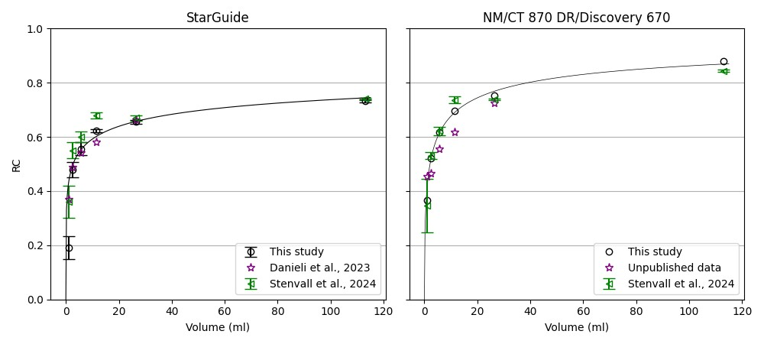
Supplementary Figure 4: Different sets of RCs for StarGuideTM (left panel) and NM/CT 870 DR/Discovery 670 (right panel) obtained with the NEMA phantom with (black and green) and without (purple) the 60 mm sphere. Error bars represent one SD. Data for Stenvall et al., referred to as “mean relative errors”, are taken from Table 3 of their paper (4).

References
1. Kim CH, Yeom YS, Petoussi-Henss N, Zankl M, Bolch WE, Lee C, et al. ICRP Publication 145: Adult Mesh-Type Reference Computational Phantoms. Ann ICRP. 2020 Oct;49(3):13–201.
2. Formlabs. Safety Data Sheet Clear Resin [Internet]. [cited 2024 Mar 25]. Available from: https://formlabs-media.formlabs.com/datasheets/1801037-SDS-ENEU-0.pdf
3. Kalidindi Y, Ganapathy AK, Nayak Y, Elumalai A, Chen DZ, Bishop G, et al. Computed Tomography Attenuation of Three-Dimensional (3D) Printing Materials—Depository to Aid in Constructing 3D-Printed Phantoms. Micromachines [Internet]. 2023;14(10). Available from: https://www.mdpi.com/2072-666X/14/10/1928
4. Stenvall A, Ceric Andelius I, Nilsson E, Lindvall A, Larsson E, Gustafsson J. Bias and precision of SPECT-based 177Lu activity-concentration estimation using a ring-configured solid-state versus a dual-headed anger system. EJNMMI Phys [Internet]. 2024;11(1):91. Available from: https://doi.org/10.1186/s40658-024-00693-5

