Supplementary Figure 1

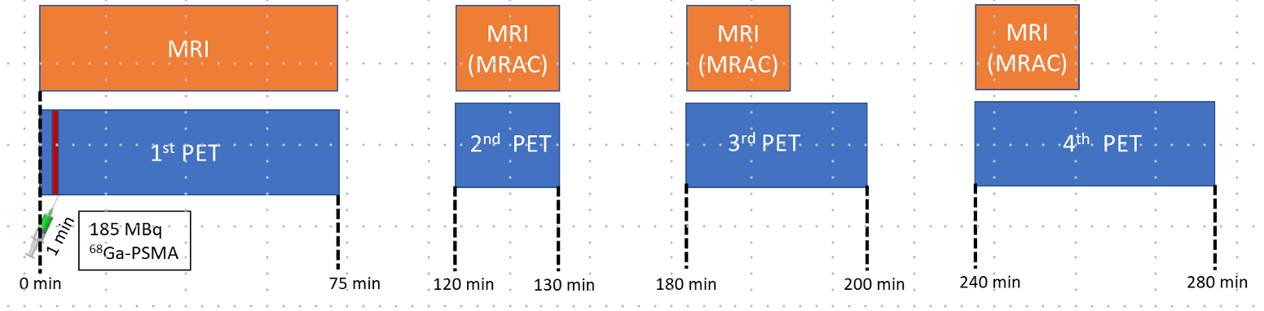
Supplementary Figure 1. PET–MRI scanning protocol used for dynamic and static [⁶⁸Ga]-PSMA-11 imaging in patients with high-grade glioma (HGG).

Supplementary Figure 2
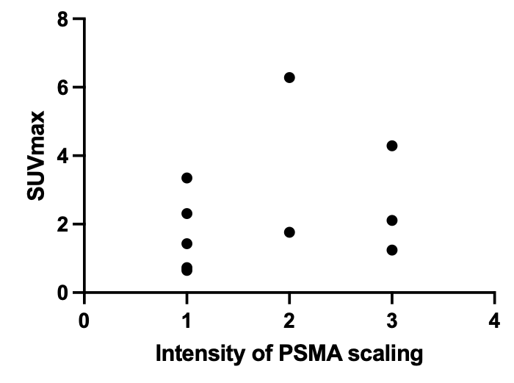

Supplementary Figure 2. Graph showing maximum standardised uptake value (SUV_{max}) within a particular region of interest of brain tumour on the Prostate-Specific Membrane Antigen (PSMA) PET-MRI against immunohistochemical staining intensity within 10 co-localised tumour biopsies. Immunohistochemical staining intensity was determined using a semi-quantitative 5-point scale (see methods section for further details) by an experienced neuropathologist. There was only a weakly positive correlation (Pearson correlation coefficient r = 0.27, p = 0.45).

Supplementary Methods:

PET-MRI:
A static 15 min series was reconstructed at 60-75 min post-injection (PET₆₀₋₇₅). The dynamic data were unlisted into 60 x 1 s, 8 x 15 s, 4 x 60 s, 7 x 120 s and 11 x 300 s frames. Anatomical and functional MRI sequences were acquired during the first 75 min; parametric maps of K_{trans} and V_{e} were generated from the Dynamic Contrast Enhanced (DCE) MRI sequence and maps of relative cerebral blood volume (rCBV) from the Dynamic Susceptibility Contrast (DSC) sequence (for MRI acquisition parameters see Supplementary Methods).

Anatomical and post-contrast T₁-weighted MRI acquisition:
The anatomical T₁ image was performed using a gradient recalled inversion recovery sequence (22.4 x 25.6 cm field of view; 256 x 224 matrix of 176, 1.1 mm thick slices; TE: 2.63 ms, TR: 1700 ms) and the post-contrast T₁ with a spin echo sequence (24 x 24 cm field of view; 512 x 512 matrix of 160 0.9 mm thick slices; TE:11ms, TR:700ms).

Dynamic Contrast Enhanced and Dynamic Susceptibility Contrast MRI acquisition:
DCE MRI was performed using a spoiled gradient echo sequence (24 x 24 cm field of view; 128 x 128 matrix of 12, 5 mm thick slices; TE 1.19 ms TR 4.3 ms, 100 sets, 4 s per set). Initial T₁ values were measured with a similar T₁ weighted sequence (TE 1.2 ms TR 8.7 ms) acquired from the same volume at flip angle of 2, 5, 7, 10 and 15 degrees [1]. DSC MRI was also acquired with a spoiled gradient echo sequence (24 x 24 cm field of view; 96 x 96 matrix of 20, 5 mm thick slices; single shot echo planar imaging (EPI), 80 sets, TR 1.6 s). DCE data was quantified assuming a haemotocrit of 0.42, and a relaxivity of 4.5 s⁻¹mM⁻¹ at 3 T [2]. A venous input function (VIF) was taken from the mean of the 5 highest signal points in the superior sagittal sinus [3]. This was used to calculate the fractional volume of the extravascular-extracellular space and the transfer-rate constant (K_{trans} expressed as min⁻¹) from the Tofts model [4]. The DSC-MRI data were used to calculate a relative cerebral blood volume map (rCBV) with reference to a 0.225 ml volume of white matter, taken from above the ventricles in the centre of the brain contralateral to the tumour.

References:
- Fram EK, Herfkens RJ, Johnson GA, Glover GH, Karis JP, Shimakawa A, Perkins TG, Pelc NJ. Rapid calculation of T1 using variable flip angle gradient refocused imaging. Magn Reson Imaging. 1987;5(3):201-8. doi: 10.1016/0730-725x(87)90021-x.

- Hittmair K, Gomiscek G, Langenberger K, Recht M, Imhof H, Kramer Method for the quantitative assessment of contrast agent uptake in dynamic contrast-enhanced MRI. J. Magn Reson Med. 1994 May;31(5):567-71. doi: 10.1002/mrm.1910310516.

- Thrippleton MJ, Backes WH, Sourbron S, Ingrisch M, van Osch MJP, Dichgans M, Fazekas F, Ropele S, Frayne R, van Oostenbrugge RJ, Smith EE, Wardlaw JM. Quantifying blood-brain barrier leakage in small vessel disease: Review and consensus recommendations. Alzheimers Dement. 2019 Jun;15(6):840-858. doi: 10.1016/j.jalz.2019.01.013.

- Tofts PS, Kermode AG. Measurement of the blood-brain barrier permeability and leakage space using dynamic MR imaging. 1. Fundamental concepts. Magn Reson Med. 1991 Feb;17(2):357-67. doi: 10.1002/mrm.1910170208.

