Electronic supplementary material (Online Resource 1).

Supplementary Table S1. Detailed scanner-specific acquisition and CT parameters
Parameter | Siemens Digital SiPM PET/CT | Canon Digital SiPM PET/CT
Matrix size | 440 × 440 | 128 × 128
Zoom factor | 2 | None
CT kVp | 120 kVp | 120 kVp
Tube current | Automatic exposure control | 300 mA
Pitch | 0.55 | 0.813
Rotation time | 1.0 s | 0.5 s
Reconstruction kernel | Hf38 | FC07
MAR | Off | Off
Abbreviations: CT, computed tomography; MAR, metal artifact reduction; SiPM, silicon photomultiplier

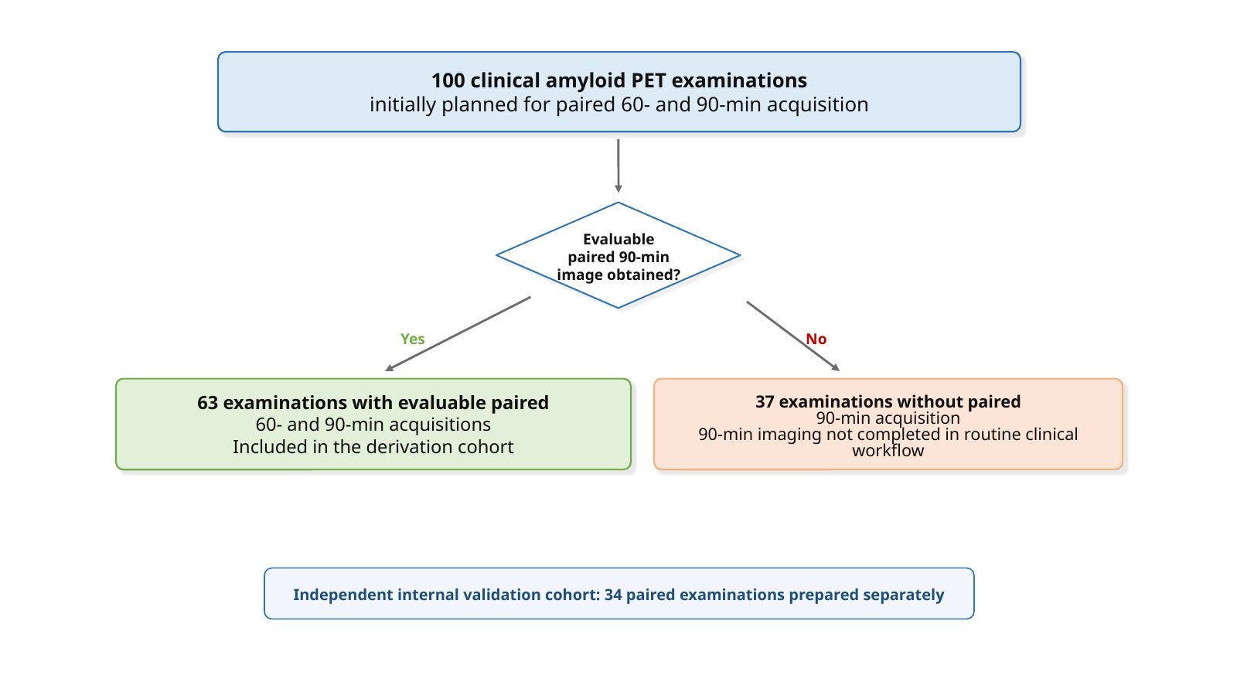
Supplementary Fig. S1 Study flow for construction of the derivation cohort. The derivation cohort was constructed from 100 examinations initially planned for paired 60- and 90-min amyloid PET acquisition. Because the study was performed within routine clinical workflow, paired acquisition was feasible in 63 examinations, which were included in the derivation cohort. PET, positron emission tomography.

Supplementary Table S2 Participant characteristics stratified by the majority VA at 90 min
Characteristic | Overall | Aβ− | Aβ+ | p
Participants, n | 63 | 31 | 32
Age, years, mean ± SD | 77.7 ± 7.8 | 77.2 ± 9.1 | 78.1 ± 6.3 | 0.663
Female, n (%) | 43 (68.3%) | 21 (67.7%) | 22 (68.8%) | 1.000
Education, years, mean ± SD (available n) | 13.2 ± 2.4 (n = 53) | 12.7 ± 2.4 (n = 25) | 13.6 ± 2.4 (n = 28) | 0.206
MMSE, mean ± SD (available n) | 24.9 ± 2.6 (n = 57) | 24.9 ± 2.6 (n = 25) | 25.0 ± 2.6 (n = 32) | 0.863
Global CDR, median [IQR]  (available n) | 0.5 [0.5, 0.5] (n = 57) | 0.5 [0.5, 0.5] (n = 25) | 0.5 [0.5, 0.5] (n = 32) | 0.899
Scanner (BV/CP), n | 38/25 | 17/14 | 21/11 | 0.446
Exam type (insurance/checkup), n | 57/6 | 25/6 | 32/0
Notes: p-values were calculated using Welch’s t-test (continuous variables), Fisher’s exact test (categorical variables), and the Mann-Whitney U test (ordinal Global CDR). Exam type: presented descriptively; no hypothesis test performed

Supplementary Table S3 Pairwise and three-reader inter-reader agreement with 95% confidence intervals for κ, stratified by time point
Pair | Agreement n/N (%) | κ (95% CI)
60 min | 60 min | 60 min
Three-reader agreement (Fleiss’ κ) | 59/63 (93.7%) complete agreement | 0.915 (0.827 to 0.979)
Reader A vs B | 60/63 (95.2%) | 0.904 (0.778 to 1.000)
Reader A vs C | 60/63 (95.2%) | 0.905 (0.780 to 1.000)
Reader B vs C | 61/63 (96.8%) | 0.936 (0.840 to 1.000)
90 min | 90 min | 90 min
Three-reader agreement (Fleiss’ κ) | 56/63 (88.9%) complete agreement | 0.852 (0.742 to 0.937)
Reader A vs B | 60/63 (95.2%) | 0.905 (0.780 to 1.000)
Reader A vs C | 57/63 (90.5%) | 0.811 (0.660 to 0.936)
Reader B vs C | 58/63 (92.1%) | 0.841 (0.687 to 0.968)
Notes: Agreement is shown as n/N (%). κ values are shown with bootstrap 95% confidence intervals. Fleiss’ κ was used for three-reader agreement, and Cohen’s κ was used for pairwise reader agreement.

Supplementary Table S4 Reader agreement with the majority VA at each time point (contingency counts and positive/negative percent agreement)
Reader | TP | FN | FP | TN | Positive agreement (PPA) | Negative agreement (NPA)
60 min
Reader A | 33 | 0 | 2 | 28 | 100.0% | 93.3%
Reader B | 33 | 0 | 1 | 29 | 100.0% | 96.7%
Reader C | 32 | 1 | 0 | 30 | 97.0% | 100.0%
90 min
Reader A | 32 | 0 | 2 | 29 | 100.0% | 93.5%
Reader B | 31 | 1 | 0 | 31 | 96.9% | 100.0%
Reader C | 28 | 4 | 0 | 31 | 87.5% | 100.0%
Majority VA was defined as ≥2/3 readers at the same time point. PPA=TP/(TP+FN); NPA=TN/(TN+FP)

Supplementary Table S5 Region-wise agreement between 60- and 90-min acquisitions (majority and reader-level)
 | Majority |  | Reader A |  | Reader B |  | Reader C
Region | Agr. n/N (%) | κ | Agr. | κ | Agr. | κ | Agr. | κ
Global (overall VA) | 62/63 (98.4%) | 0.97 (0.90 to 1.00) | 62/63 (98.4%) | 0.97 (0.90 to 1.00) | 60/63 (95.2%) | 0.90 (0.78 to 1.00) | 59/63 (93.7%) | 0.87 (0.75 to 0.97)
Frontal cortex | 62/63 (98.4%) | 0.97 | 62/63 (98.4%) | 0.97 | 60/63 (95.2%) | 0.90 | 60/63 (95.2%) | 0.90
Posterior cingulate / precuneus | 63/63 (100.0%) | 1.00 | 62/63 (98.4%) | 0.97 | 63/63 (100.0%) | 1.00 | 62/63 (98.4%) | 0.97
Temporal cortex | 59/63 (93.7%) | 0.87 | 60/63 (95.2%) | 0.90 | 59/63 (93.7%) | 0.87 | 58/63 (92.1%) | 0.84
Parietal cortex | 62/63 (98.4%) | 0.97 | 62/63 (98.4%) | 0.97 | 62/63 (98.4%) | 0.97 | 60/63 (95.2%) | 0.90
Striatum | 58/63 (92.1%) | 0.82 | 61/63 (96.8%) | 0.94 | 61/63 (96.8%) | 0.92 | 57/63 (90.5%) | 0.78
Notes: Region-wise agreement between 60- and 90-min acquisitions is shown for the majority VA and each reader. Agr., agreement; κ, Cohen’s kappa. For the global overall VA row, κ values are shown with bootstrap 95% confidence intervals; region-specific κ values are descriptive.

Supplementary Table S6 Peak MNI coordinates and peak statistics from voxel-wise paired SPM comparison (90 min vs 60 min)
Contrast | Region (peak/cluster) | MNI (x, y, z) | Z value
90 min > 60 min | Cerebral white matter | -22, -36, 44 | > 8.0
90 min < 60 min | Cerebellar cortex | 36, -74, -38 | 7.53
90 min < 60 min | Thalamus (bilateral cluster) | -10, -20, -4 | 7.57
90 min < 60 min | Hippocampus (bilateral cluster) | 22, -8, -22 | 7.10
Note: Voxel-wise preprocessing and spatial smoothing were performed using Amyquant® (ver. 1.00.0013; Brain Linkege Inc.). Voxel-wise inference was voxel-level FWE corrected (p < 0.05) with a cluster-extent threshold of k = 100. Bilateral cluster: reported coordinate corresponds to the peak voxel within the cluster. These voxel-wise results are descriptive findings under the applied whole-cerebellum-normalized preprocessing pipeline.

Supplementary Table S7. Confidence intervals for key Analysis 2 agreement statistics in the derivation cohort.
Comparison | n | Pearson r (95% CI) | Lin's CCC (95% CI) | Bias (95% CI) | Lower LoA (95% CI) | Upper LoA (95% CI) | Notes
Raw SUVR₆₀ vs SUVR₉₀ | 63 | 0.997 (0.994 to 0.998) | 0.977 (0.970 to 0.981) | -0.032 (-0.047 to -0.016) | -0.152 (-0.179 to -0.125) | 0.088 (0.062 to 0.115) | Bias and LoA are x-y.
CL₉₀(est.60) vs CL₉₀ | 63 | 0.997 (0.996 to 0.998) | 0.997 (0.996 to 0.998) | -0.01 (-0.77 to 0.76) | -5.94 (-7.26 to -4.62) | 5.93 (4.61 to 7.25) | Bias and LoA are x-y.
Notes: Pearson r confidence intervals were calculated using Fisher’s z transformation. Confidence intervals for Lin’s concordance correlation coefficient, Bland–Altman bias, and limits of agreement were estimated using nonparametric bootstrap resampling. Bias and limits of agreement are expressed in SUVR units for SUVR comparisons and in CL units for CL comparisons.

Supplementary Table S8. Confidence intervals for key Analysis 2 agreement statistics in the independent internal validation cohort.
Comparison | n | Pearson r (95% CI) | Lin’s CCC (95% CI) | Bias (95% CI) | Lower LoA (95% CI) | Upper LoA (95% CI) | Within ±5 CL
Raw SUVR₆₀ vs SUVR₉₀ | 34 | 0.998 (0.995 to 0.999) | 0.974 (0.961 to 0.980) | -0.038 (-0.061 to -0.016) | -0.172 (-0.201 to -0.131) | 0.095 (0.067 to 0.114) | —
Raw CL₆₀ vs CL₉₀ | 34 | 0.998 (0.995 to 0.999) | 0.974 (0.961 to 0.981) | -4.74 (-7.53 to -2.03) | -21.09 (-24.70 to -16.15) | 11.61 (8.23 to 13.94) | 18/34 (52.9%)
Fixed CL₉₀(est.60) vs CL₉₀ | 34 | 0.998 (0.995 to 0.999) | 0.997 (0.994 to 0.998) | -1.78 (-2.84 to -0.76) | -8.00 (-9.71 to -5.99) | 4.43 (2.87 to 5.63) | 30/34 (88.2%)
Published CL₉₀(pub.60) vs CL₉₀ | 34 | 0.998 (0.995 to 0.999) | 0.994 (0.989 to 0.997) | -3.33 (-4.49 to -2.22) | -10.13 (-11.92 to -7.94) | 3.47 (1.88 to 4.72) | 23/34 (67.6%)
Notes: Pearson r confidence intervals were calculated using Fisher’s z transformation. Confidence intervals for Lin’s concordance correlation coefficient, Bland–Altman bias, and limits of agreement were estimated using nonparametric bootstrap resampling. Bias and limits of agreement are expressed in SUVR units for SUVR comparisons and in CL units for CL comparisons. The fixed CL₉₀(est.60) values were calculated using the derivation-cohort equation and applied without refitting.

Supplementary Table S9. Absolute quantitative distributions by scanner in the derivation cohort.
Metric | Scanner | n | Mean ± SD | Median | IQR | Mann-Whitney p | Welch t-test p
CL₉₀ | BV | 38 | 30.37 ± 39.40 | 28.40 | -7.00 to 62.18 | 0.584 | 0.460
CL₉₀ | CP | 25 | 38.94 ± 47.75 | 26.10 | -7.00 to 80.60 | 0.584 | 0.460
CL₉₀(est.60) | BV | 38 | 30.09 ± 39.34 | 27.44 | -5.63 to 59.49 | 0.482 | 0.423
CL₉₀(est.60) | CP | 25 | 39.35 ± 47.49 | 20.92 | -3.28 to 82.81 | 0.482 | 0.423
Raw CL₆₀ | BV | 38 | 27.00 ± 32.94 | 24.80 | -2.90 to 51.68 | 0.482 | 0.423
Raw CL₆₀ | CP | 25 | 34.75 ± 39.78 | 19.20 | -0.90 to 71.10 | 0.482 | 0.423
SUVR₆₀ | BV | 38 | 1.25 ± 0.27 | 1.23 | 1.00 to 1.45 | 0.482 | 0.423
SUVR₆₀ | CP | 25 | 1.31 ± 0.32 | 1.18 | 1.02 to 1.61 | 0.482 | 0.423
SUVR₉₀ | BV | 38 | 1.27 ± 0.32 | 1.26 | 0.97 to 1.53 | 0.584 | 0.460
SUVR₉₀ | CP | 25 | 1.34 ± 0.39 | 1.24 | 0.97 to 1.68 | 0.584 | 0.460
Notes: These scanner-stratified descriptive statistics do not establish formal cross-calibration. BV/CP comparisons are shown only to describe whether absolute quantitative distributions differed between scanner groups in this cohort. In the derivation cohort, scanner-stratified agreement for CL₉₀(est.60) versus CL₉₀ was high within both scanner groups: BV, n = 38, CCC = 0.998, bias = −0.28 CL, 95% LoA −5.06 to 4.50 CL, 36/38 (94.7%) within ±5 CL; CP, n = 25, CCC = 0.997, bias = +0.41 CL, 95% LoA −6.99 to 7.80 CL, 21/25 (84.0%) within ±5 CL.

Supplementary Table S10. Absolute quantitative distributions by scanner in the independent internal validation cohort.
Metric | Scanner | n | Mean ± SD | Median | IQR | Mann-Whitney p | Welch t-test p
CL₉₀ | BV | 19 | 24.48 ± 44.10 | 10.70 | -7.60 to 59.00 | 0.386 | 0.367
CL₉₀ | CP | 15 | 38.97 ± 47.06 | 32.60 | -1.35 to 70.15 | 0.386 | 0.367
Raw CL₆₀ | BV | 19 | 19.99 ± 36.52 | 9.60 | -4.50 to 45.50 | 0.331 | 0.293
Raw CL₆₀ | CP | 15 | 33.91 ± 38.46 | 27.70 | 2.60 to 58.60 | 0.331 | 0.293
CL₉₀(est.60) | BV | 19 | 21.75 ± 43.58 | 9.33 | -7.46 to 52.15 | 0.331 | 0.292
CL₉₀(est.60) | CP | 15 | 38.39 ± 45.93 | 31.03 | 0.97 to 67.92 | 0.331 | 0.292
CL₉₀(pub.60) | BV | 19 | 20.37 ± 42.59 | 8.23 | -8.18 to 50.08 | 0.331 | 0.292
CL₉₀(pub.60) | CP | 15 | 36.63 ± 44.89 | 29.44 | 0.06 to 65.49 | 0.331 | 0.292
SUVR₆₀ | BV | 19 | 1.19 ± 0.30 | 1.10 | 0.99 to 1.40 | 0.331 | 0.292
SUVR₆₀ | CP | 15 | 1.30 ± 0.31 | 1.25 | 1.05 to 1.50 | 0.331 | 0.292
SUVR₉₀ | BV | 19 | 1.23 ± 0.36 | 1.11 | 0.96 to 1.51 | 0.386 | 0.368
SUVR₉₀ | CP | 15 | 1.34 ± 0.38 | 1.29 | 1.02 to 1.60 | 0.386 | 0.368
Notes: These scanner-stratified descriptive statistics do not establish formal cross-calibration. BV/CP comparisons are shown only to describe whether absolute quantitative distributions differed between scanner groups in this cohort. Differences may reflect both scanner-related factors and case mix. In the internal validation cohort, scanner-stratified agreement for CL₉₀(est.60) versus CL₉₀ was: BV, n = 19, CCC = 0.996, bias = −2.73 CL, 95% LoA −8.50 to 3.04 CL, 16/19 (84.2%) within ±5 CL; CP, n = 15, CCC = 0.998, bias = −0.59 CL, 95% LoA −6.72 to 5.55 CL, 14/15 (93.3%) within ±5 CL.

Supplementary Table S11. Baseline characteristics of the independent internal validation cohort
Characteristic | Internal validation cohort (n = 34)
Participants, n | 34
Age, years, mean ± SD | 77.2 ± 6.8
Female, n (%) | 16 (47.1%)
Scanner (BV/CP), n | 19/15
Exam type (insurance/checkup), n | 34/0
Education, years, mean ± SD (available n) | 13.5 ± 2.7 (n = 32)
MMSE, mean ± SD (available n) | 25.3 ± 2.7 (n = 34)
Global CDR, median [IQR] (available n) | 0.5 [0.5, 0.5] (n = 25)
Notes: Values are shown as mean ± SD, median [IQR], or n (%), as appropriate. Age, sex, and MMSE were available for all 34 cases. Available sample sizes are indicated for variables with incomplete clinical background data. Education was unavailable in two cases, and Global CDR was available in 25 cases because cognitive staging was not uniformly performed within routine clinical workflow. CDR, Clinical Dementia Rating; MMSE, Mini-Mental State Examination.

