SUPPLEMENT
Supplemental Methods
Radiotracer delivery
The radiotracer, [18F]SynVesT-1, was delivered as a slow (3 min.) bolus to aid in capturing the input function peak with manual blood sampling and to minimize inter-subject/scan variability. Notably, this approach can result in a dispersed IF that deviates from the “idealized” sharp peak of an IF derived from an immediate bolus, which in turn, can cause issues the model’s ability to distinctly identify K₁ from other parameters, potentially increasing variability and bias in its estimation. However, we did not observe AIF or IDIF peak dispersal, as evidenced by the respective TACs. Further, 1TC model K₁ relative standard errors (rSE, ranging from 2.75% in sensory-motor cortex to 3.77% in brainstem) are not indicative of the slow bolus approach having a significant impact on K₁estimation. In sum, the benefits of using a slow bolus outweigh the minor decrease in K₁ precision, which, as noted remained quite good, leading the selection of the slow bolus protocol for these experiments.

Image reconstruction
Scans performed on the FOCUS220 (F220) were reconstructed using the 3D ordered subset expectation maximization method (OSEM; 2 iterations, 16 subsets; with frames 12x0.5 min, 2x2 min, 10x5min) with maximum a posteriori probability algorithm (MAP; 25 iterations). Scans performed on the NeuroEXPLORER (NX) were reconstructed using OSEM (7 iterations, 10 subsets; with frames 12x0.5 min, 2x2 min, 10x5min). For attenuation correction, the F220 used transmission scans; scans on the NX employed CT scans. All images were corrected for decay, attenuation, scatter, normalization and randoms. Reconstructed, three-dimensional [18F]SynVesT-1 PET images were co-registered to the Sigma rat magnetic resonance template (https://www.nitrc.org/projects/sigma_template) [1, 2]. Linear registration was performed with 6 degree-of-freedom using FMRIB’s Linear Image Registration Tool in FSL. After image reconstruction and preprocessing, time-activity curves (TACs) were extracted from TACs from each ROI were fitted with one and two tissue compartment models with metabolite corrected arterial or image-derived input functions.
Defining the left ventricle ROI for the IDIF
The dynamic PET images were averaged over 0-60 minutes and utilized for the identification and definition of the left ventricle (LV), specifically to facilitate the visualization of the myocardium and the top of the liver, thereby ensuring avoidance of the spill-out effects into the ventricle. Images were displayed in FreeSurfer (Charlestown, MA, USA) and a region of interest (ROI) of the LV was drawn from the bottom upwards in axial view. In the Siemens Focus 220 PET (Focus; Knoxville, TN, USA) scanner acquisition, 3 pixels (2.37 mm, voxel size of 0.95x0.95x0.79mm) upwards were used, whereas for NeuroEXPLORER (NX; United Imaging Healthcare, Houston, TX) acquisition 6 pixels (3mm, voxel size of 0.5x0.5x0.5mm) of height were employed. In the axial plane, due to differences in reconstructed voxel sizes between scanners, for the Focus acquisition, the whole LV excluding myocardium and liver spill-outs was used as an initial ROI. In NX acquisition, a circular mask of a radius of 4 pixels (2 mm) was utilized. The resulting mask was read as a 3D matrix using Python (v 3.9.7). The non-zero areas of the mask were selected and applied to an image to select the masked area of the LV. The selected area was inverted and the skeletonization filter [3-5] was applied in order to ascertain the center of the LV. Furthermore, the resulting mask was dilated geometrically, to ensure the size of 5 pixels in axial view.

Kinetic modeling

In house IDL code was used to perform 1TC and 2TC modeling. In the previous studies, the delay between AIF and the tissue TACs was found to be very minimal in rats (less than 5 ms). Thus, for these analyses no delay between AIF and tissues was assumed. Additionally, fractional blood volumes were manually set to 0.05 mL/cm³ for both 1TC and 2TC models.

Table S1. Summary of A] the data collected from each rat and how it was included in each analysis, with B] the corresponding flow chart. C] Details of arterial blood sampling. D] Voxel number and volume corresponding to each brain region used in these analysis, and PET aligned to the rat brain atlas in coronal view.
A] | Rat ID | Strain | Sex | Age (m) | Weight (g) | Study | Dose (MBq) | Mass (µg) | Molar  Activty^{c}  TOI | PET  Camera | 𝛾-counter sample (#) | Inj. (rout) | TLC samples for PBMC (#) | AIF vs IDIF AUC | 1TC vs 2TC model fit | Sex-based PBMC | AIF  vs IDIF vs PBMC | Test/  Re-test
 | 1 | LE | M | 3 | 323 | Test | 25.9 | nr | nr | FOCUSª | 9 | IV | - | + | - | - | - | -
 | 2 | LE | M | 3 | 307 | Test | 21.46 | 0.079 | 83.62 | FOCUSª | 9 | IV | - | + | - | - | - | -
 | 3 | SD | F | 6 | 320 | Test | 18.13 | nr | nr | - | 12 | IV | 12 | - | - | - | - | -
 | 4 | SD | F | 6 | 277 | Test | 17.02 | nr | nr | - | 12 | IV | 12 | - | - | - | - | -
 | 5 | SD | F | 3 | 291 | Test | 29.97 | 0.075 | 121.34 | NX | 9 | IV | - | + | - | - | - | -
 | 6 | SD | F | 3 | 289 | Test | 19.98 | 0.096 | 63.93 | NX | 12 | IV | - | + | + | + | - | -
 | 7 | LE | F | 3 | 254 | Test | 39.59 | 0.073 | 166.09 | FOCUS | 9 | IV | - | + | + | + | - | -
 | 8 | LE | F | 3 | 236 | Test | 40.7 | 0.086 | 144.95 | FOCUS | 15 | IV | - | + | + | + | - | -
 | 9 | LE | M | 3 | 416 | Test | 20.35 | 0.042 | 148.50 | NX | 9 | IV | 9 | + | + | + | + | -
 | 10 | LE | M | 3 | 427 | Test | 25.53 | 0.126 | 61.35 | NX | 15 | IV^{b} | 15 | - | + | + | + | -
 | 11 | SD | F | 3 | 279 | Test | 12.95 | 0.048 | 82.20 | - | 12 | IV | 12 | - | - | - | - | -
 | 12 | SD | M | 3 | 410 | Test | 14.06 | 0.071 | 60.89 | - | 9 | IV | 9 | - | - | - | - | -
 | 13 | SD | M | 3 | 410 | Test | 10.73 | 0.078 | 41.79 | - | 12 | IV | 12 | - | - | - | - | -
 | 14 | LE | F | 3 | 280 | Test | 27.75 | 0.063 | 134.83 | NX | 9 | IV | 9 | + | + | + | + | +
 | 14 | LE | F | 3 | 284 | Retest | 45.14 | 0.173 | 79.29 | NX | 8 | IM | - | - | + | + | + | +
 | 15 | LE | M | 3 | 335 | Test | 22.57 | 0.090 | 77.26 | NX | 9 | IV | 9 | + | + | + | + | +
 | 15 | LE | M | 3 | 356 | Retest | 17.76 | 0.034 | 160.51 | NX | 9 | IV | 9 | + | + | + | + | +
 | 16 | SD | M | 4 | 543 | Test | 29.23 | 0.111 | 80.33 | NX | 6 | IV | 6 | + | + | + | + | +
 | 16 | SD | M | 4 | 566 | Retest | 32.56 | 0.061 | 164.16 | NX | 8 | IV | 8 | + | + | + | + | +
 | 17 | LE | F | 3 | 274 | Test | 26.64 | 0.200 | 40.55 | NX | 2 | IV | 2 | - | + | + | - | +
 | 17 | LE | F | 3 | 269 | Retest | 24.79 | 0.088 | 85.81 | NX | 9 | IV | 9 | + | + | + | + | +

Note: “+” indicates data from the rat was included and “-” indicates from the rat was excluded/not collected for the specified analysis. Highlighted rows indicate studies whoes data was used both to generate the population-based metabolite correction and to evaluate IDIF-PBMC performance.
ªBrain not included in FOCUS camera field-of-view
^{b}Upon post hoc review, it was determined that most of the radiotracer was administered subcutaneously
^{c}Molar activity is expressed as MBq/nmol
Abbreviations: One tissue compartment (1TC); Two tissue compartment (2TC); Area under the curve (AUC); Arterial input function (AIF); Female (F); Image-derived input function (IDIF); Intramuscular (IM); intravenous (IV); Long Evans (LE); Male (M); NeuroEXPLORER (NX); Not recorded (nr); Population based metabolite correction (PBMC); Sprague Dawley (SD); Time of Injection (TOI)
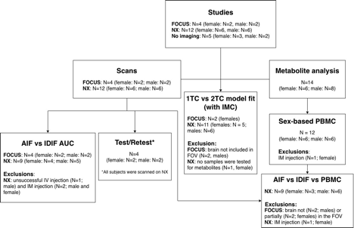
B]
C] | Time (min) | Maximum  Volume (cc) | n | D] | ROI | Voxel # | Volume [mm³]
 | 0.5 | 0.1 | 2 |  | Hippocampus | 204181 | 148.848
 | 1.5 | 0.1 | 10 |  | Striatum | 141336 | 103.034
 | 2.5 | 0.1 | 11 |  | Amygdala | 23278 | 16.970
 | 3 | 0.1 | 9 |  | Prefrontal cortex | 104124 | 75.906
 | 3.25 | 0.1 | 2 |  | Sensorimotor cortex | 973996 | 710.043
 | 3.5 | 0.1 | 2 |  | Cerebellum | 462121 | 336.886
 | 4 | 0.1 | 9 |  | Brainstem | 438353 | 319.559
 | 5 | 0.35 | 12 |  | 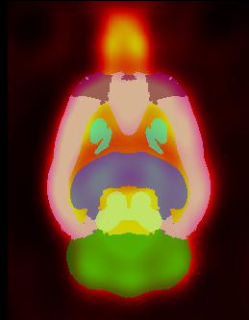
 | 10 | 0.1 | 11
 | 15 | 0.35 | 11
 | 20 | 0.1 | 4
 | 30 | 0.5 | 8
 | 40 | 0.1 | 4
 | 50 | 0.1 | 4
 | 60 | 0.7 | 11
 | Total Maximumª | 3.0 | N=110
 | ªMaximum volume of 3.0 cc was only achieved for one (terminal) study. Otherwise, the maximum volume was 0.9 cc.

Timeframe | %Diff | |%Diff| | *p-value
0-60 minutes | 18.34±21.45 | 22.42±16.72 | 0.004
0-10 minutes | 27.12±18.42 | 27.12±18.42 | 0.001
10-60 minutes | 16.03±25.78 | 22.60±19.73 | 0.027
Table S2. Differences between whole blood and left ventricle time activity area under the curve

Note: Data presented as mean±SD for n=13 scans performed in n=11 rats
*Paired-sample t-test comparing whole blood and left ventricle area under the curve

Table S3. 1TC model parameters, parameter rSE, and AIC by region after applying the A] Unified and B] Sex-specific metabolite correction to the IDIF.

A. | 1TC IDIF-unified PBMC
 | V_{T}ª | V_{T} rSE | K₁^{c} | K₁ rSE | AIC
Hippocampus | 31.62±10.49 | 2.55±0.93 | 1.45±0.35 | 2.52±1.00 | 462.92±56.63
Striatum | 34.23±12.31 | 2.35±0.91 | 1.45±0.35 | 2.28±0.81 | 460.53±51.98
Amygdala | 21.51±8.91 | 3.91±1.25 | 0.88±0.27 | 3.50±1.21 | 458.77±42.78
Prefrontal Ctx. | 32.77±12.70 | 2.85±1.36 | 1.27±0.35 | 2.55±0.90 | 460.09±46.16
Sensorimotor Ctx. | 28.75±10.04 | 2.51±1.01 | 1.10±0.31 | 2.34±0.88 | 449.55±53.97
Cerebellum | 21.99±6.03 | 2.44±0.91 | 1.57±0.30 | 2.82±1.02 | 464.09±52.69
Brainstem | 21.86±6.30 | 2.87±1.04 | 1.67±0.38 | 3.18±1.13 | 471.75±48.67
B. | 1TC IDIF-sex specific PBMC
 | V_{T}^{b} | V_{T} rSE | K₁^{d} | K₁ rSE | AIC
Hippocampus | 34.46±12.13 | 2.60±0.77 | 1.38±0.32 | 2.19±0.57 | 461.12±46.52
Striatum | 37.41±14.35 | 2.38±1.02 | 1.39±0.29 | 1.92±0.65 | 455.72±42.23
Amygdala | 23.68±11.23 | 3.79±1.12 | 0.84±0.19 | 3.12±1.03 | 454.92±39.60
Prefrontal Ctx. | 35.80±14.88 | 2.86±1.16 | 1.21±0.30 | 2.17±0.59 | 456.47±40.06
Sensorimotor Ctx. | 31.60±12.39 | 2.80±1.03 | 1.04±0.28 | 2.13±0.58 | 448.95±40.90
Cerebellum | 23.90±7.33 | 2.40±0.83 | 1.50±0.27 | 2.32±0.66 | 459.18±46.82
Brainstem | 23.74±7.74 | 2.80±0.98 | 1.59±0.29 | 2.71±0.79 | 467.26±44.61
Note: Data presented as mean±SD for n=13 scans performed in n=9 rats
ªInclusive 0f 6 outlier values (n=2 from one rat and n=4 from a different rat)
^{b}Inclusive of 7 outlier values (all from one rat)
^{c}Inclusive of 2 outlier values (all from one rat)
^{d}Inclusive of 1 outlier value

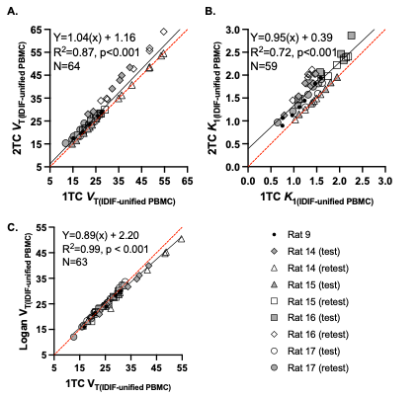

Figure S1. Correlations between 1TC and 2TC A] V_{T} and B] K₁, and C] 1TC and Logan plot V_{T} parameter estimates. Parameter measures originating from a single scan are represented by a unique symbol. Data from nine scans (performed in six rats) are visualized; excluding V_{T} and K₁ estimates with high rSE (>10%). The linear equation, R² and p-values, and the number of values included in the regression analysis (N) are provided. Each graph is displayed with the regression fit line (solid) across all rats and ROIs (hippocampus, striatum, prefrontal cortex, sensorimotor cortex, amygdala, cerebellum, and brainstem) and line of identity (dashed) are displayed. The Rat number corresponds to that provided in Table S1.

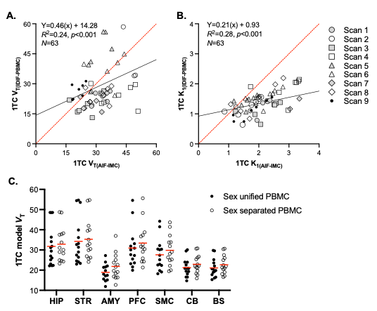

Figure S2. Comparison of A] V_{T} and B] K₁ values as estimated by the 1TC model using an IDIF with sex unified population-based metabolite correction relative to AIF-IMC V_{T} and K₁. C] Significant differences in 1TC model V_{T} estimates using the sex unified versus the sex-specific population-based metabolite correction (PBMC). Individual values are displayed with the population mean. Mixed-effect ANOVA (repeated measures of PBMC and ROI): F_{1,14} = 77.65, p < 0.0001.

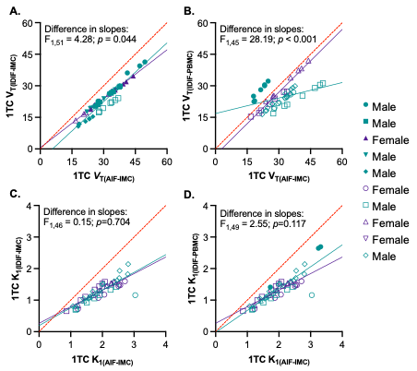
Key
Figure S3. Correlations between 1TC model estimates of A,B] V_{T} and C,D] K₁ using the AIF-IMC relative to the A,C] IDIF-IMC or the B,D] IDIF-PBMC. Parameter measures originating from a single scan are represented by a unique symbol, with males in teal and females in purple. Parameter estimates with high rSE (>10%) were excluded. The test for the difference in slopes between males and females are provided. Data from each individual rat/study is assigned a unique symbol (see figure Key). Each graph is displayed with regression fit lines (solid) across all male (teal) and female (purple) rats and ROIs (hippocampus, striatum, prefrontal cortex, sensorimotor cortex, amygdala, cerebellum, and brainstem) and the line of identity (dashed).

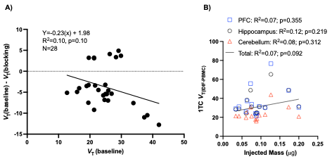
Figure S4. To test for potential effects of [¹⁸F]SynVesT-1 specific activity, A) A Lassen plot analysis of test-retest scans was conducted where lower injected mass was considered “baseline”, and the higher injected mass was designated as the “blocking” condition. Each data point corresponds to a different brain region (n=7) for different rats (n=4). B) Linear regressions were used to test for potential influence of total injected mass on V_{T} values (n=14 studies).

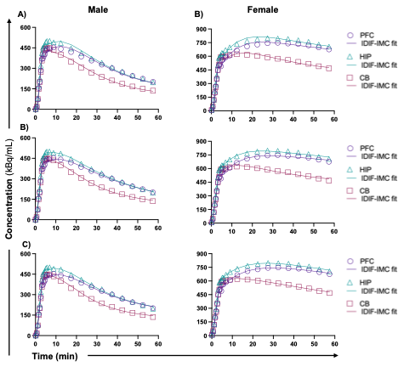
Figure S5. Representative two-tissue compartment (2TC) model fits. Male (left) and female (right) 2TC model fits using the A) arterial input function (AIF) or B) image-derived input function (IDIF) after applying the individual metabolite correction (IMC), and C) the IDIF using the population-based metabolite correction (PBMC) presented for selected brain ROIs: prefrontal cortex (PFC), hippocampus (HIP), and cerebellum (CB). The 1TC model fits for these same rats are provided in Figure 4.

SUPPLEMENTAL REFERENCES
1. Barrière DA, Magalhães R, Novais A, Marques P, Selingue E, Geffroy F, et al. The SIGMA rat brain templates and atlases for multimodal MRI data analysis and visualization. Nature Communications. 2019;10:5699. doi:10.1038/s41467-019-13575-7.
2. Sadasivam P, Fang XT, Toyonaga T, Lee S, Xu Y, Zheng MQ, et al. Quantification of SV2A Binding in Rodent Brain Using [(18)F]SynVesT-1 and PET Imaging. Mol Imaging Biol. 2021;23:372-81. doi:10.1007/s11307-020-01567-9.
3. Lee T-C, Kashyap RL, Chu CN. Building Skeleton Models via 3-D Medial Surface/Axis Thinning Algorithms. CVGIP Graph Model Image Process. 1994;56:462-78.
4. Zhang TY, Suen CY. A fast parallel algorithm for thinning digital patterns. Commun ACM. 1984;27:236–9. doi:10.1145/357994.358023.
5. contributors s-i. Skeletonize — scikit-image. 2024.

