Supplementary Figure
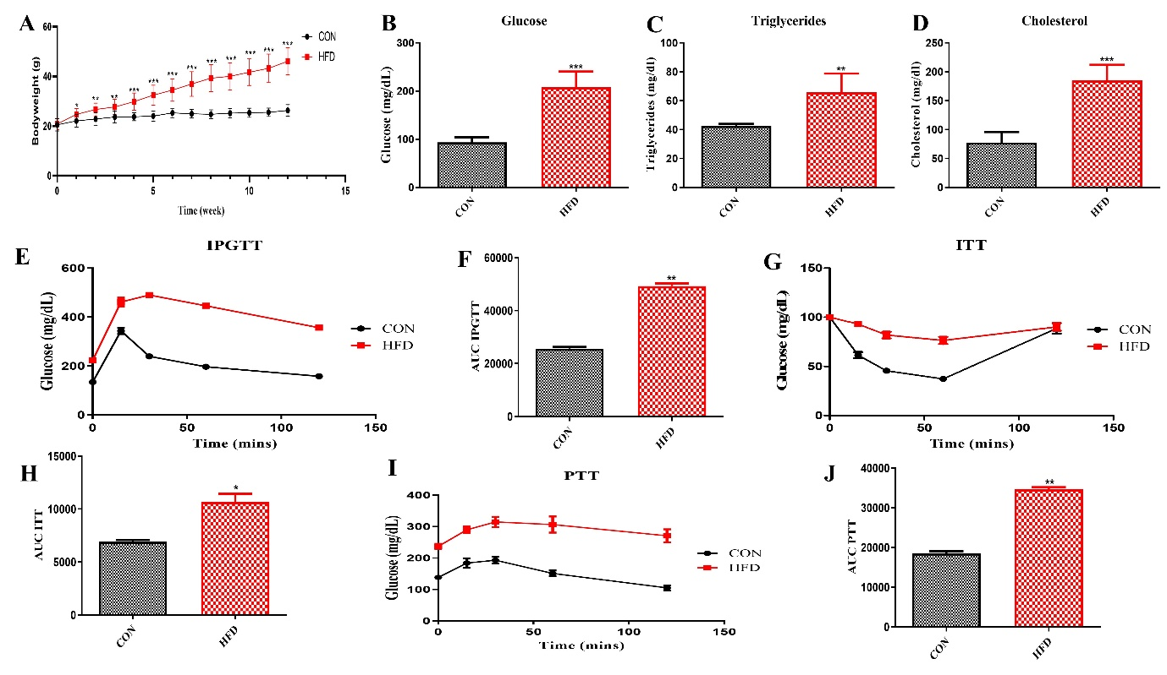
Fig. S1. High fat diet feeding for 12 weeks develops insulin resistance in C57BL/6J mice. At the end of 12 weeks, animals were fasted overnight, blood was withdrawn from the retro-orbital plexus, and glucose, triglycerides, and cholesterol were estimated. For IPGTT and PTT animals were fasted overnight whereas fasting time before ITT was 4 hrs. The figure shows body weight after 12 week HFD feeding (A), plasma glucose (B), triglycerides (C), total cholesterol (D), IPGTT (E), AUC of IPGTT (F), ITT (G), AUC of ITT (H), PTT (I) and AUC of PTT (J). Data are expressed as mean ±SD. (N=6,18), *p<0.05, **p<0.01, ***p<0.001. * vs CON.
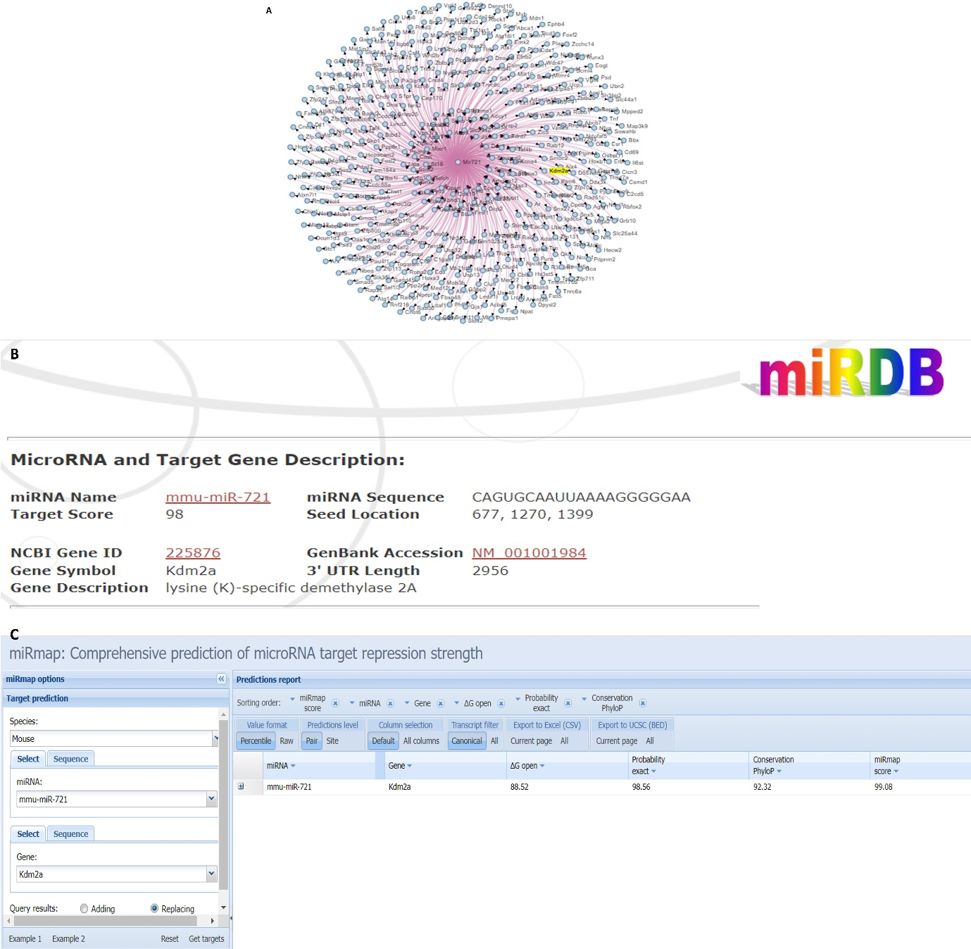
Fig. S2. Insilico analysis of mm-miR-721 targets. The figure shows (A) miR-721 target prediction analysis performed at www.informatics.jax.org/ , (B) miR-721 interaction details obtained from miRDB.org and (C) miR-721 targeting of Kdm2A as predicted by miRmap.

