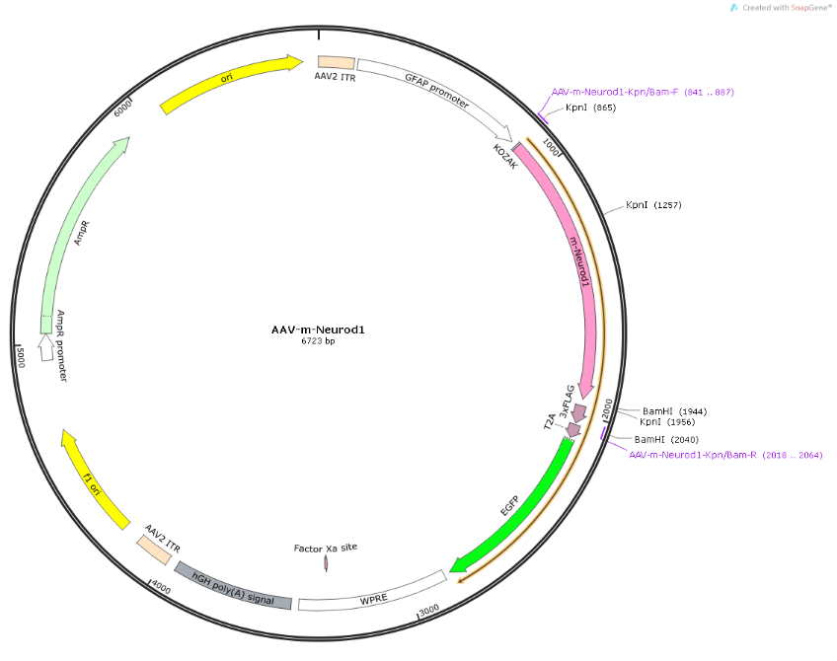
Figure S1. Vector map of the NeuroD1 overexpression viral vector, HBAAV2/9-GFAP-m-Neurod1-3xflag-EGFP.
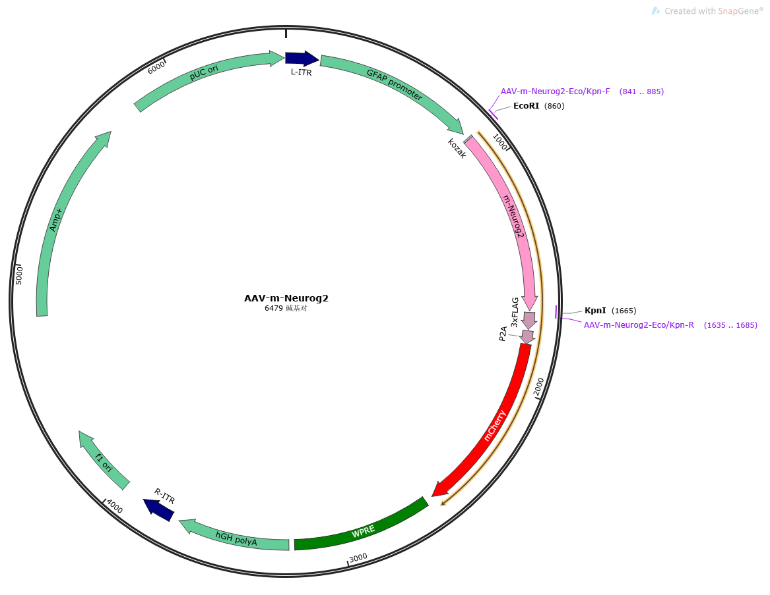
Figure S2. Vector map of the Ngn2 overexpression viral vector, HBAAV2/9-GFAP-m-Neurog2-3xflag-mcherry.

