Supplementary Material

Supplementary Figures and Tables

Supplementary Figure

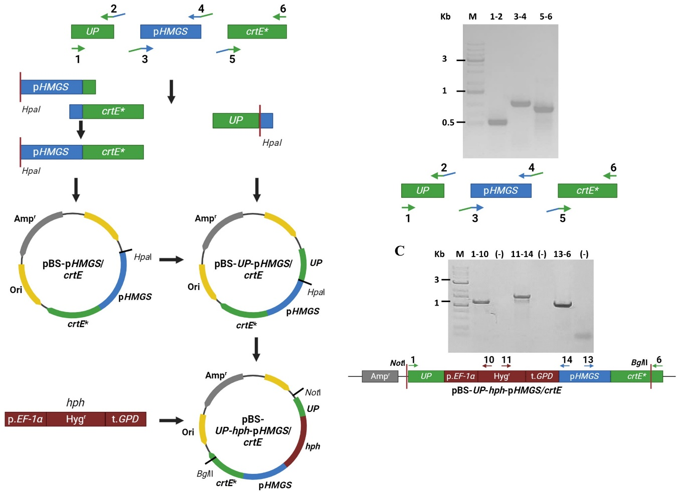
Supplementary Figure 1. Representation, construction, and analysis of the pBS-Up-hph-pHMGS/crtE vector. A) Fragments of interest were amplified, including an upstream region of the crtE gene promoter (UP), the HMGS gene promoter region (pHMGS), and a portion from exon 1 to 81 bp of exon 4 of the crtE gene (crtE*). Specific primers were designed (Table 1.2.1 in the supplementary material) to generate amplicons with 10 complement bases, allowing the fusion of pHMGS and crtE* through Overlap Extension PCR (OE-PCR). Subsequently, the generated fragment was inserted at the EcoRV site of plasmid pBS, giving rise to the pBS-pHMGS/crtE vector with the HpaI restriction site added upstream of pHMGS. The UP region, also amplified by PCR, was inserted at the HpaI site of pBS-pHMGS/crtE, resulting in the pBS-UP-pHMGS/crtE* vector. The UP region also included a HpaI restriction site to insert at this site the Hygromycin B resistance module (hph) in pBS-UP-pHMGS/crtE*, obtaining the vector pBS-Up-hph-pHMGS/crtE*. The figure also shows the enzymatic restriction sites, NotI in the UP region, and BglII in the exon 4 region, enzymes that were used to release the DNA fragment used to transform the strains of this study: wild-type strain CBS6938 and the mutant strains CBS.cyp61⁻ and CBS.SRE1N.FLAG of X. dendrorhous. B) The amplification of each DNA fragment was confirmed by agarose gel electrophoresis. The numbers associated with each lane represent the primers used in the PCR reactions, and DNA from the wild-type X. dendrorhous strain CBS6938 was used as template. C) Verification of the pBS-Up-hph-pHMGS/crtE* vector was performed by amplifying three different regions of the plasmid with specific primers (Table 1.2.1 in the supplementary material). In the agarose gel image, the numbers at the top of the lanes indicate the primers used in the PCR reactions. M = GeneRulerTM 1 kb Plus DNA Ladder molecular weight marker. (-) represents a control without DNA.

Supplementary Table

Supplementary Table 1. Primers used in this work.

N° | Name | Sequence (5´- 3´) | Orientation
1 | FwUp** | GTTGGACGAATGTAGCCG | D
2 | RvUp* | GTTCGAACTGGGTTAACCATCAAGGAGAGTACTCTCG | R
3 | Fhmgs* | CTCCTTGATGGTTAACCCAGTTCGAACGAGAGTATCGT | D
4 | RvHmgs | TCGCGTAATCCATAACTGGATATCTAGATTGAGAT | R
5 | Fwcrte | ATATCCAGTTATGGATTACGCGAACATCCTC | F
6 | Rvcrte** | GGAGGAATTACAGGCATGGGT | R
7 | Gpd.F | ACGGTTCTCTCCAAACCCTC | D
8 | H.out.R | TCCATCACAGTTTGCCAGTG | R
9 | P.tef.F | GGCTCATCAGCCGACAGTTCA | D
10 | Hyg.Rev.In** | TGTCAAGCACTTCCGGAATCG | R
11 | Int.Hyg.F** | GTGTCACGTTGCAAGACCTG | D
12 | FwUp2** | GAATTCCAACACAAGCTGGA | D
13 | FwHmgs2** | GATTGACCTTGAGTACGCGG | D
14 | RvHmgs2** | CGGCCAAGGTATGTAAGTTC | R
15 | Rvcrte2 | CCAACAACGTTCTGGATGAC | R
16 | M13Fw | GTAAAACGACGGCCAGT | D
17 | M13Rv | GTCATAGCTGTTTCCTG | R
18 | FwD2check | AGACCGAGGAGAAGGTTTCATG | D
19 | FUP2 | CTTAAAAGCTCGCACTGGTC | D
20 | crtE.out.F1 | ATGACTCTTGCCGGCGATTTGA | D
21 | R1.crtE | AAGCTGGACAAAGTCTCTAC | R
22 | FwUp.Sc | GTTGGACGAATGTAGCCG | D
23 | RvHyg.Sc | GTCGGCTGATGAGCCGAT | R
24 | FwHMGS.Sc | CCATCATCTCCGTCATCT | D
25 | RvHMGS.Sc | CCGACTCAGTAGAGTTCT | R
26 | FwHMGS2.Sc | CAGAGTACACCGTATCGA | D
27 | RvcrtE.Sc | TACGGTTCAAGGAGCACG | R
28 | FwcrtE.Sc | CGTGCTCCTTGAACCGTATC | D
29 | FwcrtE2.Sc | CGCTAGCTTATTGTGAGTC | D
30 | RvcrtE2.Sc | AGACTCACAATAAGCTAGCG | R
31 | RvcrtE3.Sc | CTCTTGATAAGCCAGAAAGT | R
32 | mActF-RT | CCGCCCTCGTGATTGATAAC | F
33 | mActR-RT | TCACCAACGTAGGAGTCCTT | R
34 | mcrtEF-RT | TGTTGGCATGCTACATACCCG | F
35 | mcrtER-RT | GTTGGGCGAAGCTTGAAGAT | R
36 | hmgsRT2-F | AAGCAGGTTGAGCCTGGAATGA | F
37 | HmgrsRT2-R | AAAGCGGTTGAGCTCTTGACCT | R
Primers D = Forward; R = Reverse.* Primers with an added HpaI sequence, highlighted in bold. ** Intermediate primers of the construction module.

