Suplementary results

Concurrent high-intensity interval plus resistance training improves vascular health in breast cancer survivors with high chemotherapy exposure
running title: Concurrent training effects on breast cancer

Cristian Álvarez¹, Carolina Fuentes², Cristóbal Durán-Marín³, Pedro Delgado-Floody⁴, Gabriel Rojas-Rojas¹, Manuel Gomez⁵, Alvaro Gurovich⁶, David C. Andrade^{7*}
¹ Exercise and Rehabilitation Sciences Institute, School of Physical Therapy, Faculty of Rehabilitation Sciences, Universidad Andres Bello, Santiago, 7591538, Chile.
² School of Kinesiology, Universidad Andres Bello, Santiago, Chile.
³ Exercise and Rehabilitation Sciences Institute, Doctorate in Rehabilitation Science Program, Faculty of Rehabilitation Sciences, Universidad Andres Bello, Santiago, Chile.
⁴ Department of Physical Education, Sport and Recreation, Universidad de La Frontera, Temuco, Chile.
⁵ Clinical Applied Physiology Laboratory, College of Health Sciences, The University of Texas at El Paso, El Paso, TX 79968, USA.
⁶ Department of Physical Therapy and Movement Sciences, College of Health Sciences, The University of Texas at El Paso, El Paso, TX, United States.
⁷ Exercise Applied Physiology Laboratory, Centro de Investigación en Fisiología y Medicina de Altura (FIMEDALT), Departamento Biomédico, Facultad de Ciencias de la Salud, Universidad de Antofagasta, Antofagasta, Chile.

*Corresponding author: David C. Andrade, Ph.D.
https://orcid.org/0000-0003-2006-1444
Exercise Applied Physiology Laboratory
Centro de Investigación en Fisiología y Medicina de Altura
Departamento Biomédico
Facultad de Ciencias de la Salud
Universidad de Antofagasta
Av. Universidad de Antofagasta #02800 Antofagasta, Chile
Tel: +56 9 88928666
E-mail: david.andrade@uantof.cl
dcandrade@uc.cl

SUPPLEMENTARY TABLES

Supplementary table S1. Characteristics of the concurrent training progression.

 | “Familiarization period” |  |  |  |  |  | Complete protocol
 | Week 1 |  |  | Week 2 |  |  | Weeks 3-4 | Weeks 5-8
Session Number | 1 | 2 | 3 | 4 | 5 | 6 | 7-12 | 13-24
HIIT | 15 s x 2 | 15 s x 4 | 30 s x 3 | 30 s x 5 | 45 s x 4 | 60 s x 5 | 60 s x 5 | 60 s x 7
Intensity (beats/min) | 80-100% HR_{peak} (Individually adapted session by session)
Recovery criteria | Complete resting ≤70% Heart rate
RT | 3 Exercises  -Back:  15 s x 1  -Biceps:  15 s x 1  -Shoulder:  15 s x 1 | 3 Exercises  -Back:  15 s x 2  -Biceps:  15 s x 2  -Shoulder:  15 s x 2 | 3 Exercises  -Back:  30 s x 2  -Biceps:  30 s x 2  -Shoulder:  30 s x 2 | 3 Exercises  -Back:  30 s x 2  -Biceps:  30 s x 2  -Shoulder:  30 s x 2 | 3 Exercises  -Back:  45 s x 2  -Biceps:  45 s x 2  -Shoulder:  45 s x 2 | 3 Exercises  -Back:  45 s x 2  -Biceps:  45 s x 2  -Shoulder:  45 s x 2 | 3 Exercises  -Back:  60 s x 2  -Biceps:  60 s x 2  -Shoulder:  60 s x 2 | 5 Exercises  -Step  60 s x 2  -FEG  60 s x 2  -Back:  60 s x 2  - Biceps:  60 s x 2  -Shoulder:  60 s x 2
Intensity (1RM%/Borg) | 20-50% 1RM / 8-10 points of Borg (1-10 points)
Recovery criteria | ≤3 points Borg (1-10 points)
(HIIT) High-intensity interval training, (RT) Resistance training. (HR_{peak}) Heart rate peak, (1RM) One–maximum repetition strength test. (FEG) Flexion-extension gastrocnemius.

SUPPLEMENTARY FIGURES

Supplementary Figure S1

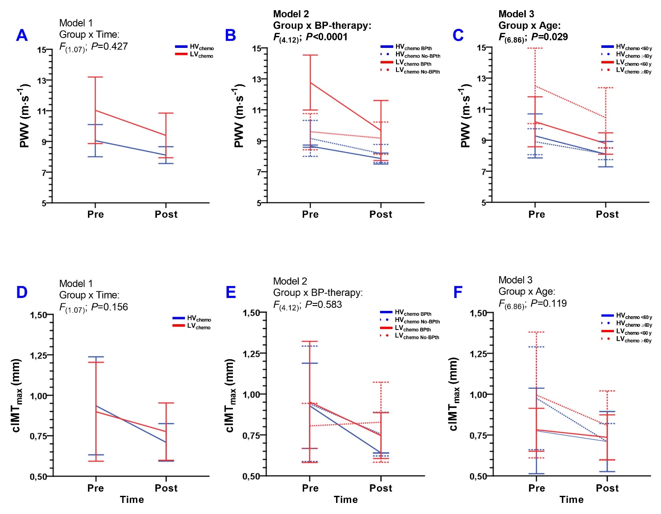
Supplementary Figure S1. Interaction of group x time (A, D; Pre vs. Post-test), group x blood pressure therapy (B, E; Blood pressure therapy uses vs. No Blood pressure therapy use) and group x age (C, F; <60 years vs. ≥60 years old) in breast cancer survivor’s participants of 8 weeks of concurrent training. Groups are described as; (Panel A and D; [HV_{chemo}] High-volume chemotherapy group, (LV_{chemo}) Low-volume chemotherapy group, (Panel B and E; [HV_{chemo} BPth] High-volume chemotherapy using blood pressure therapy, [HV_{chemo} No-BPth] High-volume chemotherapy group not using blood pressure therapy), and ([LV_{chemo} BPth] Low-volume chemotherapy using blood pressure therapy, and [LV_{chemo} No-BPth] Low-volume chemotherapy group not using blood pressure therapy), and (Panel C and F; [HV_{chemo} <60 y] High-volume chemotherapy group participants <60 years old, [HV_{chemo} ≥60 y] High-volume chemotherapy group participants ≥60 years old, [LV_{chemo} <60 y] Low-volume chemotherapy group participants <60 years old, and [LV_{chemo} ≥60 y] Low-volume chemotherapy group participants ≥60 years old. Outcomes are described as; (PWV) Pulse wave velocity, and (cIMT_{max}) Carotid intima-media thickness maximum. Bold values denote significant interaction at P<0.05.
Supplementary Figure S2

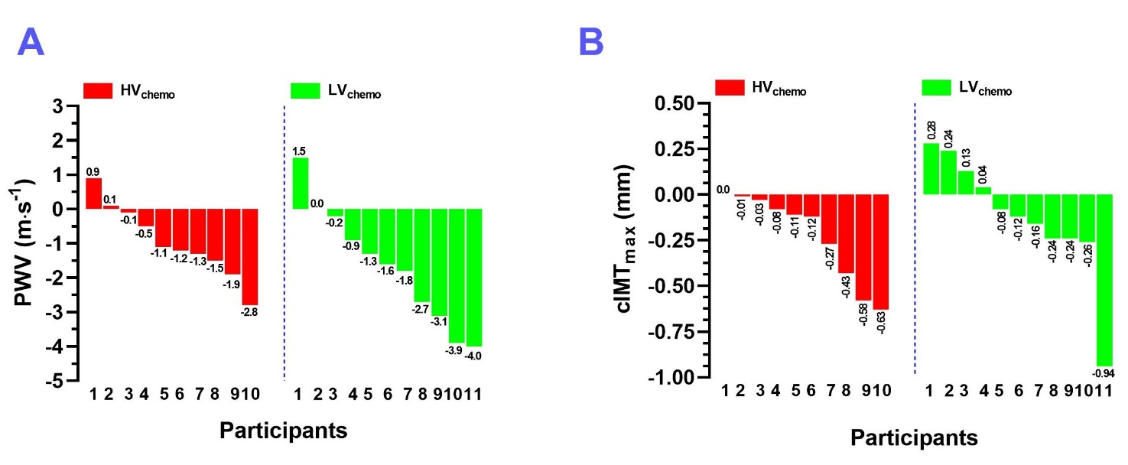
Supplementary Figure S2. Inter-individual variability after 8 weeks of concurrent training in breast cancer survivors in functional and structural vascular outcomes. Groups are described as; (Panel A and D; [HV_{chemo}] High-volume chemotherapy group, (LV_{chemo}) Low-volume chemotherapy group. Outcomes are described as; (PWV) Pulse wave velocity, and (cIMT_{max}) Carotid intima-media thickness maximum.

Supplementary Figure S3
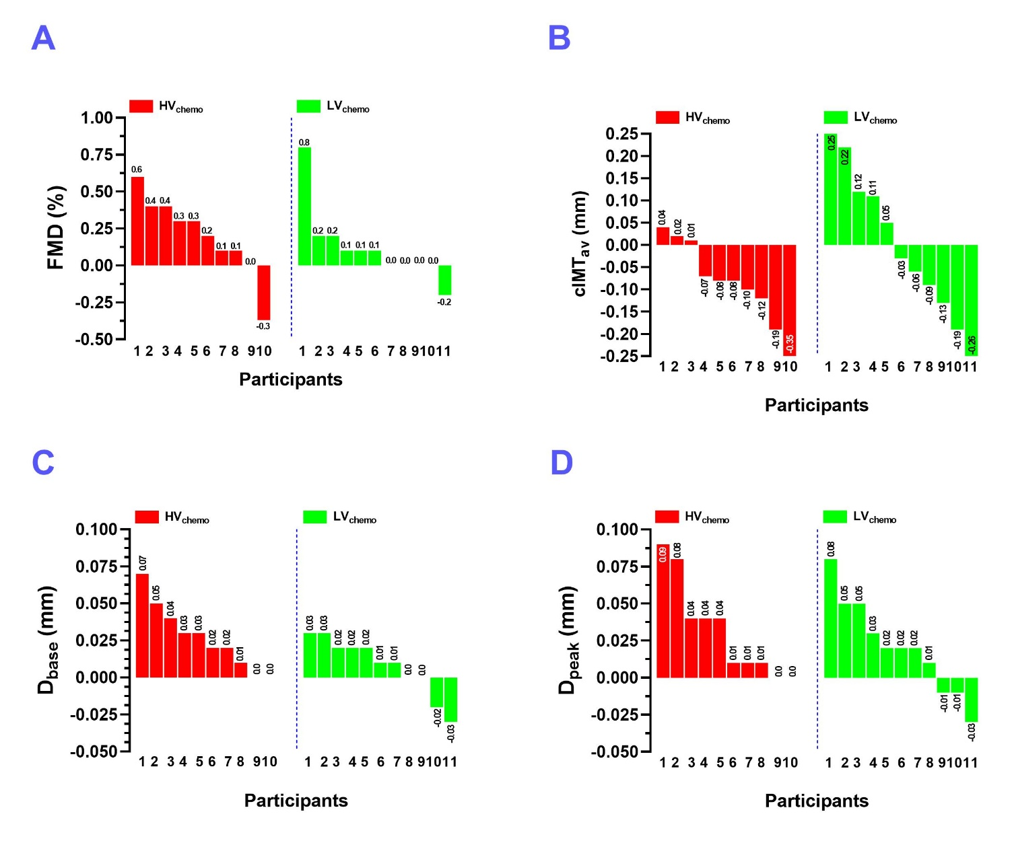

Supplementary Figure S3. Inter-individual variability after 8 weeks of concurrent training in breast cancer survivors in functional and structural vascular outcomes. Groups are described as; (Panel A and D; [HV_{chemo}] High-volume chemotherapy group, (LV_{chemo}) Low-volume chemotherapy group. Outcomes are described as; (FMD) Flow-mediated dilation, (cIMT_{av}) Carotid intima-media thickness average, (D_{base}) Brachial artery diameter at baseline, and (D_{peak}) Peak brachial artery diameter after 5 minutes occlusion.

Supplementary Figure S4

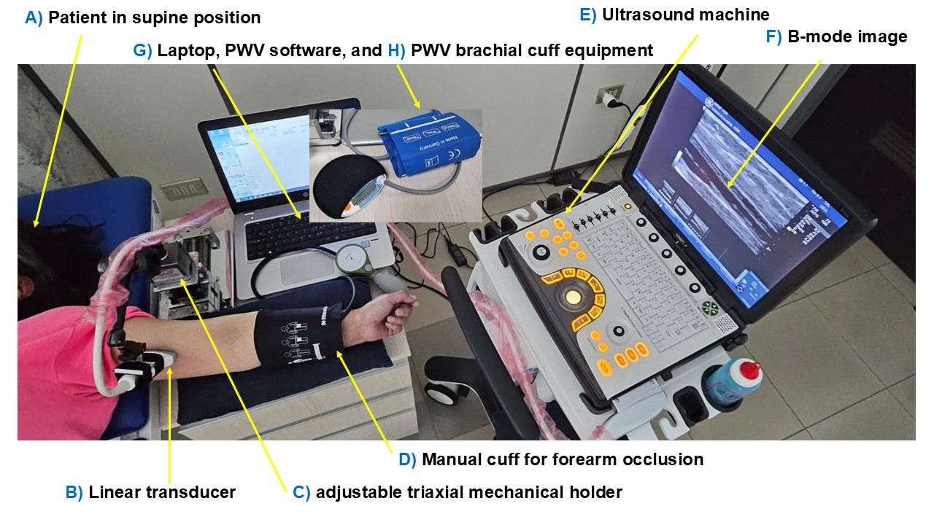
Supplementary Figure S4. Schematic image of flow-mediated dilation and pulse wave velocity measurement from the brachial artery.

