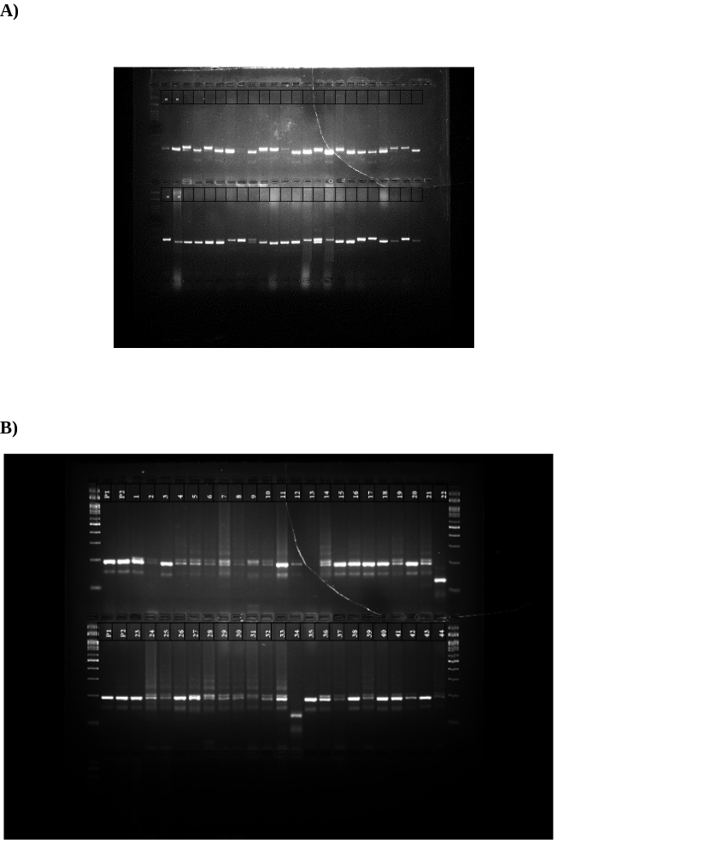
Supplementary Fig. 1: Molecular validation of resistance genes (xa13 and Xa21) with the gene-specific molecular markers

