Supplementary Information

Age-related changes in the levels of active DNA demethylation pathway products in urine and in DNA isolated from leukocytes.
Fabian Lesniewski¹, Aleksandra Skalska-Bugala¹, Marta Starczak¹, Jolanta Guz¹, Ewelina Zarakowska¹, Aleksandra Wasilow¹, Pawel Mijewski¹, Agnieszka Siomek-Gorecka¹, Andrzej Koltan², Kinga Linowiecka³, Zbigniew Banaszkiewicz⁴, Daniel Gackowski¹, Ryszard Olinski^{1*}, Rafal Rozalski^{1*}

¹ Department of Clinical Biochemistry, Faculty of Pharmacy, Collegium Medicum in Bydgoszcz, Nicolaus Copernicus University in Toruń, Bydgoszcz, Poland; fabian.lesniewski@gmail.com (F.L.); aleksandraaskalska@gmail.com (A.S.-B.); marta.starczak@cm.umk.pl (M.S.); jolaguz@cm.umk.pl (J.G.); ewelinaz@cm.umk.pl (E.Z.); aleksandra.wasilow@gmail.com (A.W.) asiomek@cm.umk.pl (A.S.-G.); danielg@cm.umk.pl (D.G.); ryszardo@cm.umk.pl (R.O.); rafalr@cm.umk.pl (R.R.)
² Department of Pediatric, Hematology and Oncology, Collegium Medicum in Bydgoszcz, Nicolaus Copernicus University in Toruń, 85–094 Bydgoszcz, Poland; akoltan@by.home.pl (AK)
³ Department of Human Biology, Faculty of Biological and Veterinary Sciences, Nicolaus Copernicus University, 87-100 Toruń, Poland; klinowiecka@umk.pl (K.L.)
⁴Department of Surgery, Faculty of Medicine, Collegium Medicum in Bydgoszcz, Nicolaus Copernicus University in Toruń, Bydgoszcz, Poland; banasz@cm.umk.pl (Z.B.)

Contact Information: rafalr@cm.umk.pl (Rafal Rozalski); ryszardo@cm.umk.pl (Ryszard Olinski); Tel.: 0048 52 5853749 (R.O. and R.R.)

Table S1. Univariate linear regression analysis of active DNA demethylation products adjusted for age and gender in urine.
 | β | St. Err β | R² | t | p
5-(hydroxymethyl)-2’-deoxycytidine | -0,5187 | 0,1038 | 0,3268 | -4,998 | <0,0001
8-oxo-7,8-dihydro-2′-deoxyguanosine | 0,0333 | 0,1091 | 0,3831 | 0,305 | 0,7608
5-hydroxymethylcytosine | -0,5175 | 0,0910 | 0,3782 | -5,684 | <0,0001
5-methyl-2’-deoxycytidine | -0,3460 | 0,1053 | 0,2423 | -3,287 | 0,0015
5-carboxycytosine | -0,4248 | 0,0964 | 0,3320 | -4,405 | <0,0001
5-formylcytosine | -0,2669 | 0,1037 | 0,1962 | -2,574 | 0,0120
5-(hydroxymethyl)-2′-deoxyuridine | -0,2274 | 0,1058 | 0,1733 | -2,149 | 0,0349
5-hydroxymethyluracil | -0,6144 | 0,0829 | 0,4897 | -7,410 | <0,0001

Table S2. Univariate linear regression analysis of active DNA demethylation products adjusted for age and gender in DNA isolated from leukocytes.
 | β | St. Err β | R² | t | p
5-methyl-2’-deoxycytidine | -0,2762 | 0,0929 | 0,2012 | -2,974 | 0,0037
5-(hydroxymethyl)-2’-deoxycytidine | -0,4444 | 0,0884 | 0,3106 | -5,021 | <0,0001
8-oxo-7,8-dihydro-2′-deoxyguanosine | 0,0501 | 0,0989 | 0,1386 | 0,507 | 0,6135
5-carboxy-2′-deoxycytidine | 0,2732 | 0,0954 | 0,2154 | 2,865 | 0,0051
5-formyl-2′-deoxycytidine | -0,1148 | 0,0978 | 0,1489 | -1,174 | 0,2434
5-(hydroxymethyl)-2′-deoxyuridine | -0,0394 | 0,0984 | 0,1326 | -0,400 | 0,6898
2′-deoxyuridine | -0,0732 | 0,0963 | 0,1396 | -0,760 | 0,4488

Table S3. The coefficients of variation (%CV) for control samples used in urine analysis of active demethylation products.

 | Control 1 |  | Control 2
 | %CV
5-(hydroxymethyl)-2’-deoxycytidine | 4% | 5%
8-oxo-7,8-dihydro-2′-deoxyguanosine | 7% | 6%
5-hydroxymethylcytosine | 6% | 4%
5-methyl-2’-deoxycytidine | 5% | 6%
5-carboxycytosine | 13% | 13%
5-formylcytosine | 5% | 8%
5-(hydroxymethyl)-2′-deoxyuridine | 9% | 12%
5-hydroxymethyluracil | 3% | 5%

Table S4. Transition patterns and specific detector settings for all compounds analyzed by 2D UPLC–MS/MS in urine.
compound name |  | ionization mode | nominal molecular mass (Da) | pseudo-molecular ion formulation | nominal parent ion (Da) | nominal daughter ion | capillary (kV) | cone (V) | collision (eV)
5-hydroxymethylcytosine | quantifier | UniSpray+ | 141 | [M+H]⁺ | 142 | 81 | 1.3 | 40 | 18
5-hydroxymethylcytosine | qualifier | UniSpray+ | 141 | [M+H]⁺ | 142 | 124 | 1.3 | 40 | 12
[D₃]-5-hydroxymethylcytosine | quantifier | UniSpray+ | 144 | [(M+3)+H]⁺ | 145 | 84 | 1.3 | 40 | 18
[D₃]-5-hydroxymethylcytosine | qualifier | UniSpray+ | 144 | [(M+3)+H]⁺ | 145 | 127 | 1.3 | 40 | 12
5-hydroxymethyl-2'-deoxycytidine | quantifier | UniSpray+ | 257 | [M+H]⁺ | 258 | 124 | 1.3 | 35 | 22
5-hydroxymethyl-2'-deoxycytidine | qualifier | UniSpray+ | 257 | [M+H]⁺ | 258 | 142 | 1.3 | 35 | 10
[D₃]-5-hydroxymethyl-2'-deoxycytidine | quantifier | UniSpray+ | 260 | [(M+3)+H]⁺ | 261 | 127 | 1.3 | 35 | 22
[D₃]-5-hydroxymethyl-2'-deoxycytidine | qualifier | UniSpray+ | 260 | [(M+3)+H]⁺ | 261 | 145 | 1.3 | 35 | 10
5-carboxylcytosine | quantifier | UniSpray- | 155 | [M-H]⁻ | 154 | 67 | 1.3 | 60 | 12
5-carboxylcytosine | qualifier | UniSpray- | 155 | [M-H]⁻ | 154 | 110 | 1.3 | 60 | 12
[¹³C₁₀, ¹⁵N₂]-5-carboxylcytosine | quantifier | UniSpray- | 162 | [(M+7)-H]⁻ | 161 | 71 | 1.3 | 60 | 12
[¹³C₁₀, ¹⁵N₂]-5-carboxylcytosine | qualifier | UniSpray- | 162 | [(M+7)-H]⁻ | 161 | 116 | 1.3 | 60 | 12
8-oxo-2’-deoxyguanosine | quantifier | UniSpray+ | 283 | [M+H]⁺ | 284 | 168 | 1.3 | 30 | 18
8-oxo-2’-deoxyguanosine | qualifier | UniSpray+ | 283 | [M+H]⁺ | 284 | 140 | 1.3 | 30 | 18
[¹⁵N₅]-8-oxo-2'-deoxyguanosine | quantifier | UniSpray+ | 288 | (M+5)+H+ | 289 | 173 | 1.3 | 20 | 15
[¹⁵N₅]-8-oxo-2'-deoxyguanosine | qualifier | UniSpray+ | 288 | (M+5)+H+ | 289 | 145 | 1.3 | 20 | 15
5-formylcytosine | quantifier | UniSpray+ | 139 | [M-H]⁻ | 140 | 97 | 1.3 | 40 | 15
5-formylcytosine | qualifier | UniSpray+ | 139 | [M-H]⁻ | 140 | 70 | 1.3 | 40 | 15
[¹³C₁₀, ¹⁵N₂]-5-formylcytosine | quantifier | UniSpray+ | 146 | [(M+7)-H]⁻ | 147 | 102 | 1.3 | 40 | 15
[¹³C₁₀, ¹⁵N₂]-5-formylcytosine | qualifier | UniSpray+ | 146 | [(M+7)-H]⁻ | 147 | 73 | 1.3 | 40 | 15
5-methyl-2’-deoxycytidine | quantifier | UniSpray+ | 241 | [M-H]⁻ | 242 | 126 | 1.3 | 30 | 12
5-methyl-2’-deoxycytidine | qualifier | UniSpray+ | 241 | [M-H]⁻ | 242 | 224 | 1.3 | 30 | 12
[¹³C₁₀, ¹⁵N₂]-5-methyl2’-deoxycytidine | quantifier | UniSpray+ | 253 | [(M+12)-H]⁻ | 254 | 133 | 1.3 | 30 | 12
[¹³C₁₀, ¹⁵N₂]-5-methyl2’-deoxycytidine | qualifier | UniSpray+ | 241 | [(M+12)-H]⁻ | 254 | 236 | 1.3 | 30 | 12

Table S5. Comparison of TET3 and SMUG1 expression between men and women (U-Mann-Whitney test).
 | Women | Men | p
 | median (interquartile range)
TET 3 | 1,104 (0,605-1,794) | 1,459 (0,941-1,841) | 0,198
SMUG1 | 0,756 (0,551-0,939) | 0,939 (0,695-1,153) | 0,093

Table S6. Spearman’s rank correlation with age and urinary levels of active DNA demethylation products of 5-methylcytosine and 8-oxo-7,8-dihydro-2’-deoxyguanosine. The results are presented in nmol of modified nucleobase or deoxynucleoside per mmol of creatinine.
 | Median (Interquartile Range)  [nmol/mmol creatinine] | Correlation with age
 | Median (Interquartile Range)  [nmol/mmol creatinine] | R | p-value | N
5-hydroxymethylcytosine | 2.379 (1.879-3.203) | -0.30 | 0,007 | 80
5-formylcytosine | 1.889 (1.418-2.556) | -0,25 | 0,023 | 81
5-carboxycytosine | 2.837 (2.038-4.060) | -0,48 | <0,001 | 78
5-methyl-2’-deoxycytidine | 0.772 (0.412-1.562) | -0,36 | <0,001 | 83
5-(hydroxymethyl)-2’-deoxycytidine | 2.317 (1.699-3.253) | -0,46 | <0,001 | 78
5-hydroxymethyluracil | 7.728 (6.464-10.487) | -0,61 | <0,001 | 82
5-(hydroxymethyl)-2′-deoxyuridine | 6.226 (3.747-10.062) | -0,03 | 0,807 | 78
8-oxo-7,8-dihydro-2′-deoxyguanosine | 1.105 (0.873-1.621) | 0,12 | 0,278 | 78

p-values < 0.05 are marked in red.

Table S7. Spearman’s rank correlation with age and levels of active demethylation products of 5-methylcytosine and 8-oxo-7,8-dihydro-2’-deoxyguanosine in DNA isolated from leukocytes. The /10^{x}dN notation indicates the number of modified deoxynucleosides per 10^{x} native deoxynucleosides in DNA.
 | Median  (Interquartile Range) | Correlation with age
 | Median  (Interquartile Range) | R | p-value | N
5-methyl-2’-deoxycytidine /10³dN | 8.624 (8.452-8.775) | -0,21 | 0,080 | 68
5-(hydroxymethyl)-2’-deoxycytidine /10³dN | 0.060 (0.051-0.070) | -0,33 | 0,006 | 68
5-formyl-2′-deoxycytidine /10⁶dN | 0.147 (0.117-0.198) | -0,17 | 0,149 | 71
5-carboxy-2′-deoxycytidine /10⁹dN | 10.541 (3.253-15.287) | 0,05 | 0,670 | 69
2′-deoxyuridine/10⁶dN | 4.932 (4.312-5.370) | -0,22 | 0,067 | 72
5-(hydroxymethyl)-2′-deoxyuridine/10⁶dN | 0.434 (0.259-0.762) | -0,12 | 0,325 | 71
8-oxo-7,8-dihydro-2′-deoxyguanosine /10⁶dN | 1.567 (1.133-2.190) | -0,10 | 0,410 | 70
p-values < 0.05 are marked in red.

Table S8. Spearman’s rank correlation with age and urinary levels of active DNA demethylation products of 5-methylcytosine and 8-oxo-7,8-dihydro-2’-deoxyguanosine. Infants (age < 3) were excluded. The results are presented in nmol of modified nucleobase or deoxynucleoside per mmol of creatinine.
 | Median (Interquartile Range)  [nmol/mmol creatinine] | Correlation with age
 | Median (Interquartile Range)  [nmol/mmol creatinine] | R | p-value | N
5-hydroxymethylcytosine | 2,357 (1,872-3,108) | -0,25 | 0,028 | 78
5-formylcytosine | 1,927 (1,410-2,597) | -0,27 | 0,016 | 79
5-carboxycytosine | 2,806 (2,022-4,063) | -0,47 | <0,001 | 76
5-methyl-2’-deoxycytidine | 0,772 (0,419-1,554) | -0,37 | 0,001 | 81
5-(hydroxymethyl)-2’-deoxycytidine | 2,268 (1,637-3,182) | -0,44 | <0,001 | 76
5-hydroxymethyluracil | 7,683 (6,337-10,112) | -0,59 | <0,001 | 80
5-(hydroxymethyl)-2′-deoxyuridine | 6,134 (3,742-9,982) | 0,03 | 0,789 | 76
8-oxo-7,8-dihydro-2′-deoxyguanosine | 1,129 (0,892-1,641) | 0,07 | 0,559 | 76

p-values < 0.05 are marked in red.

Table S9. Spearman’s rank correlation with age and levels of active demethylation products of 5-methylcytosine and 8-oxo-7,8-dihydro-2’-deoxyguanosine in DNA isolated from leukocytes. Infants (age < 3) were excluded. The /10^{x}dN notation indicates the number of modified deoxynucleosides per 10^{x} native deoxynucleosides in DNA.
 | Median  (Interquartile Range) | Correlation with age
 | Median  (Interquartile Range) | R | p-value | N
5-methyl-2’-deoxycytidine /10³dN | 8,63 (8,465-8,794) | -0,17 | 0,183 | 66
5-(hydroxymethyl)-2’-deoxycytidine /10³dN | 0,060 (0,051-0,070) | -0,27 | 0,027 | 66
5-formyl-2′-deoxycytidine /10⁶dN | 0,160 (0,121-0,200) | -0,16 | 0,199 | 69
5-carboxy-2′-deoxycytidine /10⁹dN | 5,988 (2,810-13,590) | 0,03 | 0,801 | 67
2′-deoxyuridine/10⁶dN | 4,983 (4,397-5,370) | -0,27 | 0,025 | 70
5-(hydroxymethyl)-2′-deoxyuridine/10⁶dN | 0,426 (0,264-0,700) | -0,12 | 0,322 | 69
8-oxo-7,8-dihydro-2′-deoxyguanosine /10⁶dN | 1,386 (1,076-1,852) | -0,11 | 0,374 | 68
p-values < 0.05 are marked in red.

Table S10. Correlation between age and the ratio of active DNA demethylation products to 5-mdC.
 | Median (Interquartile Range) | Correlation with age
 | Median (Interquartile Range) | R | p-value | N
Urine 5-hmCyt/5-mdC | 2,855 (1,739-6,258) | 0,151 | 0,177 | 81
Urine 5-hmdC/5-mdC | 3,194 (2,153-4,467) | 0,003 | 0,980 | 78
Urine 5-fdC/5-mdC | 2,164 (1,164-5,025) | 0,239 | 0,031 | 81
Urine 5-cadC/5-mdC | 3,263 (1,917-7,036) | 0,142 | 0,214 | 78
DNA 5-hmdC/5-mdC | 0,007 (0,006-0,008) | -0,286 | 0,005 | 94
DNA 5-fdC/5-mdC | 0,017 (0,013-0,023) | -0,150 | 0,145 | 96
DNA 5-cadC/5-mdC | 1,178 (0,365-1,756) | 0,130 | 0,210 | 95

p-values < 0.05 are marked in red.

Figure S1. Chromatograms of internal standards (IS) in water and urine samples.

Figure S2. Chromatograms of blanks with internal standards (IS) and DNA samples.

Figure S3. Correlations of mRNA expression of TET3 and SMUG1 with age.

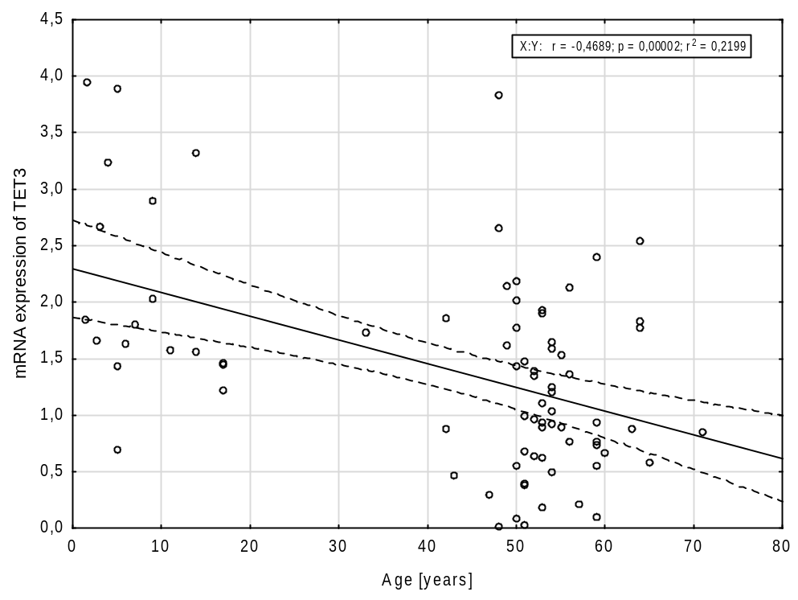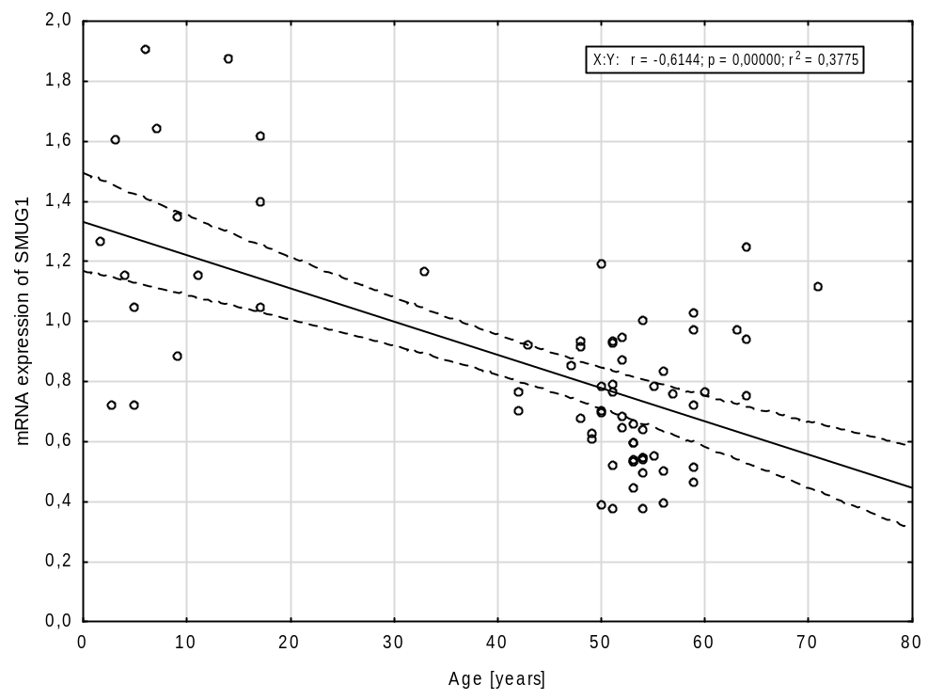

Figure S4. mRNA expression of TET3 and SMUG1 in male and female groups.
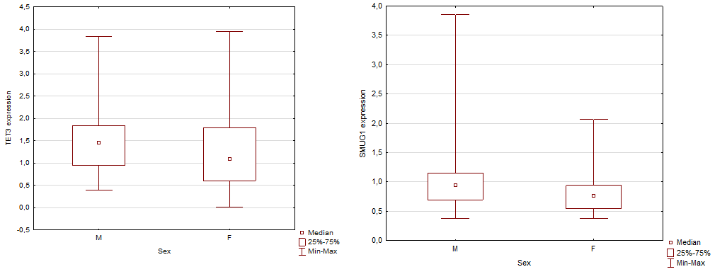

Figure S5. Remaining correlations between the levels of DNA epigenetic modifications in urine and age.

Figure S6. Remaining correlations between the levels of DNA epigenetic modifications in DNA isolated from leukocytes and age.

