Additional file 1. Workflow of ultra-widefield color fundus photograph (UWFCFP) collection and cohort division. ARN, acute retinal necrosis; NAU, non-ARN uveitis; WMUEH, Eye Hospital of Wenzhou Medical University; NEH, Ningbo Eye Hospital.
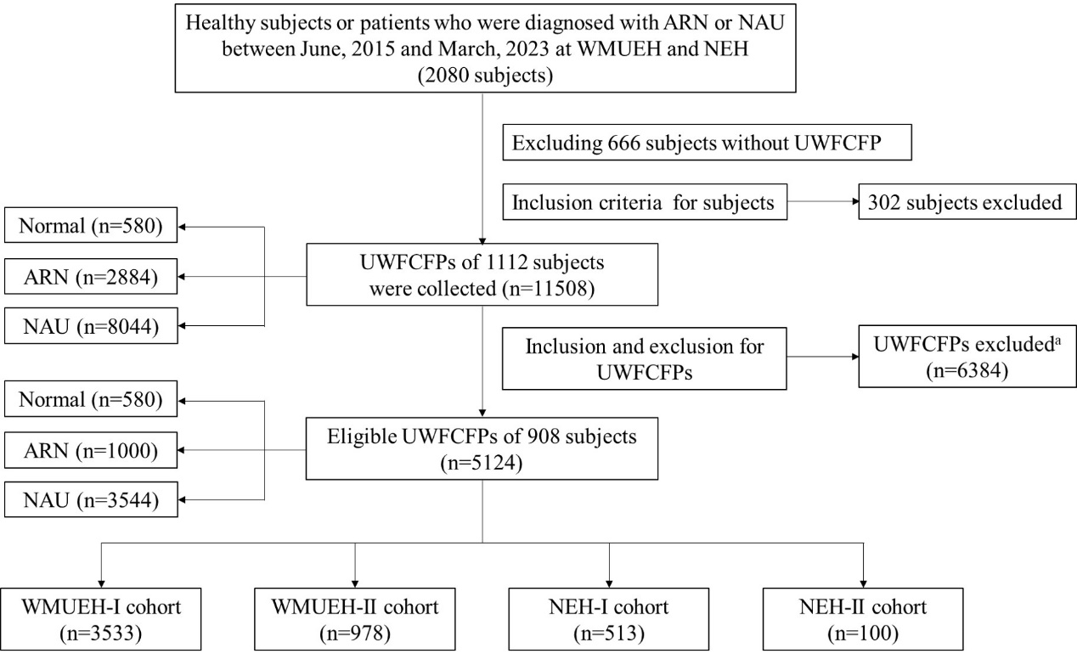
Notes: ª Two hundred and four subjects with no UWFCFP qualified were excluded.

