Supplemental Table S1. Primary antibodies for Western blot and immunofluorescence
Antibody | Catalog number | Manufacturers
anti-HK2 | 2867 | CST, USA
anti-Brg1 | 49360 | CST, USA
anti-AKT | 9272 | CST, USA
anti-pSer472 AKT | 4060 | CST, USA
anti-PI3K | 4249 | CST, USA
anti-Phospho-PI3K | 13857 | CST, USA
anti-β-actin | ab8226 | Abcam, USA
anti-PKM2 | 15822 | Proteintech, Wuhan, China
anti-LDHA | 21799 | Proteintech, Wuhan, China
CST denotes Cell Signaling Technology, Inc.

Supplemental Table S2. Primer sequences for conventional quantitative real-time polymerase chain reaction (qRT-PCR)
Gene | Forward primer (5′-3′) | Reverse primer (5′-3′)
PI3KCA | GGACTGTGTGGGTCTCATCG | TCTCGCCCTTGTTCTTGTCC
AKT1 | CCTCAAGAACGATGGCACCT | TGCAGGCAGCGGATGATAAA
cGAS | GGGCACAAAAGTGAGGACCA | CGCCAGGTCTCTCCTTGAAA
STING | ACTCTTCTGCCGGACACTTG | TTCCGTCTGTGGGTTCTTGG
Wnt1 | TGACAACATCGATTTTGGTCGC | CCTCGTTGTTGTGAAGGTTCATG
β-catenin | AGACAGCTCGTTGTACTGCT | GTGTCGTGATGGCGTAGAAC
Nrf2 | CACATCCAGTCAGAAACCAGTGG | GGAATGTCTGCGCCAAAAGCTG
HO-1 | TGCTCGCATGAACACTCTG | TCCTCTGTCAGCAGTGCCT
β-actin | GTACCACCATGTACCCAGGC | AACGCAGCTCAGTAACAGTCC

Supplemental Table S3. Pathway screening literature summary
Study | Annotation | Main conclusion
Xuan et al. 2024 [1] | PI3K/AKT | BRG1 improves reprogramming efficiency by enhancing glycolytic  metabolism.
Wenjing et al. 2018 [2] | PI3K/AKT/mTOR | Brg1 aggravates airway inflammation in asthma via inhibition of the PI3K/Akt/mTOR pathway.
Dong et al. 2022 [3] | PI3K/AKT/Wnt/β-catenin | ROS/PI3K/Akt and Wnt/β-catenin signalings activate HIF-1α-induced metabolic reprogramming to impart 5-fluorouracil resistance in colorectal cancer.
Wangqiu et al. 2021 [4] | Wnt/β-catenin | Brahma-related gene-1 promotes tubular senescence and renal fibrosis through Wnt/β-catenin/autophagy axis.
Chen et al. 2025 [5] | cGAS/STING | BRG1 deficiency promotes cardiomyocyte inflammation and apoptosis by activating the cGAS-STING signaling in diabetic cardiomyopathy.
Mian et al. 2017 [6] | Nrf2/HO-1 | Brg1-mediated Nrf2/HO-1 pathway activation alleviates hepatic ischemia–reperfusion injury.
Sun et al. 2020 [7] | Nrf2/HO-1 | Upregulation of heme oxygenase-1 by Brahma-related gene 1 through Nrf2 signaling confers protective effect against high glucose-induced oxidative damage of retinal ganglion cells.
References
1 Ren X, Huang S, Xu J, Xue Q, Xu T, Shi D, et al. BRG1 improves reprogramming efficiency by enhancing glycolytic metabolism. Cell Mol LIFE Sci. 2024;81(1):482.
2 Zou W, Ding F, Niu C, Fu Z, Liu S. Brg1 aggravates airway inflammation in asthma via inhibition of the PI3K/Akt/mTOR pathway. Biochem Biophys Res Commun. 2018;503(4):3212–8.
3 Dong S, Liang S, Cheng Z, Zhang X, Luo L, Li L, et al. ROS/PI3K/Akt and Wnt/β-catenin signalings activate HIF-1α-induced metabolic reprogramming to impart 5-fluorouracil resistance in colorectal cancer. J Exp Clin Cancer Res. 2022;41(1):15.
4 Gong W, Luo C, Peng F, Xiao J, Zeng Y, Yin B, et al. Brahma-related gene-1 promotes tubular senescence and renal fibrosis through Wnt/β-catenin/autophagy axis. Clin Sci (Lond). 2021;135(15):1873–95.
5 Chen Z, Lai X, Li J, Yuan X, Li Y, Zhang X, et al. BRG1 deficiency promotes cardiomyocyte inflammation and apoptosis by activating the cGAS-STING signaling in diabetic cardiomyopathy. Inflammation. 2025;48(1):299–315.
6 Ge M, Yao W, Yuan D, Zhou S, Chen X, Zhang Y, et al. Brg1-mediated Nrf2/HO-1 pathway activation alleviates hepatic ischemia-reperfusion injury. Cell Death Dis. 2017;8(6):e2841.
7 Sun W, Yu J, Kang Q. Upregulation of heme oxygenase-1 by Brahma-related gene 1 through Nrf2 signaling confers protective effect against high glucose-induced oxidative damage of retinal ganglion cells. Eur J Pharmacol. 2020;875:173038.

Supplementary Figure S1. Immunofluorescence images showing changes in BRG1 fluorescence intensity following subconjunctival injection. Groups: control (Ctrl), diabetic (DM), DM + subconjunctival empty vector control (DM+VC), subconjunctival pCMV-Smarca4-3flag-mcmv-EGFP (BRG1-OE), subconjunctival m-Smarca4 shRNA1 (BRG1-KD). Scale bars: 50 μm. BRG1, Brahma-related gene 1; DAPI, 4',6-diamidino-2-phenylindole

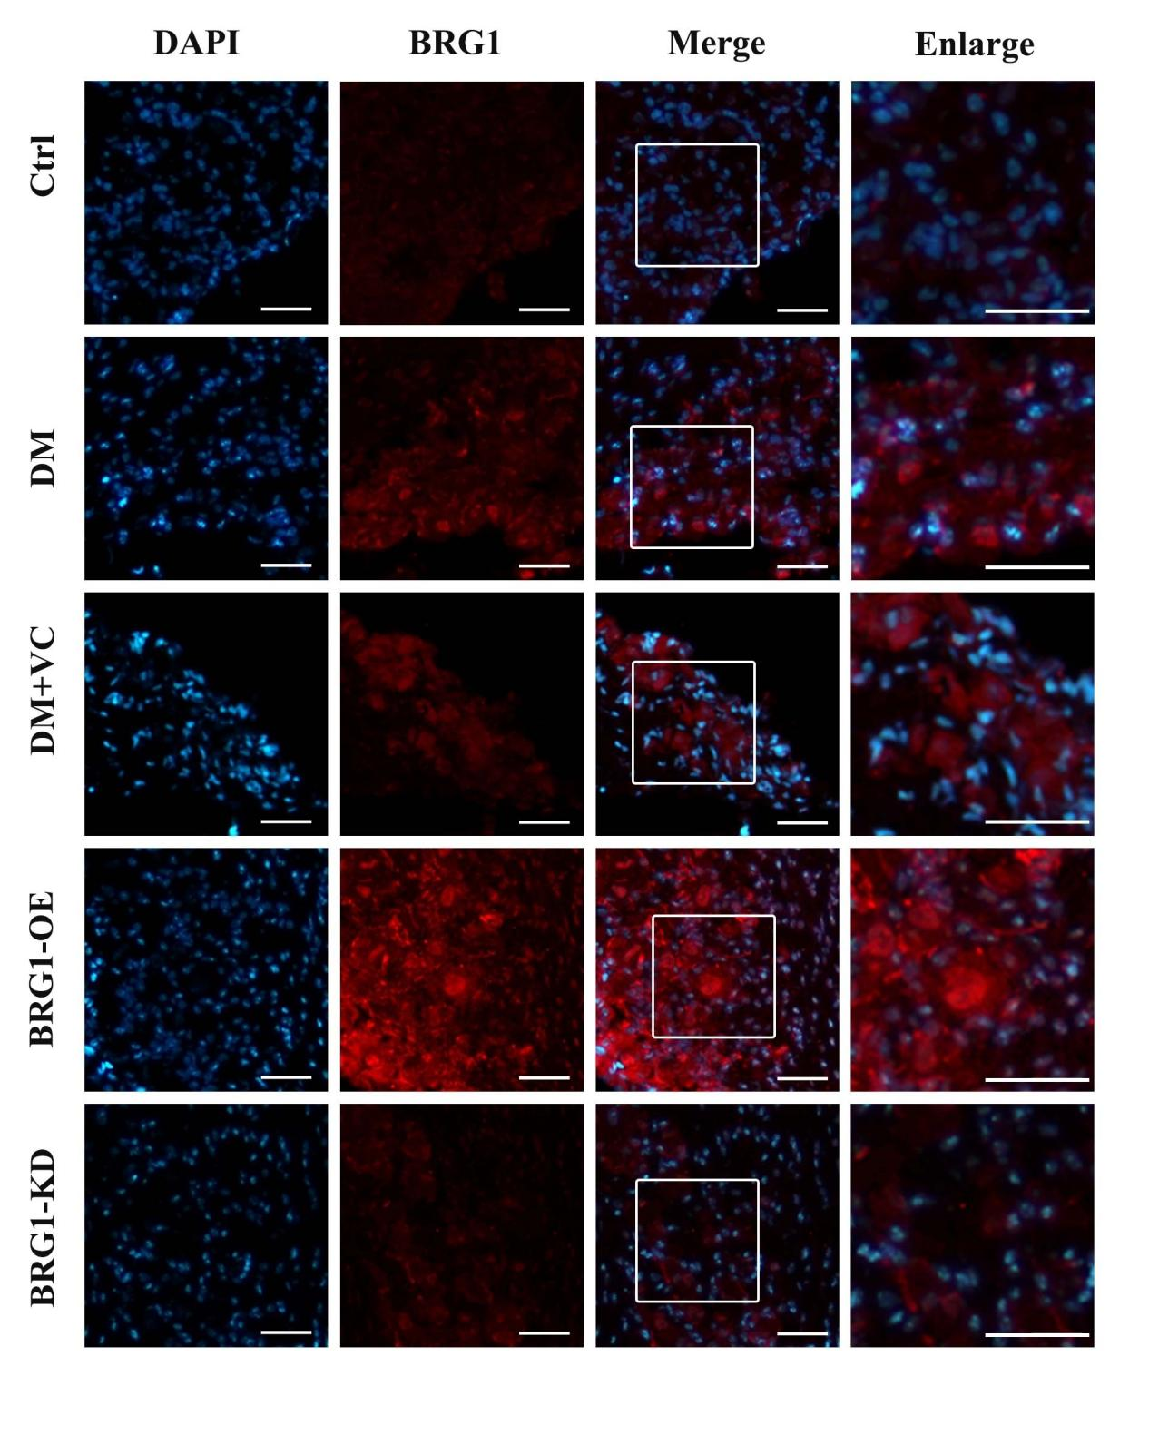

Supplementary Figure S2. Changes in epithelial healing and corneal nerve density after subconjunctival BRG1 intervention. a Dynamic corneal epithelial healing post-debridement. Groups: control (Ctrl), diabetic (DM), DM + subconjunctival empty vector control (DM+VC), subconjunctival pCMV-Smarca4-3flag-mcmv-EGFP (BRG1-OE), subconjunctival m-Smarca4 shRNA1 (BRG1-KD). a1 Representative sodium fluorescein staining images at 0, 12, 24, and 36 hours. a2 Quantified epithelial defect area (%). b Corneal nerve regeneration analysis (n = 6). b1 Representative βIII-tubulin-stained whole-mount images. b2 Quantitative analysis of corneal nerve fiber density. c Corneal sensitivity threshold across groups (n = 6). Scale bars: 50 μm. ns, not significant; *, P < 0.05; **, P < 0.01; ***, P < 0.001; ****, P < 0.0001.
