Supplementary Materials
Supplemental Fig. S1. Gene-expression profiles and pathway-enrichment analysis in KC. a Venn diagram of gene-expression overlaps among male and female patients with KC and controls. b PCA plot showing distinct clusters between patients with KC and controls. c Volcano plot depicting differentially expressed genes (DEGs) between the KC and control groups. Orange dots indicate up-regulated genes, blue dots indicate down-regulated genes, and grey dots represent genes that did not show significant expression differences. d, e GO-based biological process enrichment of (d) up-regulated and (e) down-regulated DEGs. The bubble size represents the number of genes enriched in each pathway, and the colour intensity indicates the adjusted P value (P adj.). f, g KEGG-based pathway enrichment of (f) up-regulated and (g) down-regulated DEGs. The bar length represents the gene count in each pathway, and the colour intensity indicates the adjusted P value. h Selection of soft-thresholding powers. FDA, false-discovery rate; GO, Gene Ontology; KC, keratoconus; KEGG, Kyoto Encyclopaedia of Genes and Genomes; PCA, principal component analysis.

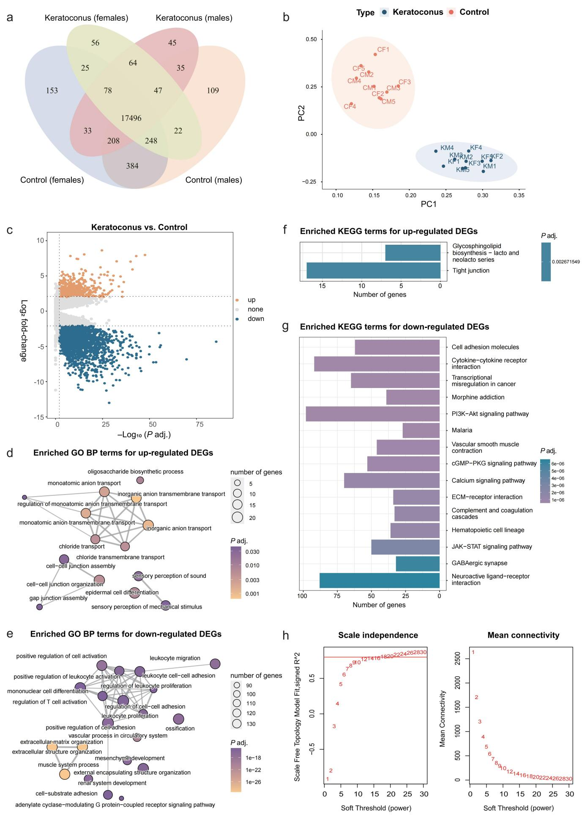
Supplemental Fig. S2. Impact of flutamide and fulvestrant on HCSF viability. a HCSF viability after exposure to increasing concentrations of flutamide. b HCSF viability after exposure to increasing concentrations of fulvestrant. HCSF, human corneal stromal fibroblast.
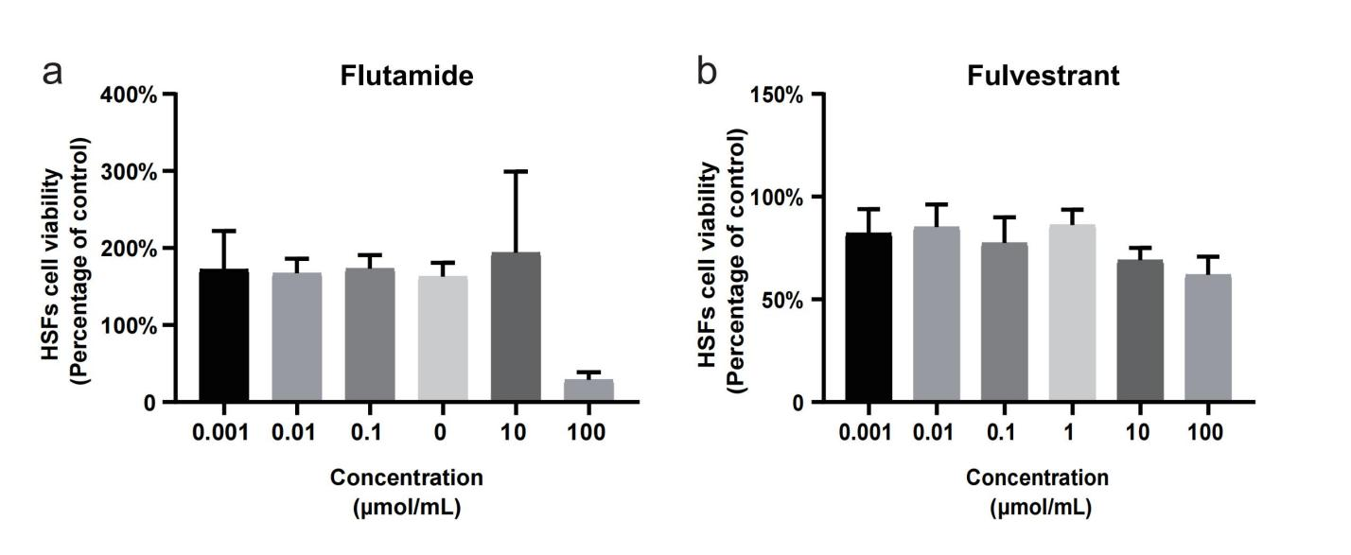

Supplemental Fig. S3. Analysis of differentially expressed circRNAs, miRNAs, and mRNAs in KC. a–c Differentially expressed circRNAs (a), miRNAs (b), and mRNAs (c) in KM vs. CM and in KF vs. CF. Red dots indicate up-regulated RNAs (adjusted P value < 0.05 and log₂ fold-change > 1), blue dots indicate down-regulated RNAs (adjusted P value < 0.05 and log₂ fold-change < −1), and grey dots indicate non-differentially expressed RNAs (adjusted P value > 0.05 or |log₂ fold-change| < 1). circRNA, circular RNA; CF, female control; CM, male control; KC, keratoconus; KM, male with KC; KF, male with KC; miRNA, microRNA; mRNA, messenger RNA.

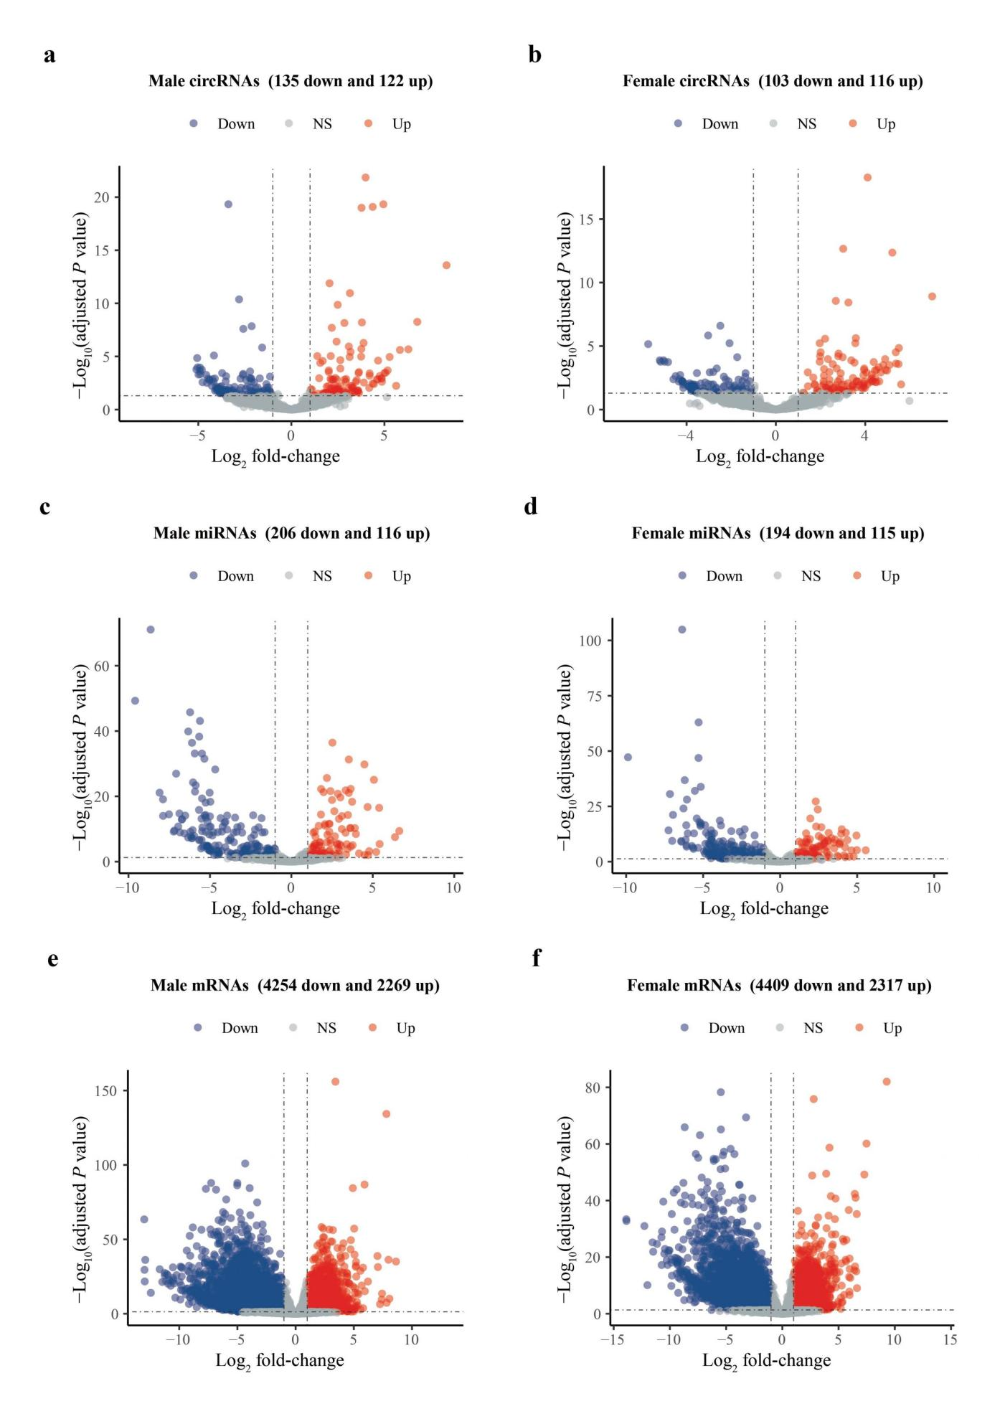
Supplemental Fig. S4. Expression of circEPB41L2_00001 and EPB41L2 in HCSFs from females and males after siRNA treatment (siRNA1 and siRNA2). circRNA, circular RNA; HCSF, human corneal stromal fibroblast; siRNA: small-interfering RNA.