Additional file 1
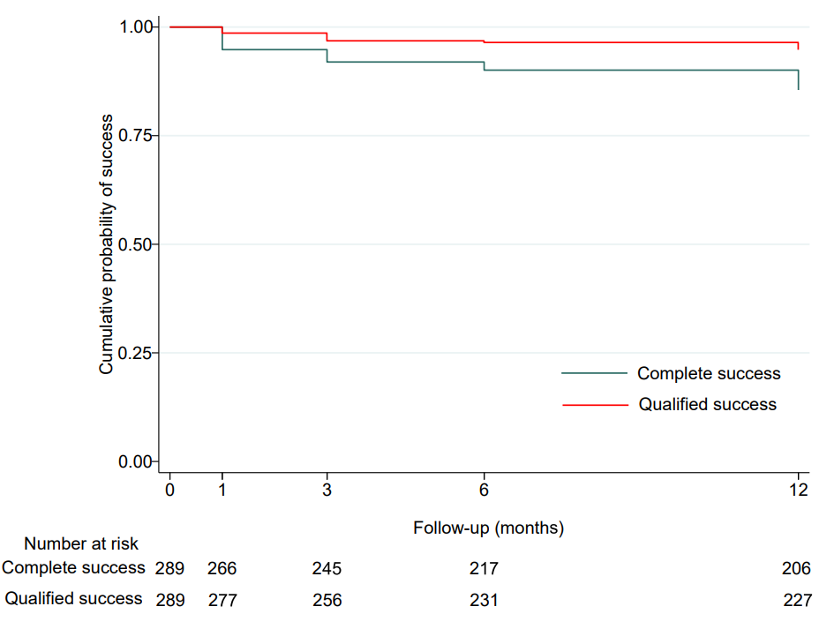
Figure S1. Kaplan–Meier survival curves during follow-up after combined phacoemulsification and goniosynechialysis surgery (6 ≤ IOP ≤ 21 mmHg).

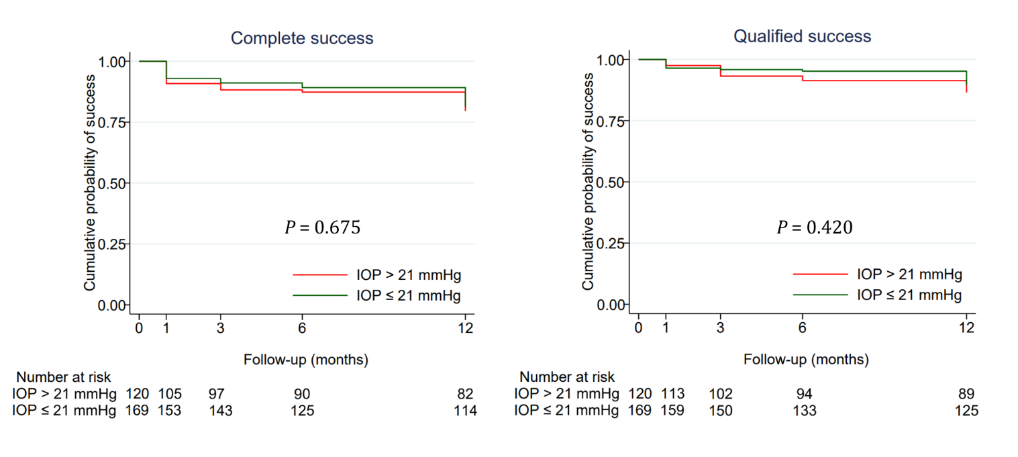
Figure S2. Kaplan–Meier survival curves of subgroup based on preoperative intraocular pressure (IOP).

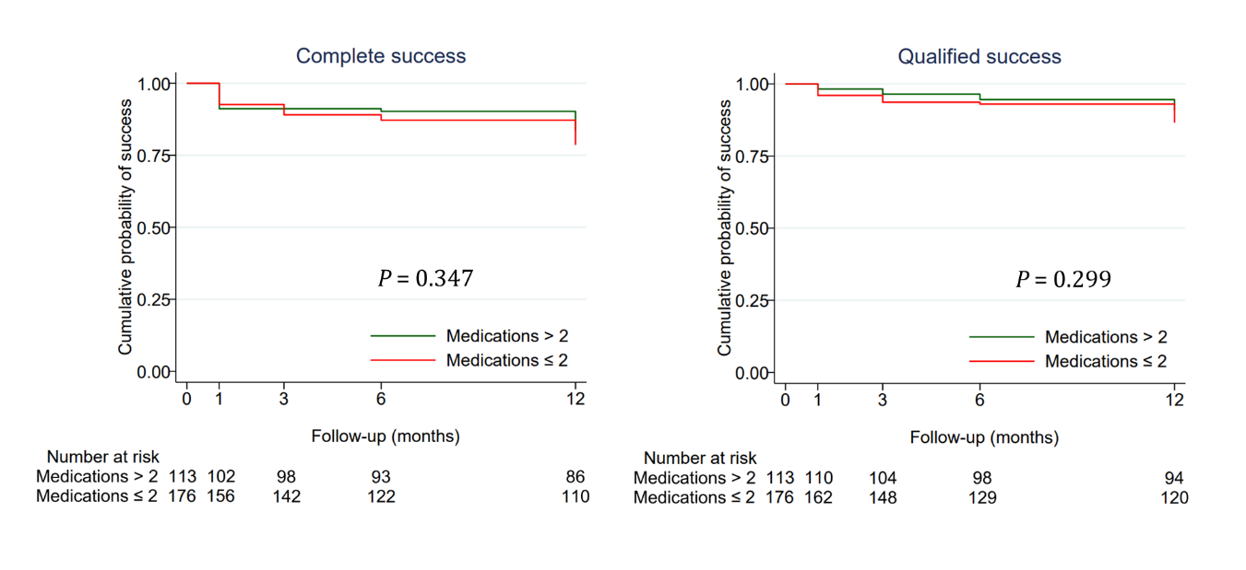
Figure S3. Kaplan–Meier survival curves of subgroups according to numbers of antiglaucoma medications.

Figure S4. Intraocular pressure at baseline and each of 6 follow-up points in patients with early-to-moderate and advanced primary angle-closure glaucoma (PACG).
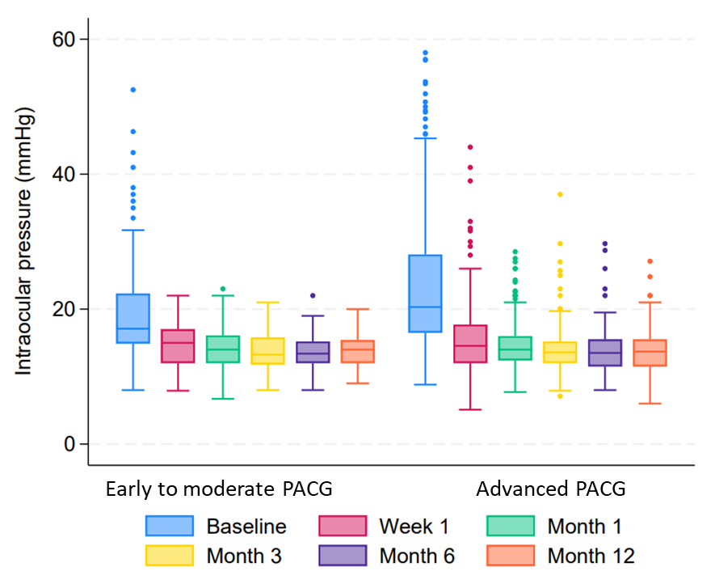
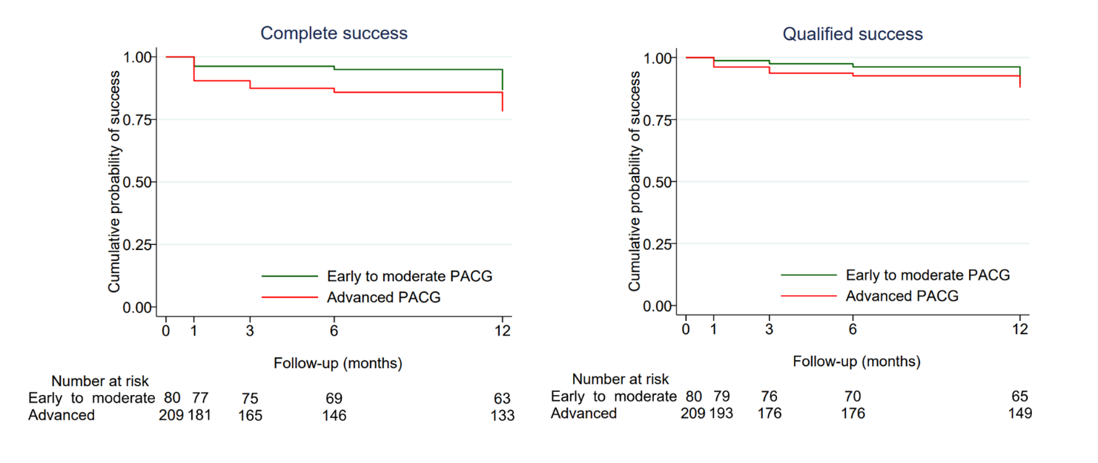
Figure S5. Kaplan–Meier survival curves during follow-up after combined phacoemulsification and goniosynechialysis in patients with early-to-moderate and advanced primary angle-closure glaucoma (PACG).

Table S1. Comparisons of demographics and clinical baselines of patients who completed follow-up and those who did not
Characteristics | Follow-up completed | Follow-up incomplete | P
Number of eyes | 237 | 52 | -
Age (years) | 67.1 ± 8.5 | 69.4 ± 9.6 | 0.084
Female, n (%) | 137 (57.8%) | 29 (55.8%) | 0.788
Systolic pressure (mmHg) | 134.3 ± 19.2 | 135.9 ± 17.9 | 0.570
Diastolic pressure (mmHg) | 77.7 ± 10.8 | 79.4 ± 9.3 | 0.296
Hypertension, n (%) | 97 (40.9%) | 20 (38.5%) | 0.743
Diabetes, n (%) | 45 (19.0%) | 7 (13.5%) | 0.348
BCVA (LogMAR) | 0.47 ± 0.65 | 0.56 ± 0.63 | 0.358
Previous LPI, n (%) | 34 (14.4%) | 3 (5.8%) | 0.094
Baseline IOP (mmHg) | 22.9 ± 10.2 | 22.8 ± 21.8 | 0.502
MD of visual field (dB) | −19.52 ± 10.54 | −21.59 ± 9.94 | 0.205
Mean AL (mm) | 22.6 ± 0.87 | 22.8 ± 0.66 | 0.190
Mean CACD (mm) | 1.90 ± 0.26 | 1.86 ± 0.26 | 0.355
Mean CCT (μm) | 530.2 ± 38.1 | 528.4 ± 33.6 | 0.778
AL = axial length; BCVA = best-corrected visual acuity; CACD = central anterior chamber depth; CCT = central corneal thickness; IOP = intraocular pressure; LPI = laser peripheral iridotomy; MD = mean deviation
Continuous and categorical data are shown as means ± SD, or n (%)
Table S2. Results of the Cox regression analysis for predictors of complete success

Variables | Univariate |  | Multivariate
Variables | HR (95% CI) | P-value | HR (95% CI) | P-value
Age (per year) | 0.98 (0.95–1.01) | 0.124 | 0.98 (0.95–1.01) | 0.141
Sex (male) | 0.90 (0.52–1.56) | 0.702
Hypertension | 0.85 (0.48–1.49) | 0.562
Diabetes | 1.20 (0.61–2.33) | 0.597
Previous LPI | 0.83 (0.36–1.95) | 0.673
Baseline IOP (per mmHg) | 1.01 (0.98–1.03) | 0.502
MD of visual field (per dB) | 0.98 (0.95–1.00) | 0.098 | 0.98 (0.95–1.01) | 0.101
Baseline extent of PAS | 0.99 (0.92–1.07) | 0.874
CACD (per mm) | 0.42 (0.12–0.85) | 0.023 | 0.38 (0.13–1.09) | 0.072
AL (per mm) | 0.73 (0.53–1.01) | 0.059 | 0.80 (0.58–1.11) | 0.183
ECD (cells/mm²) | 1.00 (1.00–1.00) | 0.979
AL = axial length; CACD = central anterior chamber depth; ECD = endothelial cell density; HR = hazard ratios; IOP = intraocular pressure; LPI = laser peripheral iridotomy; MD = mean deviation; PAS = peripheral anterior synechiae
Table S3. Results of the Cox regression analysis for predictors of qualified success
Variables | Univariate |  | Multivariate
Variables | HR (95% CI) | P | HR (95% CI) | P
Age (per year) | 0.95 (0.92–0.99) | 0.016 | 0.96 (0.92–1.00) | 0.056
Sex (male) | 0.83 (0.40–1.71) | 0.612
Hypertension | 0.80 (0.38–1.67) | 0.556
Diabetes | 1.29 (0.55–2.99) | 0.556
Previous LPI | 0.74 (0.30–1.83) | 0.509
Baseline IOP (per mmHg) | 1.02 (0.99–1.05) | 0.188 | 1.01 (0.98–1.04) | 0.431
MD of visual field (per dB) | 0.99 (0.95–1.02) | 0.460
Baseline extent of PAS | 0.98 (0.87–1.08) | 0.635
CACD (per mm) | 0.29 (0.10–0.94) | 0.039 | 0.25 (0.10–0.96) | 0.044
AL (per mm) | 0.59 (0.40–0.88) | 0.010 | 0.67 (0.45–1.00) | 0.050
ECD (cells/mm²) | 1.00 (1.00–1.00) | 0.320
AL = axial length; CACD = central anterior chamber depth; ECD = endothelial cell density; HR = hazard ratio; IOP = intraocular pressure; LPI = laser peripheral iridotomy; MD = mean deviation; PAS = peripheral anterior synechiae
Table S4. Numbers of antiglaucoma medications at baseline and five follow-up points based
on primary angle-closure glaucoma (PACG) severity

PACG severity | No. of antiglaucoma medications | 0 | 1 | 2 | 3 | 4 | 5
Early-to- moderate | Baseline (n = 80) | 22 (27.5) | 23 (28.8) | 14 (17.5) | 15 (18.8) | 6 (7.5) | 0 (0)
Early-to- moderate | Month 12 (n = 70) | 68 (97.1) | 2 (2.9) | 0 (0) | 0 (0) | 0 (0) | 0 (0)
Advanced | Baseline (n = 209) | 19 (9.1) | 20 (9.6) | 78 (37.3) | 66 (31.6) | 22 (10.5) | 4 (1.9)
Advanced | Month 12 (n = 167) | 146 (87.4) | 15 (9.0) | 2 (1.2) | 3 (1.8) | 1 (0.6) | 0 (0)
Data are presented as n (%). n represents the number of patients.

