Supporting information

Effects of forest management on biomass stocks in Romanian beech forests

O. Bouriaud^{1, 2} (obouriaud@gmail.com), A. Don³ (axel.don@thuenen.de), I. A. Janssens⁴ (ivan.janssens@uantwerpen.be), G. Marin^{2,5} (ghmarin@roifn.ro), E.-D. Schulze⁶ (dschulze@bgc-jena.mpg.de)

^{1.} Integrated Center for Research, Development and Innovation in Advanced Materials, Nanotechnologies, and Distributed Systems for Fabrication and Control, Stefan cel Mare University, Suceava 720229, Romania
^{2.} National Forest Inventory, National Research Development Institute for Silviculture, Romania
^{3.} vTI, Braunschweig, Germany
^{4.} Department of Biology, University of Antwerpen, Universiteitsplein 1, 2610 Wilrijk, Belgium
^{5.} Faculty of Silviculture and Forest Engineering, Transilvania University of Brasov, Str. Sirul Beethoven, nr. 1, 500123 Brasov, Romania
^{6.} Max-Planck Institute for Biogeochemistry, PO Box 100164, 07701 Jena, Germany

Supp. Fig. 1 Location of the NFI plots used for the analysis. Plots were selected based on the species composition such that beech represents at least 90% of the aboveground volume
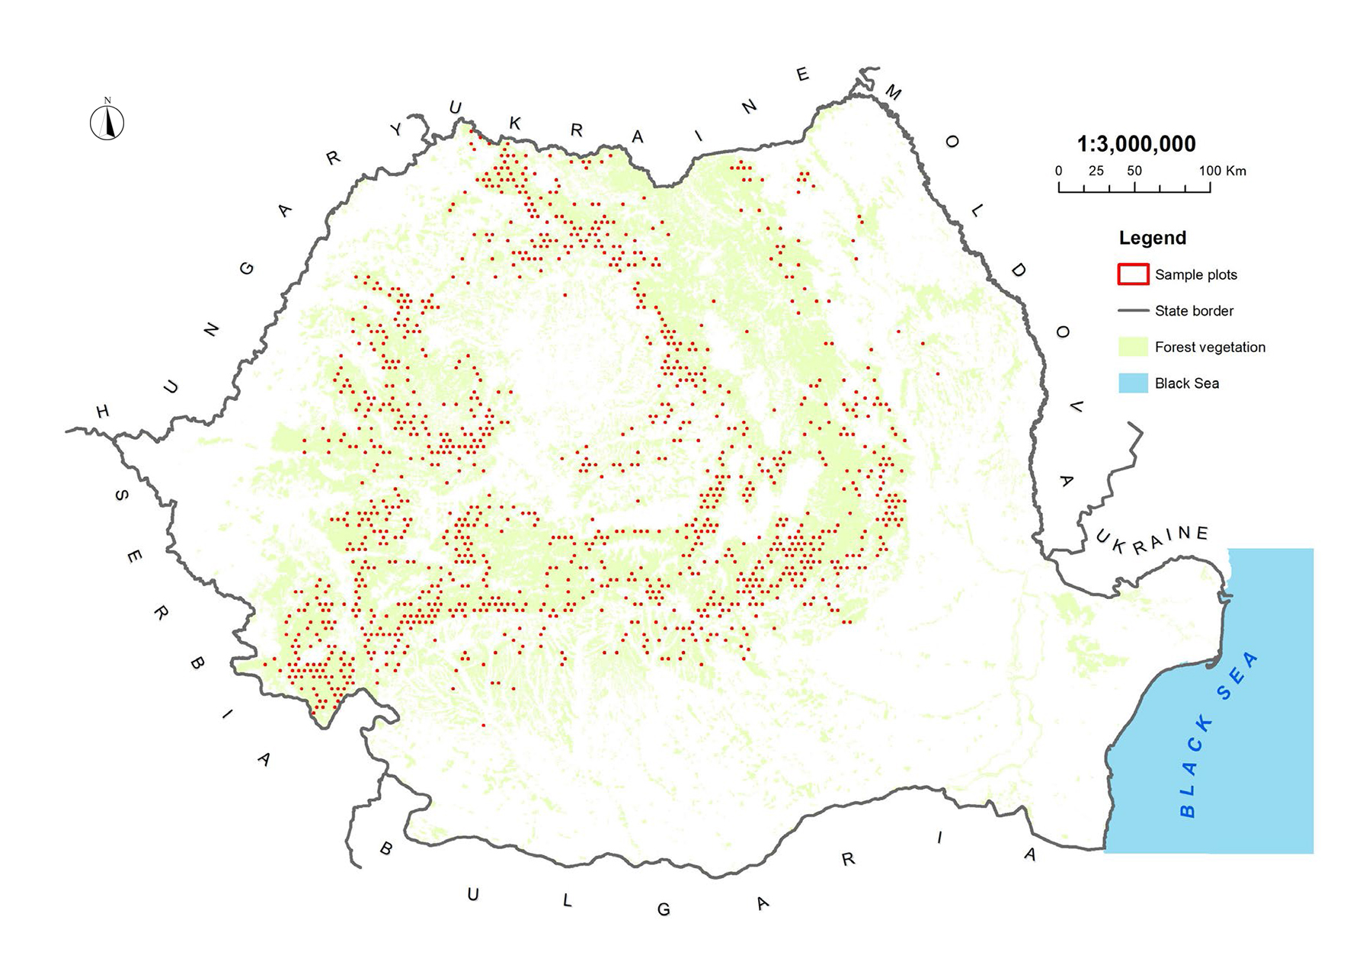

Supp. Fig. 2 Relationship between the stand density (N·ha^{–1}) and the mean quadratic diameter (cm) of the stands plotted for pure beech stands from the NFI network
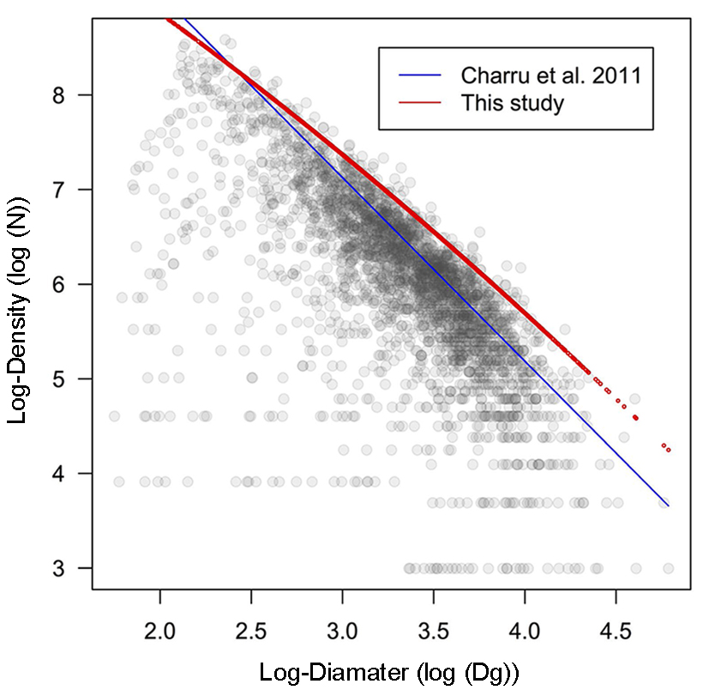

Supp. Fig. 3 Dominant height model fitted to the beech stands sampled, all management types included
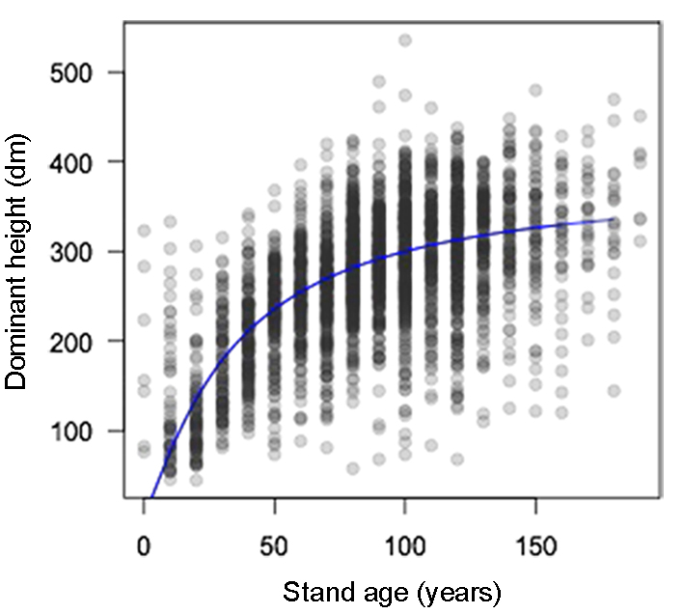

Supp. Fig. 4 Relation between the productivity (mean aboveground biomass increment over the last 5 years) and the stands’ dominant height (up) and stem density (down) according to the forest management type and treatment
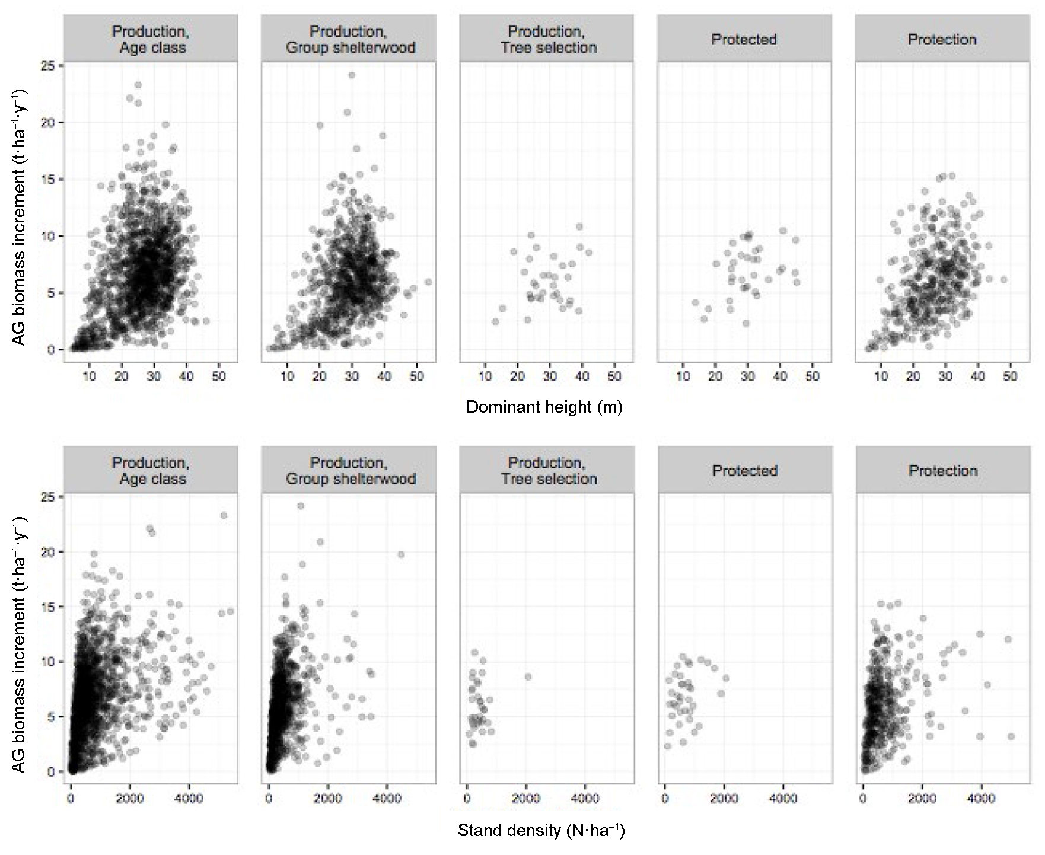

Supp. Fig. 5 Comparison of the mean deadwood biomass stock per management type and treatment against stand age. The confidence bands represent the mean and 2 standard deviation interval over 200-iterations resampling that aims at compensating for the difference in plot number between categories: 35 plots are randomly selected with replacement within each category, 36 being the number of plots in the less replicated category (protected forests, cf. Table 1)
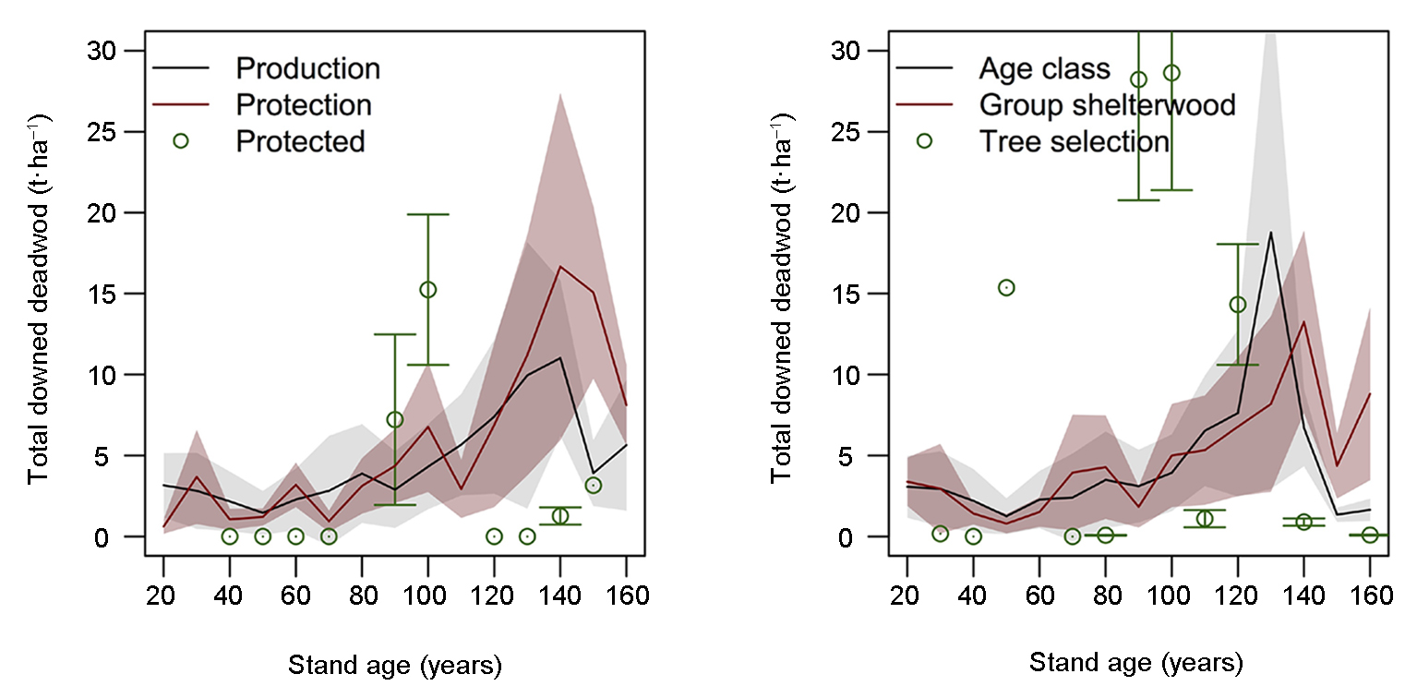

Supp. Table 1 Variance analysis (ANOVA) table for aboveground biomass with management type as factor (left) or treatment as factor (right). Df values are residuals’ degrees of freedom
Age class | Management type |  |  |  |  | Treatment
 | Df | F value | p-value | Type 2  error at 0.05 |  | Df | F value | p-value | Type 2  error at 0.05
20 | 87 | 0.5189 | 0.4733 | 0.2785 |  | 86 | 0.0931 | 0.9112 | 0.8820
30 | 99 | 4.9352 | 0.0289 | 0.0018 |  | 97 | 4.0502 | 0.0093 | 0.4425
40 | 153 | 1.9240 | 0.1674 | 0.0314 |  | 151 | 0.4573 | 0.7215 | 0.8296
50 | 159 | 0.2124 | 0.6455 | 0.7268 |  | 157 | 0.7729 | 0.5108 | 0.4853
60 | 179 | 8.4484 | 0.0042 | 0.0000 |  | 178 | 4.1540 | 0.0173 | 0.4595
70 | 224 | 1.7385 | 0.1887 | 0.0497 |  | 222 | 0.7446 | 0.5265 | 0.8715
80 | 359 | 6.0463 | 0.0144 | 0.0000 |  | 357 | 2.0201 | 0.1107 | 0.4018
90 | 294 | 0.1198 | 0.7295 | 0.8314 |  | 292 | 0.1959 | 0.8992 | 0.7377
100 | 329 | 1.4290 | 0.2328 | 0.1237 |  | 327 | 0.4396 | 0.7249 | 0.9107
110 | 172 | 1.4803 | 0.2254 | 0.1983 |  | 170 | 1.4293 | 0.2360 | 0.2657
120 | 281 | 2.7035 | 0.1012 | 0.0366 |  | 279 | 2.7988 | 0.0404 | 0.4490
130 | 142 | 1.0742 | 0.3018 | 0.5234 |  | 141 | 0.9352 | 0.3949 | 0.7899
140 | 89 | 0.7033 | 0.4584 | 0.5656 |  | 87 | 0.8324 | 0.4797 | 0.9609
150 | 65 | 2.4684 | 0.1210 | 0.0885 |  | 64 | 1.2737 | 0.2868 | 0.9747
160 | 36 | 0.2713 | 0.6057 | 0.8562 |  | 34 | 2.2906 | 0.0986 | 0.1187

