Supplementary material to “Trade-offs between ecosystem service provision and the predisposition to disturbances: a NFI-based scenario analysis”

Deadwood dynamics
We tracked the average of coarse (>7 cm in diameter) and fine and deciduous and coniferous deadwood volume (m³·ha⁻¹) across production regions and across Switzerland throughout the simulations. The deadwood volume in each of the four pools at the beginning of the simulations (NFI3: 2004/06) encompassed standing deadwood for which allometric relationships were applied to separate the coarse and fine compartments (Kaufmann 2001) and lying deadwood for which only branches and logs >7 cm were sampled and no differentiation between deciduous and coniferous wood could be made. We used the regional conifer/broadleaf proportions in the standing deadwood as an estimate of the conifer/broadleaf proportion in the lying deadwood.
The decadal accumulation of deadwood consisted of density and wind-induced mortality as well as harvesting residues. Deadwood decomposition was estimated with an exponential model (Mackensen et al. 2003). Decomposition rates for coarse woody deciduous and coniferous litter (Table S 1) were provided by Steffen Herrmann (personal communication), Thünen Institute, Eberswalde, Germany, and are based on measurements in Swiss Natural forest reserves by Lachat et al. (2014) for beech (Fagus sylvatica L.) and spruce (Picea abies (L.) H. Karst), respectively. We assumed fine woody litter to decompose twice as fast based on the relationship between log diameter and decomposition rate found by Mackensen et al. (2003).
$\left.V_{x+t}=\right. V_{x}∙e^{-k ∙ t}+\sum_{a=x}^{x+t}{V_{a}∙e^{-k ∙ \left(x+t-a\right)}}$ Eq. 1
with V_{x+t} being the deadwood volume at time step x+t (2016, 2026, … , 2106), V_{x} the deadwood volume at the beginning of the simulations (x = 2006), t being the number years between the beginning of the simulation and the time step x+t (10, 20, …, 100), k the species group- and diameter class-specific decomposition rates (Table S1), V_{a} the deadwood volume that is added to the deadwood pool through tree mortality and management at time step x+t and all preceding time steps x+t−a with a being the years of the preceding time steps.
Table S1 Decomposition rates (k) of fine an coarse woody litter for broadleaves and conifers.
Species group | Fine (<7 cm) | Coarse (≥7 cm)
broadleaves | 0.258 | 0.129
conifers | 0.078 | 0.039

Indicators for the predisposition to storm and bark beetle disturbance
The following describes calculations of indicators for bark beetle and storm damage predisposition in the order as in Figure 2 in the main text. Stand-related beetle predisposition indices are combined to PB_{stand} (Eq.5) and site-related scores to PB_{site} (Eq. 9). PB_{stand} and PB_{site} are averaged with equal weights to obtain an overall score for predisposition to disturbance by Ips typographus.

Proportion of spruce
We used the same sigmoidal fit as in Temperli et al. (2013) to translate Netherer’s (2003) categorical predisposition indices to continuous values:
${PB}_{spruce}=A+ \frac{(1-A)}{{(1+Q∙e^{-r∙\left(p_{spruce}-m\right)})}^{1/v}}$ Eq. 2
with PB_{spruce} being the predisposition index for the predisposition to bark beetle attack due to spruce basal area proportion (p_{spruce}), A = 0.08, r = 6.8455438, v = 0.3002734, Q = 0.2674846 and m = 0.375.

Dominant spruce diameter
Netherer (2003) used stand age as a proxy for the size of trees in a stand as this information was readily available from stand maps. From a beetle’s perspective, the size of spruce trees is relevant as it determines the available phloem and thus breeding habitat. For this reason we used the dominant DBH of spruce trees as a predictor for tree size-related predisposition. This variable could be calculated directly from simulated DBH in MASSIMO. We used Netherer’s (2003) predisposition index (termed “hazard score” by Netherer 2003) for stand age and the relationship between field estimates of stand age (tree ring and whorl counts) and the dominant diameters recorded during NFI3 (2004/06) to define the parameters of a logistic function relating dominant spruce diameter to beetle disturbance predisposition due to tree size (PB_{ddomspr}):
${PB}_{ddomspr}=A+ \frac{(1-A)}{1+e^{-r∙(ddomspr-m)}}$ Eq. 3
where ddomspr is the dominant diameter of spruce trees, A = 0.2 is the lower asymptote, r = 0.2 the slope parameter and m = 30 the shift of the function with respect to ddomspr. The sigmoidal shape of this relationship corresponds to observations of Opiasa (2016) in a beetle infested forest reserve in the Grisons. There, spruce trees with a DBH of 50 cm were killed by beetles with a probability of 25% to 80%, depending on crown length, fungi infestation and other factors. Hence, a high predisposition index (i.e. 0.99 for a spruce tree of 50 cm DBH) can be interpreted with a relatively high mortality probability during an ongoing beetle outbreak.

Stand-related factors for predisposition to storm damage
The stand-related factors for the predisposition to storm damage include spruce share and dominant tree height. We implemented spruce share-related storm predisposition (PS_{spruce}) as in Netherer (2003) with spruce share ≥90% being rated with 1 and <90% with 0. Storm predisposition related to tree size was assessed based on the dominant tree height. We derived tree height from DBH using the tariff- (species- and production region-) specific allometric function used in the NFI (Kaufmann 2001). Following Netherer (2003) we related dominant height linearly to storm hazard (PS_{hdom}).
$\begin{matrix}{PS}_{hdom}=0, hdom<7.5 \\ {PS}_{hdom}=-0.3+0.04∙hdom,32.5>hdom≥7.5 \\ {PS}_{hdom}=1, hdom≥32.5\end{matrix}$ Eq. 4
To obtain the stand-related predisposition to storm damage (PS_{stand}) wo combined PS_{spruce} and PS_{hdom} additively with weights 0.6 and 1, respectively.

Combination of predisposition indices to stand-related predisposition
Predisposition indices on spruce proportion, spruce size and to storm damage were combined to an indicator of predisposition to beetle disturbance based on stand-related parameters as follows:
${PB}_{stand}=1∙{PB}_{spruce}+1∙{PB}_{ddomspr}+0.8∙{PS}_{Stand}$ Eq. 5

Radiation
Radiation (as well as slope position, topex and slope) was calculated using the Spatial Analyst toolbox in Esri ArcGis 10.1 based on the 25 by 25 m digital elevation model (DHM25) by Swisstopo dhm25 © 2018 swisstopo (5704 000 000). Radiation values were linearly scaled between 0.1 and 1 to obtain radiation-related scores (PB_{rad}) with 0.1 representing minimal and 1 maximum global solar radiation (direct and diffuse radiation).

Slope position
The topographic position index (TPI) with a neighborhood size of 200 m was used to asses slope position (valley, slope, ridge) and was calculated as described in Wilson et al. (2007) and Stadelmann et al. (2014). TPI values between ‒1.47 (valley bottom) and 1.34 (ridge/peak) were scaled between 0 and 1 to values of the predisposition index PB_{slope} by linear interpolation.

Topographic exposure
The topex-to-distance indicator (topex) measures the exposure to potential storm corridors (Quine and White 1998). We used the following sigmoidal function to derive predisposition index values from topex values:
${PS}_{topex}= \frac{1}{1+e^{-r∙(topex-m)}}$ Eq. 6
where PS_{topex} is the predisposition index related to topographic exposure, r = 2.5 the slope parameter and m = 1 the shift of the function with respect to topex values (i.e. topex value where the slope of the function is maximal).

Slope
As proposed by Netherer (2003), we assigned an index value (PS_{slope}) of 0.07 for slope values >100% and for values between 0 and 100% we linearly related predisposition index values between 0.4 and 0.07. PS_{slope} is used as a site-related factor to assess predisposition to storm disturbance.

Soil coarse matter content
The content of coarse matter in the top 50 cm was derived from a digitized soil map of Switzerland (Digitale Bodeneignungskarte BEK, Federal Office of Agriculture FOAG 2012). The percentage of mineral soil components >2 mm was available in the classes <5, [5, 10), [10, 20), [20, 50), >50. We related the following index values (PS_{coarse}, PB_{coarse}) to the percentage classes: 0.025, 0.075, 0.15, 0.35, 0.8.

Soil pH
Based on the finding of increasing probability for storm damage with decreasing pH on acidic soils by Mayer et al. (2005) we assigned the following index values to the pH values measured during the first Swiss NFI (1983/85).
$\begin{matrix}{PS}_{pH}=1, pH<3 \\ {PS}_{pH}=\frac{7-pH}{4},3>pH≥7 \\ {PS}_{pH}=0,pH>7\end{matrix}$ Eq. 7

Combination of site-related indices for predisposition to storm damage
PS_{topex}, PS_{slope} and PS_{coarse} were additively combined with weights 1, 0.4 and 0.4, respectively, analogously to Eq. 9 to an index for site factor-related predisposition to storm disturbance (PS_{site}).

Soil depth
The depth of soil that is accessible to plant roots was available from the digitized soil map (Federal Office of Agriculture FOAG 2012) in 5 classes ranging from 30 to >120 cm. Following Jakoby et al. (2015) and Netherer et al. (2003) we assigned the following index values to these classes: 0.4, 0.5, 0.6, 0.9 and 1.

Water supply
We used a water balanced-based drought index (DRI) as it has been used in the forest landscape model LandClim (Schumacher 2004) as an index for water supply. In combination with a drought tolerance threshold for Norway spruce this and similar indices have previously been used to model the predisposition to bark beetles due to drought (Seidl et al. 2007; Temperli et al. 2015; Temperli et al. 2013). The calculation of DRI requires monthly temperature, latitude, slope and aspect to calculate potential evapotranspiration (PET) as per Thornthwaite and Mather (1957). PET is then related to actual evapotranspiration which is a function of PET, available water capacity, precipitation and an assumption on infiltration by the vegetation. We calculated yearly drought-indices for years 1982–2011 using gridded temperature and precipitation data (Remund et al. 2016) and available water capacity (Federal Office of Agriculture FOAG 2012) and averaged over the 30 yearly values to obtain an estimate of potential drought stress under average climatic conditions. Predisposition due to drought in spruce trees (PB_{dr}) was then derived with a sigmoidal relationship assuming that predisposition is maximal when drought reduced the growth of spruce to 20% of its potential maximum (Seidl et al. 2007; Temperli et al. 2013).

Number of potential beetle generations
While the original predisposition assessment system by Netherer (2003) used temperature as a proxy for beetle reproduction rate we used the number of potential beetle generations that were estimated with a Swiss-specific, temperature driven phenology model for Ips typographus (Jakoby et al. 2015) for each NFI plot. We averaged the number of generations for the historic climate from 1982–2011 and derived the predisposition index values with a sigmoidal function that reflects the scoring of Netherer (2003):
${PS}_{gen}= \frac{1}{1+e^{-r∙(ngen-m)}}$ Eq. 8
where r = 4, ngen being the average number of potential Ips typographus generations and m = 0.9.

Combination of predisposition indices to site-related predisposition
Predisposition to bark beetle disturbance due to site-related factors (PB_{site}) was calculated as follows:
${PB}_{site}=1∙{PB}_{rad}+0.4∙{PB}_{slope}+1∙{PS}_{site}+ {0.2∙PB}_{coarse}+0.2∙{PB}_{depth}+0.8∙{PB}_{dr}+ 1∙{PB}_{gen}$
Eq. 9

Validation of disturbance predisposition indices

Methods
We validated the storm and bark beetle predisposition indices with records of the storms Vivian (1990) and Lothar (1999) (Federal Office for the Environment FOEN 2010; Federal Office for the Environment FOEN 1992) and NFI2 (1993/95) to NFI4 (2009/17) records of insect damages (Keller 2013). Spruce bark beetles (Ips typographus, L.) caused most of these damages (Wohlgemuth et al. 2015). We used logistic regression models to evaluate the power of the site- and stand-related predisposition indices to discriminate between disturbed and undisturbed sample plots. NFI1 data (9456 sample plots) were used to calculate the stand-related predisposition indices for the prediction of the occurrence of damage from Vivian and NFI2 data (5538 sample plots) were used to predict Lothar damage occurrences. Insect damages were predicted with predisposition indices calculated from NFI2 data, for which 4396 sample plots contained tree records from NFI2 and insect damage records from NFI2 to NFI4. We calculated simple (single variable) logistic regression models (SLRM) for each predisposition index (PB_{spruce}, PB_{ddomspr}, etc., see Figure 2 and supplementary material), the composite indices for site-and stand predisposition (PS_{stand}, PS_{site}, PB_{stand} and PB_{site}) and the combined predisposition indices (P_{Storm} and P_{beetle}). We also calculated multiple logistic regression models (MLRM) that included all predisposition indices and others that included the composite indices for site- and stand-related predisposition only. We considered the odds ratios calculated from the model coefficients as relative measures of the importance of the predisposition indices. We assessed the discriminatory power of the MLRM and the SLRM with P_{Storm} and P_{beetle} as predictors by calculating area under the receiver operator curves (AUC) and true positive rates (TPR). We determined TPR via simulation based on the predicted storm probabilities for each sample plot whereby we replicated 1000 times.

Results
All indicators were significantly associated with either storm Vivian or Lothar or insect damage at least in one of the simple or the multiple logistic regression models (Table S2). Unexpectedly, drought (PB_{dr}) was negatively associated with the occurrence of insect damages in SLRM. The number of generations (PB_{gen}) was only significant in the MLRM. Odds ratios were generally larger for stand-related factors than for site-related factors in the MLRM. This conforms with the weighting scheme suggested by Netherer (2003) to calculate P_{storm} and P_{beetle} that also assigns higher importance to stand-related variables.

Table S2 Estimated effects expressed as odds ratios† in logistic regression models relating predisposition indicators to observed storm (Vivian and Lothar) and insect damages. Predisposition indices were evaluated individually with simple logistic regression models and in combination in multiple logistic regression models. Significance levels of effects (chi-squared test) are indicated as follows: p-value = 0 < *** < 0.001 < ** < 0.01 < * < 0.05 < . < 0.1 < ns < 1.
Storm Vivian (1990) |  |  | Storm Lothar (1999) |  | Insect damage (NFI2–4)
Indicator | Simple | Multiple | Simple | Multiple | Indicator | Simple | Multiple
PS_{spruce} | 8.9*** | 8.2*** | 1.7** | 2.1*** | PB_{spruce} | 13.4*** | 6.0***
PS_{hdom} | 13.8** | 29.7** | 277.2*** | 62.4*** | PB_{ddomspr} | 24.5*** | 8.6***
PS_{topex} | 2.8* | 2.3ns | 0.7ns | 4.2*** | PB_{rad} | 1.7* | 0.9ns
PS_{slope} | 0.04. | 0.005* | 25734.6*** | 7950.0*** | PB_{slPos} | 4.00*** | 3.1***
PS_{coarse} | 1.5ns | 3.8ns | 90.6*** | 3.4ns | PB_{coarse} | 9.5*** | 4.0*
PS_{pH} | 2.2ns | 2.5ns | 3.3** | 1.5ns | PB_{depth} | 2.8*** | 0.9ns
 |  |  |  |  | PB_{dr} | 0.01** | 0.3ns
 |  |  |  |  | PB_{gen} | 0.7ns | 4.0**
PS_{stand} | 250.0*** | 245.1*** | 26.5*** | 25.2*** | PB_{stand} | 50.4*** | 56.66***
PS_{site} | 19.1** | 18.8* | 6.4** | 5.6* | PB_{site} | 13.7*** | 30.86***
P_{storm} | 13311.3*** | ‒ | 264.3*** |  | P_{beetle} | 489.1*** | ‒
†Reading example: Given all other factors held constant, the odds for the occurrence of Vivian damage for a sample plot with PS_{spruce} = 1 over the odds for Vivian occurrence for a sample plot with PS_{spruce} = 0 is 8.9/1. That is, the odds (not to be confused with probability) for Vivian occurrence is 7.9 times higher if PS_{spruce} is 1 as if PS_{spruce} was 0.

The mean true positive rates for storm events are <6% (Table S3), reflecting that only 2.1% and 0.5% of sample plots were affected by Lothar or Vivian, respectively (observed rate in Table S3). The AUC estimates were >0.71 for all models indicating acceptable (0.7–0.8) to excellent (0.8–0.9) predictive power (Hosmer et al. 2013).
Table S3 True positive rate and area under receiver operator curve for simple logistic regression models relating composite predisposition indices for storm (P_{storm}) and bark beetle disturbance (P_{beetle}) and multiple logistic regression models relating single predisposition indices to observed occurrences of storm (Vivian and Lothar) and insect damage. The observed rate is the number of disturbed sample plots (N disturbed) divided by the total number of sample plots (N plots).
 | N plots | N disturbed | Observed rate | True positive rate |  | Area under curve
 |  |  |  | simple | multiple | simple | multiple
Storm Vivian (1990) | 9456 | 43 | 0.005 | 0.014 | 0.015 | 0.82 | 0.86
Storm Lothar (1999) | 5538 | 118 | 0.021 | 0.03 | 0.06 | 0.71 | 0.80
Insect damage (NFI2–4) | 4396 | 275 | 0.063 | 0.12 | 0.13 | 0.80 | 0.81

Discussion
The validation of the disturbance indicators shows that stand-related variables such as dominant height, spruce proportion and dominant spruce diameter are better than site-related predictors for single storm events (Vivian in 1990 and Lothar in 1999) and recordings of NFI2–4 insect disturbances. Climate variables such as drought or temperature were less influential or even negatively related to observed insect disturbances (Table S2). The reason for this unexpected result may be the high degree of aggregation. We used averages of the drought index and the temperature-driven number of beetle generations over a 29-year period (1982–2010) to relate to the NFI2–4 observations. Thus, the year-to-year variations, or even longer-term trends within that period were masked. Instead, the averaged climate variables better reflected the spatial distribution of cold- and moist-adapted Norway spruce, the host tree species of the most common bark beetle species Ips typographus. This may explain the negative association between the drought index (PB_{dr}) and the probability of insect damage in the simple logistic model. While the climate variables where of limited use in this application, they are highly valuable to quantify the effects of climate variability on the seasonal and year-to-year dynamics of bark beetle and other insect populations and associated disturbances (Hart et al. 2014; Mezei et al. 2017).

Additional graphs
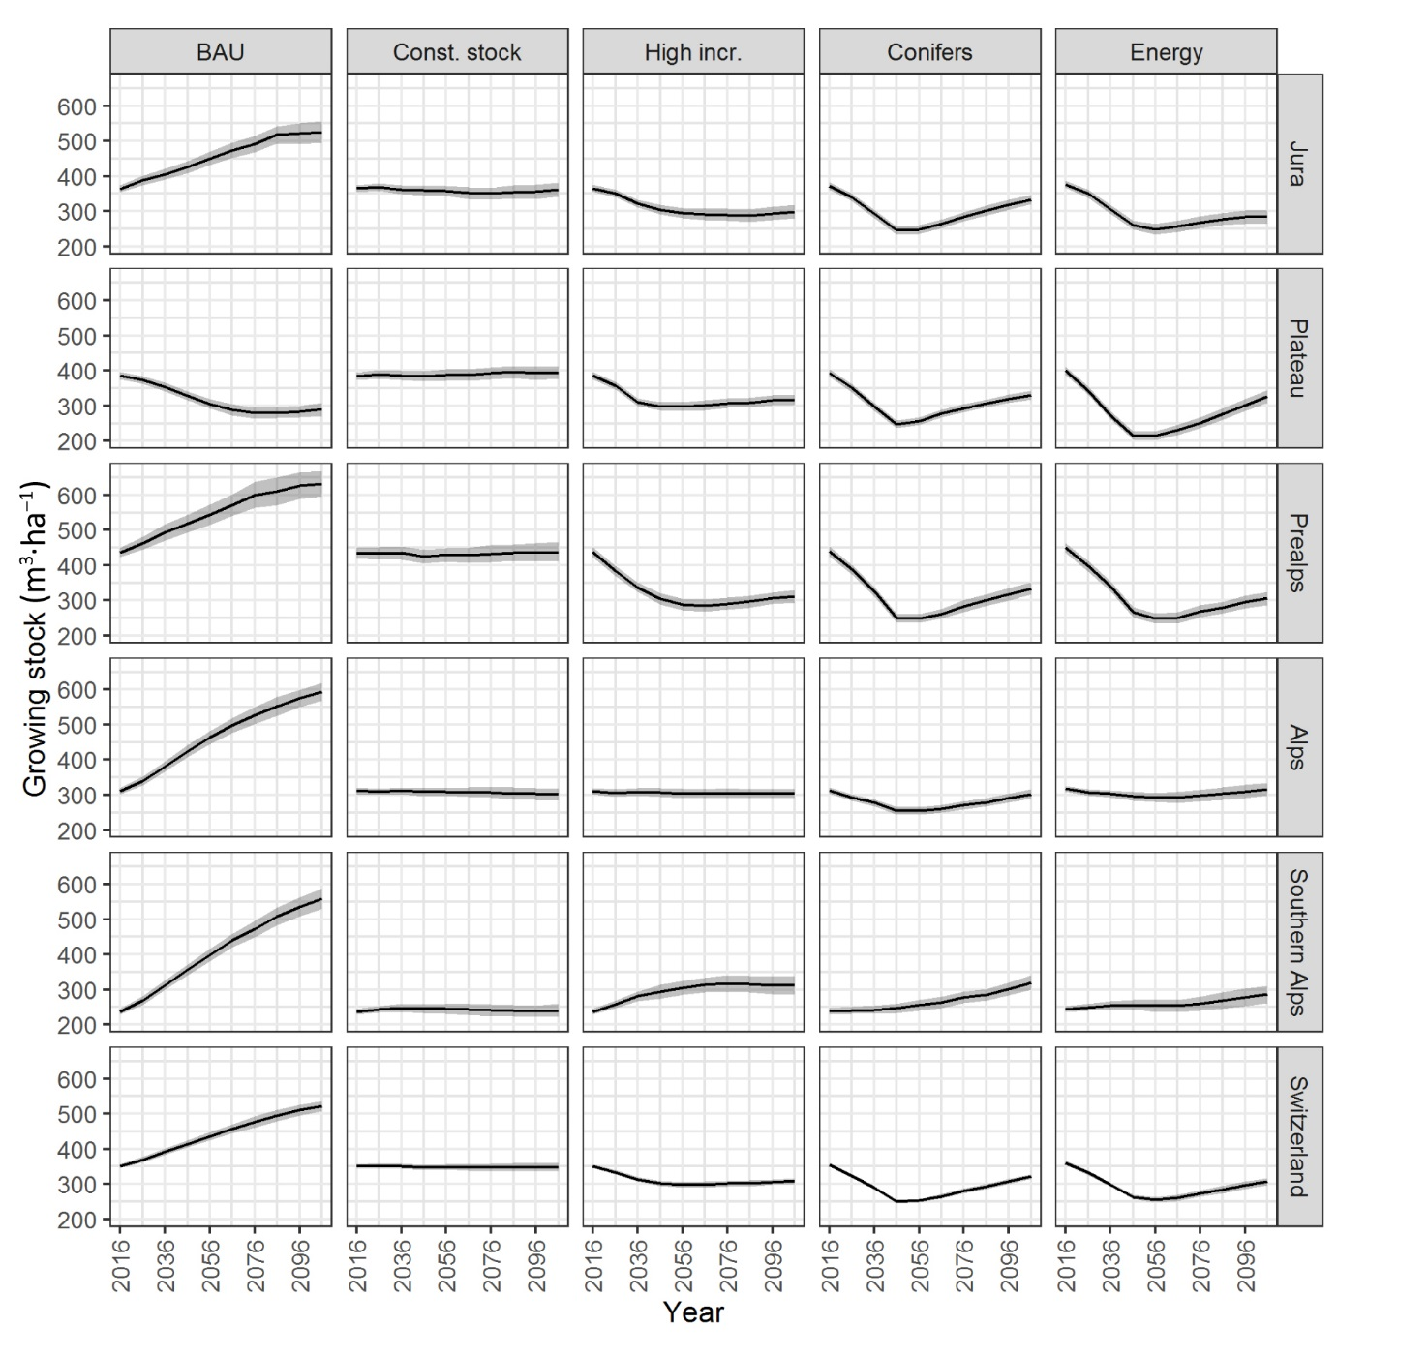
Figure S1 Development of growing stock by management scenario and NFI production region. Error bands indicate standard error of means resulting from variation among NFI sample plots and scenario simulations.
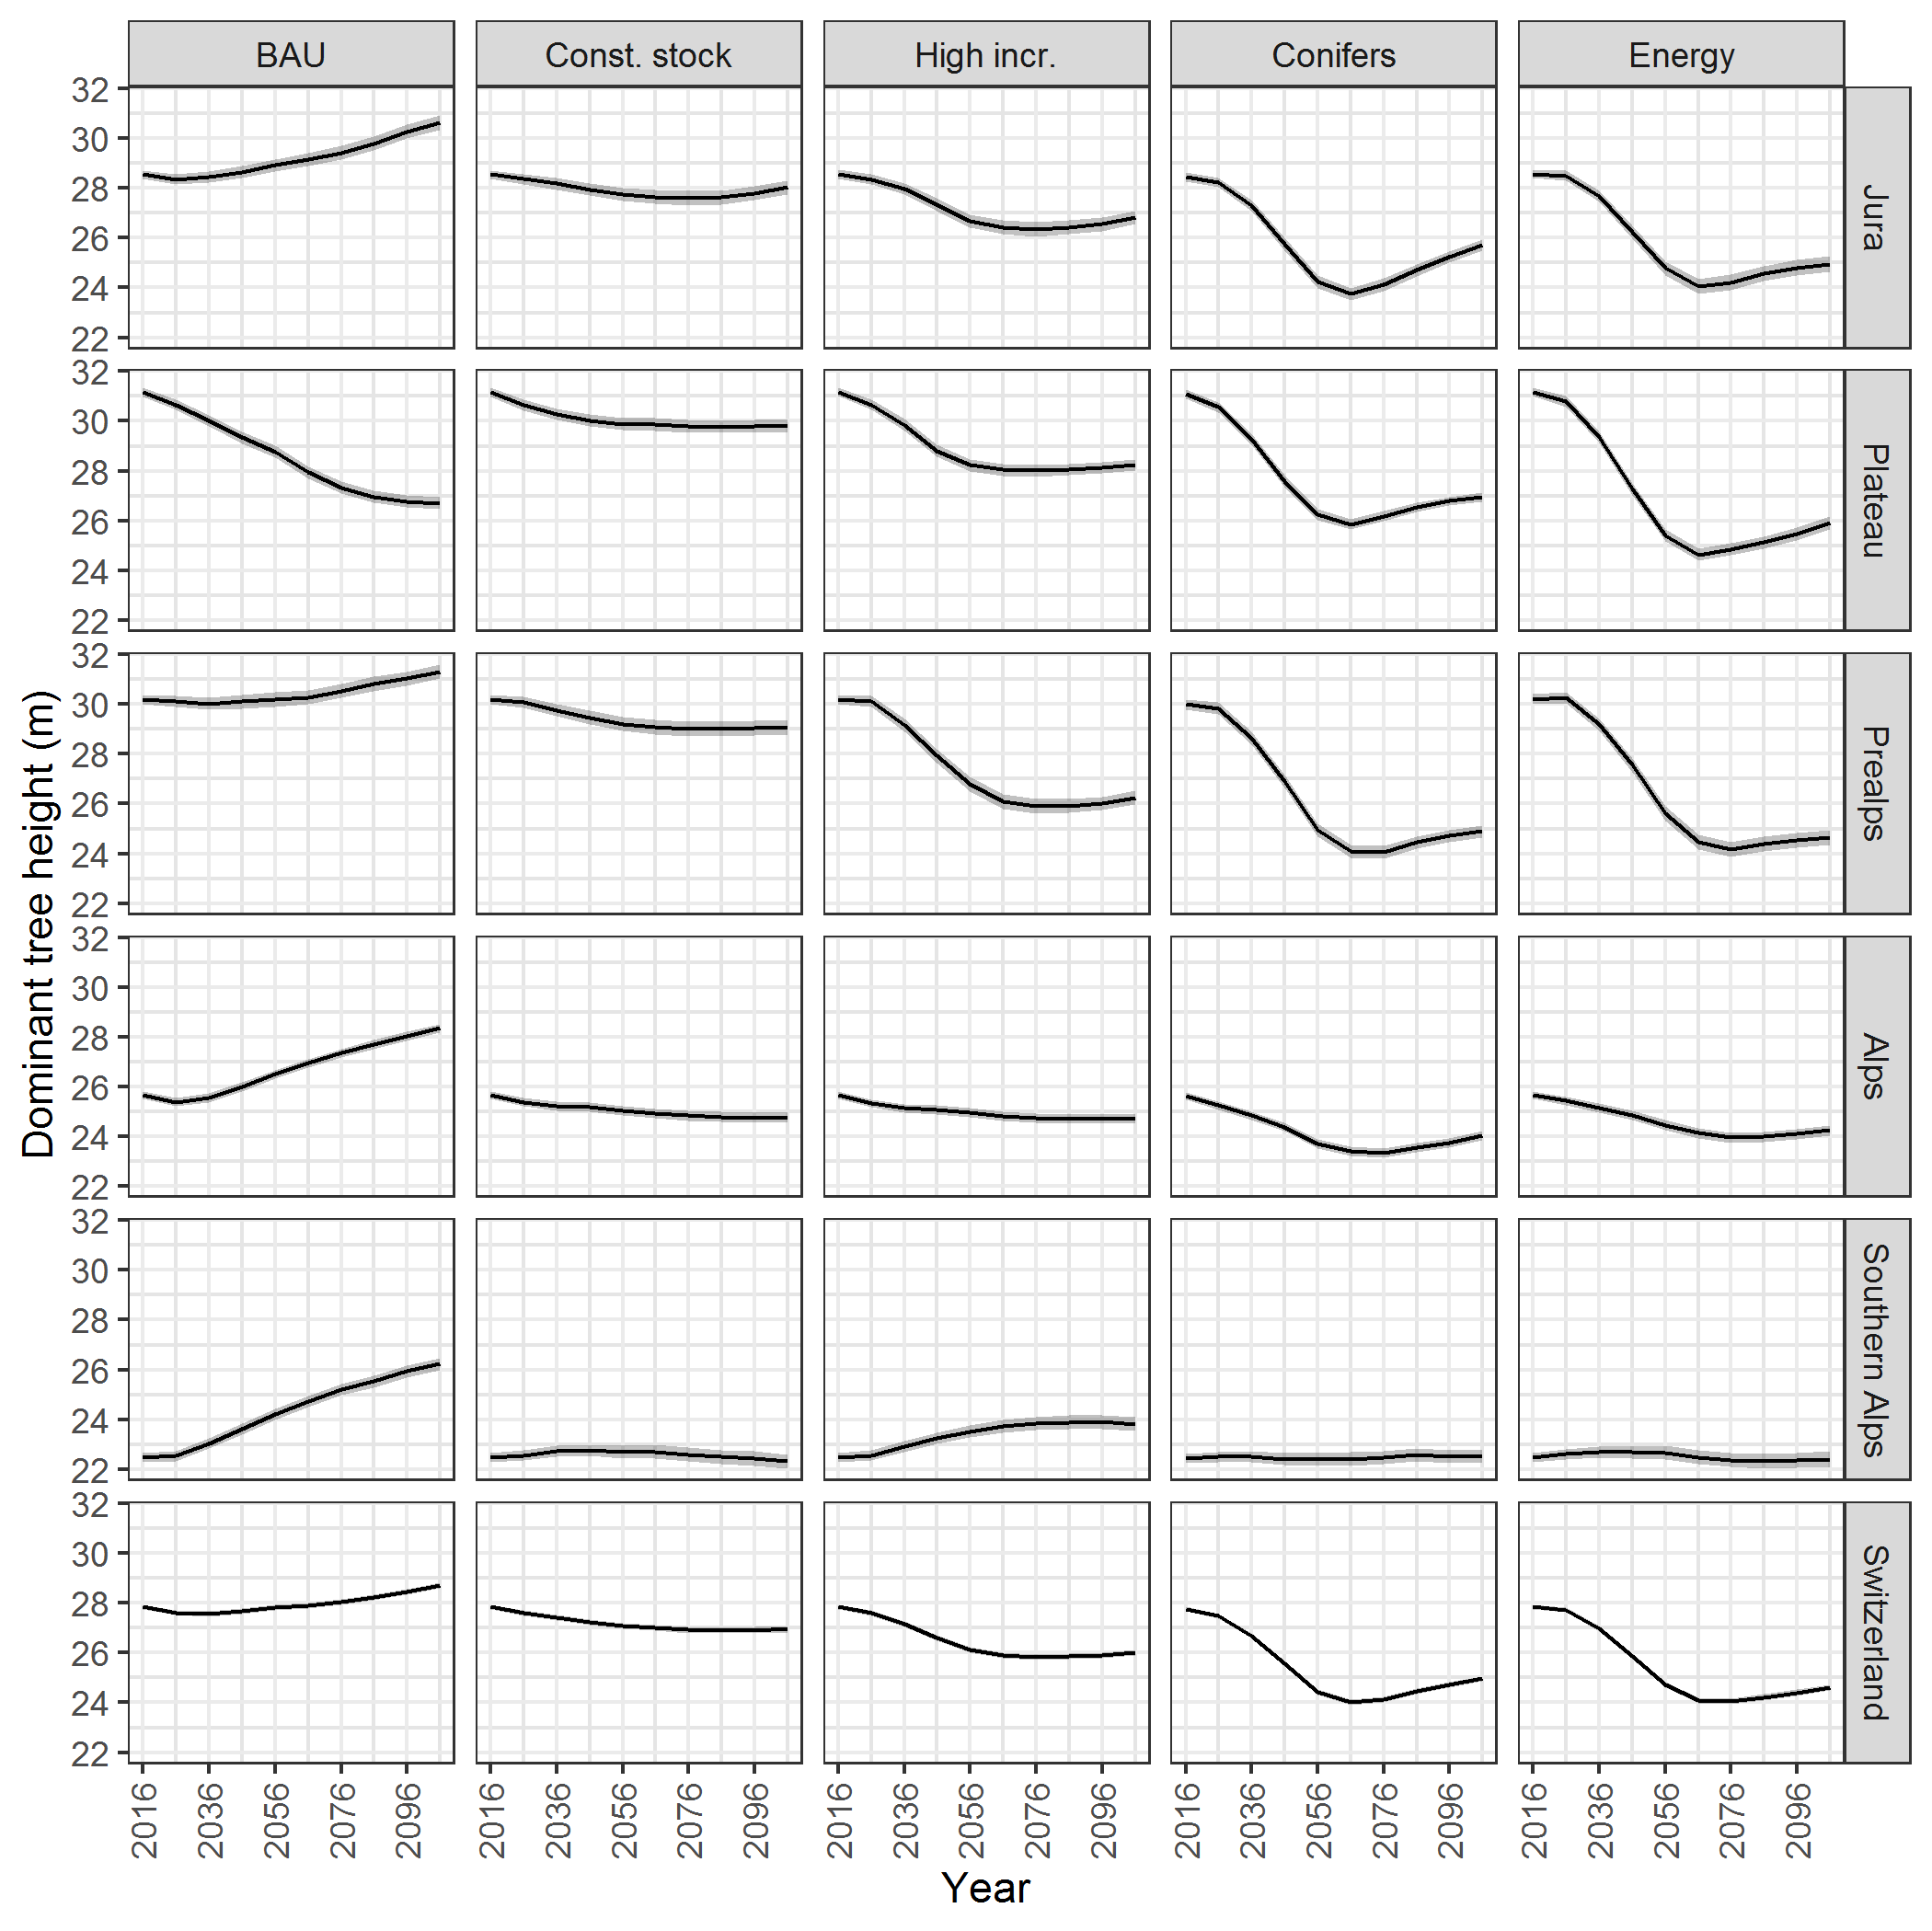
Figure S2 Development of dominant tree height (average height of 100 largest tree per ha) by management scenario and NFI production region. Error bands indicate standard error of means resulting from variation among NFI sample plots and scenario simulations.
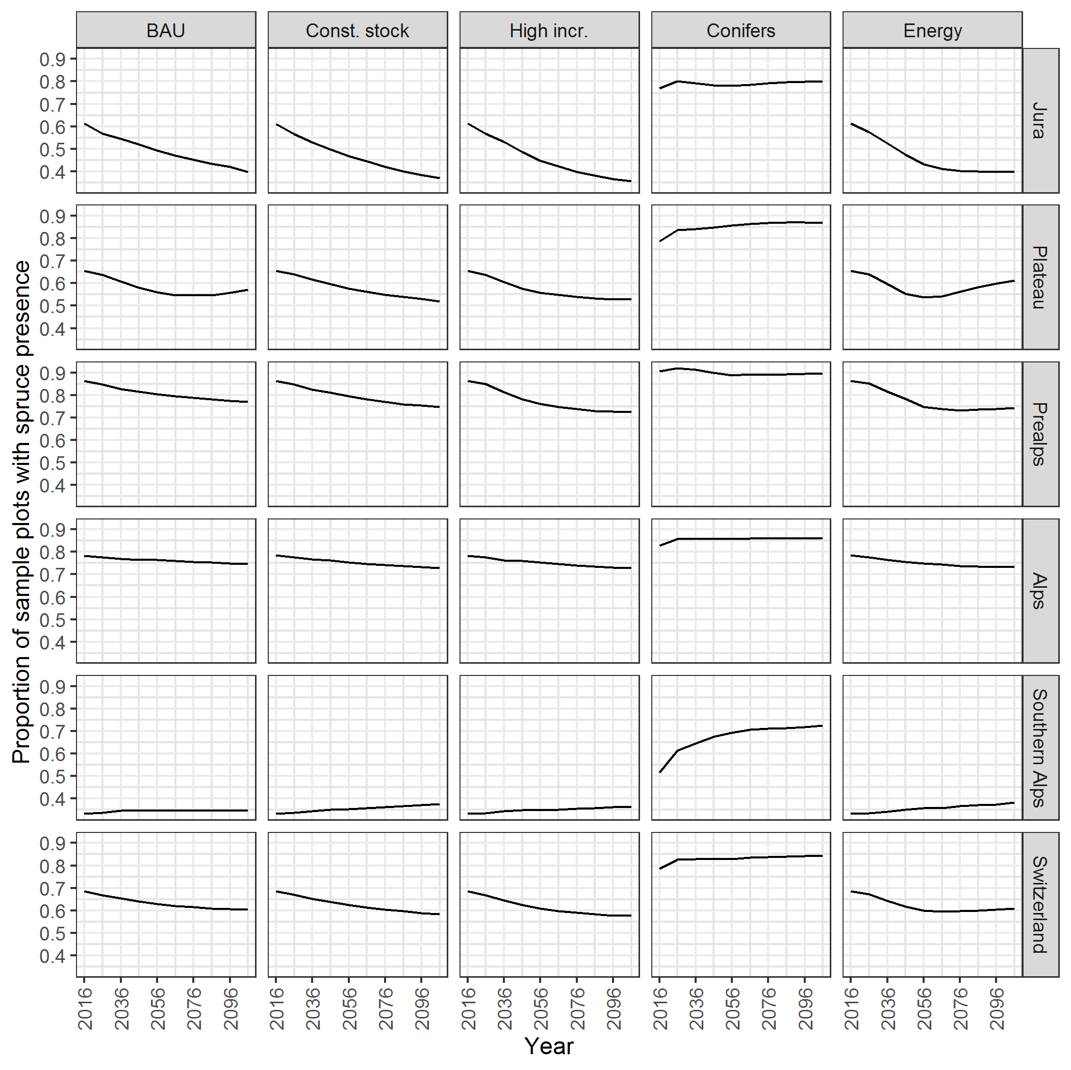
Figure S3 Development of proportion of NFI sample plots with spruce presence by management scenario and NFI production region.
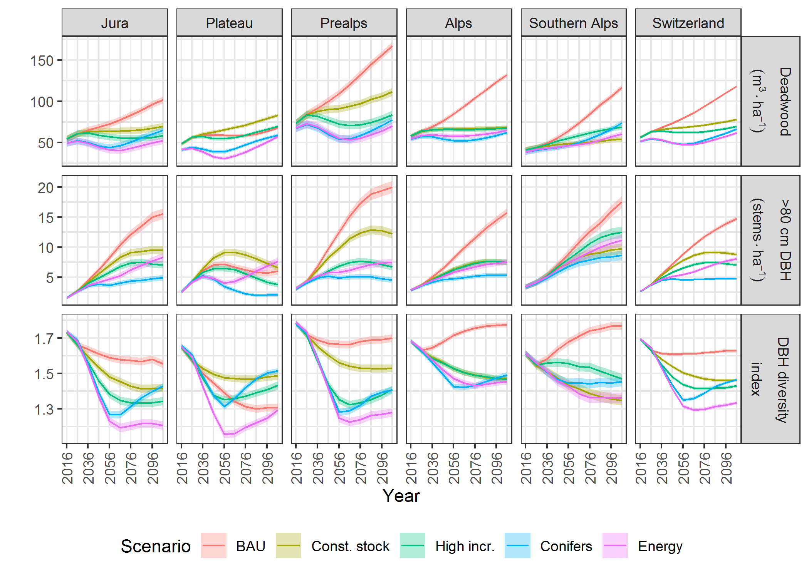
Figure S4 Development of old-growth components by management scenario and NFI production region. Error bands indicate standard error of means resulting from variation among NFI sample plots and scenario simulations.
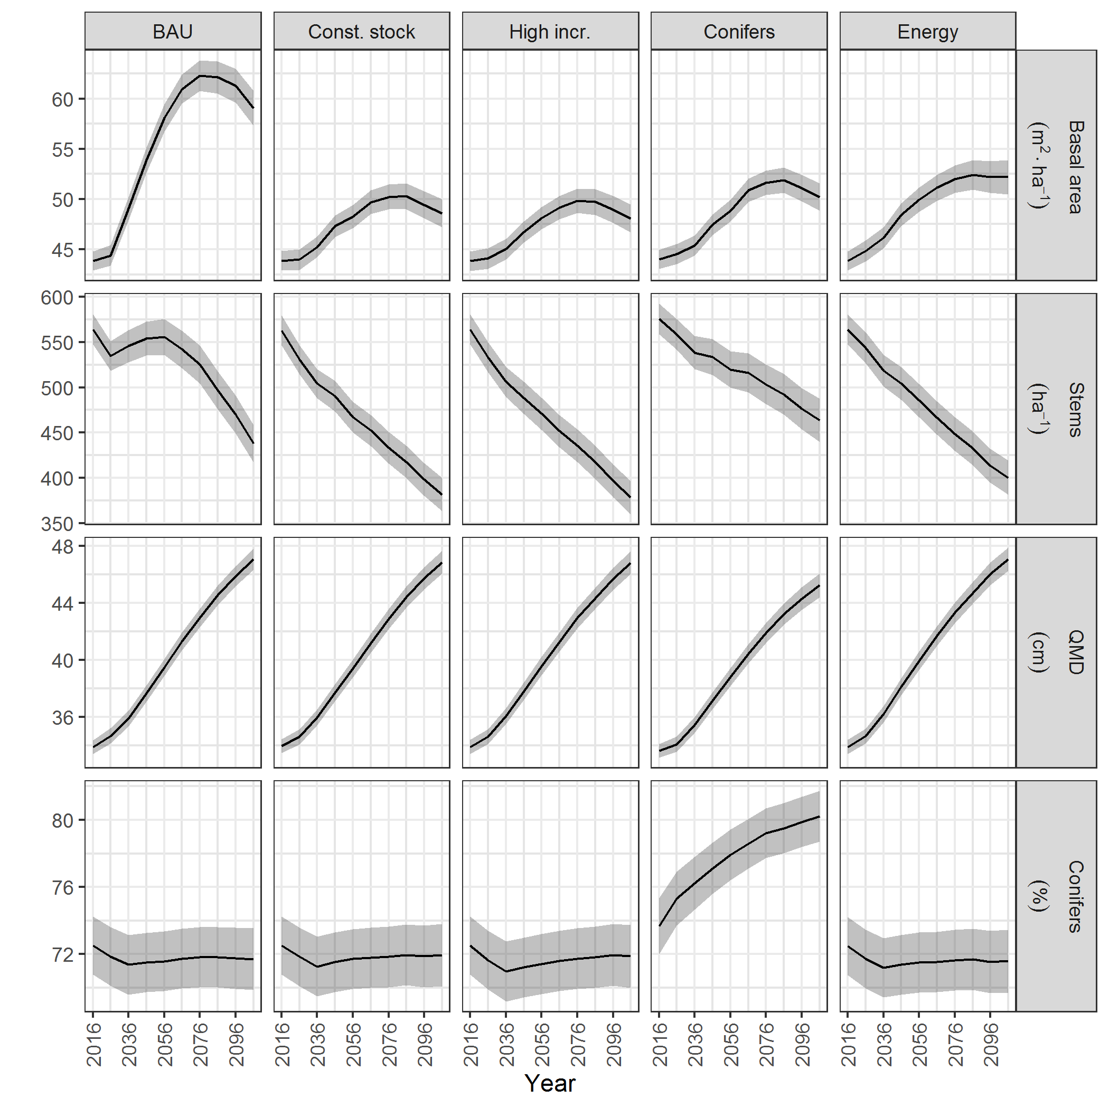
Figure S5 Development of variables on stand structure used to calculate rockfall and avalanche protection indices. Solid lines show averages across the 469 NFI sample plots in the protection forest perimeter and error bands standard errors of means resulting from variation among NFI sample plots and scenario simulations.
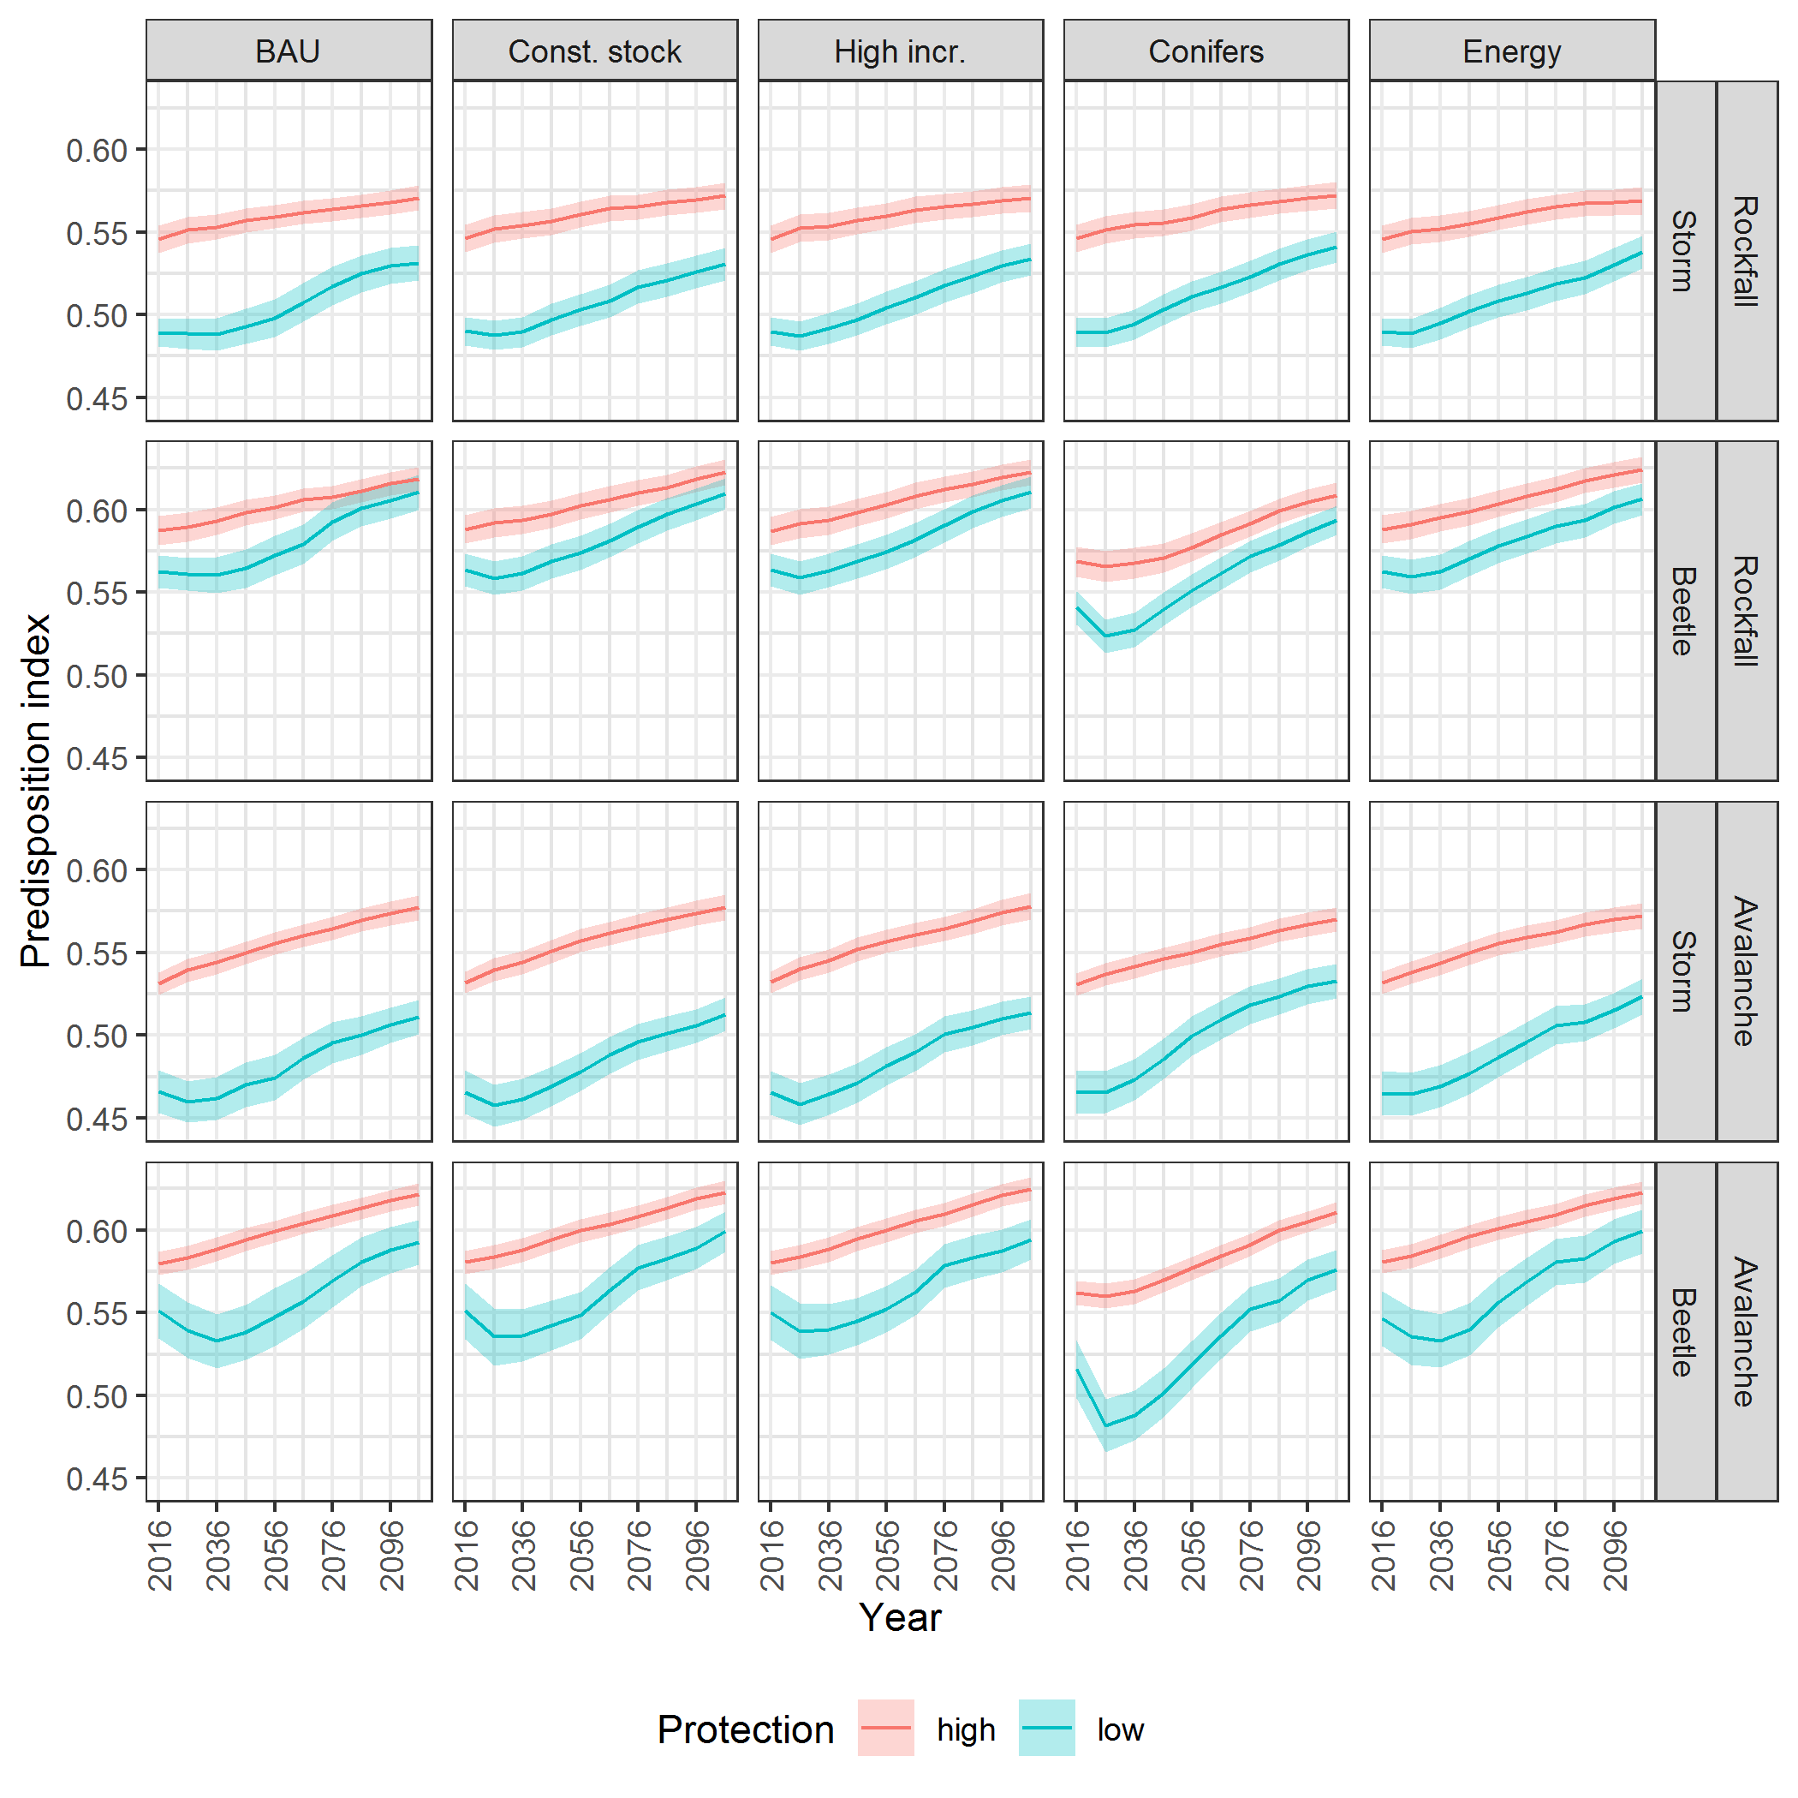
Figure S6 Development of average storm and bark beetle disturbance predisposition by management scenario (columns) and in sample plots in the protection forest perimeter with high (≥0.95) and low rockfall and avalanche protection indices. Error bands indicate standard error of means resulting from variation among NFI sample plots and scenario simulations.

References
Federal Office of Agriculture FOAG (2012) Digital Soil Suitability Map of Switzerland.
Federal Office for the Environment FOEN (2010) "Lothar” 1999 storm damage inventory | opendata.swiss. https://opendata.swiss/en/dataset/sturmschadeninventar-lothar-1999. Accessed 19 Oct 2018.
Federal Office for the Environment FOEN (1992) Areas of storm damage caused by “Vivian” in 1990 | opendata.swiss. https://opendata.swiss/en/dataset/waldschadenflachen-vivian-1990. Accessed 19 Oct 2018.
Hart SJ, Veblen TT, Eisenhart KS, Jarvis D, Kulakowski D (2014) Drought induces spruce beetle (Dendroctonus rufipennis) outbreaks across northwestern Colorado. Ecology 95:930–939. doi:10.1890/13-0230.1
Hosmer DW, Lemeshow S, Sturdivant RX (2013) Applied logistic regression, third edition. Wiley, Hoboken, NJ.
Jakoby O, Wermelinger B, Stadelmann G, Lischke H (2015) Borkenkäfer im Klimawandel - Modellierung des künftigen Befallsrisikos durch den Buchdrucker (Ips typographus). Eidg. Forschungsanstalt WSL, Birmensdorf
Kaufmann E (2001) Estimation of Standing Timber, Growth and Cut. In: Brassel P, Lischke H (eds) Swiss Natl. For. Inven. Methods Models Second Assess. Swiss Federal Research Institute WSL, Birmensdorf, pp 162–197
Lachat T, Brang P, Bolliger M, Bollmann K, Brandli U, Butler R, Herrmann S, Schneider O, Wermelinger B (2014) Totholz im Wald. Entstehung, Bedeutung und Förderung. Merkbl Für Prax Eidg Forschungsanstalt Für Wald Schnee Landsch WSL Birmensdorf 52:12.
Keller M (2013) Schweizerisches Landesforstinventar. Anleitung für die Umfrage- und Erschliessungserhebung 2013. Forschungsanstalt für Wald, Schnee und Landschaft WSL, Birmensdorf.
Mackensen J, Bauhus J, Webber E (2003) Decomposition rates of coarse woody debris – A review with particular emphasis on Australian tree species. Aust J Bot 51:27–37.
Mayer P, Brang P, Dobbertin M, Hallenbarter D, Renaud JP, Walthert L, Zimmermann S (2005) Forest storm damage is more frequent on acidic soils. Ann For Sci 62:9. doi: 10.1051/forest:2005025.
Mezei P, Jakuš R, Pennerstorfer J, Havasova M, Skvarenina J, Ferencik J, Slivinsky J, Bicarova S, Bilcik D, Blazenec M, Netherer S (2017) Storms, temperature maxima and the Eurasian spruce bark beetle Ips typographus—An infernal trio in Norway spruce forests of the Central European High Tatra Mountains. Agric For Meteorol 242:85–95. doi: 10.1016/j.agrformet.2017.04.004.
Netherer S (2003) Modelling of bark beetle development and of site- and stand-related predisposition to Ips typographus (L.) (Coleoptera; Scolytidae) - A contribution to risk assessment Dissertation. PhD Thesis, Universität für Bodenkultur BOKU
Opiasa M (2016) Predisposition of Norway spruce to European spruce bark beetle infestation and spatial development of an outbreak after windthrow. Master Thesis, ETH Zürich
Quine CP, White IMS (1998) The potential of distance-limited topex in the prediction of site windiness. For Int J For Res 71:325–332. doi: 10.1093/forestry/71.4.325
Remund J, von Arx G, Gallien L, Rebetez M, Huber B, Zimmermann NE (2016) Klimawandel in der Schweiz – Entwicklung waldrelevanter Klimagrössen. In: Pluess AR, Augustin S, Brang P (eds) Wald Im Klimawandel Grundlagen Für Adapt. Bundesamt für Umwelt BAFU Bern; Eidg. Forschungsanstalt WSL, Birmensdorf; Haupt, Bern, Stuttgart, Wien., pp 23–37
Schumacher S (2004) The role of large-scale disturbances and climate for the dynamics of forested landscapes in the European Alps. Swiss Federal Institute of Technology ETH, Zürich, Switzerland
Seidl R, Baier P, Rammer W, Schopf A, Lexer MJ (2007) Modelling tree mortality by bark beetle infestation in Norway spruce forests. Ecol Model 206:383–399. doi: 16/j.ecolmodel.2007.04.002
Stadelmann G, Bugmann H, Wermelinger B, Bigler C (2014) Spatial interactions between storm damage and subsequent infestations by the European spruce bark beetle. For Ecol Manag 318:167–174. doi: 10.1016/j.foreco.2014.01.022
Temperli C, Bugmann H, Elkin C (2013) Cross-scale interactions among bark beetles, climate change, and wind disturbances: a landscape modeling approach. Ecol Monogr 83:383–402. doi: 10.1890/12-1503.1
Temperli C, Veblen TT, Hart SJ, Kulakowski D, Tepley AJ (2015) Interactions among spruce beetle disturbance, climate change and forest dynamics captured by a forest landscape model. Ecosphere 6:art231–art231. doi: 10.1890/ES15-00394.1
Thornthwaite CW, Mather JR (1957) Instructions and tables for computing potential evapotranspiration and the water balance. Publ Climatol 10:183–311.
Wilson MFJ, O’Connell B, Brown C, Guinan JC, Grehan AJ (2007) Multiscale terrain analysis of multibeam bathymetry data for habitat mapping on the continental slope. Mar Geod 30:3–35. doi: 10.1080/01490410701295962
Wohlgemuth T, Conedera M, Engesser R, Wermelinger B, Reinhard M, Forster B, Meier F (2015) Forest damage. In: Rigling A, Schaffer HP (eds) For. Rep. 2015 Cond. Use Swiss For. Federal Office of the Environment FOEN, Bern, and Swiss Federal Institute for Forest, Snow and Landscape Reseach WSL, Birmensdorf, pp 52–57

