Supplementary Materials
Allometric equations
To estimate the aboveground biomass of the individual trees, I used the following allometric equations which were parameterized using Betula ermanii, Quercus crispula, and Abies sachalinensis in Hokkaido (Takagi et al. 2010; Ohtsu et al. 2015):
$ln\left(AGB\right)=2.833ln\left(H\right)-1.184$ (1)
$ln\left(AGB\right)=2.248ln\left(DBH\right)-2.282$ (2)
where $AGB$ is the total dry aboveground biomass of the stem, branches, and leaves (kg), $DBH$ is the diameter at breast height (cm), and $H$ is tree height (m). I used the first equation (Ohtsu et al. 2015) for trees with $H$ < 1.3 m and the second equation (Takagi et al. 2010) for trees with $H$ ≥ 1.3 m. To correct for the inevitable discrepancy in $AGB$ near $H$ = 1.3 m (i.e. $DBH≈$ 0 cm) between the equations, I assumed $AGB$ = 0.643 kg for all trees with $H$ ≥ 1.3 m and $DBH$ ≤ 2.1 cm (i.e. where the $AGB$ estimates of the two equations matched).
From 1988 to 1990, some of the Betula maximowicziana and Q. crispula trees in the experimental site had reached 1.3 m in height, but their $DBHs$ were not measured. I therefore estimated the $DBH$ of B. maximowicziana and Q. crispula trees using the following equations 3 and 4, respectively:
$DBH=0.127×exp\left(0.949H\right)$ (3)
$DBH=0.285×exp\left(0.658H\right)$ (4)
where $DBH$ and $H$ were defined the same as above. The equations 3 and 4 were estimated using B. maximowicziana and Q. crispula trees, respectively, which were planted in a different plot within the experimental site. In this plot, B. maximowicziana, Q. crispula, and A. sachalinensis were planted 1 m apart from each other. The trees were planted at the same time with trees in the other plots (i.e. 1987). The $DBH$ and $H$ in 1990 were used for the estimation. The sample size and R² were n = 29 and $R^{2}$ = 0.905 for B. maximowicziana and n = 42 and $R^{2}$ = 0.677 for Q. crispula.
In 2002 and 2003, the heights of trees with $DBH$ < 3.5 cm were not measured in the A. sachalinensis monoculture. I therefore estimated their heights using the following equation:
$H=1.3+0.816DBH$ (5)
where $DBH$ and $H$ were defined the same as above. The parameters were estimated using the $DBH$ and $H$ of trees with $DBH$ ≥ 3.5 cm in the same monoculture and A. sachalinensis trees planted in the 1 m-spaced mixed stand (n = 52; $R^{2}$ = 0.948).

State space modelling
I tested whether the net diversity, complementarity, and selection effects increased or decreased through time using Bayesian state space models:
$Y_{t} \sim N\left(y_{t}, σ_{ε}^{2}\right)$
$y_{t} \sim N\left(y_{t-1}+δ, σ_{η}^{2}\right)$ (6)
where $Y_{t}$ is the observed value and $y_{t}$ is the state variable of the net diversity, complementarity, or selection effect at time $t$, $δ$ is the parameter that determines whether $y_{t}$ changed deterministically through time, and $σ_{ε}^{2}$ and $σ_{η}^{2}$ are variations. Time $t$ was represented by the year after planting. The $y_{t}$ at $t=0$ was set $0$. The parameters $δ$, $σ_{ε}^{2}$, and $σ_{η}^{2}$ were assumed as non-informative priors: $δ \sim N\left(0, {10}^{4}\right)$, $σ_{ε}^{2}\sim Unif\left(0, {10}^{4}\right)$, and $σ_{η}^{2}\sim Unif\left(0, {10}^{4}\right)$.
Model 6 takes into account the temporal autocorrelations by assuming that $y_{t}$ is determined as $y_{t}=y_{t-1}+δ+ε$, where $ε$ is a Gaussian noise determined by$σ_{η}^{2}$. The null hypothesis here is $y_{t} \sim N\left(y_{t-1}, σ_{η}^{2}\right)$ (i.e. random walk). The constant value $δ$ tests whether $y_{t}$ increased or decreased more largely than expected from stochastic fluctuations.
The posterior distributions of the parameters were estimated using the Markov chain Monte Carlo (MCMC) method implemented by JAGS ver. 4.3.0 (Plummer 2003). I obtained posterior samples using three independent MCMC samplings, in each of which 1000 values were sampled at a 5‐step interval after a burn‐in period of 5000 MCMC steps. I judged that the MCMC calculation had converged when the $\hat{R}$ values of all the parameters were < 1.1 (Gelman et al. 2013).

Akaike information criterion
Akaike information criterion ($AIC$) of the regression models, for which the least-squares method was used to estimate the parameters, was defined as follows (Burnham and Anderson 2004):
$AIC=2\left(p+1\right)+n\left[ln\left(2π\frac{S}{n}\right)+1\right]$ (7)
where $p$ is the number of parameters, $S$ is the residual sum of squares, and $n$ is simple size.

References
Burnham KP, Anderson DR (2004) Model selection and multimodel inference. Springer, New York
Gelman A, Carlin JB, Stern HS, Dunson DB, Vehtari A, Rubin DB (2013) Bayesian data analysis, 3rd edition. CRC Press, Florida
Ohtsu H, Hishi T, Tashiro N, Inoue S, Cho K, Ogata T, Mabuchi T, Enoki T (2015) Accumulation patterns of soil carbon and nitrogen in a Japanese oak (Quercus crispula) plantation in eastern Hokkaido: analyses using continuous 0–40 years old stands. Bull Kyushu Univ For 96:1–15
Plummer M (2003) JAGS: a program for analysis of Bayesian graphical models using Gibbs sampling. Proceedings of the 3rd international workshop on distributed statistical computing (DSC 2003), vol. 124, No. 125. March 20–22, Vienna, Austria
Takagi K, Kotsuka C, Fukuzawa K, Kayama M, Makoto K, Watanabe T, Nomura M, Fukazawa T, Takahashi H, Hojyo H, Ashiya D, Naniwa A, Sugata S, Kamiura T, Sugishita Y, Sakai R, Ito K, Maebayashi M, Mizuno M, Murayama T, Kinoshita K, Fujiwara D, Hashida S, Shibata H, Yoshida T, Sasa K, Saigusa N, Fujinuma Y, Akibayashi Y (2010) Allometric relationships and carbon and nitrogen contents for three major tree species (Quercus crispula, Betula ermanii, and Abies sachalinensis) in northern Hokkaido, Japan. Eurasian J For Res 13:1–7
Table S1 Numbers of live trees (= trees of which the heights were measured) in each year
Treatment | Species | Initial | 1 | 2 | 3 | 15 | 16 | 22 | 31
Monoculture | B. maximowicziana | 51 | 30† | 30† | 42 | 7 | 6 | 4 | 1
 | Q. crispula | 51 | 50 | 50 | 50 | 12 | 12 | 9 | 3
 | A. sachalinensis | 51 | 51 | 51 | 51 | 30 | 27 | 15 | 9
Mixutre | B. maximowicziana | 56 | 54 | 52 | 50 | 16 | 15 | 10 | 8
 | Q. crispula | 56 | 56 | 56 | 56 | 24 | 24 | 22 | 13
 | A. sachalinensis | 63 | 63 | 63 | 63 | 54 | 54 | 50 | 39
Total |  | 328 | 304† | 302† | 312 | 143 | 138 | 110 | 73
† In the B. maximowicziana monoculture, only 31 trees out of the 51 initially-planted trees were measured in the first and second year, likely due to limitations in the workforce

Table S2 Results of regression analyses on the relationship between diversity effects $(Y)$ and experimental years $(X)$
Response variable $Y$ | Model | Estimates |  |  | AIC† | R²
Response variable $Y$ | Model | $$α$$ | $$β$$
Net diversity effect | $$Y=α+βX$$ | 4.398 * | 1.058 *** |  | 113.3 | 0.974
 | $$Y=α·X^{β}$$ | 8.057 * | 0.5 × 10⁻⁴ ** |  | 120.5 | 0.913
Complementarity effect | $$Y=α+βX$$ | −3.811 | 3.242 ** |  | 135.3 | 0.899
 | $$Y=αX^{β}$$ | 8.056 ** | 0.9 × 10⁻⁴ *** |  | 120.5 | 0.992
Selection effect | $$Y=α+βX$$ | 8.208 | −2.184 * |  | 135.3 | 0.802
 | $$Y=αX^{β}$$ | −1.357 * | 1.3 × 10⁻⁴ *** |  | 110.2 | 0.997
† The values of Akaike information criterion (AIC) are shown in bold face for the model which had lower AIC than the other (i.e. linear vs. exponential)
* P < 0.05, ** P < 0.01, *** P < 0.001

Table S3 Posterior distributions of Bayesian state space models on temporal changes in diversity effects $(Y)$
Variable $Y$ | Parameter $δ$ mean | 2.5% credible interval | 97.5% credible interval
Net diversity effect | 1.154 | 1.119 | 1.190
Complementarity effect | 3.416 | 3.381 | 3.451
Selection effect | −2.262 | −2.297 | −2.228

Table S4 Results of generalized linear model analyses on differences in survival rates (for which Bernoulli distributions were used to describe ‘alive vs. dead’ responses) among treatments and tree species. The values show likelihood-ratio chi-squares
Experiment year | 1 | 2 | 3 | 15 | 16 | 22 | 31
Treatment (mono vs. mix) | 3.2 | 5.0 | 2.6 | 18.7*** | 23.5*** | 38.5*** | 36.7***
Species | 4.6 | 9.3** | 14.1*** | 45.4*** | 48.7*** | 50.2*** | 34.7***
** P < 0.01, *** P < 0.001

Table S5 Results of two-way ANOVA on differences in tree heights (m) among treatments and tree species (DF = degrees of freedom, MS = mean squares, F = F-ratio)
 | 3 years after planting |  |  |  | 15 years after planting |  |  |  | 31 years after planting
 | DF | MS | F |  | DF | MS | F |  | DF | MS | F
Treatment (mono vs. mix) | 1 | 36.7 | 50.7*** |  | 1 | 66.6 | 4.4* |  | 1 | 327.4 | 10.3**
Species | 2 | 17.6 | 24.4*** |  | 2 | 13.1 | 0.9 |  | 2 | 37.9 | 1.2
Treatment × Species | 2 | 22.5 | 31.1*** |  | 2 | 129.7 | 8.5*** |  | 2 | 75.0 | 2.4
Residuals | 306 | 0.7 |  |  | 137 | 15.3 |  |  | 65 | 31.9
* P < 0.05, ** P < 0.01, *** P < 0.001

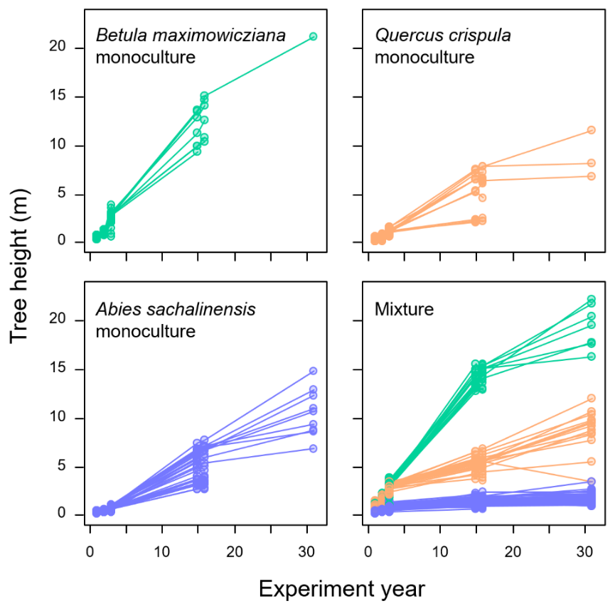
Fig. S1 Changes in tree heights across experimental years in the Furano experiment. Each set of circles connected by lines represents the change in height of an individual tree. The lines are terminated when the trees were dead. The height of some trees decreased between some measurement intervals due to stem bending or breakage

