Title: Assessing the vulnerability of ecosystems to climate change based on vegetation stability and productivity

Kai Xu, Xiangping Wang*, Chao Jiang, Osbert Jianxin Sun
College of Forestry, Beijing Forestry University, Beijing 100083, China

Appendix Figure S1
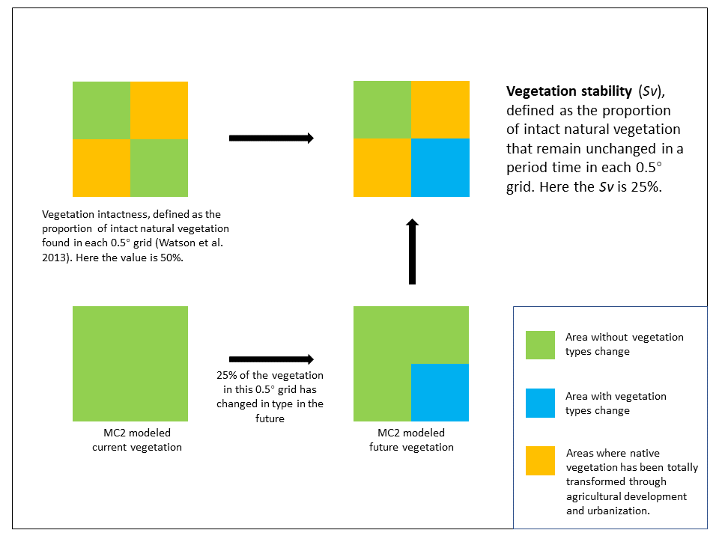
Figure S1 Schematic of the calculation of vegetation stability. Here the large square represents a 0.5° grid and is divided into four sub-grids for example. In the actual analysis, each 0.5° degree grid was divided into 100 sub-grids.

Appendix Figure S2
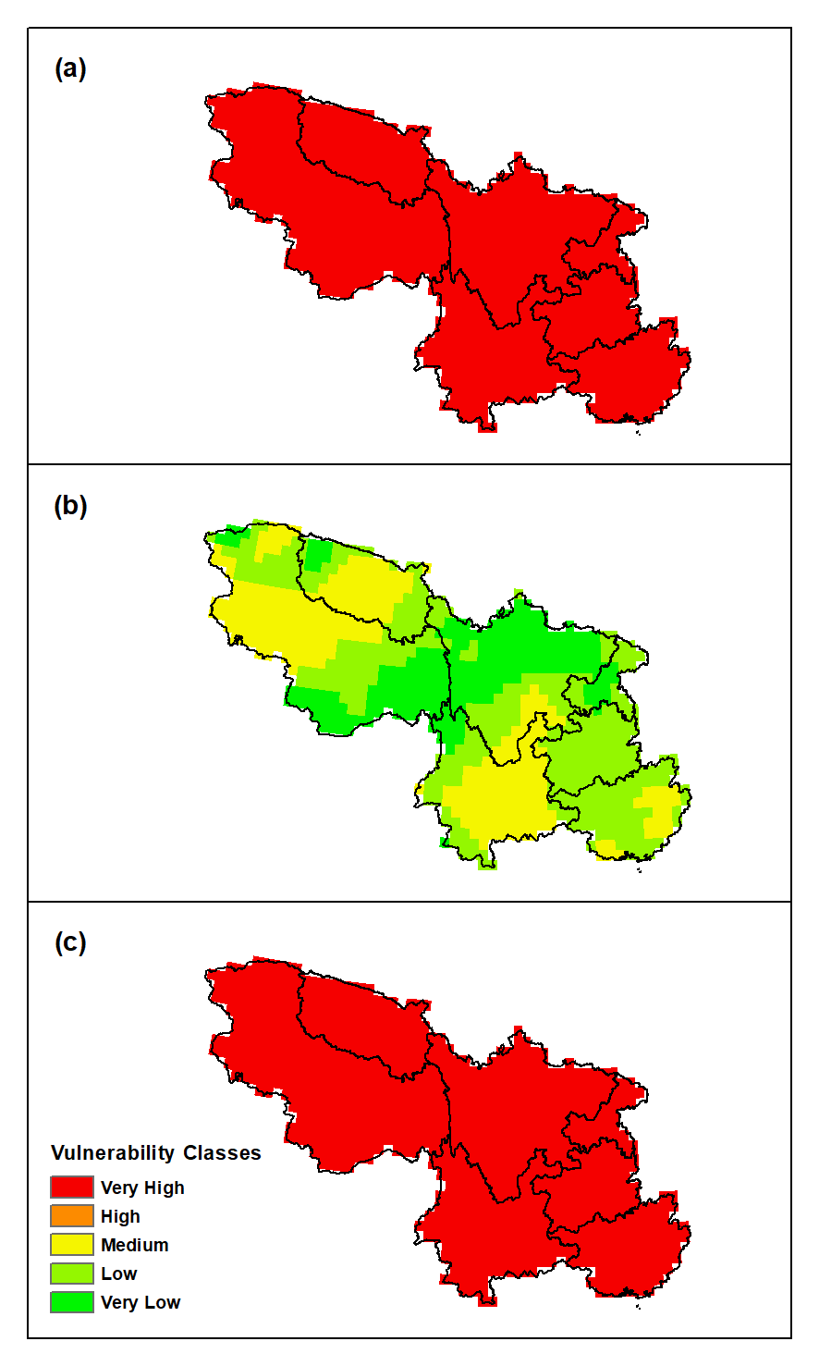
Figure S2 Vulnerability of climate exposure for the study area under future RCP 4.5 scenario, calculated based on 2017‒2100 (a) annual mean temperature, (b) annual precipitation, and (c) overlap of (a) and (b) with the method of Gonzalez et al. (2010).

