Supplementary Material

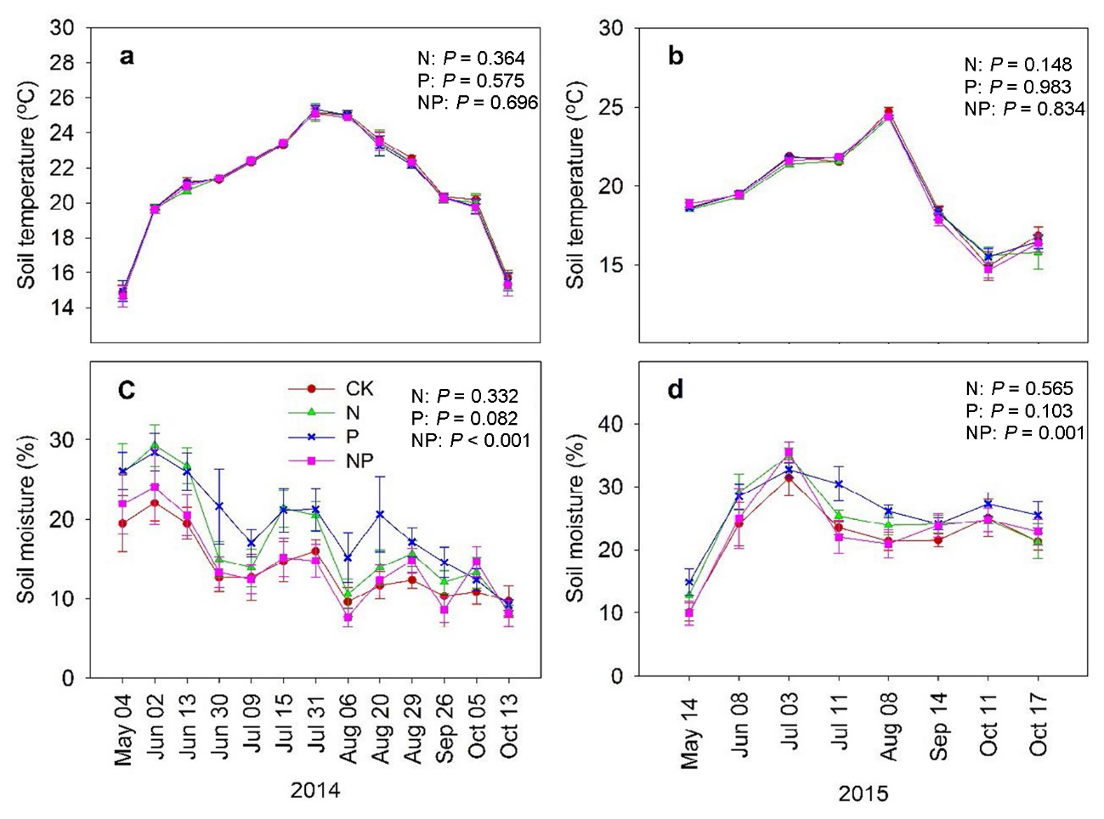
Fig. S1 Soil temperature (a, b) and soil moisture (c, d) under different treatments from 2014 to 2015 in the subtropical forest. Vertical bars show standard errors of the means (n = 4). CK, control; N, nitrogen addition; P, phosphorus addition; NP, both nitrogen and phosphorus addition. Repeated-measure ANOVA was conducted to determine the effects of N and P addition on soil temperature and moisture.

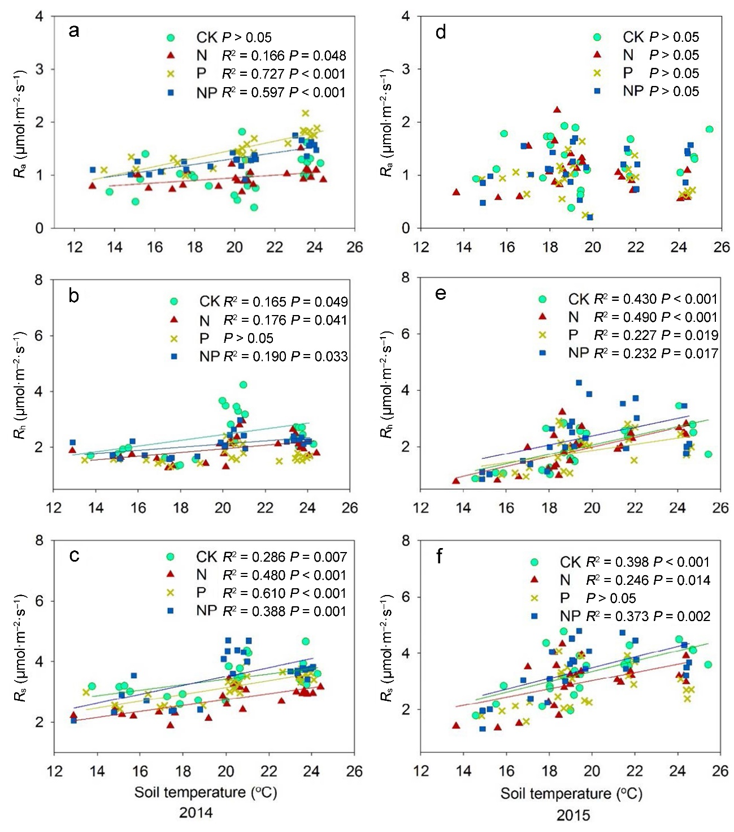
Fig. S2 Relationships between soil autotrophic respiration (R_{a}), heterotrophic respiration (R_{h}), total respiration (R_{s}) and soil temperature in 2014 and 2015, respectively.

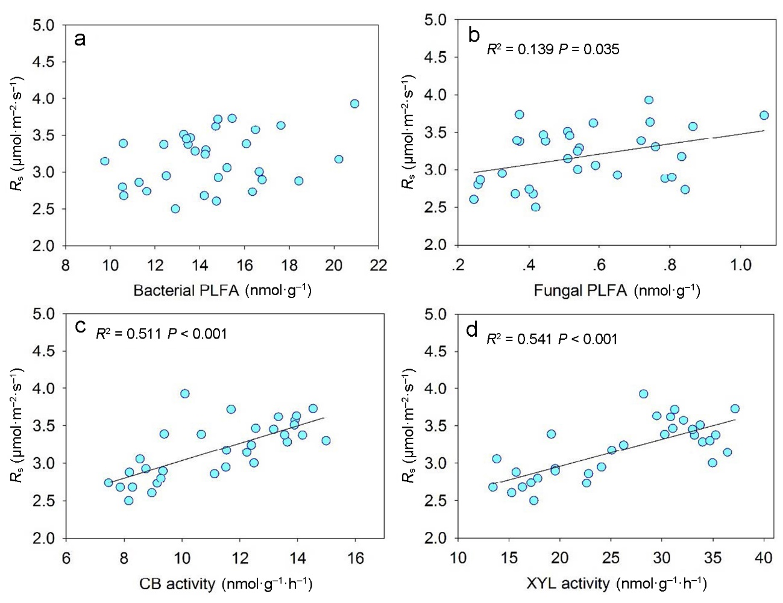
Fig. S3 Relationships between soil total respiration (R_{s}) and soil microbial community as well as soil enzyme activity.

Table S1 Statistical significance (P values) of the effects of block, year, N, P and their interactions (N × P, N × Year, P × Year, N × P × Year) on soil properties, enzyme activities, microbial composition and soil respiration in the years of 2014 and 2015. N, nitrogen addition; P, P addition. Bold numbers indicated a significant effect (P < 0.05)
 | Block | Year | N | P | N × P | N × Year | P × Year | N × P × Year
Chemical property
DOC | 0.039 | 0.615 | 0.754 | 0.012 | 0.344 | 0.661 | 0.730 | 0.851
NH₄⁺-N | 0.991 | 0.040 | < 0.001 | < 0.001 | 0.047 | 0.316 | 0.003 | 0.012
NO₃⁻-N | 0.731 | < 0.001 | < 0.001 | < 0.001 | 0.124 | 0.061 | 0.633 | 0.806
pH | 0.367 | < 0.001 | < 0.001 | 0.140 | 0.033 | 0.118 | 0.421 | 0.279
Al³⁺ | 0.338 | < 0.001 | < 0.001 | 0.023 | < 0.001 | < 0.001 | 0.007 | 0.990
Ca²⁺ | 0.137 | 0.008 | < 0.001 | 0.163 | 0.022 | 0.778 | 0.507 | 0.667
Mg²⁺ | 0.067 | 0.045 | 0.241 | 0.324 | 0.668 | 0.615 | 0.998 | 0.923
Na⁺ | 0.190 | 0.394 | 0.928 | 0.407 | 0.947 | 0.811 | 0.581 | 0.680
AP | 0.013 | 0.352 | 0.625 | < 0.001 | 0.900 | 0.674 | 0.378 | 0.881
MBC | 0.269 | 0.531 | 0.162 | < 0.001 | 0.364 | 0.752 | 0.415 | 0.961
Fine root biomass | 0.851 | 0.488 | < 0.001 | 0.003 | < 0.001 | 0.028 | 0.183 | 0.087
Enzymes
AG activity | 0.020 | 0.448 | 0.859 | 0.665 | 0.149 | 0.999 | 0.488 | 0.173
BG activity | 0.928 | < 0.001 | 0.997 | 0.555 | 0.054 | 0.329 | 0.206 | 0.453
CB activity | 0.477 | 0.005 | 0.158 | 0.049 | < 0.001 | 0.015 | 0.005 | 0.023
XYL activity | 0.580 | < 0.001 | 0.065 | 0.005 | < 0.001 | 0.007 | 0.002 | 0.003
Microbes
Bacterial PLFA | 0.350 | 0.162 | 0.063 | 0.889 | 0.146 | 0.770 | 0.038 | 0.147
Fungal PLFA | 0.152 | < 0.001 | 0.039 | 0.034 | 0.579 | 0.312 | 0.109 | 0.100
Actinobacterial PLFA | 0.483 | 0.002 | 0.079 | 0.174 | 0.304 | 0.438 | 0.093 | 0.298
Fu:Ba ratio | 0.632 | 0.003 | 0.032 | 0.099 | 0.084 | 0.949 | 0.429 | 0.880
Table S2 Pearson correlation between soil respiration and its components and soil properties
Year | Variable | DOC | pH | Al³⁺ | Ca²⁺ | Mg²⁺ | Na⁺ | MBC | Fine root biomass
2014 | R_{s} | 0.176 | 0.144 | –0.718** | –0.113 | –0.104 | –0.126 | 0.636* | 0.430
 | R_{a} | 0.406 | 0.399 | –0.866** | 0.555 | –0.095 | –0.196 | 0.582* | 0.689*
 | R_{h} | –0.069 | –0.385 | 0.289 | –0.371 | –0.268 | 0.206 | –0.058 | –0.775**
2015 | R_{s} | 0.258 | –0.274 | 0.546 | –0.214 | 0.335 | –0.062 | 0.125 | –0.275
 | R_{a} | 0.380 | –0.408 | 0.176 | –0.184 | 0.266 | –0.148 | 0.147 | –0.167
 | R_{h} | 0.124 | –0.113 | 0.494 | –0.127 | 0.194 | 0.022 | 0.088 | –0.199

