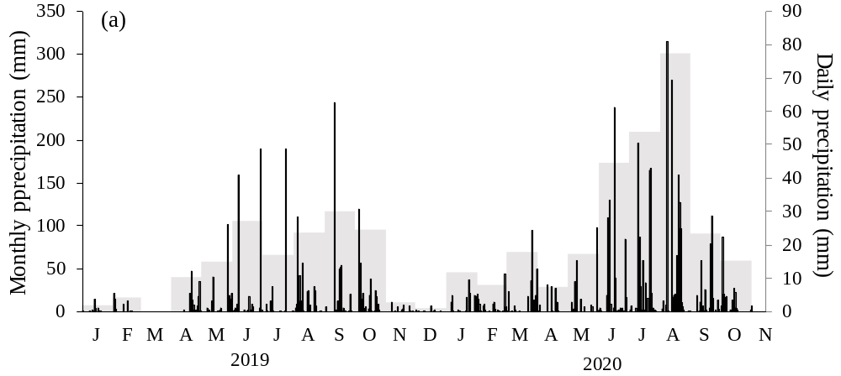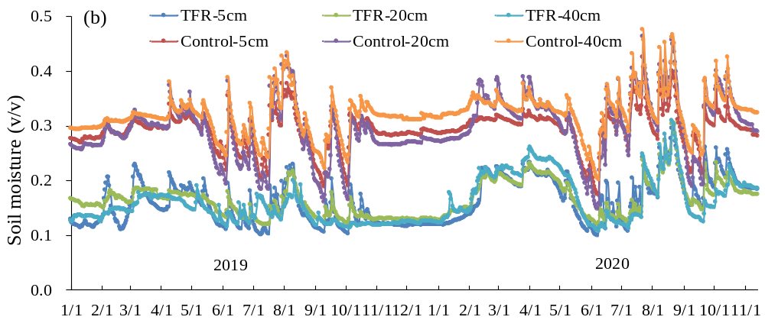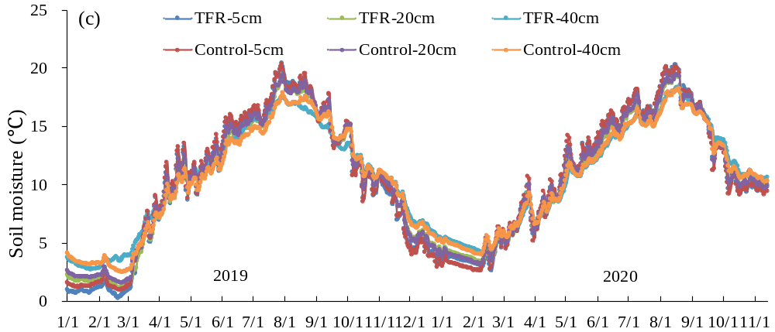
Fig. S1 Seasonal variation of daily (black bars) and monthly (grey bars) precipitation under ambient environment (a); daily averages of automatically measured (30 min interval) volumetric soil moisture content (b) and daily averages of automatically measured (30 min interval) soil temperature (c) to a depth of 40 cm under Control and throughfall reduction (TFR) conditions.

Table S1 Results (F and P values) of two-way ANOVA on the effects of throughfall reduction (TFR), year (Y) and their interactions (TFR×Y) on soil and fine root properties.
Variables | TFR |  |  | Y |  |  | TFR×Y
Variables | F | P |  | F | P |  | F | P
Soil chemical properties
SOC | 0.93 | 0.351 |  | 0.27 | 0.610 |  | 0.97 | 0.341
STN | 2.95 | 0.108 |  | 0.40 | 0.540 |  | 2.17 | 0.163
STP | 2.37 | 0.148 |  | 23.40 | <0.001 |  | 0.05 | 0.826
Fine root
Biomass (g∙kg^{‒1}) | 4.13 | 0.077 |  | 0.01 | 0.896 |  | 0.21 | 0.659
Soluble sugar (%) | 4.71 | 0.062 |  | 28.77 | 0.001 |  | 0.45 | 0.523
Starch (%) | 0.17 | 0.688 |  | 116.38 | <0.001 |  | 0.53 | 0.488
NSC (%) | 2.09 | 0.186 |  | 109.03 | <0.001 |  | 0.32 | 0.585
RC (g∙kg^{‒1}) | 0.02 | 0.883 |  | 9.55 | 0.015 |  | 0.16 | 0.698
RN (g∙kg^{‒1}) | 0.58 | 0.470 |  | 2.78 | 0.134 |  | 0.07 | 0.795
RP (g∙kg^{‒1}) | 1.16 | 0.313 |  | 84.25 | <0.001 |  | 0.01 | 0.920
Microbial biomass
MBC (mg∙kg^{‒1}) | 0.04 | 0.852 |  | 2.68 | 0.14 |  | 0.11 | 0.75
MBN (mg∙kg^{‒1}) | 0.36 | 0.567 |  | 6.31 | 0.036 |  | 0.05 | 0.826
Enzymatic activities
β-glucosidase | 1.79 | 0.218 |  | 25.37 | 0.001 |  | 0.64 | 0.446
Polyphenolase | 4.01 | 0.080 |  | 260.91 | <0.001 |  | 1.93 | 0.202
Peroxidase | 0.92 | 0.365 |  | 171.88 | <0.001 |  | 0.64 | 0.449
Amylase | 0.03 | 0.878 |  | 1.30 | 0.286 |  | 0.21 | 0.658
SOC: soil organic C, STN: soil total N, STP: soil organic P, NSC: non-structural carbohydrate, RC: root carbon content, RN: root nitrogen content, RP: root phosphorus content.

Table S2 Pearson correlation (R) between HR and measured variables. ST: soil temperature, SM: soil moisture, BR: bacterial richness, FR: fungal richness, MBC: microbial biomass carbon, MBN: microbial biomass nitrogen, BG: β-glucosidase, POP: polyphenolase, POD: peroxidase, AL: amylase.
 | ST | SM | BR | FR | MBC | MBN | BG | POP | POD | AL
SR | 0.181 | 0.051 | 0.019 | ‒0.559 | ‒0.110 | ‒0.046 | 0.216 | ‒0.048 | 0.029 | ‒0.311
HR | 0.163 | 0.234 | 0.53 | ‒0.210 | 0.321 | 0.375 | 0.151 | ‒0.021 | 0.028 | ‒0.006

Table S3 Pearson correlation (R) between AR and measured variables. ST: soil temperature, SM: soil moisture, FRB: fine root biomass, NSC: non-structural carbohydrate, RC: root carbon content, RN: root nitrogen content, RP: root phosphorus content.
 | ST | SM | FRB | Sugar | Starch | NSC | RC | RN | RP
SR | 0.245 | ‒0.045 | 0.610* | 0.095 | ‒0.101 | ‒0.098 | 0.115 | ‒0.132 | ‒0.101
AR | ‒0.056 | ‒0.259 | 0.857** | 0.216 | ‒0.059 | ‒0.015 | 0.072 | ‒0.208 | 0.008
* P < 0.05, ** P < 0.01.

Table S4 Relative abundance of microbial genera that showed a significant response (P < 0.05) to TFR.
 | Relative abundance |  |  | Taxa level |  |  | treatment
Group | Control | TFR |  | genus | phylum |  | P value
bacteria | 0.0234 | 0.0134 |  | norank_o__Vicinamibacterales | Acidobacteriota |  | 0.002
bacteria | 0.0136 | 0.0060 |  | norank_o__Rokubacteriales | Methylomirabilota |  | 0.004
bacteria | 0.0050 | 0.0040 |  | norank_f__Caulobacteraceae | Proteobacteria |  | 0.049
bacteria | 0.0049 | 0.0029 |  | Haliangium | Myxococcota |  | 0.03
bacteria | 0.0044 | 0.0019 |  | norank_o__Subgroup_7 | Acidobacteriota |  | 0.021
bacteria | 0.0042 | 0.0021 |  | norank_f__KF-JG30-B3 | Proteobacteria |  | 0.048
bacteria | 0.0040 | 0.0021 |  | norank_o__JG36-TzT-191 | Proteobacteria |  | 0.001
bacteria | 0.0039 | 0.0081 |  | Conexibacter | Actinobacteriota |  | 0.045
bacteria | 0.0035 | 0.0071 |  | Acidipila | Acidobacteriota |  | 0.015
bacteria | 0.0034 | 0.0017 |  | norank_c__Subgroup_5 | Acidobacteriota |  | 0.006
bacteria | 0.0030 | 0.0020 |  | norank_o__0319-6G20 | Bdellovibrionota |  | 0.008
bacteria | 0.0027 | 0.0015 |  | norank_c__Lineage_IIa | Elusimicrobiota |  | 0.005
bacteria | 0.0027 | 0.0016 |  | mle1-7 | Proteobacteria |  | 0.045
bacteria | 0.0023 | 0.0012 |  | norank_c__bacteriap25 | Myxococcota |  | 0.032
bacteria | 0.0023 | 0.0005 |  | norank_p__Latescibacterota | Latescibacterota |  | 0.002
bacteria | 0.0021 | 0.0004 |  | Nitrospira | Nitrospirota |  | 0.003
bacteria | 0.0018 | 0.0008 |  | norank_f__Sutterellaceae | Proteobacteria |  | 0.013
bacteria | 0.0017 | 0.0009 |  | norank_o__Subgroup_13 | Acidobacteriota |  | 0.002
bacteria | 0.0016 | 0.0030 |  | norank_c__Acidimicrobiia | Actinobacteriota |  | 0.003
bacteria | 0.0014 | 0.0028 |  | Actinospica | Actinobacteriota |  | 0.011
bacteria | 0.0013 | 0.0006 |  | Dongia | Proteobacteria |  | 0.021
bacteria | 0.0012 | 0.0003 |  | norank_f__Microscillaceae | Bacteroidota |  | 0
bacteria | 0.0010 | 0.0003 |  | norank_o__Omnitrophales | Verrucomicrobiota |  | 0.021
bacteria | 0.0010 | 0.0005 |  | norank_f__env.OPS_17 | Bacteroidota |  | 0.027
bacteria | 0.0010 | 0.0003 |  | norank_p__MBNT15 | MBNT15 |  | 0.006
bacteria | 0.0009 | 0.0004 |  | norank_o__Chitinophagales | Bacteroidota |  | 0.038
bacteria | 0.0009 | 0.0005 |  | norank_o__Lineage_IV | Elusimicrobiota |  | 0.05
bacteria | 0.0009 | 0.0015 |  | FCPS473 | Chloroflexi |  | 0.02
bacteria | 0.0008 | 0.0003 |  | norank_f__Anaerolineaceae | Chloroflexi |  | 0.031
bacteria | 0.0007 | 0.0003 |  | Novosphingobium | Proteobacteria |  | 0
bacteria | 0.0007 | 0.0002 |  | norank_c__BD7-11 | Planctomycetota |  | 0.02
bacteria | 0.0007 | 0.0002 |  | Lacunisphaera | Verrucomicrobiota |  | 0.002
bacteria | 0.0007 | 0.0002 |  | norank_f__AKYH767 | Bacteroidota |  | 0.04
bacteria | 0.0007 | 0.0002 |  | norank_f__A4b | Chloroflexi |  | 0.009
bacteria | 0.0004 | 0.0001 |  | norank_o__11-24 | Acidobacteriota |  | 0.017
bacteria | 0.0004 | 0.0001 |  | norank_f__BIrii41 | Myxococcota |  | 0.004
bacteria | 0.0004 | 0.0001 |  | norank_o__S085 | Chloroflexi |  | 0.04
bacteria | 0.0003 | 0.0010 |  | 1959-1 | Chloroflexi |  | 0.05
bacteria | 0.0003 | 0.0009 |  | Tundrisphaera | Planctomycetota |  | 0.043
bacteria | 0.0002 | 0.0001 |  | KD3-10 | Myxococcota |  | 0.036
bacteria | 0.0002 | 0.0001 |  | norank_o__Subgroup_12 | Acidobacteriota |  | 0.038
bacteria | 0.0001 | 0.0004 |  | unclassified_o__Frankiales | Actinobacteriota |  | 0.014
fungi | 0.0957 | 0.3254 |  | Russula | Basidiomycota |  | 0.019
fungi | 0.3301 | 0.1933 |  | Mortierella | Mortierellomycota |  | 0.046
fungi | 0.0007 | 0.0063 |  | Trechispora | Basidiomycota |  | 0.01
fungi | 0.0002 | 0.0008 |  | Leptobacillium | Ascomycota |  | 0.008
fungi | 0.0029 | 0.0006 |  | unclassified_p__Mortierellomycota | Mortierellomycota |  | 0.042

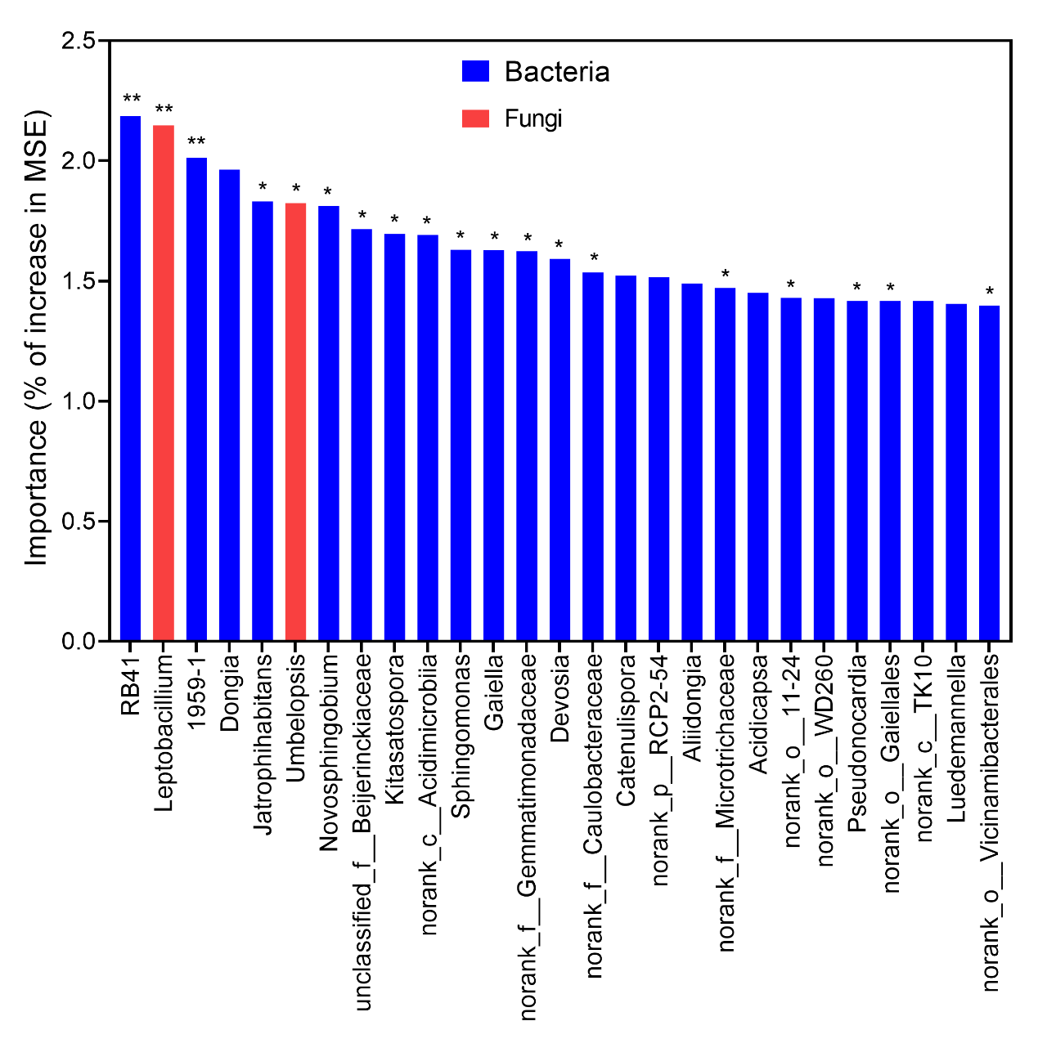
Fig. S2 Random Forest regression model shows the main microbial drivers of HR. MSE, is the mean square error. *P < 0.05, **P < 0.01.

