Supplementary figure 4

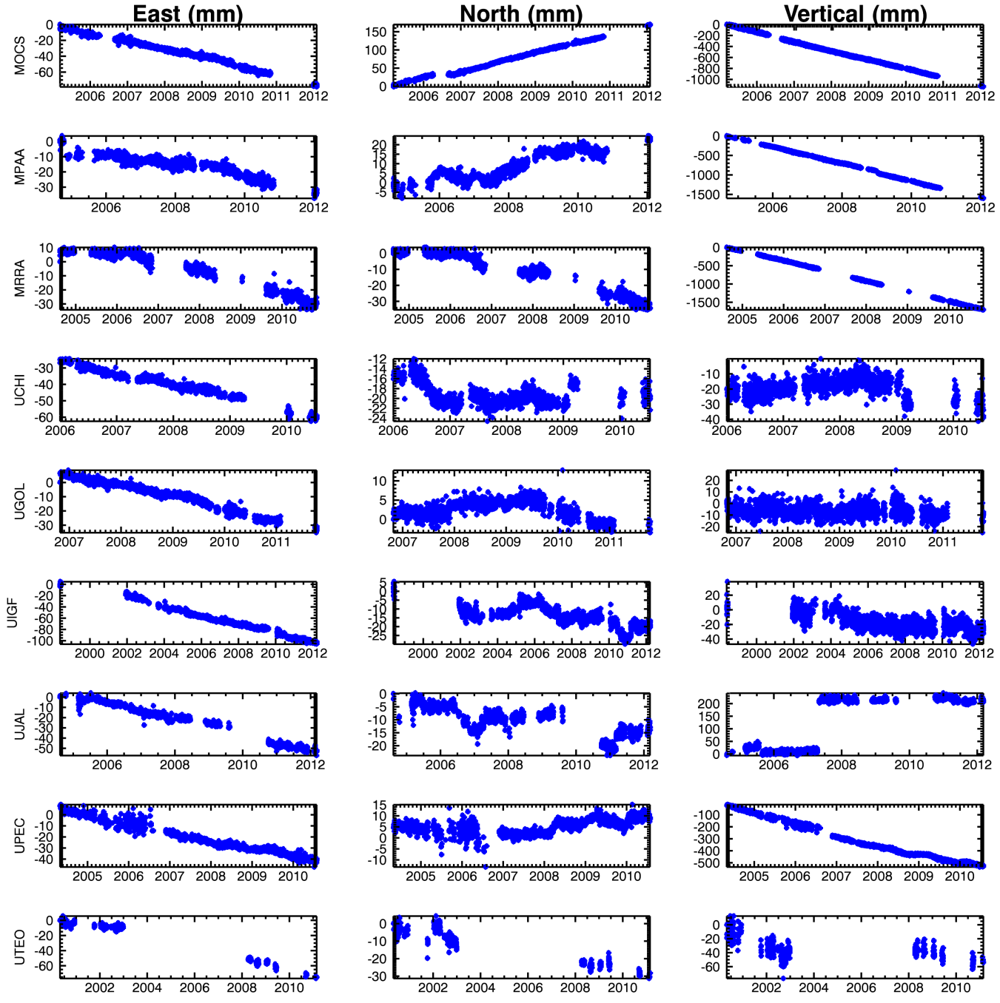

Fig. 4 North, east, and vertical components of motion observed by the permanent GPS stations (blue points) using point positioning and the ITRF-2000 reference frame. GPS rates are provided in Table 1

