Additional file 1

Appendix A
List of the crania of A. olivacea and O. longicaudatus analyzed in this study. All sampled sites were located in the Southern Patagonia of Chile (^{L} = sample used for linear morphometrics; ^{G} = sample used for geometric morphometric)
Abrothrix olivacea
Mainland (34)
Locality Parque Nacional Torres del Paine 51˚07’24” S, 73˚07´47” W (6): NK105657^{(L,G)}, NK105692^{(G)}, NK105693^{(L,G)}, NK105724^{(L,G)}, NK105725^{(L,G)}, NK105744^{(L,G)}.
Locality Parque Nacional Pali Aike 52°4'35.69" S, 69°46'30.39" W (16): NK160093^{(L,G)}, NK160097^{(L,G)}, NK160098^{(L,G)}, NK160102^{(L,G)}, NK160104^{(L,G)}, NK160105^{(L,G)}, NK160108^{(L,G)}, NK160113^{(L,G)}, NK160114^{(L,G)}, NK160115^{(L,G)}, NK160116^{(L,G)}, NK160117^{(L,G)}, NK160118^{(L,G)}, NK160121^{(L,G)}, NK160123^{(L,G)}, NK160180^{(L)}.
Locality Puerto de Hambre 53˚36’09” S, 70˚56’26” W (6): NK129277^{(L,G)}, NK129280^{(L)}, NK129282^{(L,G)}, NK129285^{(L,G)}, NK129331^{(L,G)}, NK129346^{(L)}.
Locality Fuerte Bulnes 53˚37' 42" S, 70˚55´ 19” W (6): NK129310^{(L,G)}, NK129315^{(L,G)}, NK129316^{(L)}, NK129320^{(L,G)}, NK129343^{(L,G)}, NK129348^{(L,G)}.
Island (46)
Locality Isla Wellington 49˚10' 90" S; 74˚12" 70 W (7): NK106018^{(L)}, SSUCMA331^{(L,G)}, SSUCMA332^{(L,G)}, SSUCMA333^{(L,G)}, SSUCMA334^{(L,G)}, SSUCMA335^{(L,G)}, SSUCMA336^{(L,G)}.
Locality Isla Riesco 52˚51’48” S, 71˚32’45” W (12): NK142501^{(L,G)}, NK142502^{(L,G)}, NK142503^{(L,G)}, NK142504^{(L,G)}, NK142505^{(L,G)}, NK142508^{(L,G)}, NK142509^{(L,G)}, NK142510^{(L,G)}, NK142516^{(L,G)}, NK142519^{(L,G)}, NK142521^{(L,G)}, NK142525^{(L,G)}.
Locality Isla Capitán Aracena 54°06'46″ S, 71°17°42″ W (2): NK160084^{(G)}, NK160088^{(G)}.
Locality Isla Tierra del Fuego, Porvenir 53˚27'49" S, 70˚10´52" W (13): NK160159^{(L,G)}, NK160167^{(L,G)}, NK160170^{(L,G)}, NK160175^{(L,G)}, NK160176^{(L,G)}, NK160179^{(L,G)}, NK160180^{(G)}, NK160183^{(L,G)}, NK160187^{(L,G)}, NK160188^{(G)}, NK160193^{(L,G)}, NK160201^{(L,G)}, NK160206^{(L)}.
Locality Isla Tierra del Fuego, Karukinka 54°14'20.69" S, 68°43'17.79" W (12): UCK2043^{(L,G)}, UCK2045^{(L,G)}, UCK2048^{(L,G)}, UCK2053^{(L)}, UCK2055^{(L,G)}, UCK2056^{(L,G)}, UCK2057^{(L,G)}, UCK2058^{(L,G)}, UCK2059^{(L,G)}, UCK2060^{(L,G)}, UCK2061^{(L,G)}, UCK2062^{(L,G)},
Oligoryzomys longicaudatus
Mainland (28)
Locality Parque Nacional Torres del Paine 51˚07’24” S, 73˚07´47” W (14): NK104944^{(L,G)}, NK104977^{(L,G)}, NK105649^{(L,G)}, NK105650^{(L,G)}, NK105659^{(L,G)}, NK105675^{(L,G)}, NK105680^{(L,G)}, NK105683^{(L,G)}, NK105684^{(L,G)}, NK105692^{(L)}, NK105731^{(L,G)}, NK105745^{(L,G)}, NK105747^{(L,G)}, NK105750^{(L,G)},
Locality Reserva Nacional Magallanes 53˚07’59” S, 71˚01’30” W (1): NK129229^{(L,G)}.
Locality Fuerte Bulnes 53˚37'42" S, 70˚55´19” W (11): NK129313^{(L,G)}, NK129337^{(L)}, NK129338^{(L,G)}, NK129339^{(L,G)}, NK129340^{(L,G)}, NK129342^{(L,G)}, NK129351^{(L,G)}, NK129352^{(L,G)}, NK129356^{(L,G)}, NK129357^{(L,G)}, NK129358^{(L,G)}.
Locality Puerto de Hambre 53˚36’09” S, 70˚56’26” W (2): NK129284^{(L,G)}, NK129292^{(L)}.
Island (21)
Locality Isla Wellington 49˚10' 90" S; 74˚12" 70 W (7): NK108810^{(L,G)}, SSUCMA337^{(L,G)}, SSUCMA338^{(L,G)}, SSUCMA339^{(L,G)}. SSUCMA340^{(L,G)}, SSUCMA341^{(L,G)}, SSUCMA342^{(L,G)}.
Locality Parque Nacional Kawésqar 51˚52’06” S, 73˚08´02” W (2): NK108795^{(L,G)}, NK108796^{(L,G)}.
Locality Isla Riesco 52˚51’48” S, 71˚32’45” W (6): NK142512^{(L,G)}, NK142513^{(L,G)}, NK142530^{(L,G)}, UCK2112^{(L,G)}, UCK2114^{(L,G)}, UCK2128^{(L,G)}.
Locality Isla Tierra del Fuego, Porvenir 53˚27'49"S, 70˚10´52" W (2): NK160205^{(L,G)}, UCK2104^{(L,G)}.
Locality Isla Tierra del fuego, Karukinka 54°14'20.69" S, 68°43'17.79" W (1): NK142550^{(L,G)}.
Locality Isla Navarino 54˚57’S, 67˚39´ W (3): AMNH 99993^{(L)}, AMNH 99994^{(L)}, AMNH 126567^{(L)}

Appendix B

Test of Sexual Dimorphism in the crania of A. olivacea and O. longicaudatus by performing a Discriminant Function Analysis implemented in the software MorphoJ v. 1.06d (Klingenberg, 2011), based on geometric morphometric data. Discriminant Function “Sex”; Comparison Female/Male

A. olivacea: N evaluated = 68 (Female 28; Male 40)
T-square = 63,0851; P = 0,3791
True % of classification after cross-validation test: Female 53,57%; Male 50%
O. longicaudatus: N evaluated = 43 (Female 19; Male 24)
T-square = 103,6221; P = 0,6171
True % of classification after cross-validation test: Female 36,84%; Male 45,83%

Table S1. Result of the Procrustes ANOVA, testing the error of digitization (“Error 1”, in the Table). SS (sums of squares), MS (mean squares), d.f. (degrees of freedom), F (F statistic), P (P value).

Effect | SS | MS | d.f. | F | P
Individual | 0,53955657 | 0,0001513483 | 3565 | 6,28 | <0.0001
Side | 0,00993219 | 0,0003972877 | 25 | 16,47 | <0.0001
Ind*Side | 0,06934203 | 0,0000241190 | 2875 | 1,56 | <0.0001
Error 1 | 0,10043979 | 0,0000154618 | 6496

Appendix C

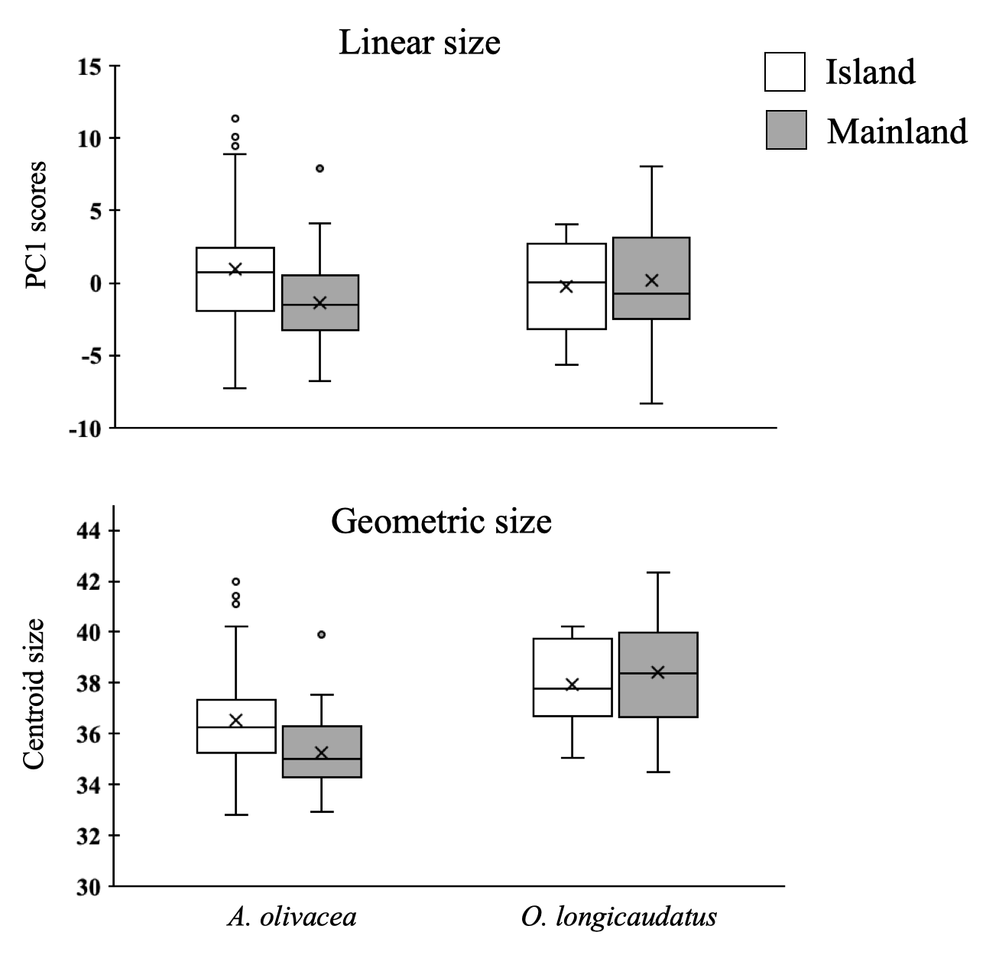
Boxplots of cranial linear and geometric size variation of A. olivacea and O. longicaudatus.

