Genomics Resources for the Rapa Nui (Eastern Island)
spiny lobster Panulirus pascuensis (Crustacea: Decapoda: Achelata)

J. Antonio Baeza^{1,2,3,*} and Stacy Pirro⁴

1 Department of Biological Sciences, Clemson University, Clemson, SC, USA

2 Departamento de Biología Marina, Universidad Catolica del Norte, Coquimbo, Chile

3 Smithsonian Marine Station at Fort Pierce, Smithsonian Institution, Fort Pierce, FL, USA

4 Iridian Genomes, Silver Spring, MD, USA

*corresponding author. Department of Biological Sciences, Clemson University, Clemson, SC, USA. email: baeza.antonio@gmail.com

Supplementary Materials

Fig. S1. Sankey diagram of the Kraken2 report results obtained for Panulirus pascuensis filtered reads before genome size estimation using a k-mer approach.

Table S1. Codon usage analysis in the mitochondrial protein coding genes of Panulirus pascuensis

AmAcid Codon Number /1000 Fraction

Ala GCG 26.00 7.00 0.12
Ala GCA 60.00 16.15 0.29
Ala GCT 76.00 20.45 0.36
Ala GCC 47.00 12.65 0.22

Cys TGT 36.00 9.69 0.73
Cys TGC 13.00 3.50 0.27

Asp GAT 43.00 11.57 0.54
Asp GAC 36.00 9.69 0.46

Glu GAG 36.00 9.69 0.42
Glu GAA 50.00 13.46 0.58

Phe TTT 206.00 55.44 0.66
Phe TTC 105.00 28.26 0.34

Gly GGG 82.00 22.07 0.33
Gly GGA 76.00 20.45 0.30
Gly GGT 57.00 15.34 0.23
Gly GGC 35.00 9.42 0.14

His CAT 39.00 10.50 0.46
His CAC 46.00 12.38 0.54

Ile ATT 204.00 54.90 0.70
Ile ATC 88.00 23.68 0.30

Lys AAG 40.00 10.76 0.43
Lys AAA 52.00 13.99 0.57

Leu TTG 112.00 30.14 0.20
Leu TTA 180.00 48.44 0.32
Leu CTG 55.00 14.80 0.10
Leu CTA 90.00 24.22 0.16
Leu CTT 79.00 21.26 0.14
Leu CTC 50.00 13.46 0.09

Met ATG 74.00 19.91 0.40
Met ATA 113.00 30.41 0.60

Asn AAT 67.00 18.03 0.63
Asn AAC 39.00 10.50 0.37

Pro CCG 28.00 7.53 0.19
Pro CCA 34.00 9.15 0.23
Pro CCT 54.00 14.53 0.36
Pro CCC 33.00 8.88 0.22

Gln CAG 27.00 7.27 0.40
Gln CAA 41.00 11.03 0.60

Arg CGG 12.00 3.23 0.19
Arg CGA 30.00 8.07 0.48
Arg CGT 11.00 2.96 0.18
Arg CGC 9.00 2.42 0.15

Ser AGG 37.00 9.96 0.09
Ser AGA 54.00 14.53 0.13
Ser AGT 19.00 5.11 0.05
Ser AGC 14.00 3.77 0.03
Ser TCG 35.00 9.42 0.09
Ser TCA 75.00 20.18 0.19
Ser TCT 111.00 29.87 0.28
Ser TCC 57.00 15.34 0.14

Thr ACG 12.00 3.23 0.06
Thr ACA 58.00 15.61 0.30
Thr ACT 80.00 21.53 0.41
Thr ACC 45.00 12.11 0.23

Val GTG 43.00 11.57 0.15
Val GTA 83.00 22.34 0.29
Val GTT 113.00 30.41 0.40
Val GTC 43.00 11.57 0.15

Trp TGG 40.00 10.76 0.40
Trp TGA 60.00 16.15 0.60

Tyr TAT 73.00 19.64 0.54
Tyr TAC 61.00 16.42 0.46

End TAG 3.00 0.81 0.25
End TAA 9.00 2.42 0.75

Table S2. Microsatellites in the Control Region of the spiny lobster Panulirus pascuensis detected by the online tool Microsatellite repeats finder.

Position Cycle Repeats Sequence
107 2 4 TTTTTTTT
225 2 4 TATATATA
606 2 5 CCCCCCCCCC
668 2 3 TTTTTT

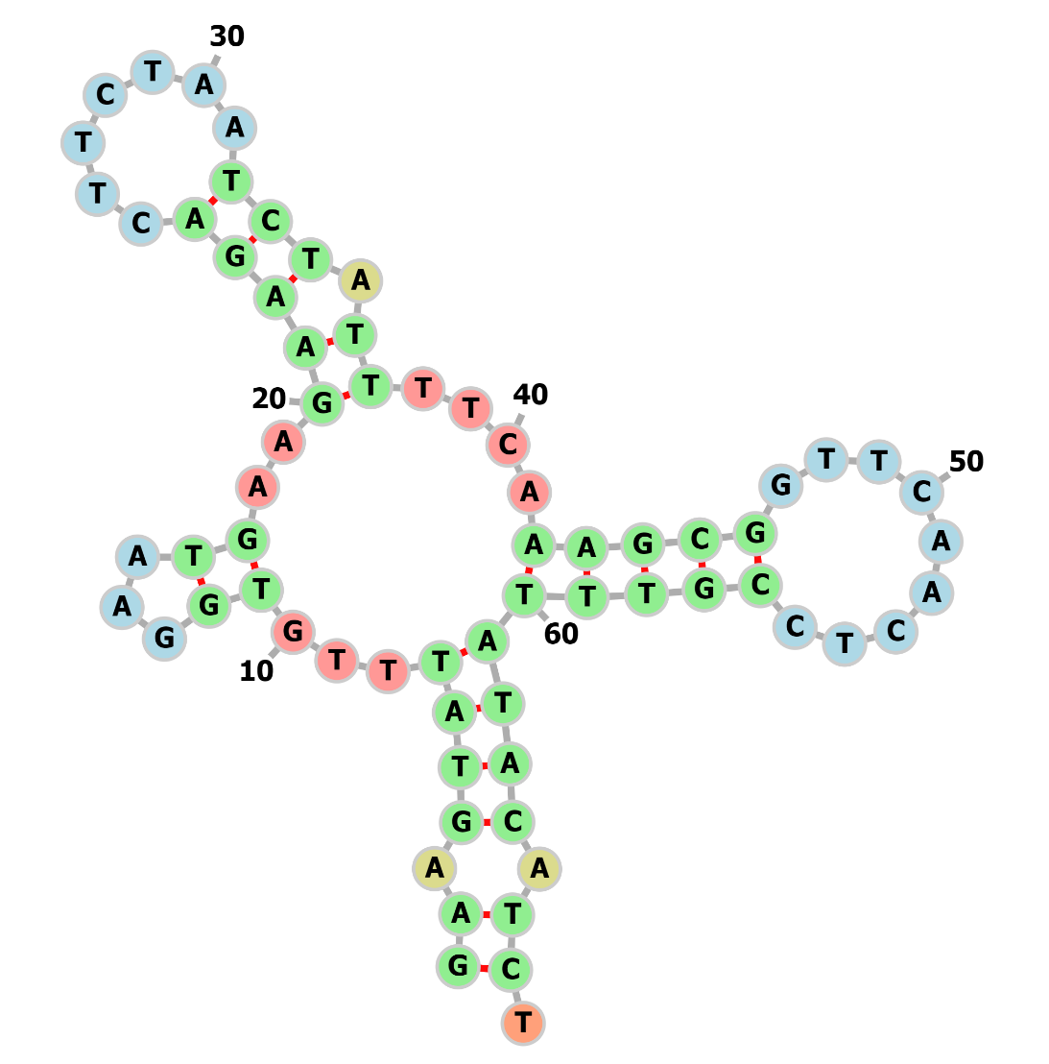
Figure S2. Secondary structure prediction of tRNA-Ser1 gene in the mitochondrial genome of Panulirus pascuensis

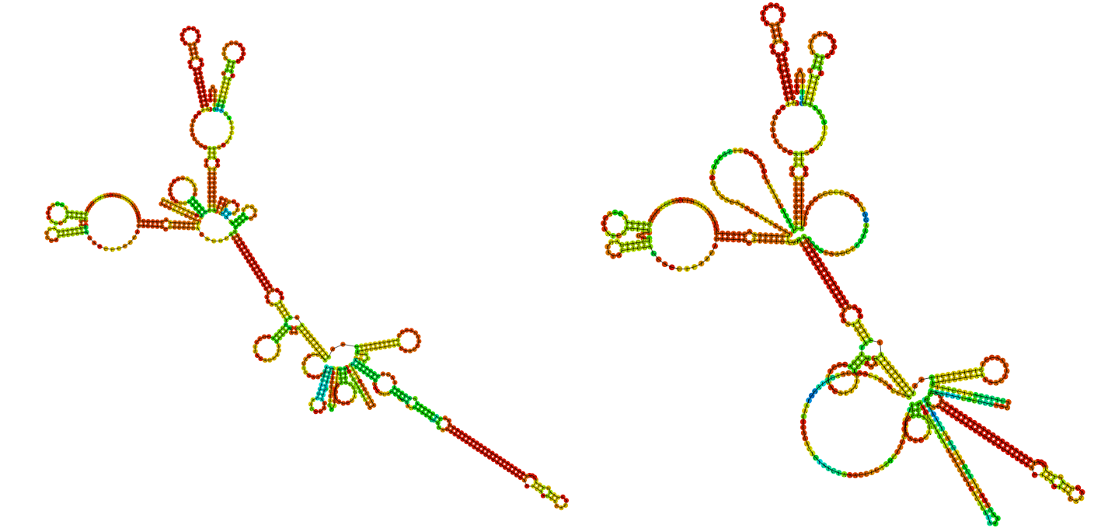

Figure S3. Secondary structure prediction (minimum free energy and Centroid optimization, left and right, respectively) of the control region in the mitochondrial genome of Panulirus pascuensis

