Supplementary Figures

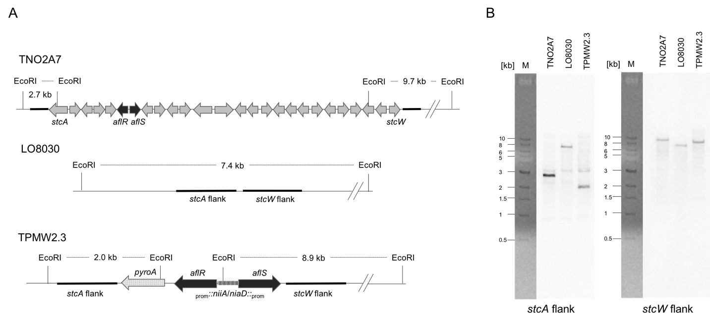
Figure S1 Integration strategy and Southern analysis of TPMW2.3 harboring the nitrate inducible aflR/S genes at the native sterigmatocystin cluster locus in LO8030
- Integration strategy of the niaD/niiA-driven aflR/S construct at the sterigmatocystin cluster locus in LO8030. EcoRI restriction sites are indicated in all strains and flanks used for hybridization are highlighted in bold.
- Southern blot analysis of indicated strains. Restriction digest was carried out with EcoRI and blots were hybridized with indicated flanks shown in panel A.

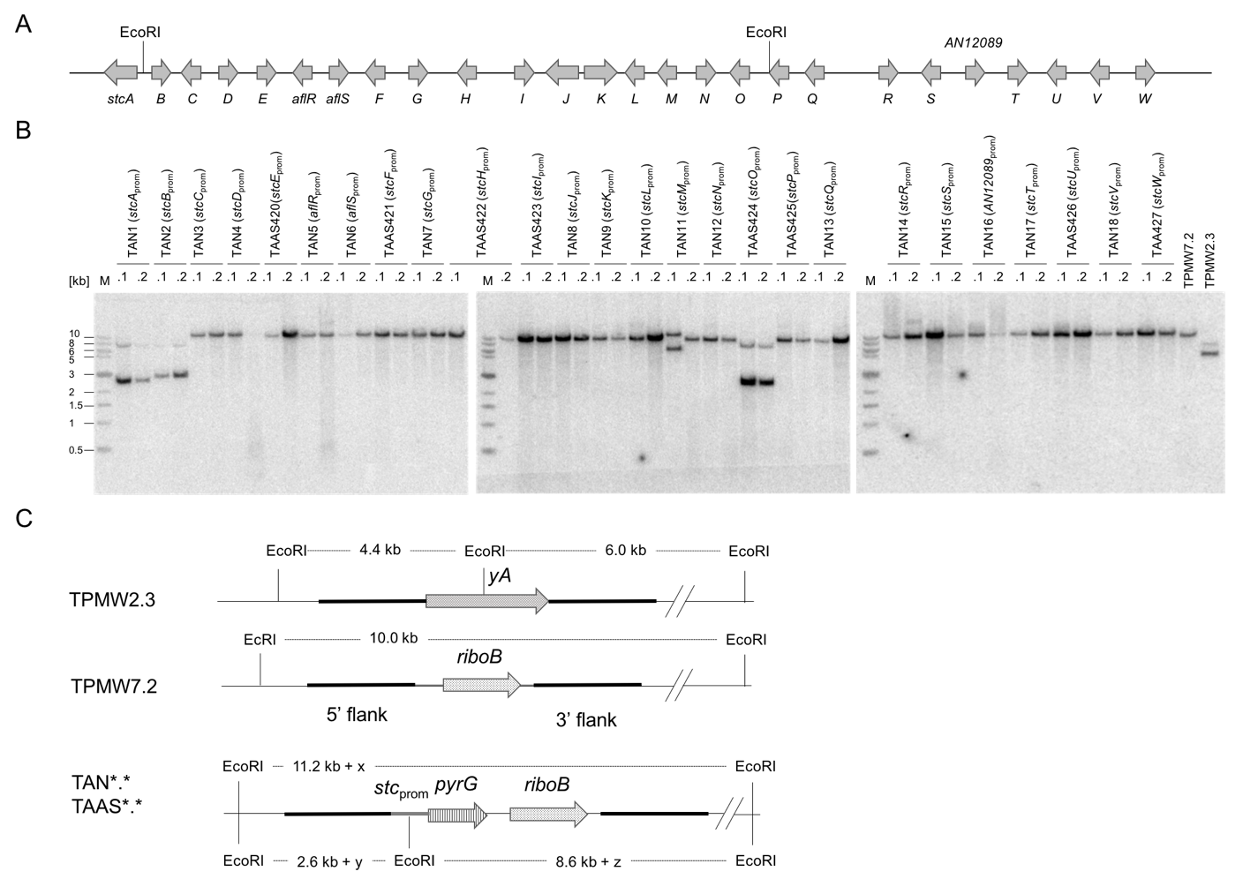Figure S2 Integration strategy and Southern analysis of stc promoter test strains driving pyrG intograted at the yA locus in TPMW2.3
- Schematic overview of EcoRI restriction sites within the sterigmatocystin gene cluster in A. nidulans TNO27A.
- Southern analysis of strains harboring each of the stc promoters in front of pyrG, the recipient strain TPMW2.3. and the control strain TPMW7.2. Restrictions were carried out with EcoRI and blots were hybridized with indicated flanks from panel C.
- Integration strategy of the stc-promoter-driven pyrG construct at the sterigmatocystin cluster locus in TPMW2.3. EcoRI restriction sites are indicated in all strains and flanks used for hybridization are highlighted in bold. Strains TAN1, TAN2, and TAAS424 harbor an additional EcoRI restriction site causing hybridization of two fragments in panel B. Strain TAN11.1 shows an incorrect integration pattern in panel B.

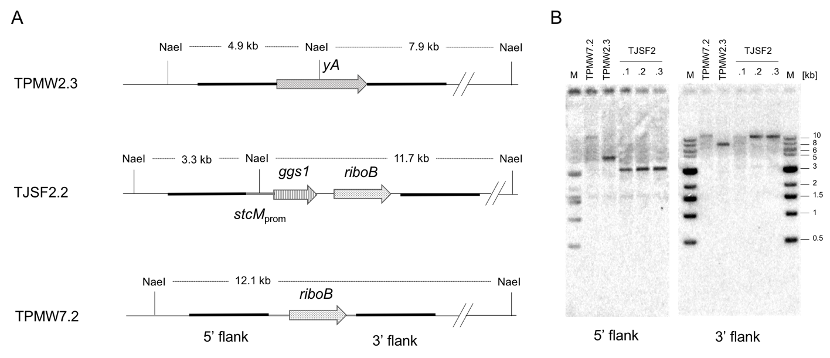
Figure S3 Integration strategy and Southern analysis of the A. nidulans strain TJSF2 harboring the stcM-promoter-driven ggs1 gene from F. fujikuroi at the yA locus in TPMW2.3
- Integration strategy of the stcM-promoter-driven ggs1 gene construct and the control construct at the yA cluster locus in TPMW2.3, respectively. NaeI restriction sites are indicated in all strains and flanks used for hybridization are highlighted in bold.
- Southern blot analysis of indicated strains. Restriction digests were carried out with NaeI and blots were hybridized with indicated flanks shown in panel A.

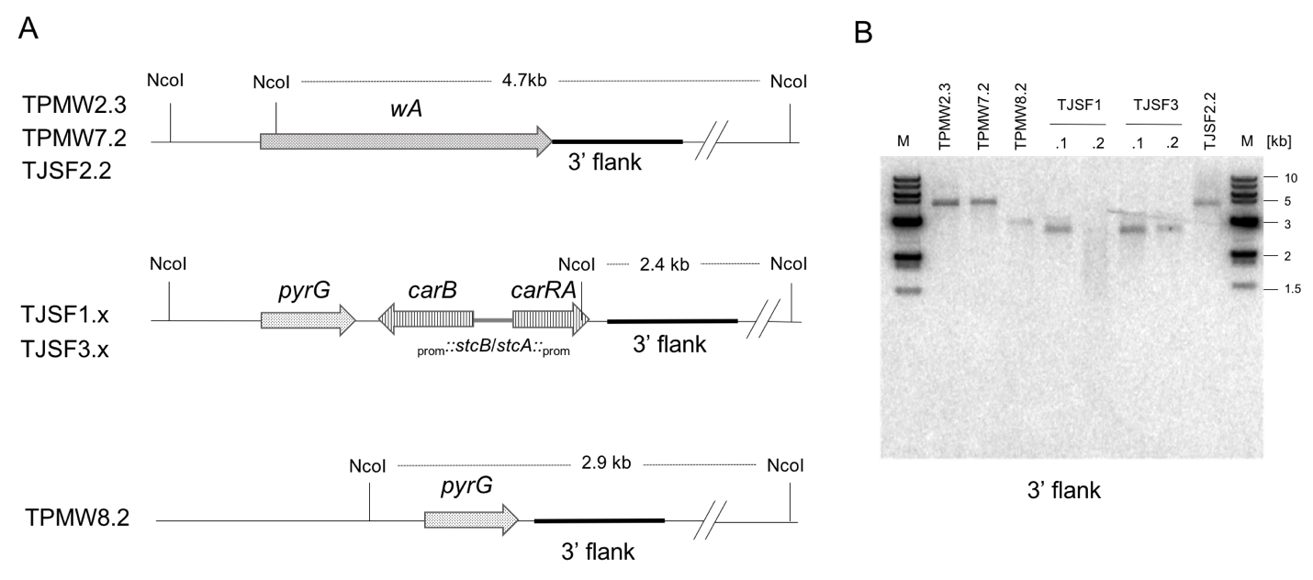
Figure S4 Integration strategy and Southern analysis of the A. nidulans strain TJSF1 and TJSF3 harboring the stcA/B-promoter-driven carRA and carB genes from F. fujikuroi at the wA locus in TPMW7.2 and TJSF2.2
- Integration strategy of the stcA/B-promoter-driven carRA and carB gene construct and the control construct at the wA cluster locus in TPMW7.2 and TJSF2.2, respectively. NcoI restriction sites are indicated in all strains and the flank used for hybridization is highlighted in bold.
- Southern blot analysis of indicated strains. Restriction digest was carried out with NcoI and blots were hybridized with the indicated flank shown in panel A.

