Additional File

Table S1: DNA oligos, crRNA protospacer sequences and A. niger strains used in this work.
 | DNA ID | Sequence | Description
Oligos for MoClo parts | oPEEL-266 | GCATCGTCTCATCGGTCTCACAATCGAGTGCCTTTCTGGACTAT | 5' gaaX flanking seq, 1500 bp FWD
Oligos for MoClo parts | oPEEL-257 | GCATCGTCTCATCGGTCTCACAATATCGACAGCGAGTGAGATAT | 5' gaaX flanking seq, 1000 bp FWD
Oligos for MoClo parts | oPEEL-258 | GCATCGTCTCATCGGTCTCACAATTCAAGATCCTCTCTTCCTTG | 5' gaaX flanking seq, 500 bp FWD
Oligos for MoClo parts | oPEEL-259 | GCATCGTCTCATCGGTCTCACAATGATCTCTTCCTCCGCGATCG | 5' gaaX flanking seq, 100 bp FWD
Oligos for MoClo parts | oPEEL-260 | ATGCCGTCTCAGGTCTCAAGGGCAGTATACTGCTCGTTCTCA | 5' gaaX flanking seq 100-1500, REV
Oligos for MoClo parts | oPEEL-261 | GCATCGTCTCATCGGTCTCAGAGTTGAACTGTATCCACTCCTGG | 3' gaaX flanking seq, 100-1500 bp FWD
Oligos for MoClo parts | oPEEL-262 | ATGCCGTCTCAGGTCTCATCGGCCAGATTCTTGCAGGCGTTG | 3' gaaX flanking seq, 1500 bp REV
Oligos for MoClo parts | oPEEL-263 | ATGCCGTCTCAGGTCTCATCGGTTGCAGGCCTCACAGCTG | 3' gaaX flanking seq, 1000 bp REV
Oligos for MoClo parts | oPEEL-264 | ATGCCGTCTCAGGTCTCATCGGTGCCAGTCAGTAGTCGTCGT | 3' gaaX flanking seq, 500 bp REV
Oligos for MoClo parts | oPEEL-265 | ATGCCGTCTCAGGTCTCATCGGCTGTTGGATCATCACACTGC | 3' gaaX flanking seq, 100 bp REV
Oligos for MoClo parts | oPEEL-290 | GCATCGTCTCATCGGTCTCATACACAGGCTTGTCAGATATGTTC | A. oryzae PyrG to MoClo FWD
Oligos for MoClo parts | oPEEL-291 | ATGCCGTCTCAGGTCTCAACTCAAATGGTGGCTAGGCTCTGA | A. oryzae PyrG to MoClo REV
Oligos for MoClo parts | oPEEL-296 | GCATCGTCTCATCGGTCTCATATGTTGAGCTCCACCATGGCCT | UDH to moclo type 3 FWD
Oligos for MoClo parts | oPEEL-297 | ATGCCGTCTCAGGTCTCAGGATGGTTACTTATCGCCGAAGGG | UDH to moclo type 3 REV
Oligos for MoClo parts | oPEEL-311 | GCATCGTCTCATCGGTCTCACAATACAGCATCCAAGACTCACAT | 5' 39104 flanking seq, 1500 bp FWD
Oligos for MoClo parts | oPEEL-312 | ATGCCGTCTCAGGTCTCAAGGGAAACGCCCTACTATATCGGA | 5' 39104 flanking seq, 1500 bp REV
Oligos for MoClo parts | oPEEL-313 | GCATCGTCTCATCGGTCTCAGAGTGTAGGATTGAACAAGAGTGC | 3' 39104 flanking seq, 1300 bp FWD
Oligos for MoClo parts | oPEEL-314 | ATGCCGTCTCAGGTCTCATCGGTTGGAGTCGAAACCGTCCTC | 3' 39104 flanking seq, 1300 bp REV
Oligos for MoClo parts | oPEEL-322 | GCATCGTCTCATCGGTCTCAAACGTCAAGTGGGAGTTTGTGGAC | gaaB promoter to MoClo Type 2 FWD
Oligos for MoClo parts | oPEEL-324 | ATGCCGTCTCAGGTCTCACATAGGTGTCGGTTGTTTCTGTTC | gaaB promoter to MoClo Type 2 REV
Oligos for MoClo parts | oPEEL-325 | GCATCGTCTCATCGGTCTCACAATGCTATCGAGTTTATCACGGC | 5' gaaA flanking seq, 1500 bp FWD
Oligos for MoClo parts | oPEEL-326 | ATGCCGTCTCAGGTCTCAAGGGAGCCAGCGAACAATCCATTC | 5' gaaA flanking seq, 1500 bp REV
Oligos for MoClo parts | oPEEL-327 | GCATCGTCTCATCGGTCTCAGAGTTAATTGACAGGGGCGAACAA | 3' gaaA flanking seq, 1500 bp FWD
Oligos for MoClo parts | oPEEL-328 | ATGCCGTCTCAGGTCTCATCGGGGATCGAGGTAGGAGAACAC | 3' gaaA flanking seq, 1500 bp REV
Oligos for MoClo parts | oPEEL-352 | GCATCGTCTCATCGGTCTCACAATGGAAGGAGTGCAGAGTCGAG | 5' albA flanking seq, 1000 bp FWD
Oligos for MoClo parts | oPEEL-355 | ATGCCGTCTCAGGTCTCAAGGGGTTGAATTCAGCAGAGCAGC | 5' albA flanking seq, 1000 bp REV
Oligos for MoClo parts | oPEEL-356 | GCATCGTCTCATCGGTCTCAGAGTGTTATGCATTACGCCTTCCT | 3' albA flanking seq, 1000 bp FWD
Oligos for MoClo parts | oPEEL-358 | ATGCCGTCTCAGGTCTCATCGGTCTTTCCCTGTTCATACTAC | 3' albA flanking seq, 1000 bp REV
Oligos for colony PCR | oPEEL-279 | GGTGTCATTATTCGAAGTTC | gaaX deletion, colony PCR 5' region FWD
Oligos for colony PCR | oPEEL-334 | GGCGAAAAAGGTATGGCAGA | gaaX deletion, colony PCR 3' region REV
Oligos for colony PCR | oPEEL-292 | GAACATATCTGACAAGCCTG | Colony PCR, pyrG promoter REV
Oligos for colony PCR | oPEEL-293 | TCAGAGCCTAGCCACCATTT | Colony PCR, pyrG promoter FWD
Oligos for colony PCR | oPEEL-294 | GTTCTGGTCAACACGCATTG | gaaX ORF FWD
Oligos for colony PCR | oPEEL-295 | CATGTTGACCGCTGAGAGGA | gaaX ORF REV
Oligos for colony PCR | oPEEL-333 | CCACAATCTTCTTCTCGACG | gaaB checking protomoter
Oligos for colony PCR | oPEEL-335 | CCTCACCACCGATCTCATTG | gaaA/gaaC deletion 5' region FWD
Oligos for colony PCR | oPEEL-336 | GCTAGGGTGTTGTCCGTAAG | gaaA/gaaC deletion 3' region REV
Oligos for colony PCR | oPEEL-337 | GACCTCCGACAAGAAAGTGG | gaaA ORF FWD
Oligos for colony PCR | oPEEL-338 | TCTTGGGCTGACTCATGTAG | gaaA ORF REV
Oligos for colony PCR | oPEEL-339 | GACCAGAGTTGACGACGATA | 39114 deletion 5' region FWD
Oligos for colony PCR | oPEEL-340 | GGAATCCTCATCCTCATCGT | 39114 deletion 3' region REV
Oligos for colony PCR | oPEEL-341 | TCGGACAGCTCTCAAAGAAC | 39114 ORF FWD
Oligos for colony PCR | oPEEL-342 | AAGAGTTCTGTGCGAGTTGG | 39114 ORF REV
Oligos for qPCR | oPEEL-373 | CCGTCACCATGGGTAAAGCT | reference gene actin version 1 FWD
Oligos for qPCR | oPEEL-374 | TGGGGTATCTGAGGGTGAGG | reference gene actin version 1 REV
Oligos for qPCR | oPEEL-375 | CCCTCTGGCGCTTATGGAAA | reference gene actin version 2 FWD
Oligos for qPCR | oPEEL-376 | GCACAGCGGATATGAGGAGG | reference gene actin version 2 REV
Oligos for qPCR | oPEEL-377 | CATGATGTCCACCTGGCTGT | target gene UDH version 1 FWD
Oligos for qPCR | oPEEL-378 | AATCCTTGGGGGCGTAATCG | target gene UDH version 1 REV
Oligos for qPCR | oPEEL-379 | GGAAGTCCAGGTCTGCGATC | target gene UDH version 2 FWD
Oligos for qPCR | oPEEL-380 | CGGCCTCGTAGATGTGGAAC | target gene UDH version 2 REV
 | crRNA ID | crRNA protospacer sequence | Target gene
Protospacer  sequences | gERA-001 | GTGGAAGTGGACGTCGCCAG | gaaX
Protospacer  sequences | gERA-002 | GGTGATTGGCGGGTGAACGG | gaaX
Protospacer  sequences | gERA-009 | GCGTAAACCTCTTCAATCAG | gaaA-gaaC
Protospacer  sequences | gERA-010 | GGCTTCTCCGGACTGCACAG | gaaA-gaaC
Protospacer  sequences | gERA-015 | CTGAGTACGAAGGGAAACGA | 39114
Protospacer  sequences | gERA-016 | AAACTGACCGAGAGAAACCA | 39114
Protospacer  sequences | gERA-017 | AGTGGGATCTCAAGAACTAC | albA
 |  | Strain name / genotype | Description
A. niger strains |  | ∆pyrG | Pyrimidine-deficient A. niger ATCC105
A. niger strains |  | M1767 / ΔgaaA-Δ39114-UDH | Previously described galactarate producing strain, disrupted  galacturonate reductase, gaaA, and the galactarate catabolism gene, 39114, introduced bacterial uronate dehydrogenase, UDH under gpdA promoter.
A. niger strains |  | ΔgaaA-ΔgaaC_{0-264bp}-UDH | Strain generated in this study using single-taget CRISPR/Cas9,  disrupted galacturonate reductase, gaaA, and  2‐keto‐3‐deoxy‐L‐galactonate aldolase, gaaC, introduced  bacterial uronate dehydrogenase, UDH, under gaaB promoter.
A. niger strains |  | ΔgaaA-ΔgaaC_{0-264bp}-Δ39114-UDH | Strain generated in this study using two-taget CRISPR,  disrupted galacturonate reductase, gaaA, 2‐keto‐3‐deoxy‐L‐galactonate aldolase, gaaC,  and galactarate catabolism gene 39114, introduced  bacterial uronate dehydrogenase, UDH, under gaaB promoter.
A. niger strains |  | ΔgaaA-ΔgaaC_{0-264bp}-Δ39114-ΔgaaX-UDH | Strain generated in this study using three-taget CRISPR,  disrupted galacturonate reductase, gaaA, 2‐keto‐3‐deoxy‐L‐galactonate aldolase, gaaC, the galactarate catabolism gene 39114, and the regulatory protein gaaX,  introduced bacterial uronate dehydrogenase, UDH, under gaaB promoter.

Figure S1: Transformation plates of gaaX deletion in A. niger using 1 µg of donor DNA, different concentrations of RNP complex and 10⁵ or 10⁶ protoplasts per transformation.
Figure S2: Stock solutions and dilutions of Cas9, crRNA and tracrRNA for RNP complex preparation and in transformation.
Figure S3: Agarose gel pictures of colony PCR reactions detecting replacement of gaaX with the deletion cassette. Junctions between the donor DNAs and double-strand brakes at the 5’ (5’ junctions, oPEEL-279/-292) and 3’ (3’ junctions, oPEEL-293/-334) ends were analysed. In addition, the absence of gaaX open reading frame was confirmed (ORF, oPEEL-294/-295).
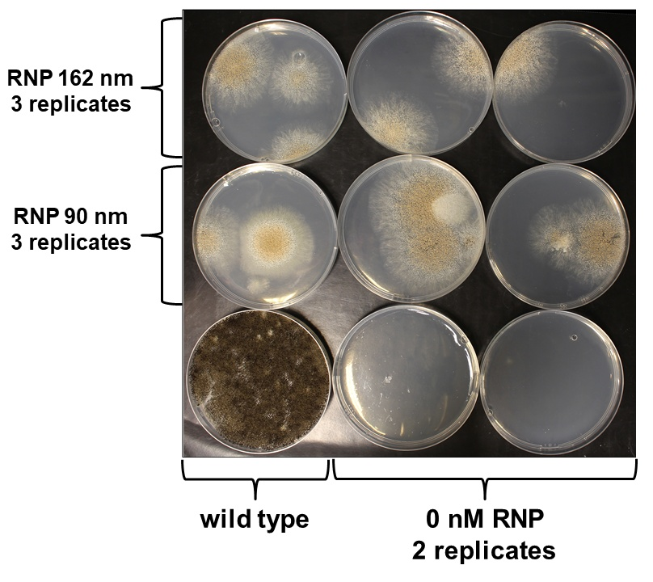
Figure S4: Transformation plates of albA deletion in A. niger using 162, 90 or 0 mM RNP complex, 1 µg of donor DNA with 1000 bp flanking sequences (also with 0 nM RNP) and 10⁵ protoplasts per transformation. Correct deletion of albA results in disruption of conidia pigment formation.
Figure S5: The pipetting workflow with the liquid handling robot. Circles represent microtiter plate wells and rounded rectangles reservoir plates.
Figure S6: Transformation plates resulting from liquid handling robot facilitated transformation reactions for gaaX deletion in A. niger using 1 µg of donor DNA with 1500 bp flanking sequences, different concentrations of RNP complex and 10⁵ protoplasts per transformation.

Figure S7: CRISPR/Cas9 transformation plates of engineered A. niger strains for galactarate production. Single (in ΔgaaA-ΔgaaC_{0-264bp}-UDH strain), two (in ΔgaaA-ΔgaaC_{0-264bp}-Δ39114-UDH strain) or three (in ΔgaaA-ΔgaaC_{0-264bp}-Δ39114-ΔgaaX-UDH strain) genomic targets were replaced with the UDH expression cassette. The RNP complex concentration of 90 nM and 1 µg of donor DNA with 1500 bp flanking sequences were used for each of the genomic targets. The protoplast concentration 10⁵ per transformation was used in all of the transformations. gERA numbers (sequences presented in Additional File: Table S1) represent different crRNA combinations used in the RNPs. When two different crRNAs for a single genomic target was used (gERA: 15+9+16+10 and gERA: 15+9+1+16+10+2), the concentration of each of the RNPs was 45 nM.

Figure S8: Agarose gel pictures of colony PCR reactions detecting replacement of gaaA-gaaC and 39114 with the UDH expression cassette in the multiplexed CRISPR/Cas9 transformations for two target loci. Junctions between the donor DNAs and double-strand brakes at the 5’ (5’ junctions, at gaaA-gaaC oPEEL-335/-333, at 39114 oPEEL-339/-333) and 3’ (3’ junctions, at gaaA-gaaC oPEEL-293/-336, at 39114 oPEEL-293/-340) ends were analysed.
Figure S9: Agarose gel pictures of colony PCR reactions detecting replacement of gaaA-gaaC 39114 and gaaX with the UDH expression cassette in the multiplexed CRISPR/Cas9 transformations for three target loci. Junctions between the donor DNAs and double-strand brakes at the 5’ (5’ junctions, at gaaA-gaaC oPEEL-335/-333, at 39114 oPEEL-339/-333, at gaaX oPEEL-279/-333) and 3’ (3’ junctions, at gaaA-gaaC oPEEL-293/-336, at 39114 oPEEL-293/-340, at gaaX oPEEL-293/-334) ends were analysed.
Figure S10: Genomic DNA sequence analysis of the genomic junctions between the flanking sequences in the donor DNA cassettes and target loci in the engineered A. niger strains after multiplexed CRISPR/Cas9 genome editing.

Figure S11: qPCR genomic copy number analysis of the UDH cassettes in the strains ΔgaaA-ΔgaaC_{0-264bp} -UDH (yellow, number 1), ΔgaaA-ΔgaaC_{0-264bp}-Δ39114 -UDH (orange, number 2) and ΔgaaA-ΔgaaC_{0-264bp}-Δ39114-ΔgaaX-UDH (blue, number 3). Oligos oPEEL-373-380 were used in the analysis. Values represent the means of 24 technical replicates ± standard deviation.

