Supplementary materials
Extrusion-based additive manufacturing of fungal-based composite materials using the tinder fungus Fomes fomentarius

Huaiyou Chenª, Amanmyrat Abdullayevª, Maged F. Bekheetª, Bertram Schmidt^{b}, Isabel Regler^{b}, Carsten Pohl^{b}, Cekdar Vakifahmetoglu^{c}, Mathias Czasnyª, Paul H. Kamm^{d}, Vera Meyer^{b}, Aleksander Gurloª, Ulla Simon^{a,}*

ª Technische Universität Berlin, Faculty III Process Sciences, Institute of Material Science and Technology, Chair of Advanced Ceramic Materials, Straße des 17. Juni 135, 10623 Berlin, Germany
^{b} Technische Universität Berlin, Faculty III Process Sciences, Institute of Biotechnology, Chair of Applied and Molecular Microbiology, Straße des 17. Juni 135, 10623 Berlin, Germany
^{c} Department of Materials Science and Engineering, Izmir Institute of Technology, 35430, Urla, Izmir, Turkey
^{d} Helmholtz-Zentrum Berlin für Materialien und Energie, Institute of Applied Materials, Hahn-Meitner-Platz 1, 14109 Berlin, Germany
* Corresponding author. Contact details: ulla.simon@ceramics.tu-berlin.de

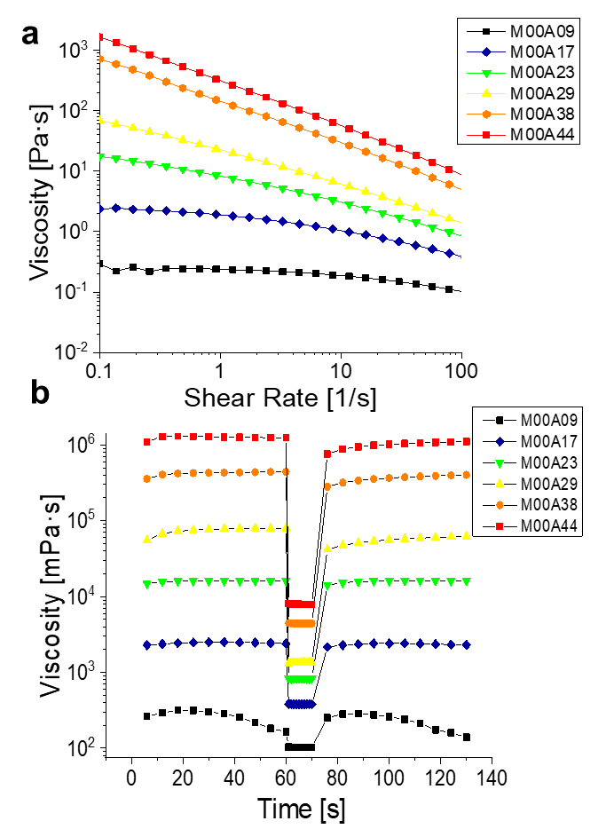
Figure S1 Rheological properties of pure alginate gel pastes: a) results of the flow tests and b) results of the three-step flow recovery tests.

