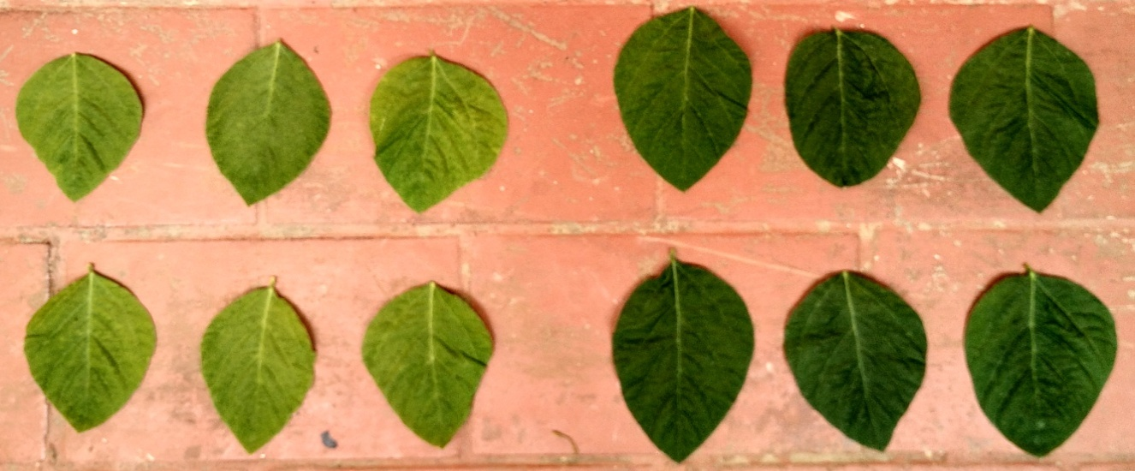
Irrigated un-inoculated control Irrigated inoculated control

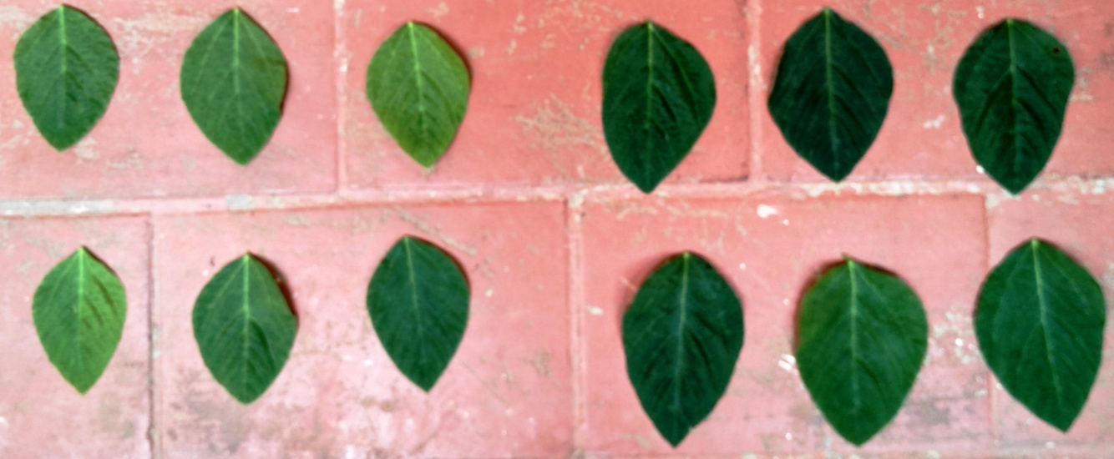
Un-inoculated stress Inoculated stress

Additional file 3: Fig. S3: Comparison of leaf growth in soybean cultivar, MAUS 2 inoculated with Ambispora leptoticha + Bradyrhizobium liaoningense grown under irrigated and moisture stressed field conditions.

