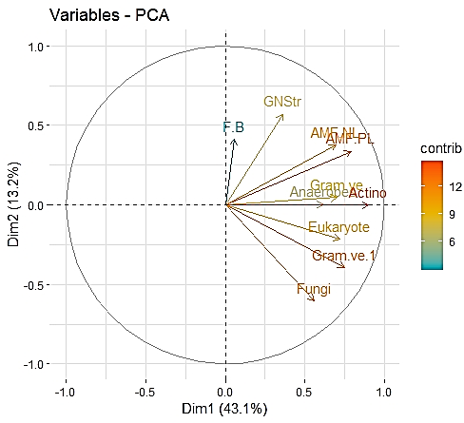
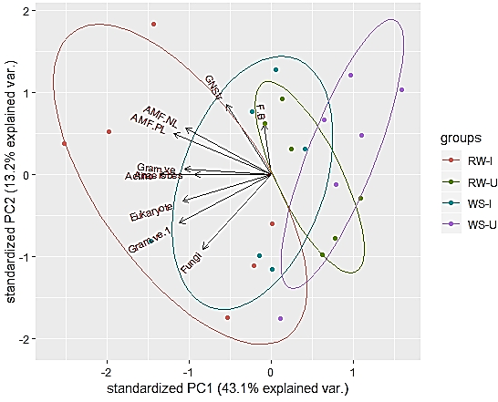
a
b
UI
I
UIS
IS

Additional file 7: Fig. S4: a) Principal Component analysis of the PLFA biomarkers from the rhizosphere soils of soybean cultivar, MAUS 2 inoculated with Ambispora leptoticha + Bradyrhizobium liaoningense. b) PLFA variables subjected to redundancy analysis by PCA. [10 PLFA biomarkers (including 2 ratios) were selected for the PCA model where axis labels indicate variables that were strong negative or positive factors on each axis (biomarker- Fungi, Gram –ve, Eukaryote contributed negatively]; UI= Un-inoculated; I= Inoculated; UIS= Un-inoculated stress; IS= Inoculated stress

