Additional Files Additional Table 1. Forward and reverse primers used for qPCR analysis of six transcripts from T. versicolor after three weeks of growth on LSX, LSHG, HS, and WT hybrid poplar.
Transcript | Transcript Number¹ | Forward Primer (5’-3’) | Reverse Primer (5’-3’) | Amplicon (bp)
EBG | 34218 | TCCAGTGCCACTTCATCGTC | CGGATGTCGAGTTCCGTGAT | 106
P450 | 130124 | TCGCTCCTGAACGGTTTCTC | GGACATATACGGCGAGCGAA | 91
GH5 | 164424 | GGGGATGGGTCGACGATTAC | CGTGCACTGTTGTTGTACGG | 110
GH92 | 116603 | CCGCGAGCTACTACTCTGTG | CGAACGTGAATCGAAGGTGC | 102
UROD | 60497 | AAGCTCCGGCAACTTATGCT | ACTGACGAGCAAGTCCGAAG | 114
PGK | 146564 | GACTACTTCGCCAAGGCTCT | AGCGAGTTGACCTTGTCCAG | 119

¹ From Trametes versicolor v1.0 (Trave1) datasets provided by the Joint Genome Institute (40)

Additional Figure 1. Populus tremula × alba (INRA 717-1B4) wood of an individual stem after 12 months of field growth from WT (a) or transgenic lines LSX-1 (b), LSX-2 (c), LSHG-1 (d), LSHG-2 (e), HS-1 (f), and HS-2 (g).

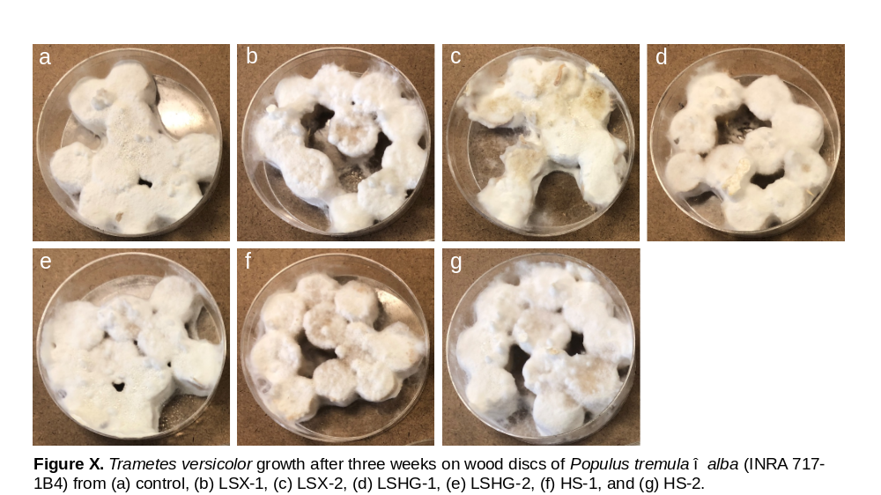 Additional Figure 2. Trametes versicolor growth after three weeks on wood discs of Populus tremula × alba (INRA 717-1B4) from (a) WT, (b) LSX-1, (c) LSX-2, (d) LSHG-1, (e) LSHG-2, (f) HS-1, and (g) HS-2.

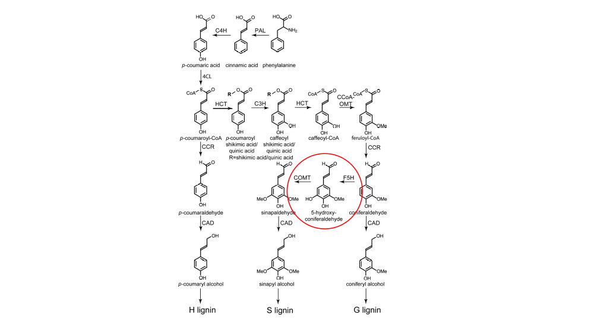
Additional Figure 3. Biosynthetic pathways for lignin moieties in plants (42). The hydroxy-G derivative (red circle) featured in the LSX lines is result of the downregulation of caffeic acid-O-methyltransferase activity (COMT) using RNAi technology.

