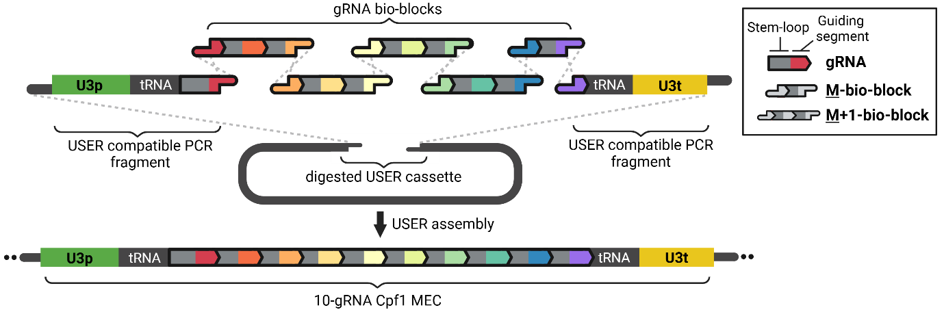
Figure S1: Schematic for the USER assembly of a 10-gRNA Cpf1 multiplex vector. The gRNA multiplex expression cassette (MEC) is assembled into a linearized Cpf1 cloning vector from two USER compatible PCR fragments, four M+1-bio-blocks, and one M-bio-block in a one-step USER reaction. Graphics legend is presented in the box.

