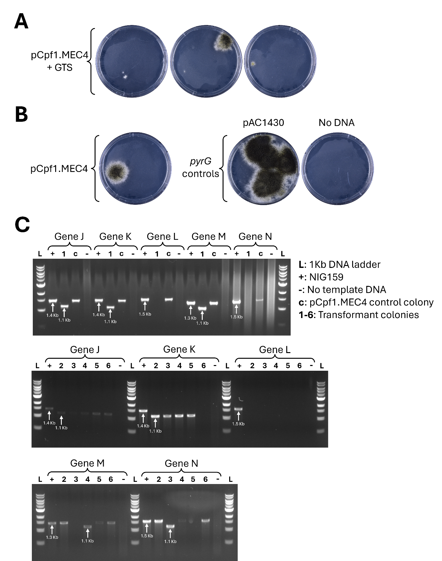
Figure S3: Five-target Cpf1 multiplex gene deletion in A. niger. A Co-transformation with five-target Cpf1 multiplex vector (pCpf1.MEC4) and appropriate gene targeting substrate (GTS) molecules. B Transformation without GTS. C Genotyping of transformants with diagnostic PCR. Target gene of the amplified locus is indicated above each gel with brackets and PCR sample keys are indicated top right. PCR reactions using reference strain (NIG159) DNA as template are included as positive controls, and PCR reactions without template DNA are included as negative controls (-). Each primer set anneals outside of the region homologous with the GTS used for transformation, and intended deletions are approximately 300 bps. Whenever possible, expected sizes for wild-type and deletion amplicons are indicated with a white arrow.

