Additional files

Table S1: List of all inputs from various categories available after processing the data obtained from the applied behavioral analysis (ABA) patient intake forms. The table also indicates in bold font certain features that were derived from a combination of input features obtained from the ABA patient intake forms.

Input Categories | Input Features
Demographics | Age
Demographics | Sex
Demographics | Is the patient multilingual?
Demographics | Is English the primary language?
Demographics | Child’s parents have a divorce decree
Schooling | Attends School?
Schooling | Grade (If attends school)
Schooling | Is the child in a general education classroom?
Schooling | Child has individualized education plan (IEP) or admission, review, and dismissal (ARD)
Schooling | Child received additional services as part of IEP/ARD
Schooling | Child has a school aide/support during school hours
Parent’s Medical History | Mother or Father has history/presence of depression or manic-depression
Parent’s Medical History | Mother or Father has history/presence of autism spectrum disorder (ASD)
Parent’s Medical History | Mother or Father has history/presence of substance abuse or dependence
Parent’s Medical History | Mother or Father has history/presence of anxiety disorders (OCD, phobias, etc.)
Parent’s Medical History | Mother or Father has history/presence psychosis/schizophrenia
Parent’s Medical History | Mother or Father has history/presence of learning disability
Parent’s Medical History | Mother or Father has history/presence of attention deficit hyperactivity disorder (ADHD)
Seizure | Child has had seizures in the past?
Seizure | Is a seizure plan in place for the child?
Treatment/Therapy | Child has current ABA treatment
Treatment/Therapy | Child has had any ABA treatment(current or past)
Treatment/Therapy | Child has received prior ABA treatment
Treatment/Therapy | Amount of prior ABA treatment(hours of treatment per week)
Treatment/Therapy | Amount of prior ABA treatment(years)
Treatment/Therapy | History of Physical Therapy: Has the patient ever received Physical Therapy?
Treatment/Therapy | History of Occupational Therapy: Has the patient ever received Occupational Therapy?
Treatment/Therapy | History of Speech Therapy: Has the patient ever received Speech Therapy?
Treatment/Therapy | History of Other Therapy: Has the patient ever received any other Therapy?
Behavioral and Skill Related Inputs | Behavioral Assessment
Behavioral and Skill Related Inputs | Does the child display aggression?
Behavioral and Skill Related Inputs | How frequently does the child exhibit aggression?
Behavioral and Skill Related Inputs | How severe is the child's aggressive behavior?
Behavioral and Skill Related Inputs | Does the child engage in self-injury?
Behavioral and Skill Related Inputs | How frequently does the child engage in self-injury?
Behavioral and Skill Related Inputs | Does the child engage in stereotypy?
Behavioral and Skill Related Inputs | How frequently does the child exhibit stereotypy?
Behavioral and Skill Related Inputs | Does the child destroy property?
Behavioral and Skill Related Inputs | How frequently does the child destroy property?
Behavioral and Skill Related Inputs | Aggression Score: Level of the patient’s engagement in aggressive behavior derived from the frequency and severity of aggression
Behavioral and Skill Related Inputs | Stereotypy Score: Level of the patient’s engagement in Stereotypical repetitive behavior derived from the frequency and severity of stereotypy behavior
Behavioral and Skill Related Inputs | Self Injury Score: Level of the patient’s engagement in self injury derived from the frequency and severity of the patient’s engagement in self injury
Behavioral and Skill Related Inputs | Destroy Property Score: Level of the patient’s engagement in destroying property derived from the frequency and severity of the patient’s engagement in destroying property
Behavioral and Skill Related Inputs | Child is described as easy-going or "go with the flow"
Behavioral and Skill Related Inputs | Child is described as anxious or easily upset by abnormal things
Behavioral and Skill Related Inputs | Does the child usually follow simple directions in the home setting?
Consequences for Misbehavior | Consequence for misbehavior is to ignore behavior
Consequences for Misbehavior | Consequence for misbehavior is to verbally reprimand child
Consequences for Misbehavior | Consequence for misbehavior is to redirect child to another activity
Consequences for Misbehavior | Consequence for misbehavior is to negotiate/reason with child
Consequences for Misbehavior | Consequence for misbehavior is to threaten to remove privileges
Consequences for Misbehavior | Consequence for misbehavior is to actually remove privileges
Consequences for Misbehavior | Consequence for misbehavior is to spank child
Consequences for Misbehavior | Consequence for misbehavior is to give child a time-out
Consequences for Misbehavior | Consequence for misbehavior is to send child to room
Consequences for Misbehavior | Consequences Count - How many of the 'consequences for misbehavior' options were checked off
Communication Skills | Communication Ability - child communicates vocally (with words/sentences, asks questions, etc.)
Communication Skills | Communication Ability - child communications through gestures and physical touch
Communication Skills | Communication Ability - child communicates with devices or through pictures
Communication Skills | Primary Communication Method - verbal
Communication Skills | Primary Communication Method - gestures
Communication Skills | Primary Communication Method - behaviors
Communication Skills | Primary Communication Method - grabbing
Communication Skills | Primary Communication Method - pictures
Communication Skills | Primary Communication Method - devices
Communication Skills | Primary Communication Method - pointing
Communication Skills | Primary Communication Method - guiding
Communication Skills | Primary Communication Method - sign language
Communication Skills | Child had speech abilities which were lost
Communication Skills | Was there illness at the time of the child losing the ability to speak?
Communication Skills | Understanding - parent can usually understand child
Communication Skills | Understanding - strangers can usually understand child
Communication Skills | Understanding - child can hold a conversation about their favorite topic
Communication Skills | Listening - Child can follow vocal instructions without cues
Communication Skills | Listening - Level of child's understanding of parents
Feeding and Drinking Habits | Child can feed themselves with a spoon or fork (independently)
Feeding and Drinking Habits | Child can feed themselves finger foods (independently)
Feeding and Drinking Habits | Child needs some or significant help eating with utensils
Feeding and Drinking Habits | Child needs assistance for both finger feeding and using utensils
Feeding and Drinking Habits | Child eats most foods
Feeding and Drinking Habits | Child is a picky eater
Feeding and Drinking Habits | Child refuses some foods
Feeding and Drinking Habits | Child loves some foods
Feeding and Drinking Habits | Child has food allergies
Feeding and Drinking Habits | Child has food sensitivities
Feeding and Drinking Habits | Child requires a special diet
Feeding and Drinking Habits | Child has issues with certain food textures
Feeding and Drinking Habits | Child's family eats together
Feeding and Drinking Habits | Child is currently or has previously seen a feeding specialist
Feeding and Drinking Habits | Child can drink from a glass
Feeding and Drinking Habits | Child can drink from a sippy cup
Feeding and Drinking Habits | Child can drink from a bottle
Feeding and Drinking Habits | Child can drink with a straw
Feeding and Drinking Habits | Food Choice Score: Score indicating food choice behaviors
Feeding and Drinking Habits | Drinking Ability Score: Score indicating drinking skills
Toileting and Bathing Skills | Child can use the toilet independently
Toileting and Bathing Skills | Child requires parent assistance for toileting
Toileting and Bathing Skills | Child can use the toilet during the daytime
Toileting and Bathing Skills | Child has some toilet accidents
Toileting and Bathing Skills | Child is solely bladder trained
Toileting and Bathing Skills | Child wears a diaper or pull-up at night
Toileting and Bathing Skills | Child has difficulty with constipation
Toileting and Bathing Skills | Child has difficulty with diarrhea
Toileting and Bathing Skills | Child is not potty trained
Toileting and Bathing Skills | Child's ability to dress themselves
Toileting and Bathing Skills | Child's ability to undress themselves
Toileting and Bathing Skills | Child prefers bathing
Toileting and Bathing Skills | Child prefers showers
Toileting and Bathing Skills | Bathing Ability - Ability of patients to bathe themselves
Toileting and Bathing Skills | Toileting Independence Score: Score indicating independence in toileting skills
Stim/RRB | Stim/RRB - engages in hand-flapping
Stim/RRB | Stim/RRB - engages in toe-walking
Stim/RRB | Stim/RRB - rocks torso/upper body
Stim/RRB | Stim/RRB - lines up toys
Stim/RRB | Stim/RRB - looks at things out of corner of eye or indirectly
Stim/RRB | Stim/RRB - smells odd items one would not typically smell
Stim/RRB | Stim/RRB - eats or places inedible items in mouth
Stim/RRB | Stim/RRB - repeats the same lines from movies or videos
Stim/RRB | Stim/RRB - insist on things being done the same way every time
Stim/RRB | Stim/RRB - tries to direct actions of parents or others in home
Stim/RRB | Stim/RRB - gets upset at interruptions or changes in routine
Stim/RRB | Stim/RRB - is unusually attached to toys or objects
Stim/RRB | Stim/RRB - insists on carrying objects around
Stim/RRB | Stim/RRB - difficulty leaving objects at home
Stim/RRB | Stim/RRB - engages in repetitive activities which may be odd
Stim/RRB | Stim/RRB Count: Count of Stim/RRB options checked for a patient
Social Skills | Social Skills - child has friends
Social Skills | Social Skills - child wants to have friends
Social Skills | Social Skills - tends to gravitate towards older children
Social Skills | Social Skills - prefers playing alone
Social Skills | Social Skills - has difficulty playing with other children
Social Skills | Social Skills - has age appropriate toy play skills
Social Skills | Social Skills - exhibits odd behaviors when with other children
Social Skills | Social Skills - plays any group sports
Social Skills | Social Skills - belongs to any clubs or organizations
Social Skills | Social Skills - has been removed from a social setting due to behavior
Social Skills | Social Skills - shows affection to parent and/or other family
Social Skills | Social Skills - notices when parent is upset or hurt
Social Skills | Social Skills - makes eye contact with others
Social Skills | Social Skills - looks at parent when his/her name is called
Social Skills | Social Skills - utilizes eyes to gain parents' attention
Social Skills | Social Skills - responds to his/her name being called
Social Skills | Social Skills - seeks comfort from parent when upset
Social Skills | Social Skills - greets parent or other family members when they enter house/room
Social Skills | Social Skills - interested in activities of other family members
Social Skills | Social Skills - attempts to join in activities or plays of others
Social Skills | Social Skills - asks parents to join his/her play
Social Skills | Social Skills - responds better to some people vs. others
Social Skills | Social Count: Score indicating social skills
Sleep and Wake Patterns: | Sleep and Wake Patterns - Is a good sleeper?
Sleep and Wake Patterns: | Sleep and Wake Patterns - Wake up at night?
Sleep and Wake Patterns: | Sleep and Wake Patterns - Sleeps through the night?
Sleep and Wake Patterns: | Sleep and Wake Patterns - Appears rested in the morning?
Sleep and Wake Patterns: | Sleep and Wake Patterns - Has a bedtime routine?
Sleep and Wake Patterns: | Sleep and Wake Patterns - Has a regular bedtime?
Sleep and Wake Patterns: | Sleep and Wake Patterns - Wakes up at the same time?
Sleep and Wake Patterns: | Sleep and Wake Patterns - Takes medication for sleep?
Expected Parent Goals | Expected Parent Goals - improve communication skills
Expected Parent Goals | Expected Parent Goals - improve social skills
Expected Parent Goals | Expected Parent Goals - improve ability to participate in family activities
Expected Parent Goals | Expected Parent Goals - decrease challenging behaviors
Expected Parent Goals | Expected Parent Goals - get along better with parents and/or siblings
Expected Parent Goals | Expected Parent Goals - learn toilet training
Expected Parent Goals | Expected Parent Goals - learn to eat healthier/more balanced diet
Expected Parent Goals | Expected Parent Goals - learn to be more independent
Expected Parent Goals | Expected Parent Goals - new ways to express frustration or when upset
Expected Parent Goals | Expected Parent Goals - new ways to leave non-preferred activities
Expected Parent Goals | Expected Parent Goals - do what he/she is told without responding inappropriately
Expected Parent Goals | Expected Parent Goals - keep his/her body and others around him/her safe
Expected Parent Goals | Expected Parent Goals - increase participation in general education classroom/settings
Expected Parent Goals | Expected Parent Goals - increase flexibility and be less rigid
Medical History | ADHD Diagnosis
Medical History | Anxiety Diagnosis
Medical History | Depression Diagnosis
Medical History | Communication and Speech related Diagnosis
Medical History | Diagnoses of other medical conditions
Medical History | Medication for ASD, ADHD, Anxiety, Depression, Behavior or Mood related conditions
Medical History | Medication for Sleep
Medical History | Medication for Allergies
Medical History | Medication for other medical conditions

Table S2: Performance metrics demonstrating the discriminative capabilities of the machine learning prediction algorithm (MLPA) by comparison with the standard of care (SOC) comparator in three different age groups (i.e., < 5 years, 5 to < 8 years, >= 8 years). Metrics used include area under the receiver operator characteristic curve (AUROC), sensitivity, specificity, positive predictive value (PPV), and negative predictive value (NPV) for the three age groups, demonstrating the superior performance of the MLPA in all three age groups. All metrics include a 95% confidence interval (CI). Abbreviations: machine learning prediction algorithm (MLPA); standard of care (SOC); area under the receiver operator characteristic curve (AUROC); confidence interval (CI); positive predictive value (PPV); negative predictive value (NPV).

Performance Metrics | Age < 5 years |  | Age 5 to < 8 years |  | Age >= 8 years
Number of Patients | 25 |  | 19 |  | 27
Model | MLPA | SOC | MLPA | SOC | MLPA | SOC
AUROC  (95% CI) | 0.853  (0.698 - 0.971) | 0.711  (0.500 - 0.88) | 0.798  (0.550 - 1.00) | 0.596  (0.288 - 0.869) | 0.889  (0.615 - 1.00) | 0.833  (0.609 - 1.00)
Sensitivity (95% CI) | 0.857  (0.674 - 1.00) | 0.857  (0.674 - 1.00) | 0.500  (0.100 - 0.900) | 0.500  (0.100 - 0.900) | 0.667  (0.133 - 1.00) | 0.667  (0.133 - 1.00)
Specificity (95% CI) | 0.474  (0.249 - 0.698) | 0.316  (0.107 - 0.525) | 0.947  (0.847 - 1.00) | 0.632  (0.415 - 0.848) | 1.00  (1.00 - 1.00) | 0.833  (0.684 - 0.982)
PPV  (95% CI) | 0.545  (0.337 - 0.754) | 0.480  (0.284 - 0.676) | 0.750  (0.326 - 1.00) | 0.300  (0.016 - 0.584) | 1.00  (1.00 - 1.00) | 0.333  (0.044 - 0.711)
NPV  (95% CI) | 0.818  (0.590 - 1.00) | 0.750  (0.450 - 1.00) | 0.857  (0.707 - 1.00) | 0.800  (0.598 - 1.00) | 0.96  (0.883 - 1.00) | 0.952  (0.861 - 1.00)

Figure S1: Confusion matrices providing a visual representation of the machine learning prediction algorithm’s (MLPA’s) output for the hold-out test dataset in three different age groups (i.e., < 5 years, 5 to < 8 years, >= 8 years). Abbreviations: comprehensive (Comp.), true positive (TP); false positive (FP); true negative (TN); false negative (FN).
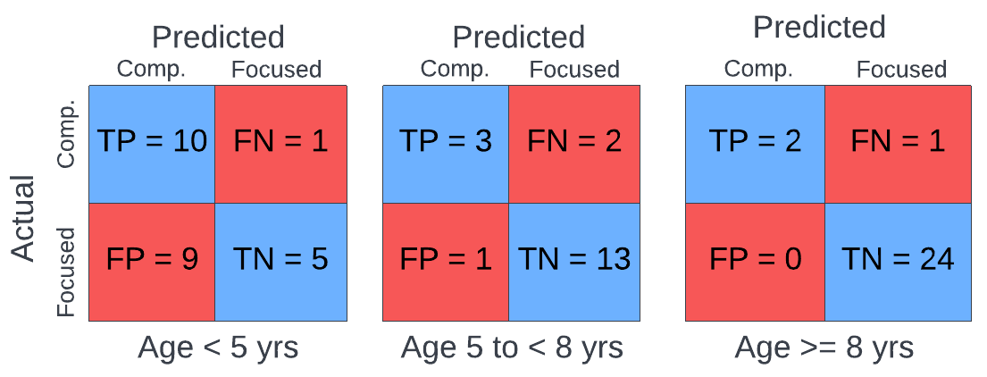

Figure S2: Area under the receiver operator characteristic curves (AUROCs) demonstrating the superior performance of the machine learning prediction algorithm (MLPA) by comparison with the standard of care comparator in three different age groups (i.e., < 5 years, 5 to < 8 years, >= 8 years). The baseline curve represents a model that is equivalent to a random coin-flip, and unable to discriminate between the classes (i.e., types of applied behavioral analysis (ABA) treatment plans). Abbreviations: machine learning prediction algorithm (MLPA); area under the receiver operator characteristic curve (AUROC).

2A. Age Group: < 5 years old
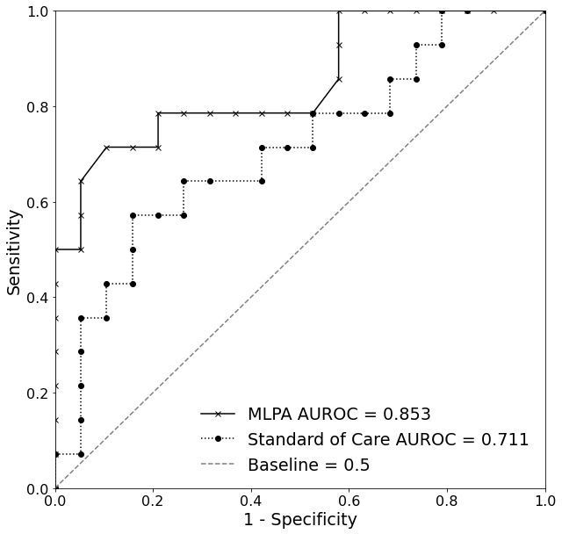

2B. Age Group: 5 to < 8 years old
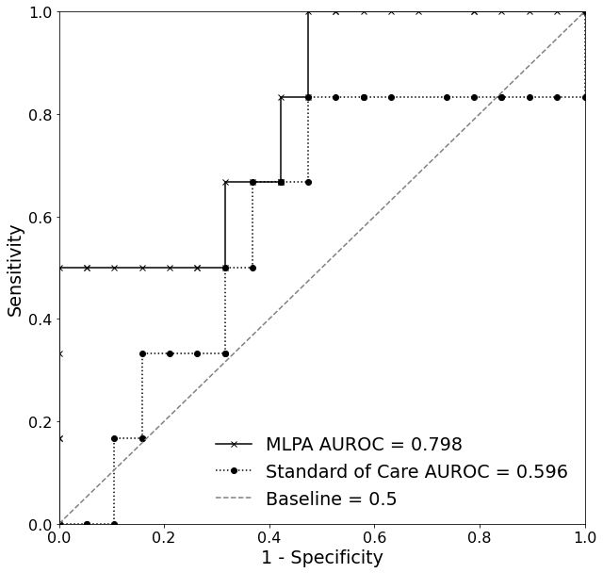

2C. Age Group: >= 8 years old
