Supplementary
S.1 Implementation Details
Although our framework involves high-dimensional transformations, segmentation modules, and diffusion processes—resulting in relatively high computational costs—training remains within an acceptable efficiency range. All experiments were conducted on four NVIDIA RTX 4090 Ti GPUs (24 GB VRAM each). The semantic and visual encoders were trained for 180 and 120 epochs, respectively, with the total training time kept under 30 hours. During inference, decoding a single image from fMRI signals takes approximately 17 seconds on average, while textual annotation generation is substantially faster, requiring only 1.8 seconds per caption. However, the current inference speed remains far from meeting the requirements of practical BCI applications. Therefore, we position this work not as an immediate solution for real-time BCI, but rather as a foundational proof-of-concept that advances the state-of-the-art in decoding quality. Looking forward, achieving practical BCI systems will require substantial efforts in improving computational efficiency. We anticipate that future work could significantly reduce inference time through strategies such as: (1) knowledge distillation into smaller, specialized networks; (2) advanced sampling techniques for diffusion models; and (3) model quantization and hardware-specific optimizations.

S.2 Text Retrieval Results
A visual representation of the Top-5 text retrieval results from the COCO dataset is presented. As illustrated in Fig. 1, descriptions of scenes involving elephants, horses, and clock towers exhibit considerable similarity, which, to a certain extent, limits the retrieval performance.

Seen Image | COCO Captions | Top-1 | Top-2 | Top-3 | Top-4 | Top-5
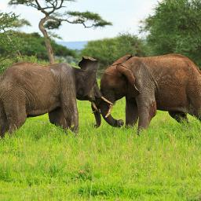 | Two elephants fighting against each other in the field. | Two elephants fighting against each other in the field. | Two elephants are fighting in a grassy field. | A couple of elephants standing near some green trees. | Four elephants crowded closely together in a clearing. | Two elephants standing next to each other in a forest.
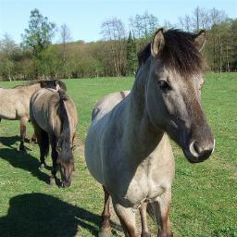 | Two horses in a field near a camera. | Two horses in a field near a camera. | a couple of animals are laying in a pin. | The horse is all alone in the field. | A photo of a crowd of people getting ready to ski. | A cat sniffs around in a suit case.
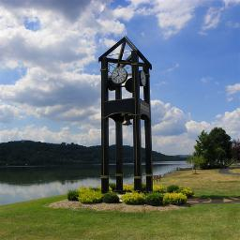 | A clock tower stands on a cloudy day. | A clock is shown at the top of a tower. | A clock tower stands on a cloudy day. | The clock tower is in front of the mountains. | The building is tall and brown and large. | A clock hangs from the wall of a beat up room.
Fig. 1. fMRI-to-text retrieval Top-3 samples of Brain-Imager on Subject1. The red font highlights the ground-truth coco captions of the seen image, indicating correct search results.

S.3 Brain Captioning Results
It is important to note that the relevant code and models for UniBrain [1], MindSemantix [2], and Ferrante [3] have not been publicly released. Additionally, the experimental results for MindEye2 [4] were derived from the complete set of 40 NSD sessions, whereas other methods (including this study) were trained using data from 37 sessions. To ensure a fair comparison, we also performed qualitative comparisons with methods such as Takagi et al. [5]. As shown in Fig. 2, we present representative examples of captions generated from visual stimuli, spanning various categories, including animals, vehicles, sports, and household items. Overall, the captions generated by Brain-Imager not only maintain semantic accuracy and richness but also demonstrate more natural and intuitive language expression, owing to the integration of the T5 optimization model. For instance, for objects such as tree branches, cars, fire hydrants, and herds of cows, Brain-Imager successfully captured key visual details and generated accurate, natural descriptions, while baseline methods failed to effectively recognize the target information in these scenarios.

Seen Image | COCO Captions | GIT Captions | Brain-Imager | Takagi et al. | Seen Image | COCO Captions | GIT Captions | Brain-Imager | Takagi et al.
 | Small colorful bird sitting on a green tree. | a bird perched on top of a tree branch. | A bird perched on a branch. | a bird with its head in the air | 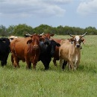 | A small herd of cows standing in the grass and looking at the camera. | a herd of cows walking across a lush green field. | A herd of cattle grazing on a field. | a group of wild animals
 | a table with many chairs around a couch with windows | a dining room table and chairs in a living room. | A kitchen with a dining table and chairs. | a kitchen in a house |  | A medium engine plane flying across a sunset sky. | a plane is flying in the sky at sunset. | A plane that is flying in the air. | an airplane in the sky
 | A school bus drives down the long road. | a school bus driving down a country road. | A bus driving down a road next to a mountain. | he sky with clouds and trees |  | A red and black train engine traveling past a forest. | a black and red train traveling down train tracks. | A train is driving down the tracks. | a train on the tracks
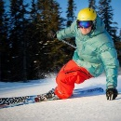 | A man is turning while he is skiing. | a man riding skis down a snow covered slope. | A man is riding skis down a snow covered slope. | a man on a skateboard |  | two white dogs on a ship gazing at | two dogs are sitting on the front of a boat. | A dog is sitting in a chair next to a window. | an old house with the door open
 | A red fire hydrant in the grass. | a red fire hydrant sitting on top of a lush green field. | A fire hydrant is in the grass. | an old fashioned car |  | A person that is riding on a horse in a grass field. | a man riding on the back of a brown horse. | A man riding a horse on top of a grass covered field. | a man in the wild
Fig. 2. Brain captioning samples of Brain-Imager compared with Takagi et al. on Subject1.

S.4 Decomposition Sampling Results
Fig. 3 illustrates the results of multi-scale decomposition sampling using LPM. The performance of the first three layers reveals that panoramic segmentation failed to provide sufficiently effective image information. This suggests that simple interpolation for fusion not only fails to enhance performance but may also introduce redundant information, leading to less refined outcomes. The design of LPM effectively addresses this issue by performing multi-scale decomposition of images and allocating fusion weights according to the characteristics of different levels, thereby significantly improving the quality and efficiency of information integration.

 | Initial Guess |  | Level-1 |  | Level-2 |  | Level-3 |  | Level-4 |  | Level-5 |  | Level-6 |  | Level-7
Z_{N1} | 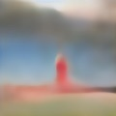 |  | 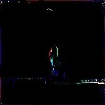 |  | 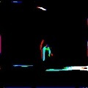 |  |  |  |  |  | 
 |  |  | w_{n}=1 |  | w_{n} =1 |  | w_{n} =1 |  | w_{n} =1 |  | w_{n} =0.6 |  | w_{n} =0.8 |  | w_{n} =0.8
Z_{P1} |  |  | 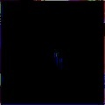 |  | 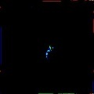 |  | 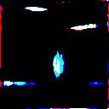 |  |  |  | 
 |  |  | w_{p}=0 |  | w_{p} =0 |  | w_{p} =0 |  | w_{p} =0 |  | w_{p} =0.4 |  | w_{p} =0.2 |  | w_{p} =0.2
Z_{N2} |  |  |  |  |  |  |  |  |  |  | 
 |  |  | w_{n}=1 |  | w_{n} =1 |  | w_{n} =1 |  | w_{n} =1 |  | w_{n} =0.6 |  | w_{n} =0.8 |  | w_{n} =0.8
Z_{P2} |  |  |  |  | 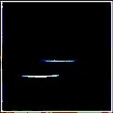 |  |  |  |  |  | 
 |  |  |  | w_{p}=0 |  | w_{p} =0 |  | w_{p} =0 |  | w_{p} =0 |  | w_{p} =0.4 |  | w_{p} =0.2 |  | w_{p} =0.2
Fig. 3. Sampling results from 7 layers of multi-scale decomposition. The figure shows two examples, the first column is the input of the LPM module, which is the initial guess of the natural image and the panoramic segmentation image. The remaining columns are the results of sampling at different scales of LPM. Here, w_{n} denotes the fusion weight assigned by the LPM to each layer of the natural image, while w_{p} indicates the fusion weight for each layer of the panoramic segmentation image.

S.5 Brain Captioning Ablation
In the context of brain captioning, we conducted ablation experiments on Subject 1, comparing performance on the COCO and GIT datasets to investigate the impact of each component, as presented in Table I. The results indicate that the removal of the retrieval module significantly reduced model performance, particularly on metrics such as CIDEr and CLIP-L. This phenomenon suggests that the retrieval module, by providing semantically relevant prior information, effectively narrows the generative space, thereby significantly enhancing the semantic consistency and accuracy of the generated captions, underscoring its critical role in the reconstruction process. The T5 optimization module slightly improved overall performance but made a substantial contribution to the readability and grammatical quality of the generated text. Notably, the removal of the T5 module resulted in the highest CIDEr score. This may be due to the fact that the CIDEr metric is more sensitive to lexical consistency, and the T5 module, while optimizing grammar, may interfere with the matching of certain specific words. Overall, the quantitative results from the ablation experiments demonstrate the importance of each component in the model, with the complete Brain-Imager model outperforming all ablated versions.

Table I
A quantitative comparison of Brain-Imager captioning performance with various ablations of a complete model on Subj1. The best value is shown in bold. W/o is short for without.

Dataset | Method | Low-Level |  |  |  | High-Level
Dataset | Method | Meteor | Rouge-L | Rouge-1 | CIDEr | Sentence | SPICE | CLIP-B | CLIP-L
COCO | W/o Retrieval | 0.234 | 0.297 | 0.323 | 0.412 | 46.1% | 14.8% | 73.5% | 63.7%
COCO | W/o T5 | 0.251 | 0.310 | 0.338 | 0.472 | 48.3% | 16.1% | 74.4% | 65.0%
COCO | Attention | 0.225 | 0.299 | 0.324 | 0.392 | 47.5% | 16.1% | 74.5% | 64.6%
COCO | Resnet | 0.239 | 0.308 | 0.332 | 0.436 | 47.4% | 15.9% | 74.4% | 64.7%
COCO | Brain-Imager | 0.254 | 0.312 | 0.340 | 0.491 | 48.3% | 16.2% | 74.5% | 65.1%
GIT | W/o Retrieval | 0.349 | 0.411 | 0.439 | 0.948 | 50.9% | 20.3% | 75.1% | 66.7%
GIT | W/o T5 | 0.381 | 0.435 | 0.466 | 1.088 | 54.0% | 22.5% | 76.5% | 68.8%
GIT | Attention | 0.314 | 0.392 | 0.418 | 0.567 | 52.0% | 21.1% | 75.3% | 67.0%
GIT | Resnet | 0.353 | 0.428 | 0.452 | 0.688 | 52.9% | 22.7% | 76.1% | 68.0%
GIT | Brain-Imager | 0.382 | 0.435 | 0.466 | 0.807 | 54.0% | 22.5% | 76.6% | 68.8%

S.6 Human Subjective Evaluation
To assess the cognitive plausibility of the generated text, we conducted a systematic double-blind human evaluation focused on semantic accuracy, linguistic naturalness, and informational completeness. A total of 982 test-set images were used as evaluation stimuli, each paired with three types of captions: human-annotated, generated by our method, and generated by a baseline (Takagi et al. [5]). We invited 30 experts (15 neurologists and 15 linguists) from Shengjing Hospital of China Medical University to rate the subtitle quality using a 5-point Likert scale. To ensure methodological rigor, we employed a double-blind design: experts were blinded to caption sources, and evaluators were not involved in the annotation process. To minimize fatigue effects, each expert evaluated 40 randomly selected images. Each image was displayed for 5 seconds, followed by independent ratings of the randomly ordered captions.
Experimental results show that our method significantly surpass those of the baseline in semantic accuracy (4.1 ± 0.2 vs. 3.5 ± 0.2) and linguistic naturalness (4.0 ± 0.3 vs. 3.4 ± 0.1), achieving performance comparable to human annotations (4.7 ± 0.3 vs. 4.8 ± 0.2). For informational completeness, our method (3.6 ± 0.3) trails slightly behind human annotations (4.6 ± 0.3), yet still outperforms the baseline by a significant margin (3.2 ± 0.3). These findings indicate that our method effectively captures core semantic content while maintaining high linguistic fluency. Further error analysis revealed that most discrepancies arose from missing fine-grained details or partial semantic generalization, rather than fundamental semantic errors—further supporting the cognitive plausibility of the generated captions.

S.7 Stability at Different Noise Levels
To assess the model’s robustness to real-world fMRI noise, we conducted a systematic noise-resilience evaluation using data from Subject 1. Given that real fMRI signals are frequently contaminated by scanner noise, head motion artifacts, and inherently low spatial resolution, we simulated a range of degradation scenarios by progressively injecting Gaussian noise at varying intensities (10%, 20%, 30%, 50%, 70%, and 90%). These levels represent a continuum from mild to severe data corruption. Fig. 4 provides qualitative visualizations, while Fig. 5 presents the corresponding quantitative performance across the test set under each noise condition. The experimental results demonstrate that the model maintains stable decoding performance at noise levels below 50%, indicating strong resilience to typical fMRI signal degradation. Even under extreme noise conditions (70%–90%), the model retains a substantial portion of its performance, highlighting its robustness and fault-tolerance. These findings validate the model’s capacity to suppress noise through its deep generative architecture, making it well-suited for decoding in noisy or complex real-world environments.

noise-0% | noise-10% | noise-20% | noise-30% | noise-50% | noise-70% | noise-90%
 |  |  |  |  |  | 
Fig. 4. Examples of qualitative changes at different noise levels

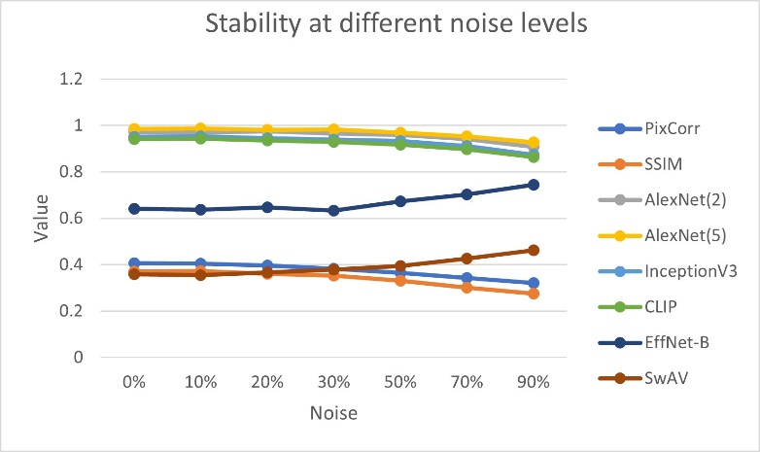
Fig. 5. Quantitative evaluation under different noise levels on the full test set of Subject 1.

S.8 More Parameter Ablation
The input resolution of the visual stimulus (e.g., n×3×512×512) directly determines the dimensionality of subsequent representations, including the VAE latent space (n×4×64×64) and VICRegL features (n×256×512). These dimensions are governed by the architectural design of the model: the VAE employs an 8× downsampling rate, while the feature dimensionality of VICRegL varies according to the input resolution. A summary of these dependencies is provided in Table II.

Table II
The Relationship Between the Size of Visual Stimuli and the Dimensionality of Model Encoding.

Size | VAE | VICRegL
(N,3,128,128) | (N,4,16,16) | (N,16,512)
(N,3,256,156) | (N,4,32,32) | (N,64,512)
(N,3,512,512) | (N,4,64,64) | (N,256,512)
(N,3,768,768) | (N,4,96,96) | (N,576,512)

To evaluate the impact of input resolution, we conducted a comparative study using resolutions ranging from 128×128 to 768×768, as presented in Table III. Experimental results indicate that an input resolution of 512×512 yields the best overall performance across most evaluation metrics (e.g., SSIM, Incep), as it effectively balances information retention with computational efficiency. Although higher resolutions (e.g., 768×768) offer marginal improvements in semantic metrics, they may introduce noise due to out-of-distribution generalization. In contrast, lower resolutions such as 256×256 improve efficiency but sacrifice high-frequency visual details, thereby reducing pixel-level reconstruction fidelity. At 128×128, substantial information loss occurs, resulting in significant performance degradation across all metrics. Based on these findings, we adopt 512×512 as the default input resolution, as it most closely aligns with the model’s pretraining distribution—presumably because Stable Diffusion was originally trained on images of this size.

Table III
Reconstruction performance at different SIZEs on Subj1.

Size | Low-Level |  |  |  | High-Level
Size | PixCorr | SSIM | Alex(2) | Alex(5) | Incep | CLIP | Eff | SwAV
(N,3,128,128) | 0.376 | 0.325 | 94.0% | 96.1% | 92.7% | 91.2% | 0.638 | 0.371
(N,3,256,156) | 0.397 | 0.365 | 96.5% | 98.3% | 95.0% | 93.9% | 0.634 | 0.354
(N,3,512,512) | 0.406 | 0.370 | 97.1% | 98.6% | 95.2% | 94.2% | 0.640 | 0.358
(N,3,768,768) | 0.401 | 0.360 | 97.5% | 98.7% | 94.9% | 94.5% | 0.657 | 0.366

S.9 More Data Set
To further assess the model’s robustness, we performed additional validation using the Generic Object Decoding (GOD) dataset [6].This dataset, widely used as a benchmark in fMRI-based visual stimulus decoding, contains brain activity recordings from five subjects as they viewed 1,250 natural images spanning 200 categories. In accordance with the standard split, the training set consists of 1,200 images from 150 categories, and the test set comprises 50 images from 50 distinct categories, with no overlap between training and testing categories.

Table IV
Quantitative comparison of Our reconstruction performance with other SOTA methods on the GOD dataset. Bold indicates best performance, while underlined numbers indicate second-best performance.

Method | SSIM | CLIP
Takagi et al. (2023) | 0.182 | 0.602
Mind-Vis (2023) | 0.251 | 0.625
VQ-fMRI (2023) | 0.423 | 0.548
GESS (2023) | 0.267 | 0.620
Mind Artist (2024) | 0.242 | 0.631
Ours | 0.418 | 0.517

Without altering the model architecture, we compared our approach with five state-of-the-art methods on this dataset (Takagi et al. [5], MinD-Vis [7], VQ-fMRI [8], GESS [9], and Mind Artist [10]). We employed two widely adopted evaluation metrics—SSIM for assessing structural fidelity and CLIP similarity for measuring semantic consistency of the reconstructions. As shown in Table IV, our model performed strongly on both metrics, exhibiting high structural similarity and accurate semantic alignment. Qualitative results in Fig. 6 further show that both structural features (e.g., an upright red object) and semantic content (e.g., birds) are well preserved. These consistent results on the GOD dataset further support the robustness of our model.

Ground Truth | 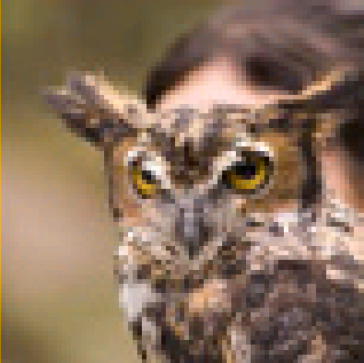 | 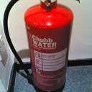 |  | 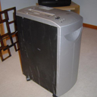
Ours |  | 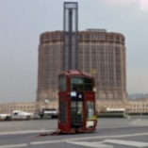 |  | 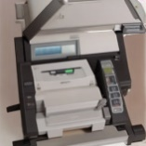
Fig. 6. Sample reconstruction results on the GOD dataset.

S.10 Ethical Considerations
The rapid advancement of brain decoding technology, as demonstrated in this study, brings forth significant ethical questions that the research community must proactively address. Our framework, Brain-Imager, which reconstructs images and captions from fMRI data, falls squarely into the domain of what is often colloquially referred to as 'mind-reading.' This raises immediate concerns regarding mental privacy — the right of an individual to keep their internal mental processes confidential.
It is crucial to contextualize our current capabilities. Our experiments utilized the publicly available NSD dataset, which was itself collected in a controlled laboratory environment with cooperative participants who had given informed consent. The decoding process requires expensive, non-portable equipment (MRI scanners) and model training on hours of data from a single subject. Therefore, the risk of surreptitious or malicious 'mind-reading' with our current technology is virtually nonexistent.
However, we cannot be complacent. As the field progresses towards greater accuracy, efficiency, and accessibility, the potential for misuse could increase. Potential risks in the future could include the non-consensual extraction of private information, neural profiling for commercial or political gain, and other forms of harmful exploitation. We believe that the scientific community has a responsibility to parallel technical innovation with rigorous ethical scrutiny. We endorse the development of clear ethical guidelines and regulatory frameworks to govern the use of brain decoding technology. These should be established through open dialogue among neuroscientists, ethicists, legal scholars, and the public.
In conclusion, while Brain-Imager represents a technical step forward, it is still far from posing an immediate privacy threat. Nonetheless, we highlight these ethical considerations now to encourage responsible development and to ensure that societal protections keep pace with scientific discovery.
S.11 Neural cross-subject Analysis
Cross-subject validation was performed by applying the identical rCCA pipeline to three additional subjects (subj02, subj05, and subj07). The results indicate that our primary findings also hold across these independent individuals.

Table Va
rCCA for model predictions and brain region activations on Subj2.

 | CLIP-Text | CLIP-Image
Dorsal | 0.435, (p<0.001) | 0.147, (p<0.001)
Ventral | 0.288, (p<0.001) | 0.319, (p<0.001)

Table Vb
rCCA for model predictions and brain region activations on Subj5.

 | CLIP-Text | CLIP-Image
Dorsal | 0.372, (p<0.001) | 0.125, (p<0.001)
Ventral | 0.265, (p<0.001) | 0.272, (p<0.001)

Table Vc
rCCA for model predictions and brain region activations on Subj7.

 | CLIP-Text | CLIP-Image
Dorsal | 0.337, (p<0.001) | 0.114, (p<0.001)
Ventral | 0.239, (p<0.001) | 0.246, (p<0.001)

S.12 Neural permutation testing
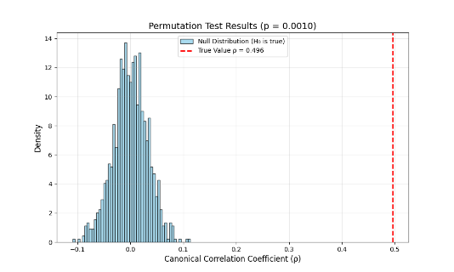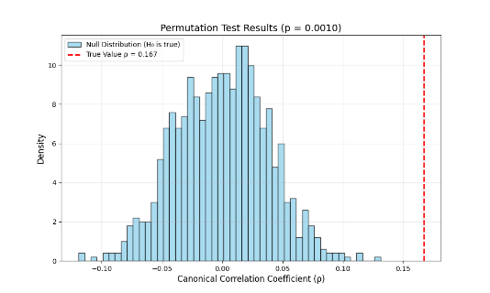
- (b)
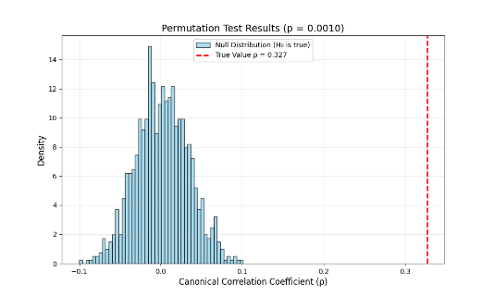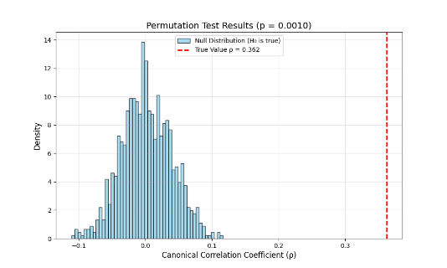
- (d)
Fig. 7. Neural Permutation Testing Results on subj1 (Corresponding to Table V in the Main Text).

References
[1] W. Mai and Z. Zhang, “UniBrain: Unify Image Reconstruction and Captioning All in One Diffusion Model from Human Brain Activity,” Aug. 14, 2023, arXiv: arXiv:2308.07428. doi: 10.48550/arXiv.2308.07428.
[2] I. Han, J. Lee, and J. C. Ye, “MindFormer: Semantic Alignment of Multi-Subject fMRI for Brain Decoding,” Oct. 06, 2024, arXiv: arXiv:2405.17720. doi: 10.48550/arXiv.2405.17720.
[3] M. Ferrante, F. Ozcelik, T. Boccato, R. VanRullen, and N. Toschi, “Brain Captioning: Decoding human brain activity into images and text,” May 19, 2023, arXiv: arXiv:2305.11560. doi: 10.48550/arXiv.2305.11560.
[4] P. S. Scotti et al., “MindEye2: Shared-Subject Models Enable fMRI-To-Image With 1 Hour of Data,” Jun. 15, 2024, arXiv: arXiv:2403.11207. doi: 10.48550/arXiv.2403.11207.
[5] Y. Takagi and S. Nishimoto, “High-resolution image reconstruction with latent diffusion models from human brain activity,” in 2023 IEEE/CVF Conference on Computer Vision and Pattern Recognition (CVPR), Jun. 2023, pp. 14453–14463. doi: 10.1109/CVPR52729.2023.01389.
[6] T. Horikawa and Y. Kamitani, “Generic decoding of seen and imagined objects using hierarchical visual features,” Nat. Commun., vol. 8, no. 1, p. 15037, May 2017, doi: 10.1038/ncomms15037.
[7] Z. Chen, J. Qing, T. Xiang, W. L. Yue, and J. H. Zhou, “Seeing Beyond the Brain: Conditional Diffusion Model with Sparse Masked Modeling for Vision Decoding,” in 2023 IEEE/CVF Conference on Computer Vision and Pattern Recognition (CVPR), Vancouver, BC, Canada: IEEE, Jun. 2023, pp. 22710–22720. doi: 10.1109/CVPR52729.2023.02175.
[8] J. Chen, Y. Qi, and G. Pan, “Rethinking Visual Reconstruction: Experience-Based Content Completion Guided by Visual Cues,” Jun. 2023, Accessed: Jun. 11, 2025.
[9] T. Fang, Q. Zheng, and G. Pan, “Alleviating the Semantic Gap for Generalized fMRI-to-Image Reconstruction,” Adv. Neural Inf. Process. Syst., vol. 36, pp. 15096–15107, Dec. 2023.
[10] J. Chen, Y. Qi, Y. Wang, and G. Pan, “Mind Artist: Creating Artistic Snapshots with Human Thought,” in 2024 IEEE/CVF Conference on Computer Vision and Pattern Recognition (CVPR), Seattle, WA, USA: IEEE, Jun. 2024, pp. 27197–27207. doi: 10.1109/CVPR52733.2024.02569.

