Supplementary Figure F1
Effect of smoothing-window length on signal robustness and inter-device consistency.
- Artifact rate vs. smoothing window for Mindtooth Touch, Emotiv EPOC X, and Muse S.
- Neurometrics inter-device correlation vs. smoothing window — correlations refer to Emotiv EPOC X and Muse S with Mindtooth Touch only.
The results show that the Mindtooth Touch maintains stable performance even without smoothing, while both consumer-grade devices benefit from 10–15 s averaging windows.
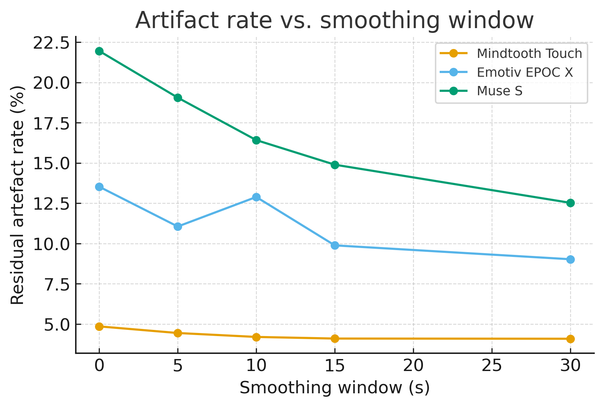
Figure A Artifact rate vs. smoothing window.
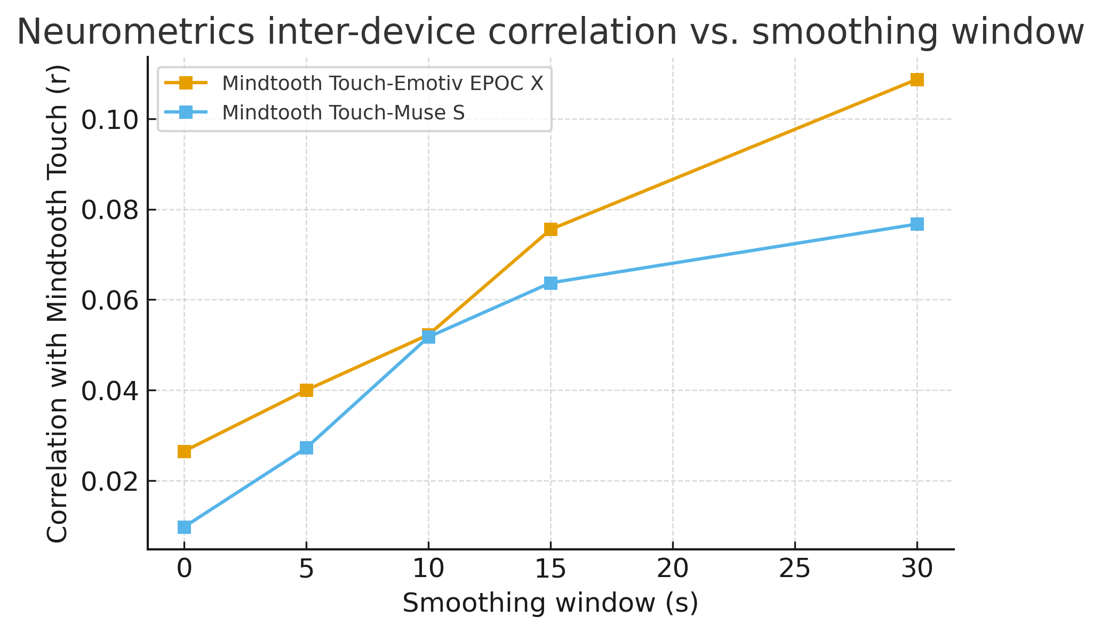
Figure B Neurometrics inter-device correlation vs. smoothing window.

