SUPPORTING INFORMATION
Synthesis and Characterization of Titanium Oxynitride Catalysts via Direct Ammonia Nitridation of Titanium Polyacrylate for Oxygen Reduction Reaction
Journal of Materials Science: Materials in Engineering

Yushi Tamakiª, Satoshi Seinoª*, Naoki Shinyoshiª, Yuta Uetake^{b,c},
Takaaki Nagai^{d}, Ryuji Monden^{d}, Akimitsu Ishihara^{d}, Takashi Nakagawaª

ª Management of Industry and Technology, Graduate school of Engineering, Osaka University, 2–1, Yamadaoka, Suita, Osaka, 565–0871, Japan
^{b} Division of Applied Chemistry, Graduate School of Engineering, Osaka University, 2–1, Yamadaoka, Suita, Osaka, 565–0871, Japan
^{c} Innovative Catalysis Science Division, Institute for Open and Transdisciplinary Research Initiatives (ICS-OTRI), Osaka University, 2–1, Yamadaoka, Suita, Osaka 565–0871, Japan
^{d} Institute of Advanced Sciences, Yokohama National University, 79–5, Tokiwadai, Hodogaya-ku, Yokohama, 240–8501, Japan

*Corresponding author. E-mail address: seino@mit.eng.osaka-u.ac.jp

S1. Preparation of titanium polyacrylate
Titanium tetraisopropoxide (5.9 mL, Sigma–Aldrich Co., LLC), acetylacetone (18 mL, FUJIFILM Wako Pure Chemical Corp.), and acetic acid (22 mL, FUJIFILM Wako Pure Chemical Corp.) were employed as initial components. The substances were combined to create a titanium acetylacetonate acetate solution. Subsequently, a 10% polyacrylic acid 25000 aqueous solution (20 g, FUJIFILM Wako Pure Chemical Corp.), ethanol (40 mL, FUJIFILM Wako Pure Chemical Corp.), acetic acid (20 mL, FUJIFILM Wako Pure Chemical Corp.), a 5 wt.% Nafion® solution (0.20 mL, DE520 CS type, FUJIFILM Wako Pure Chemical Corp.), and iron acetate (68 mg, Tokyo Chemical Industry Co., LTD) were accurately measured. These components were mixed by a magnetic stirrer for 6 h. The titanium acetylacetonate acetate solution was then added, followed by stirring overnight. Thereafter, the solution was homogenized for 30 min. Finally, it was evaporated at 60 °C, yielding titanium polyacrylate powder.

S2. X-ray absorption spectroscopy
A. Measurement procedure
Ti K-edge X-ray absorption spectroscopy (XAS) experiments were performed at the BL14B2 beamline of SPring-8 using Si(111) double-crystal monochromatized synchrotron radiation under ring conditions of 8.0 GeV and 100 mA. All the measurements were performed using the transmission mode with the quick scan technique (QXAFS) at room temperature. Ionization chambers were used to measure the intensities of the incident (I₀) and transmitted (I) X-rays. The XAS analysis was conducted using Demeter package, which is a comprehensive system for processing and analyzing XAS data (Newville 2001; Ravel and Newville 2005). Background removal and normalization of raw data were performed via the cubic spline method using Athena software. E₀ was defined as the photon energy at the absorption edge corresponding to μT = 0.5 in the normalized μ(E) spectrum. The E₀ value of Ti foil was set as 4969 eV for photon energy calibration.
The Ti sample and boron nitride (FUJIFILM Wako Pure Chemical Corp.) were ground using an agate mortar for 40 min under the ambient atmosphere. The resulting powder was pelletized using a tablet press (JASCO Co., φ = 7 mm) and a hand press. The prepared pellets were packed in a polyethylene bag and subjected to XAS measurements. The unstable samples, such as TiO, were handled in a glovebox filled with Ar gas.
TiO was purchased from Alfa Aesar. Ti₄O₇ was purchased from KOJUNDO Chemical Laboratory Co, Ltd. Ti₂O₃, TiO₂ (anatase), TiO₂ (rutile), TiC, and TiN were purchased from FUJIFILM Wako Pure Chemical Corp. Titanium polyacrylate was prepared as described in Section S1.

Newville M (2001) IFEFFIT: interactive XAFS analysis and FEFF fitting. J Synchrotron Radiat 8:322–324. https://doi.org/10.1107/S0909049500016964
Ravel B, Newville M (2005) ATHENA, ARTEMIS, HEPHAESTUS: data analysis for X-ray absorption spectroscopy using IFEFFIT. J Synchrotron Radiat 12:537–541. https://doi.org/10.1107/S0909049505012719

B. Ti K-edge XANES spectra
Figure S2 shows the XANES spectra of the catalysts prepared in this study, along with references. The spectrum of the sample calcined at 1000 °C was similar to that of TiN. As the calcination temperature decreased, the pre-edge peak intensity increased, and the edge position shifted to a higher energy.
Figure S2 Ti K-edge XANES spectra

S3. Crystalline TiO_{x}N_{1-x} phase composition
Vegard’s law between TiO (JCPDS 8–117) and TiN (JCPDS 38–1420) was applied to the strongest peak at approximately 42.8° in the XRD pattern to determine the crystalline TiO_{x}N_{1-x} phase composition. For the sample calcined at 600 °C, calculations were not performed, because the peak intensity was insufficient. As shown in Figure S3, the nitridation of the sample was suppressed as the calcination temperature decreased.

Figure S3 Relationship between the crystalline TiO_{x}N_{1-x} phase composition and the calcination temperature.

S4. Cyclic voltammograms for catalysts
Figure S4 presents cyclic voltammograms (CV) for the samples. The CV current increased as the calcination temperature increased from 600 to 900 °C. In particular, as the calcination temperature increased to 900 °C, the CV current increased significantly. However, an increase in the calcination temperature to 1000 °C reduced the CV current. The increase in CV current between 600 and 900 °C suggests an increase in the electrochemically active surface area. The observed increase in CV current with higher calcination temperatures appears to correspond to the reduction in the specific electrical resistance shown in Figure 4. Particularly noteworthy is the significant reduction in resistance between 700 and 800 °C, as shown in Figure 4, which aligns well with changes observed in the CV current. Although the specific electrical resistance was the lowest at 1000 °C, the CV current was relatively low. The reduction in the CV current at 1000 °C is attributed to the vaporization of the complex without the formation of deposited carbon due to the high temperature or the physical reduction in electrochemical surface area caused by the aggregation or coarsening of carbon and catalyst particles.

Figure S4 Cyclic voltammograms for the catalysts.

S5. TEM images for catalysts
The TEM images of each catalyst are presented on Figure S5. With an increase in the calcination temperature, coarsening of titanium oxynitride particles and a reduction in the amount of carbon residue were observed.

Figure S5 TEM images of the catalysts. Low- and high-magnification images are shown on the left and right, respectively.

S6. Slow scan voltammetry (SSV) measurements for catalysts
Figure S6 presents the SSV curves for the catalysts. The SSV measurements were conducted using a static three-electrode cell in 0.5 mol dm⁻³ H₂SO₄. The current density of the oxygen reduction reaction i_{ORR} was calculated by subtracting the current density under the N₂ atmosphere from that under the O₂ atmosphere. From the SSV curves, the i_{ORR} increased when the calcination temperature was increased to 800 °C. However, when the temperature was increased further, the i_{ORR} decreased.

Figure S6 SSV curves for the catalysts.

S7. Relationship between XANES edge positions of catalysts and E_{rest}
To investigate the factors affecting E_{rest}, the correlations between the material properties and E_{rest} were examined. E_{rest} exhibited a correlation with the XANES edge position, as shown in Figure S7. The XANES edge position reflects several factors, such as the local structure. Although a detailed discussion of the relationship between the active-site formation and the XANES edge position is beyond the scope of this study, an in-depth analysis should be performed in future research.

Figure S7 Relationship between the XANES edge positions of the catalysts and the E_{rest}. The black dashed line represents the linear fitting of the data.

S8. The influence of Fe/N/C-derived activity
Since the catalyst precursor used in this study contains iron acetate (AcFe) as a raw material, it is possible that Fe/N/C catalysts formed during the calcination process and significantly contributed to the ORR activity. To investigate the effect of Fe on the ORR activity, we prepared catalysts using precursor materials without iron acetate. Using the precursor preparation method described in S1, we prepared the catalyst precursor without iron acetate. This precursor was subjected to ammonia nitridation at a heat-treatment temperature of 800 °C to synthesize a catalyst free of Fe. Figure S8 presents the results of a comparative analysis of ORR activity in the presence and absence of Fe in the precursor. ORR current was observed even in the titanium oxynitride catalyst prepared without iron acetate, providing clear evidence that the titanium oxynitride obtained in this study exhibits intrinsic ORR activity. However, since the ORR current of the catalyst containing iron acetate was slightly higher, it is suggested that Fe/N/C structures may have formed during the ammonia nitridation process, contributing to the enhanced ORR activity of the catalyst.

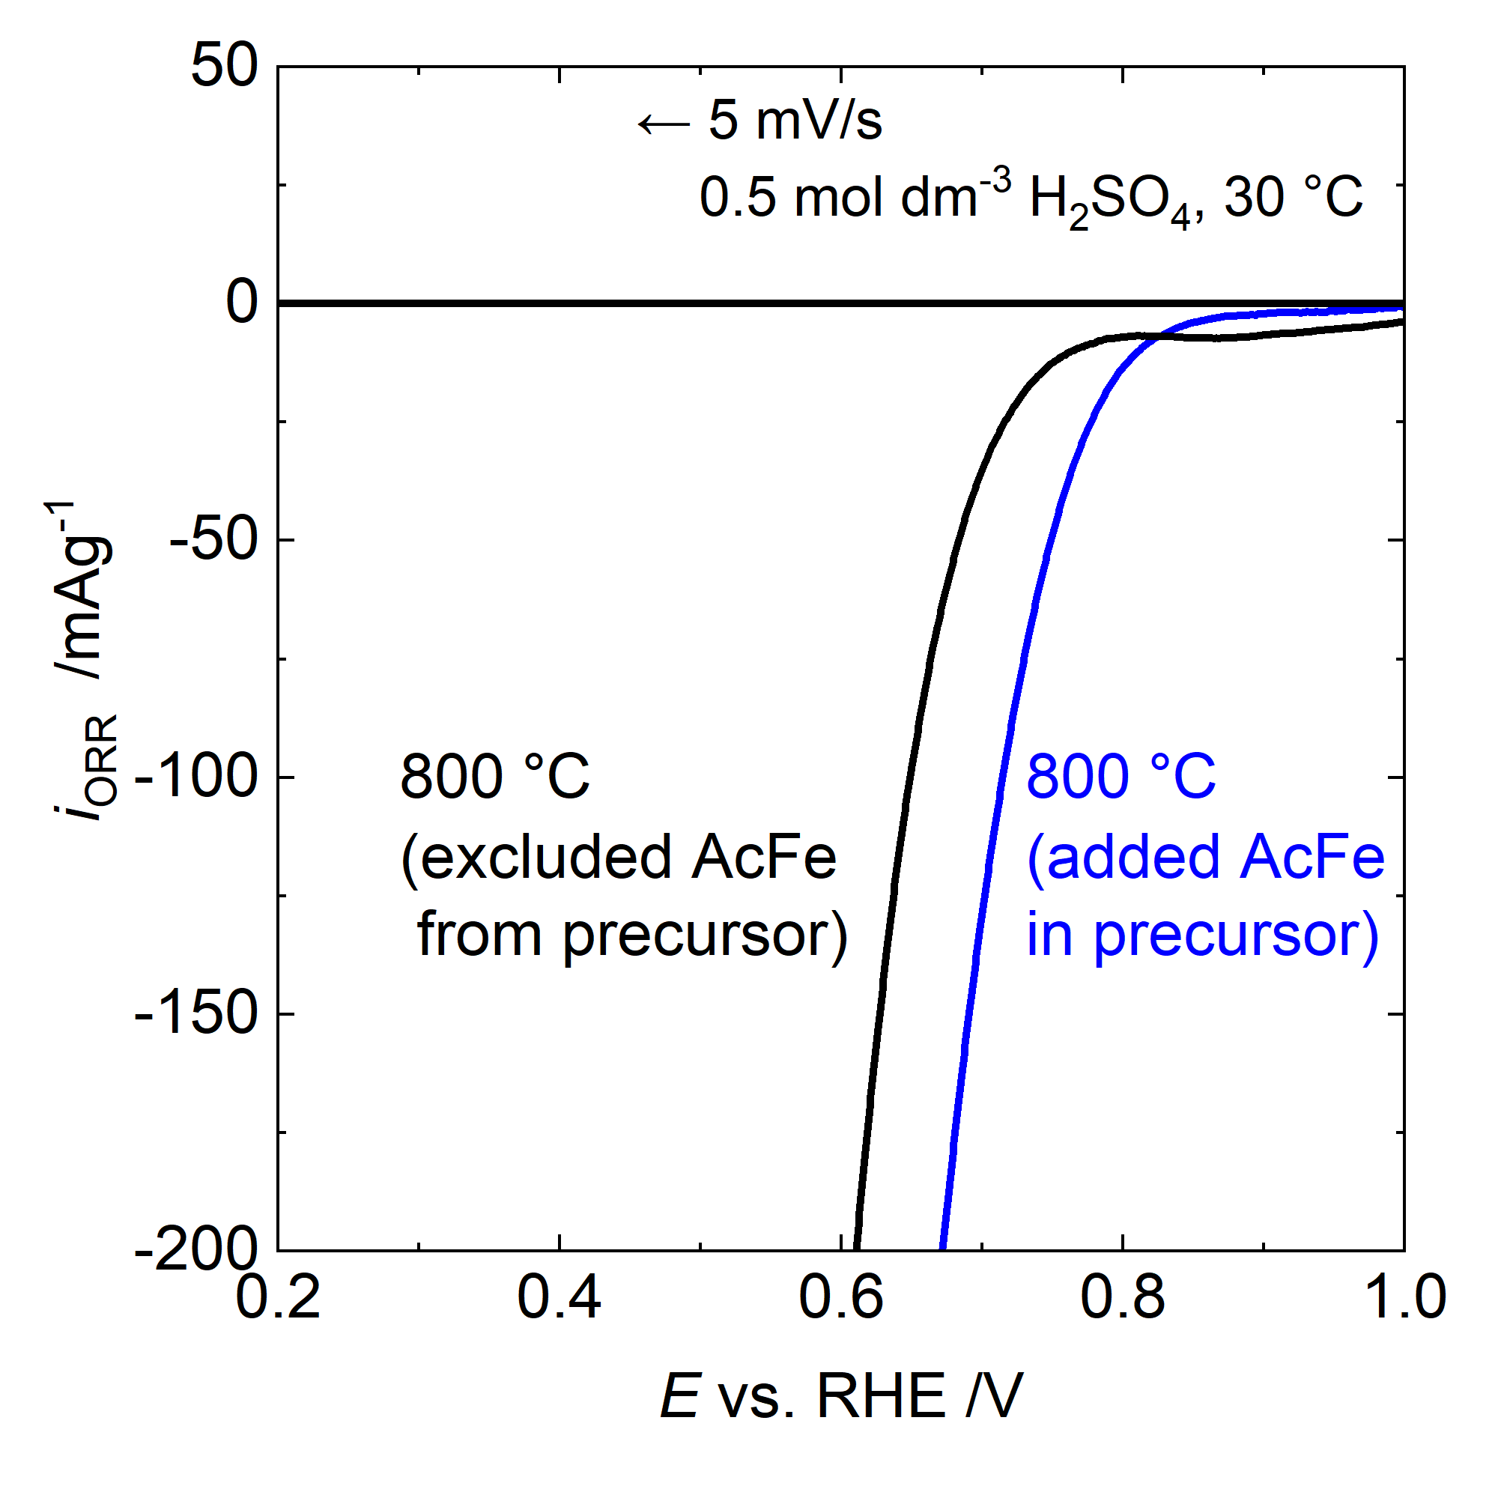
Figure S8. Comparison of SSV results based on the presence or absence of iron acetate (AcFe) in the catalyst precursor.

