Complementary material

Crystallographic charts for XRD

PDF#87-1165: QM=Calculated; d=Calculated; I=(Unknown)
Hematite
Fe₂O₃
Radiation=CuKa1 Lambda=1.5406 Filter=
Calibration= 2T=24.149-88.557 I/Ic(RIR)=3.26
Ref: Level-1 PDF

Hexagonal, R-3c(167) Z=6 mp=
CELL: 5.0353 x 5.0353 x 13.7495 <90.0 x 90.0 x 120.0> P.S=
Density(c)=5.269 Density(m)= Mwt= Vol=301.9
Ref: Ibid.

Strong Lines: 2.70/X 2.52/7 1.69/4 1.84/3 3.68/3 1.49/3 1.45/3 2.21/2

2-Theta d(Å) I(f) ( h k l) Theta 1/(2d) 2pi/d n^2
24.149 3.6824 31.4 ( 0 1 2) 12.074 0.1358 1.7063
33.158 2.6995 100.0 ( 1 0 4) 16.579 0.1852 2.3275
35.631 2.5176 71.3 ( 1 1 0) 17.815 0.1986 2.4957
39.283 2.2916 1.9 ( 0 0 6) 19.642 0.2182 2.7419
40.862 2.2066 19.2 ( 1 1 3) 20.431 0.2266 2.8474
43.508 2.0783 1.8 ( 2 0 2) 21.754 0.2406 3.0232
49.462 1.8412 34.2 ( 0 2 4) 24.731 0.2716 3.4126
54.069 1.6947 41.1 ( 1 1 6) 27.034 0.2950 3.7076
56.159 1.6365 0.5 ( 2 1 1) 28.079 0.3055 3.8395
57.448 1.6028 2.5 ( 1 2 2) 28.724 0.3120 3.9202
57.597 1.5990 8.6 ( 0 1 8) 28.799 0.3127 3.9295
62.436 1.4862 26.4 ( 2 1 4) 31.218 0.3364 4.2277
64.000 1.4536 25.7 ( 3 0 0) 32.000 0.3440 4.3226
66.031 1.4137 0.2 ( 1 2 5) 33.015 0.3537 4.4445
69.595 1.3498 2.5 ( 2 0 8) 34.798 0.3704 4.6550
71.947 1.3113 8.8 ( 1 0 10) 35.974 0.3813 4.7915
72.281 1.3061 2.1 ( 1 1 9) 36.141 0.3828 4.8108
75.191 1.2626 0.3 ( 2 1 7) 37.596 0.3960 4.9765
75.455 1.2588 5.5 ( 2 2 0) 37.727 0.3972 4.9913
77.738 1.2275 1.9 ( 0 3 6) 38.869 0.4073 5.1189
78.776 1.2139 0.9 ( 2 2 3) 39.388 0.4119 5.1762
79.486 1.2048 0.1 ( 1 3 1) 39.743 0.4150 5.2152
80.582 1.1911 1.6 ( 3 1 2) 40.291 0.4198 5.2749
80.709 1.1896 3.5 ( 1 2 8) 40.355 0.4203 5.2818
82.953 1.1630 4.3 ( 0 2 10) 41.477 0.4299 5.4025
84.485 1.1458 0.2 ( 0 0 12) 42.242 0.4364 5.4837
84.934 1.1409 6.5 ( 1 3 4) 42.467 0.4383 5.5073
88.557 1.1033 5.9 ( 2 2 6) 44.279 0.4532 5.6948

PDF#50-2241: QM=Uncommon(?); d=Diffractometer; I=(Unknown)
Cellulose
(C₆H₁₀O₅)n
Radiation=CuKa1 Lambda=1.5406 Filter=
Calibration= 2T=14.988-22.781 I/Ic(RIR)=
Ref: Level-1 PDF Z= mp= P.S=
Density(c)= Density(m)= Mwt= Vol=
Ref: Ibid.

Strong Lines: 3.90/X 5.37/3 5.91/3

2-Theta d(Å) I(f) ( h k l) Theta 1/(2d) 2pi/d n^2
14.988 5.9061 33.0 7.494 0.0847 1.0638
16.487 5.3724 33.0 8.243 0.0931 1.1695
22.781 3.9002 100.0 11.391 0.1282 1.6110

Statistics of kinetic experiments
SN-PMC

Effect | Degr. Of Freedom | Time  SS | Time  MS | Time  F | Time  p | Qt (mg/SN-PMC)  SS | Qt (mg/SN-PMC)  MS | Qt (mg/SN-PMC)  F | Qt (mg/SN-PMC)  p
Intercept | 1 | 837901.8 | 837901.8 | 15.91751 | 0.001542 | 2.378064 | 2.378064 | 38.98010 | 0.000030
Error | 13 | 684323.2 | 52640.2 |  |  | 0.793093 | 0.061007
Total | 13 | 684323.2 |  |  |  | 0.793093

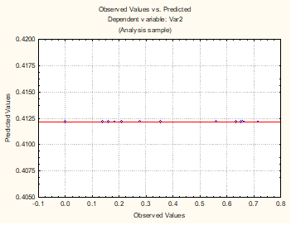
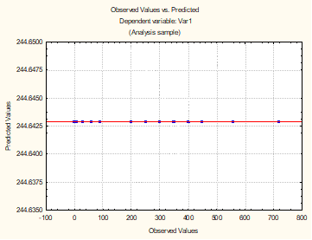
Effect | Degr. Of Freedom | Time  SS | Time  MS | Time  F | Time  p | Qt (mg/PMC)  SS | Qt (mg/PMC)  MS | Qt (mg/PMC)  F | Qt (mg/PMC)  p
Intercept | 1 | 837901.8 | 837901.8 | 15.91751 | 0.001542 | 1.701586 | 1.701586 | 53.84128 | 0.000006
Error | 13 | 684323.2 | 52640.2 |  |  | 0.410849 | 0.031604
Total | 13 | 684323.2 |  |  |  | 0.410849

Observed and predicted values ​​in variable 1 (time) and variable 2 (qt).

PMC
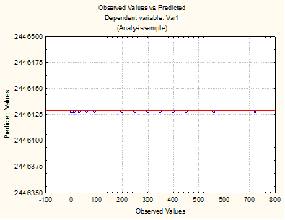
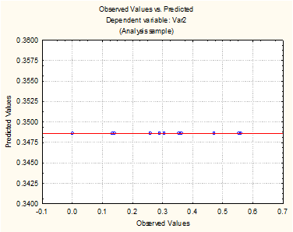

Observed and predicted values ​​in variable 1 (time) and variable 2 (qt).

Isotherm Models

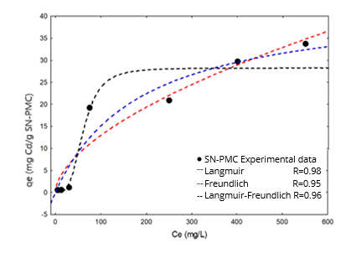
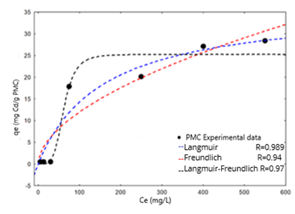

Isotherm models at 25°C and pH 5 in PMC and SN-PMC.

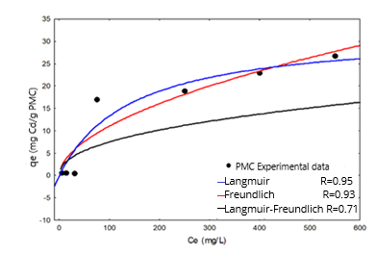
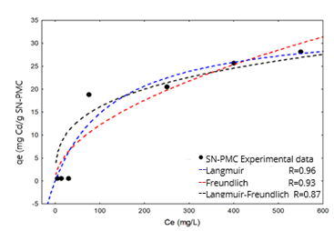

Isotherm models at 25°C and pH 4 in PMC and SN-PMC.
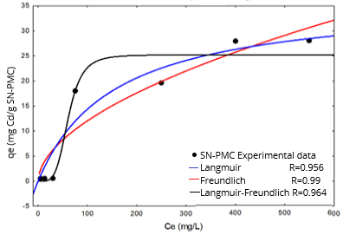
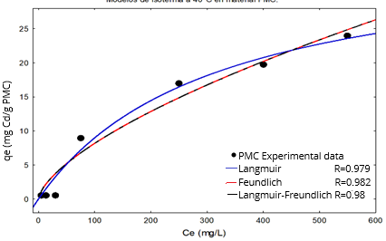

Isotherm models at 25°C and pH 3 in PMC and SN-PMC.
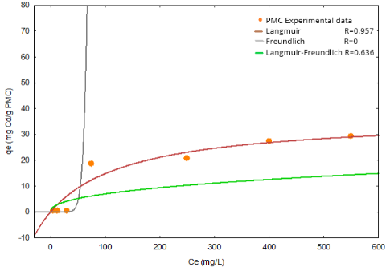
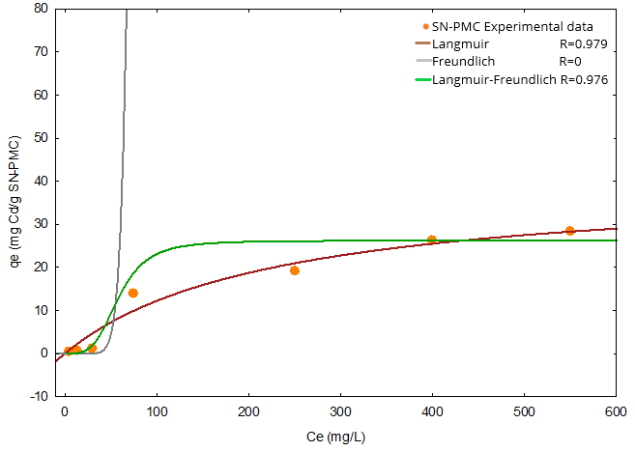

Isotherm models at 30°C and pH 5 in PMC and SN-PMC.
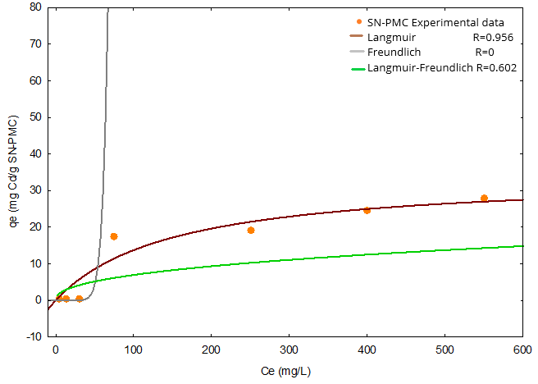
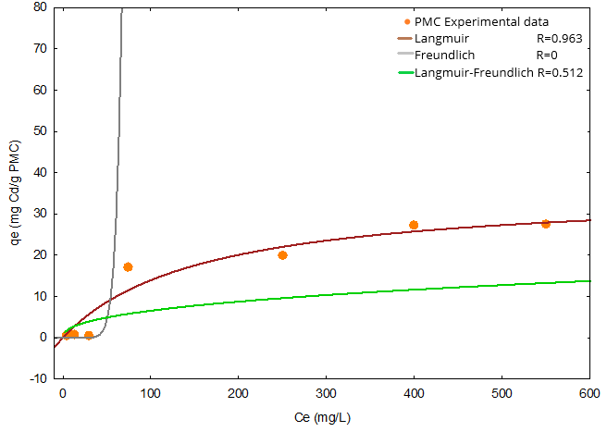

Isotherm models at 30°C and pH 4 in PMC and SN-PMC.
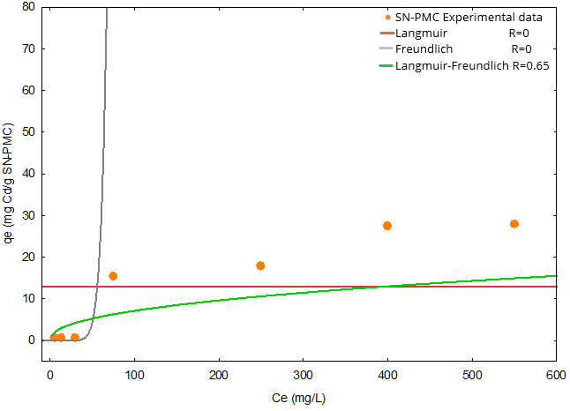
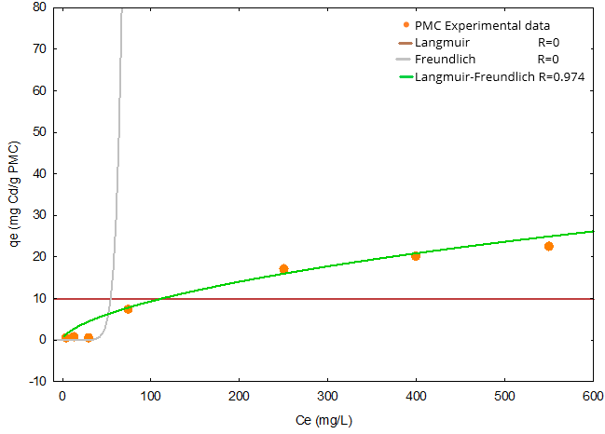

Isotherm models at 30°C and pH 3 in PMC and SN-PMC
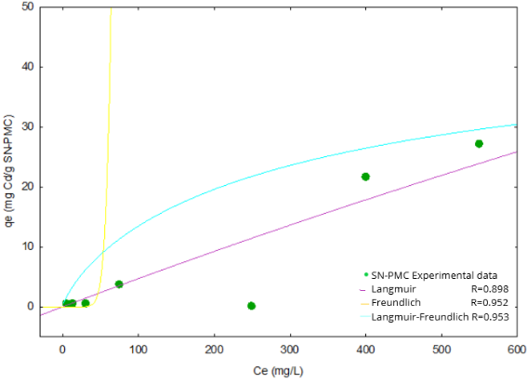
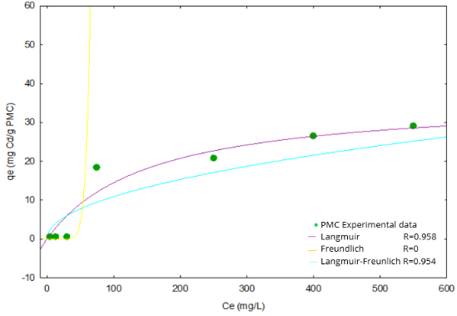

Isotherm models at 40°C and pH 5 in PMC and SN-PMC.
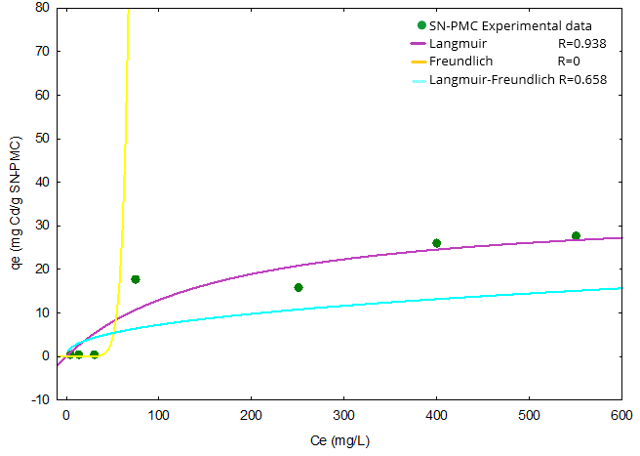
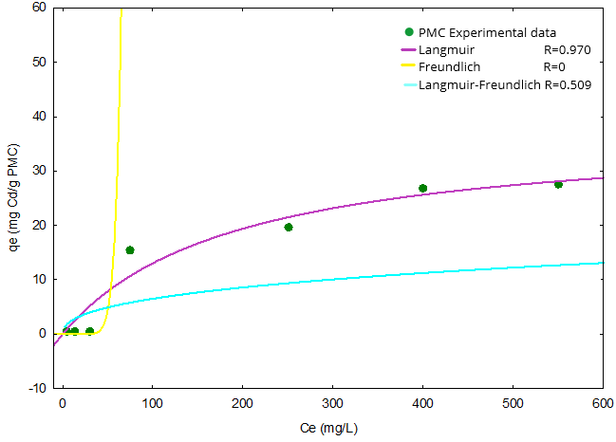

Isotherm models at 40°C and pH 4 in PMC and SN-PMC.
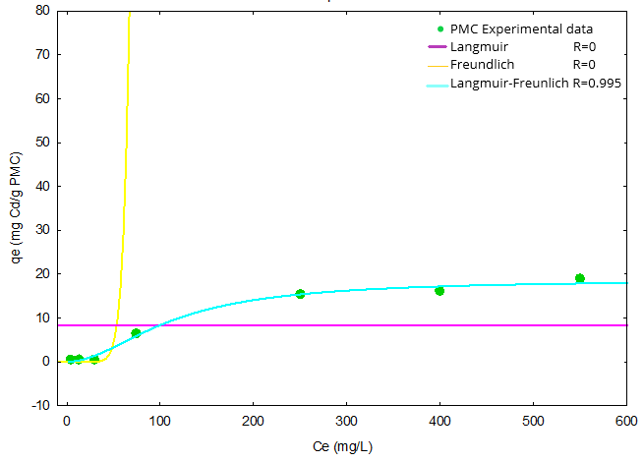
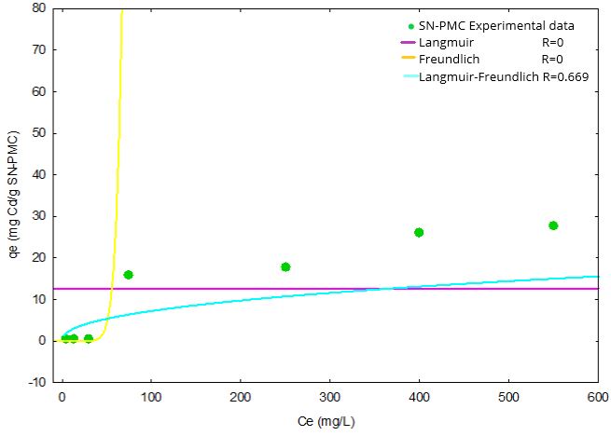

Isotherm models at 40°C and pH 3 in PMC and SN-PMC.

Variance Analysis

Variance Analysis
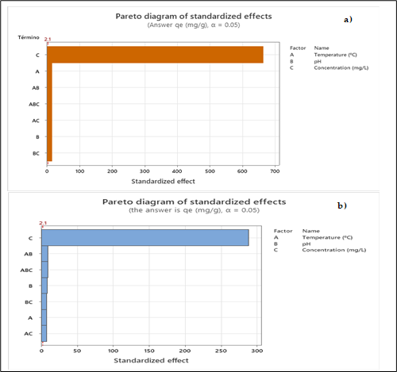

Pareto diagram a) PMC and b) SN-PMC

Variance Analysis of the adjusted models with respect to PMC adsorbent.
Fountain | GL | SC Adjust. | MC Adjust. | F value | P Value
Model | 17 | 5979.83 | 351.75 | 26988.23 | 0.000
Lineal | 5 | 5845.20 | 1169.04 | 89694.09 | 0.000
Temperature (°C) | 2 | 79.38 | 39.69 | 3045.09 | 0.000
pH | 2 | 19.61 | 9.81 | 752.35 | 0.000
Concentration (mg/L) | 1 | 5746.21 | 5746.21 | 440875.58 | 0.000
2-term interactions | 8 | 116.18 | 14.52 | 1114.22 | 0.000
Temperature (°C)*pH | 4 | 18.47 | 4.62 | 354.31 | 0.000
Temperature (°C)*Concentration (mg/L) | 2 | 78.91 | 39.46 | 3027.34 | 0.000
pH*Concentration (mg/L) | 2 | 18.79 | 9.40 | 720.91 | 0.000
3-term interactions | 4 | 18.45 | 4.61 | 353.95 | 0.000
Temperature (°C)*pH*Concentration (mg/L) | 4 | 18.45 | 4.61 | 353.95 | 0.000
Error | 18 | 0.23 | 0.01
Total | 35 | 5980.07
S | R-squared | R squared (adjusted) | R squared (pred)
0.1142 | 100.00% | 99.99% | 99.98%
S | R-squared | R squared (adjusted) | R squared (pred)
0.1142 | 100.00% | 99.99% | 99.98%

Variance Analysis of the adjusted models with respect to PMC adsorbent.

Table. Variance Analysis of the adjusted models with respect to SN-PMC.
Fountain | GL | SC Adjust. | MC Adjust. | F Value | P Value
Model | 17 | 7158.21 | 421.07 | 4920.81 | 0.000
Linear | 5 | 7119.76 | 1423.95 | 16640.90 | 0.000
Temperature (°C) | 2 | 6.56 | 3.28 | 38.31 | 0.000
pH | 2 | 7.29 | 3.65 | 42.61 | 0.000
Concentration (mg/L) | 1 | 7105.91 | 7105.91 | 83042.62 | 0.000
2-term interactions | 8 | 26.08 | 3.26 | 38.10 | 0.000
Temperature (°C)*pH | 4 | 12.86 | 3.21 | 37.57 | 0.000
Temperature (°C)*Concentration (mg/L) | 2 | 6.47 | 3.24 | 37.82 | 0.000
pH*Concentration (mg/L) | 2 | 6.75 | 3.37 | 39.44 | 0.000
3-term interactions | 4 | 12.37 | 3.09 | 36.15 | 0.000
Temperature (°C)*pH*Concentration (mg/L) | 4 | 12.37 | 3.09 | 36.15 | 0.000
Error | 18 | 1.54 | 0.09
Total | 35 | 7159.75

Table. Variance Analysis of the adjusted models with respect to SN-PMC adsorbent.
S | R-squared | R squared (adjusted) | R squared (pred)
0.2925 | 99.98% | 99.96% | 99.91%

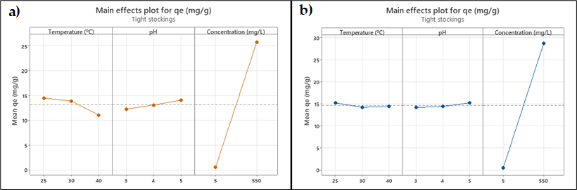

Pareto diagram a) PMC and b) SN-PMC.

Factor | Niveles | Valores
Temperature (°C) | 3 | 25, 30, 40
pH | 3 | 3, 4, 5
Concentration (mg/L) | 2 | 5, 550
Table. Factor information in PMC.

Table. Factor information in SN-PMC.
Factor | Niveles | Valores
Temperature (°C) | 3 | 25, 30, 40
pH | 3 | 3, 4, 5
Concentration (mg/L) | 2 | 5, 550

Effects and interactions of analysis of variance

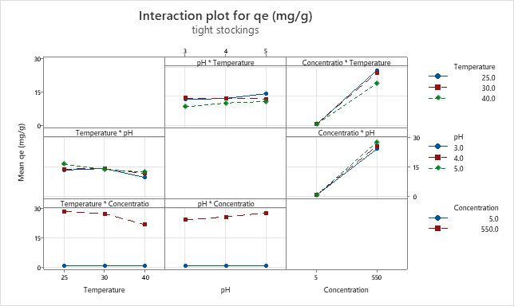

Interaction of factors (pH, Temperature, Concentration) in PMC.

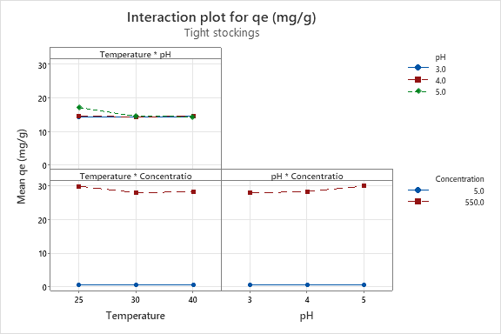

Interaction of factors (pH, Temperature, Concentration) in SM-PMC.
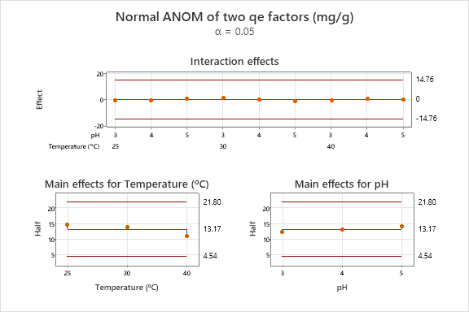

Interaction of the effects of factors (Temperatura, pH) in PMC.

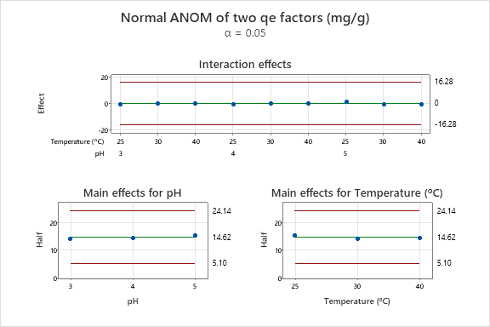

Interaction of the effects of factors (Temperatura, pH) in SN-PMC.

