Supplementary materials

Exfoliation of graphite via three-roll milling and production of films with high electrical conductivity and electromagnetic-wave shielding properties using exfoliated graphite

Emi Orihara¹, Ryota Takei¹, Kyohei Ssugata¹ and Yoshihiko Arao^{1,2*}
¹ Department of Applied Mechanics and Aerospace Engineering, Waseda University, 3-4-1 Okubo, Shinjuku-ku, Tokyo 169-0072, Japan
²Kagami Memorial Research Institute for Materials Science and Technology, Waseda University, 2-8-26 Nishiwaseda, Shinjuku-ku, Tokyo, 169-0051, Japan

*Corresponding author E-mail: arao@waseda.jp

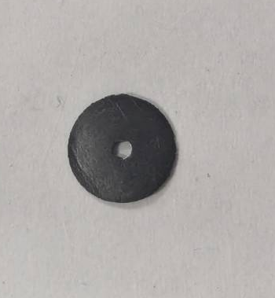
S1. Method for measuring electromagnetic shielding Effect
(b)
(a)
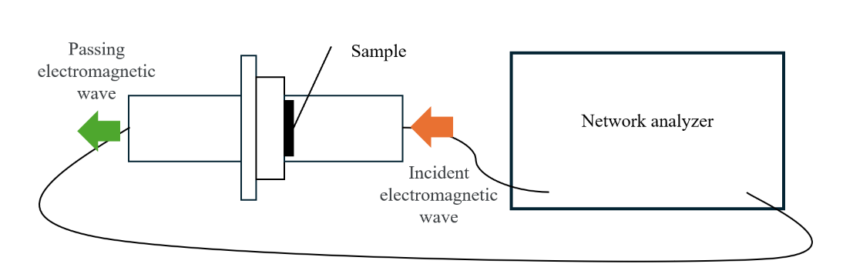
Fig. S1 Method of shielding measurement. (a) Image of coaxial transmission line method. (b) Sample film.
To measure the shielding effectiveness (SE), the coaxial transmission line method was employed. In this method, the shielding material is processed into a coaxial cylindrical shape and placed between the transmitter and receiver of a network analyzer. Electromagnetic waves are emitted from the transmitter, and the amount transmitted through the shielding material is received by the receiver, allowing the SE to be evaluated. A microwave network analyzer (KEYSIGHT, N5242B PNA) was used as the network analyzer, and a coaxial test fixture (GPC7) was used to mount the shielding material. The film was processed into a coaxial cylindrical shape by first drilling a 2.1 mm diameter hole in the center using a bench drill (Enshu Industry, ESD-3500DX), then punching out an 8 mm diameter disc using a punch tool (Three H, SP11) so that the center aligned with a pre-drilled 1.9 mm hole.

S2. Particle size and thickness distribution of GNP
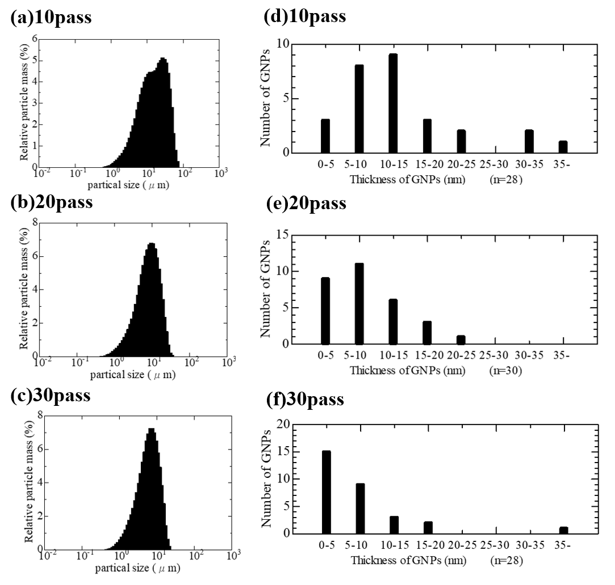
Fig.S2 GNP made by 3 roll mill. (a~c) Size distribution of GNP at (a) 10 pass count, (b) 20 pass count, (c) 30 pass count (d~f) Thickness distribution of GNP at (a) 10 pass count, (b) 20 pass count, (c) 30 pass count.

S3. Change in operation method of three-roll mill
In order to investigate the limits of peeling, the roll mill operation method was changed and the mill was operated. The normal operation method is shown in Fig. S3 (a), and the above experiment was also conducted using this method. In this study, this operation method is referred to as cycle operation. Cycle operation refers to an operation in which one cycle consists of the slurry passing from the inlet to the Feed/Center roll, then to the Center/Apron roll, and finally being recovered by the scraper, with this cycle being repeated. In cycle operation, when the roll gap is fixed, uniform shear and compressive forces can be applied to the entire slurry. This method is a common operating method used in many literature references involving roll mill.[S1][S2][25]
Another method is continuous operation, as shown in Fig. S3 (b). By not using a scraper, the slurry circulates between the Feed/Center rolls, Center/Apron rolls, Apron/Center rolls, and Center/Feed rolls. Chen et al. [29] reported that continuous operation for 12 hours resulted in the production of a nanocomposite with an average thickness of 1.13–1.41 nm and an electrical conductivity of 75 S/cm. Continuous operation allows shear and compressive forces to be applied to the slurry multiple times.
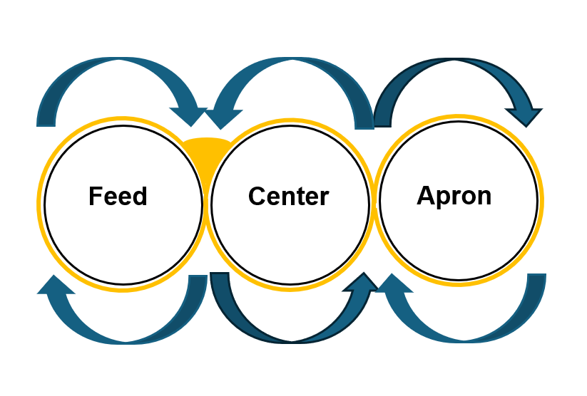
(b)
(a)
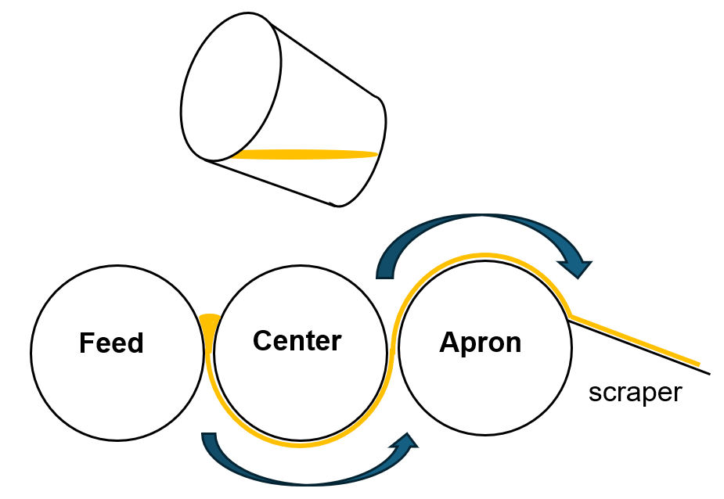
Fig.S3 Image of (a) intermittent (cycle) mechanical exfoliation / (b) Continuous mechanical exfoliation.

In continuous operation, graphite (Wako, particle size: 15 µm) was used. A graphite/CMC solution was prepared using F350HC at 0.5 wt%, like Section 2.2 of the main text. This slurry was exfoliated for 2, 4, and 6 hours under the same conditions in a roll mill. The GNP produced by exfoliation had a shape similar to that shown in Fig. S4(a–c). Compared to the TEM images of cyclic operation shown in Fig. 3(a), (c), and (e) in the main text, more fine wrinkles were observed. Fig. S4(d) shows the Raman shift of GNP, and compared to Fig. 3(g) in the main text, despite the increased number of passes through the rollers, the defects in GNP did not increase sharply. The average thickness, average particle size, and aspect ratio of GNP are shown in Table S1. Compared to cyclic operation, the decrease in average thickness was less pronounced in continuous operation. Additionally, the thickness distribution is shown in Fig. S5(b). In continuous operation, a greater proportion of thicker GNP remained compared to cyclic operation. However, thinner GNP was also observed, suggesting that shear force was applied only to certain areas, while other areas were less susceptible to shear force. Furthermore, to focus on GNP subjected to shear forces over multiple cycles, the proportion of GNP thinner than 5-0 nm—the thickness at which graphene properties begin to emerge—was investigated. However, this proportion did not increase with prolonged processing time. Therefore, even with roll mill processing, it is considered difficult to achieve an average thickness of less than 6-7 nm in this experimental system.

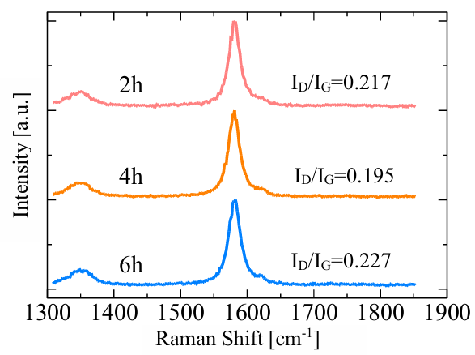
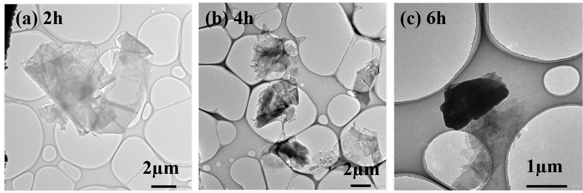
(d)

Fig.S4 Structure of GNP made by Continuous mechanical exfoliation. (a~c) TEM image of GNP made by F350HC(CMC) slurry through (a) 2h, (b) 4h, (c) 6h. (d) Raman spectrum of GNP made by different time of Continuous mechanical exfoliation.

Table S1 Characteristics of Graphene made by Continuous mechanical exfoliation
Sample | Thickness  (nm) | particle size  (µm) | aspect ratio
2h | 14.3±10.7 | 7.64 | 534
4h | 15.6±9.72 | 5.74 | 368
6h | 12.9±7.91 | 4.47 | 347

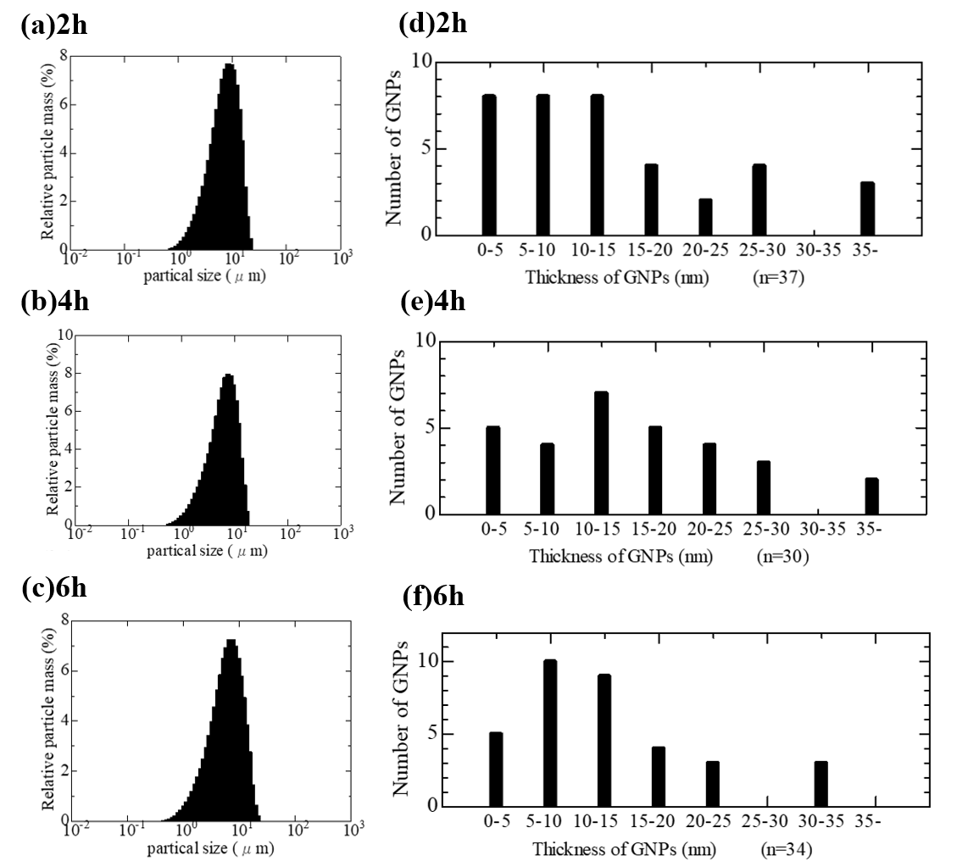
Fig.S5 GNP made by 3 roll mill. (a~c) Size distribution of GNP at (a) 2h, (b) 4h, (c) 6h. (d~f) Thickness distribution of GNP at (a) 2h, (b) 4h, (c) 6h.

S4. Energy conversion method of shear force
To calculate the shear force, the following equation proposed by Tsurutani [S3] et al. was used:

$$\begin{aligned}\begin{aligned}f=\frac{KµLπR^{2}N_{a}\left(1+n\right)}{h_{a}}\#\end{aligned}\#\left(1\right)\end{aligned}$$
where:
f: shear force [dynn]
$K$: constant
$µ:$viscosity [P]
$L:$ roll length [m]
$R:$roll radius [m]
$N_{a}:$rotational speed of the roll [rpm]
$n:$rotation ratio between the rolls
$h_{a}:$gap between the rolls [m]

Although the set gap between the center and apron rolls was 0 µm, in practice, the rolls are slightly pushed apart as the slurry passes through, creating an unavoidable gap. Therefore, in the calculated, the gap was assumed to be 1 µm.

S5. Summary of experimental data
Table S2 Summary of GNP Size, Electrical Conductivity, SE, and SSE in Films Prepared with Varying Graphite Size, Polymer Type, and Roll mill Passes
Graphite  size  [µm] | Polymer | Roll-mill  pass count  [pass] | GNP particle size  after mill  [µm] | Film’s  thickness  [mm] | Film’s  Density  [g/cm3] | Film’s  Electrical conductivity  [S/cm] | Film’s  SE  [dB] | Film’s  SSE  [dB/mm]
70 | CMC_{M} | 10 | 10.2 | 0.0624 | 1.85 | 54.0 | -27.2 | -436
70 | CMC_{M} | 20 | 6.57 | 0.0516 | 1.80 | 128 | -27.1 | -525
70 | CMC_{M} | 30 | 5.09 | 0.0518 | 1.71 | 81.5 | -24.9 | -481
500 | CMC_{M} | 10 | 17.6 | 0.0226 | 1.90 | 151 | -16.2 | -718
500 | CMC_{M} | 20 | 15.3 | 0.0388 | 1.70 | 165 | -29.9 | -770
500 | CMC_{M} | 30 | 13.1 | 0.0330 | 1.86 | 106 | -24.8 | -750
500 | CMC_{H} | 10 | 4.00 | 0.0318 | 1.18 | 54.9 | -21.3 | -668
500 | CMC_{H} | 20 | 3.93 | 0.0254 | 1.49 | 109 | -21.2 | -833
500 | CMC_{H} | 30 | 3.98 | 0.0182 | 1.81 | 129 | -21.3 | -1169
500 | PAA | 10 | 7.29 | 0.0507 | 1.94 | 773 | -38.8 | -766
500 | PAA | 20 | 6.91 | 0.0521 | 1.94 | 639 | -38.5 | -738
500 | PAA | 30 | 4.77 | 0.0580 | 1.90 | 389 | -32.6 | -562

Table S2 summarizing the graphite particle size used, the type of binder included in the slurry during exfoliation, the number of roll-milling passes, and the resulting GNP size in the fabricated films, along with their electrical conductivity, SE, and SSE.

Table S3 Thickness, density, electrical conductivity, SE, and SSE of pGNP/CMC-M and pGNP/PAA films
 | Polymer | Film’s  thickness  [mm] | Film’s  Density  [g/cm3] | Film’s  Electrical conductivity  [S/cm] | Film’s  SE  [dB] | Film’s  SSE  [dB/mm]
pGNP | CMC_{M} | 0.0586 | 1.98 | 140 | -33.0 | -564
pGNP | PAA | 0.0566 | 1.97 | 171 | -34.0 | -600

Table S3 summarizes the thickness, density, electrical conductivity, SE, and SSE of the purchased GNP films combined with CMC or PAA.

S6. Confirmation of the orientation and doping of GNP/PAA film
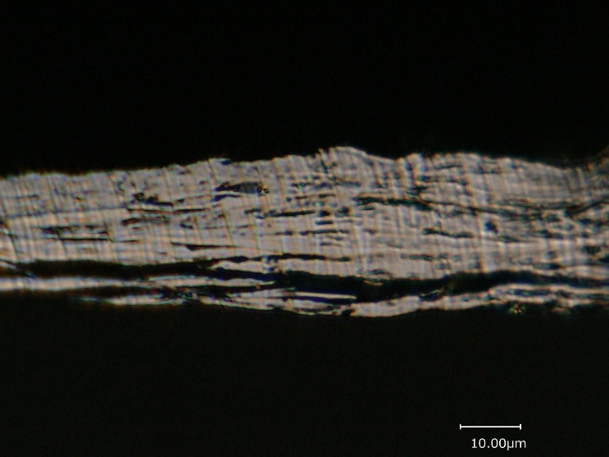
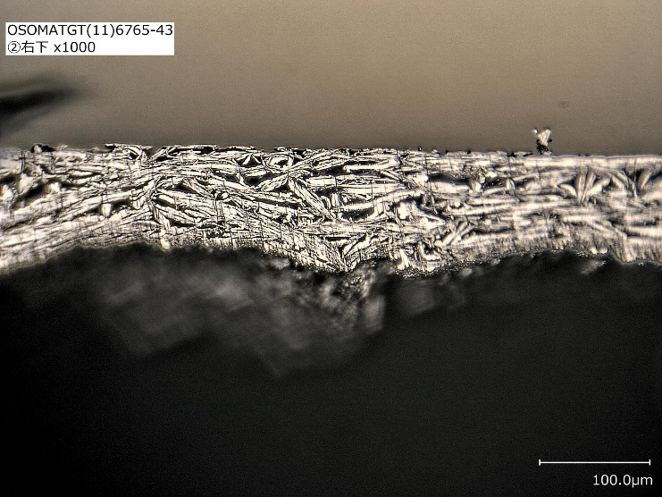
To confirm the orientation state of the GNP/PAA film, the cross section was exposed by laser processing using a cross section polisher and observed with a 3D microscope. The results are shown in Fig. S6(a). For comparison, the cross section of the GNP/CMC film is shown in Fig. S6(b). These observations were performed without press processing. PAA films are brittle and cannot be peeled off from the PET film substrate unless they have a certain thickness. Therefore, GNP/PAA films are thicker than GNP/CMC films (Table S2).The observations revealed that GNP/PAA films have significantly lower orientation than GNP/CMC films, with many GNPs layered at large angles or nearly perpendicular to the film surface. This is thought to be due to the low flexibility of the flakes caused by the large thickness and low aspect ratio of the GNP, making it difficult to align compared to CMC. Additionally, the brittleness and lack of flexibility of the PAA film are also suspected to contribute to the poor alignment of the GNP.
- GNP/CMC_{M}
- GNP/PAA
Fig.S6 Cross section of the film without pressing, prepared by processing GNP in a (a) PAA / (b) CMC_{M} containing slurry through 10 passes with a three-roll mill.

In doping-related research, the peak shift of the G band is used as a method to quantify the doping level. The peak shift is caused by the interaction between the electronic structure of GNP and phonons. The G band (approximately 1581 cm⁻¹) is a peak originating from the vibration of C–C bonds in the carbon lattice. When p-type doping occurs, carriers are introduced into the valence band, causing a change in the electronic band structure and a decrease in the Fermi level. As a result, the energy of the C–C bond vibration mode increases, phonon damping is suppressed, and the G band peak shifts toward higher wavenumbers. Based on this principle, this study attempted to quantify the doping effect of PAA through the peak shift of the G band.
To confirm the doping level, intensity mapping was performed in the range of 1550 to 1610 cm⁻¹ using a micro-Raman spectrometer (RENISHAW inVia RefreX). The measurement range was 35 × 45 µm, with a total of 1575 measurement points, and the spot size was set to 1 µm in diameter. For each acquired spectrum, 1581 cm⁻¹ (G band) was used as a reference, and a mapping image was created to identify the intensity ratio based on the peak position using colors. Fig. S6 shows the mapping image of the G band peak. Comparing the GNP/PAA film (a) and the GNP/CMC film (b), a peak shift is observed over a wide range in the GNP/PAA film, indicating significant p-type doping. On the other hand, the peak shift is limited in the GNP/CMC film, suggesting the possibility of n-type doping by Na⁺ in some areas. The average peak position of the G band in the GNP/PAA film is 1582.1 cm⁻¹, showing a shift of approximately 1 cm⁻¹ compared to the undoped state.
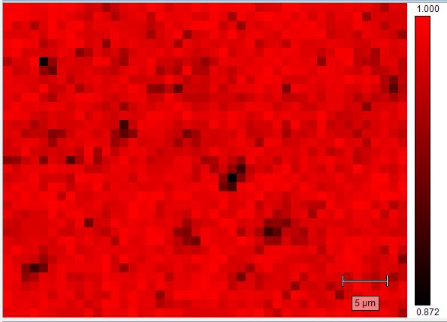
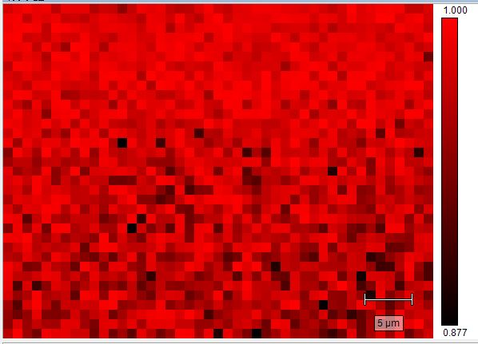
- GNP/CMC_{M}
- GNP/PAA
Fig. S7 Intensity mapping of G band of Raman spectrum. (a) GNP/PAA, (b) GNP/CMC_{M} film.

S7. Approach to evaluate the shielding mechanism of the film
This chapter describes the method to examine the shielding mechanism. In many previous papers, a method called Calculated theory, which uses scattering parameters to theoretically quantify the shielding mechanism, has been commonly used. However, in the coaxial tube method used in this study, incomplete impedance matching between the network analyzer and the fixture during measurement was observed, and it was determined that estimating the mechanism from scattering parameters was inappropriate. Therefore, in this study, we extended Schelkunoff’s theory to identify the mechanism.
We clarified the mechanism based on Schelkunoff's theory, that only absorption loss is proportional to film thickness. Specifically, we measured the shielding effect of films of different thicknesses formed from the same slurry. We performed a least-squares linear approximation of the relationship between the average shielding effect and film thickness, extended the approximation line, and assumed that only absorption loss occurs when the film thickness is zero. We calculated the ratio of absorption and reflection losses for each thickness. The film thickness, density, electrical conductivity, and shielding effect at this point are shown in Fig. 7(a) and Table S3. Compared to the experiments in the main text, despite the higher height of the doctor blade, the film thickness ranges from the same level to slightly thicker. This is because the condensation caused by the cooler to suppress shear heat varies, making it dependent on the environment in which the roll mill is operated. Since this varies each time, it is important to use the same roll mill-processed slurry to form films of various thicknesses. The density and electrical conductivity of the films produced at this time were constant, suggesting that films with the same structure were produced. The shielding effect increased as expected with thicker films.
Fig. 7(b) shows the relationship between film thickness and average shielding effect. From this plot, the reflection loss was calculated to be 22.81 dB, and the contribution of absorption loss per thickness was calculated to be 114.5 dB/mm using the least squares method. Table 7(c) summarizes the shielding mechanisms for each thickness based on this content.

Table S4 Characteristics of GNP/CMC films using the same slurry and different doctor blade heights
Doctor blade height  mm | Films’ thickness  mm | Density  g/cm³ | Electrical conductivity  S/cm | Average of SE  dB
1 | 0.0474 | 1.88 | 215.4±7.14 | 28.61
2 | 0.0632 | 1.83 | 210.1±17.5 | 29.30
3 | 0.0788 | 2.01 | 227.5±18.3 | 32.21

This method can be used to calculate reflection loss and absorption loss based on theory. However, when discussing shielding mechanisms, reflection loss and absorption loss are generally based on calculated theory. For comparison purposes, reflection loss and absorption loss based on Schelkunoff's theory are calibrated to reflection loss and absorption loss based on Calculated theory. To do this, it is necessary to describe each theory.
The decisive difference between these theories is whether they focus on the magnitude of the electric field or the power. In Schelkunoff's theory, if the magnitudes of the electric fields of the incident wave, reflected wave, and transmitted wave are denoted by $E_{i}, E_{r}$ and $E_{t}$, respectively, then
$$\begin{aligned}SE_{R}=-20\log_{10}\left(1-{\left(\frac{E_{r}}{E_{i}}\right)}^{2}\right)\#\left(2\right)\end{aligned}$$
$$\begin{aligned}SE_{A}=-20\log_{10}{\frac{\frac{E_{t}}{E_{i}}}{1-{\left(\frac{E_{r}}{E_{i}}\right)}^{2}}}\#\left(3\right)\end{aligned}$$
$$SE_{R}:Reflection loss in Schelkunoff's theory, SE_{A}: Absorption loss in Schelkunoff's theory$$
are shown. Next, in Calculated theory,
$$\begin{aligned}SE_{R}'=-10\log_{10}\left(1-{\left(\frac{E_{r}}{E_{i}}\right)}^{2}\right)\#\left(4\right)\end{aligned}$$
$$\begin{aligned}SE_{A}'=-10\log_{10}{\frac{{\left(\frac{E_{t}}{E_{i}}\right)}^{2}}{1-{\left(\frac{E_{r}}{E_{i}}\right)}^{2}}}\#\left(5\right)\end{aligned}$$
$$SE_{R}':Reflected loss in Calculated theory, SE_{A}':Absorbed loss in Calculated theory$$
are shown.
In Schelkunoff's theory, reflection loss refers to the amount of attenuation of the transmitted wave caused by the reflection of electromagnetic waves at the boundary of the shielding material. Since it is defined based on the phenomenon of reflection itself, both reflections within the shielding material and reflections at the exit boundary of the shielding material are treated as reflection loss as long as they cause attenuation of the transmitted wave. On the other hand, in Calculated theory, reflection loss refers only to the energy emitted when electromagnetic waves return to the incident space. In other words, if waves reflected inside the shielding material are absorbed internally rather than returning to the outside, they are classified as absorption loss rather than reflection loss. Therefore, reflections at the exit boundary of the shielding material are treated as reflection loss in Schelkunoff's theory and as absorption loss in Calculated theory. This difference becomes particularly pronounced when the shielding material has sufficient thickness and the reflected waves at the exit boundary of the shielding material are ultimately absorbed internally. Since the two theories fundamentally differ in their definitions of reflection loss and absorption loss, it is necessary to clearly distinguish which theory is being used when discussing the breakdown of shielding effects.
From these equations, it is show that the reflection loss in Calculated theory is half that in the Schelkunoff's theory. Furthermore, since the shielding effect SE remains unchanged in both theories, the absorption loss increases in Calculated theory to compensate for the smaller reflection loss.
$$\begin{aligned}SE^{'}=SE\#\left(6\right)\end{aligned} \\ \begin{aligned}SE_{R}'=\frac{1}{2}SE_{R}\#\left(7\right)\end{aligned}$$
$$\begin{aligned}SE_{A}'>SE_{A}\#\left(8\right)\end{aligned}$$

Therefore, as shown in Fig. S7, the absorption loss was calculated based on the Schelkunoff's theory, and the reflection loss and absorption loss in the Calculated theory were calculated from the measured total SE. The results are shown in Fig. 10 and Table S4. This method is applicable under the assumption that multiple reflection losses are negligible in Schelkuno theory. However, the obtained absorption loss values confirmed that multiple reflection losses were extremely small, clearly indicating that this assumption was valid.

Table S5 Reflection and Absorption Losses Calculated Based on the Schelkunoff’s Theory and Calculated Theory
for GNP/CMC Films Prepared with Different Doctor Blade Heights
Doctor blade height  mm | Films’ thickness  mm | Reflection loss in Schelkunoff's theory  dB | Absorption Loss of Schelkunoff's theory  dB | Reflection loss in Calculated theory  dB | Absorption loss in Calculated theory  dB
1 | 0.0474 | 22.81 | 5.4273 | 11.405 | 16.8323
2 | 0.0632 | 22.81 | 7.2364 | 11.405 | 18.6414
3 | 0.0788 | 22.81 | 9.0226 | 11.405 | 20.4276

From the above, the evaluation of reflection and absorption losses obtained by this method is reasonable, and it is useful that the shielding mechanism can be explained using the Schelkunoff's theory, which is easy to understand visually and formally, especially when organizing the contributions of reflection and absorption. Although this method is labor-intensive, it is a very effective and attractive approach in that it can clearly separate and analyze the components of the shielding effect.

S.8 Comparison with other studies

Table S6 Compare with other studies
 | Graphene-  based  material | Polymer  (polymer Concentration) | Film’s thickness  µm | Electrical  Conductivity  S/cm | Shielding  Effect  dB | Film  Fabrication  method | Film  Formation  method
[S4] | rGO | SF(2.5wt%) | 5 | 13.5 |  | Hammer method  chemical reduction | Vacuum filtration
[S5] | rGO | PAPB(4wt%) | 10-12 | 337 |  | Modified Hummers method  HI reduction | casting
[13] | PG | PI(10wt%) | 10 | 780 | 43.8 | Sonication 2h  1000℃ annealing, etching | SCC  method
[S6] | rGO | PAA(10wt%) |  | 95.5 |  | modified Hummer's method  HI reduction | vacuum assisted filtration
[S7] | rGO | CS(10wt%) | 3 | 140.4 |  | modified Hummer's method  HI reduction | Vacuum filtration
[12] | rGO | ANF(10%) |  | 84.9 | 25.6 | Sonication 1h  HI reduction | Vacuum filtration
[S8] | rGO | PVA(20wt%) | 10 | 52.65 |  | Modified Hummers method  HI reduction | casting
[S9] | GNP | BC(20wt%) | 38 | 76.9 | 36.4 | Sonication 0.5h | Vacuum filtration
[S10] | 3D  Graphene | PANI(20wt%)  (conductive polymer) |  | 50 |  | Reduction  heating at 100°C for 24h  calcining at 600 °C for 4 h | Chemical Vapor Deposition
[S11] | fGNP | PANF(10wt%) | 21 | 55.21 | 47 | Sonication 3h  heated at 100°C for 2h, 200°C for 1h and 300°C for 1 h | Vacuum filtration
[32] | Gn | NFC(10wt%) | 13 | 988.2 | 43 | Sonication 0.5h  TEMPO Oxidation  Press 150MPa | Vacuum filtration
[S12] | MWCNT | WPU(23.8wt%) | 50 | 21 | 24 | Sonication 15min 400W  Heating at 70 °C for 5 h | casting
[S13] | MWCNT | CNF(25wt%) | 150 | 30.24 | 45.8 | Sonication 2h  TEMPO Oxidation  Hot press 10MPa, 60℃ | Vacuum filtration
[S14] | A-CNT | PANI(30wt%) | 5 | 3009 | 70 | APS reduction  CSA doping | casting
This work | GNP | CMC(10wt%) | 51.6 | 128 | 27.1 | Press 100MPa | Doctor  blade

Films from other studies that contain more than 70% carbon-based materials and are composed of a single polymer and carbon material, with a thickness of less than 1 mm, were compared with our experimental results. The comparison clearly highlights how few films exist that have not undergone thermal treatment or oxidation–reduction processes. Furthermore, it was found that most previous studies employed fabrication methods such as vacuum filtration, SSC method, or vapor deposition, which are not suitable for large-scale production. Meanwhile, the electrical conductivity of our film was found to be at an intermediate level compared to conventional shielding films.

S.9 Tensile test
Tensile tests were conducted using a universal testing machine (SHIMADZU, AG-I-250 kN) to evaluate the mechanical properties of the films. Because the CMC-based films exhibit strong hygroscopic behavior and their tensile properties are highly sensitive to moisture content, all specimens were dried in a vacuum oven at 30 °C for more than 60 min prior to testing. A 1 kN load cell was used, with a gripping length of 10 mm and a gauge length of 20 mm. The crosshead speed was set to 1.0 mm min⁻¹. To prevent slippage during testing, a sheet of #1200 sandpaper was inserted between the specimen and the grips. In addition, a preload of 0.5 kN was applied to remove any slack before starting the measurement. Tensile stress and strain were calculated from the recorded load and stroke, and the Young’s modulus was determined from the slope of the stress–strain curve within the strain range of 0.05–0.25%. The tensile strength and Young’s modulus for each composition were obtained as the averages of five specimens. The stress–strain curves for both the GNP/CMC and GNP/PAA films exhibit typical brittle fracture behavior, which is reasonable given the high GNP loading of 90 wt%. At such a high filler content, the mechanical response is dominated by the rigid percolated GNP network, leading to limited plastic deformation for both systems.
Despite their similarly brittle nature, the GNP/CMC films show higher tensile stress and strain at break compared to the GNP/PAA films. This difference is likely attributed to variations in the interfacial interactions and the dispersion state of GNP within each polymer matrix. CMC, possessing abundant hydroxyl and carboxymethyl functional groups, may provide stronger interfacial adhesion with the GNP surfaces, resulting in more efficient stress transfer under tensile loading. Moreover, the CMC matrix may distribute local stress concentrations more uniformly than PAA, thereby delaying crack initiation and allowing slightly greater deformation prior to failure. In contrast, the weaker interfacial bonding and more heterogeneous microstructure in the GNP/PAA films likely promote earlier crack propagation, leading to lower tensile strength and reduced strain at fracture.
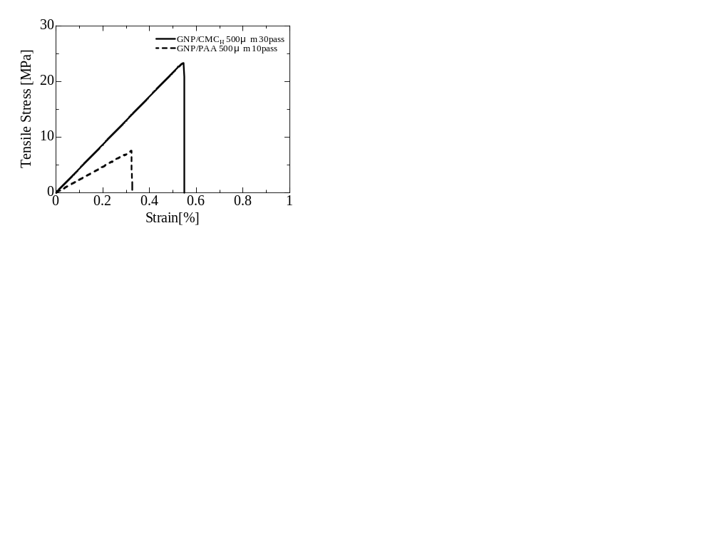
Fig. S8 Stress–strain curves of GNP/PAA and GNP/CMC_{H} films. Both films were prepared from graphite with an initial particle size of 500 µm. The GNP/PAA film was processed with the three-roll mill for 10 passes, while the GNP/CMC_{H} film was processed for 30 passes.

Table S7 Tensile strength and Young's modulus of GNP/PAA and GNP/CMC_{H} films
 | Graphite size [µm] | Roll-mill pass count [pass] | Tensile strength [MPa] | Young's modulus [GPa]
GNP/CMC_{H} | 500 | 30 | 24.34±4.15 | 4.565±0.520
GNP/PAA | 500 | 10 | 7.553±0.95 | 2.241±0.360

References
[S1] W. Xin, X. Yang, J. Huang, S. Yao, C. Zhi, C. Linlin, W. Zhaohui, F. Zhijun, Y. Huiyong, L. Xibao, J. Adv. Ceram. 13, 11 (2024).
https://doi.org/10.26599/JAC.2024.9220831
[S2] J. Throckmorton, G. Palmese, ACS Appl. Mater. Interfaces 7, 14870 (2015).
https://doi.org/10.1021/acsami.5b03465
[S3] T. Turitani, Chem. Ind. Dainippon Ink 51, 309 (1978).
https://doi.org/10.4011/shikizai1937.51.309
[S4] K. Hu, L.S. Tolentino, D.D. Kulkarni, C. Ye, S. Kumar, V.V. Tsukruk, Angew. Chem. Int. Ed. 52, 13784 (2013).
https://doi.org/10.1002/anie.201307830
[S5] M. Zhang, L. Huang, J. Chen, C. Li, G. Shi, Adv. Mater. 26, 7588 (2014).
https://doi.org/10.1002/adma.201403322
[S6] S. Wan, H. Hu, J. Peng, Y. Li, Y. Fan, L. Jiang, Q. Cheng, Nanoscale 8, 5649 (2016).
https://doi.org/10.1039/c6nr00562d
[S7] S. Wan, J. Peng, Y. Li, H. Hu, L. Jiang, Q. Cheng, ACS Nano 9, 9830 (2015).
https://doi.org/10.1021/acsnano.5b02902
[S8] W. Ren, W. Qian, Z. Zhang, Z. Wang, J. Wang, L. Cui, X. Zhao, D. He, J. Alloys Compd. 976, 173390 (2024). https://doi.org/10.1016/j.jallcom.2023.173390
[S9] M. Fan, J. Song, M. Qu, S. Li, R. Chen, Y. Ma, P. Tang, B. Yuezhen, ACS Appl. Nano Mater. 6, 10202 (2023). https://doi.org/10.1021/acsanm.3c01089
[S10] L. Wang, H. Bi, Q. Yao, D. Ren, S. Qu, F. Huang, L. Chen, Compos. Sci. Technol. 150, 135 (2017). https://doi.org/10.1016/j.compscitech.2017.07.001
[S11] M.C. Vu, P.J. Park, S.R. Bae, S.Y. Kim, Y.M. Kang, W.K. Choi, M.A. Islam, J.C. Won, M. Park, S.R. Kim, J. Mater. Chem. A 9, 8527 (2021).
https://doi.org/10.1039/d0ta12306d
[S12] Z. Zeng, M. Chen, H. Jin, W. Li, X. Xue, L. Zhou, Y. Pei, H. Zhang, Z. Zhang, Carbon 96, 768, (2016).
https://doi.org/10.1016/j.carbon.2015.10.004
[S13] H. Zhang, X. Sun, Z. Heng, Y. Chen, H. Zou, M. Liang, Ind. Eng. Chem. Res. 57, 17152 (2018). https://doi.org/10.1021/acs.iecr.8b04573
[S14] H. Li, X. Lu, D. Yuan, J. Sun, F. Erden, F. Wang, C. He, J. Mater. Chem. C 5, 8694 (2017).
https://doi.org/10.1039/c7tc02394d

