Supplementary Material: Metric-based correlation of the martensite distribution to degree of strain inhomogeneity in plasticity of dual phase steels
M. H. Joudivand Sarand ¹ and I. B. Misirlioglu ^{2, 3}
¹ Kraftwerk Living Technologies GmbH, Maria-Theresia-Straße 49, 4600 Wels, Austria
² Faculty of Engineering and Natural Sciences, Sabanci University, Orhanli/Tuzla, 34956 Istanbul, Turkey
³ Center of Excellence for Functional Surfaces and Interfaces for Nano-Diagnostics (EFSUN), Sabanci University, Orhanli/Tuzla, 34956 Istanbul, Turkey

In this document we provide the CPFEM analysis of the microstructural data provided in Basu et al [28] for their dual-phase steel alloy. We computed the MCF and CoV metrics that we formulate in our current manuscript for the experiments conducted therein [28]. Their data is limited to the initial distribution of ferrite and martensite phases and the strain maps after deformation. While it is possible to process the microstructural image to compute the MCF from digitalized data (See Figure S1), the strain data published therein is extracted from the deformed sample(s). Moreover, because we cannot convert their strain data into a digitally processable form, we ran the CPFEM plasticity simulation (See Ref. [26] for details) using their microstructural phase-data based on a random orientation distribution inside the ferrite phase with the martensite regions being the stiff phase. To construct the model, the phase distribution depicted in Figure S1(a) used from Basu et al.'s publication [28] is digitized through the implementation of a custom MATLAB image processing method, which is provided in Figure S1(c).
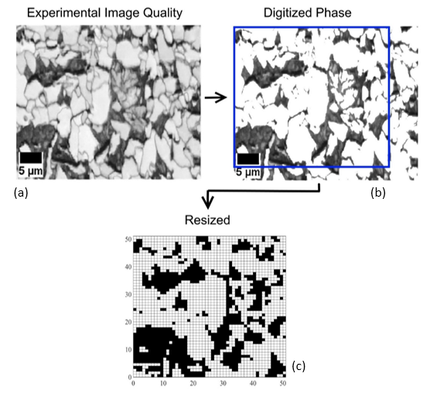
Figure S1. The procedure for processing a screenshot extracted from Figure 2 in publication of Basu et al. [28] to generate a 50 × 50 model to extract MCF via Eq. 1. In this figure, black cells represent the martensite phase, while white cells depict the ferrite phase. During this process, the martensite-to-ferrite ratio is maintained at 40.5%. The MCF is computed from the image in (c) to be 2.191.

The CPFEM simulations quite effectively replicate the overall strain distribution observed in both microstructures at 10% and 15% strain as given comparably in Figure S2. As aforementioned, we use this strain data to compute CoV as a demo case (MCF can already be retrieved from the digital data in Figure S1(c)). The CPFEM analysis of the grid in Figure S1c was carried out because the calculation of CoV and MCF requires access to specific microstructural information as explained in the main manuscript. In particular, MCF necessitates knowledge of the phase distribution of ferrite and martensite in the initial, undeformed state. This is achieved from the processed data provided in Figure S1(c). To compute CoV after applying strain to a sample (or domain), however, the strain contour must be mapped back to the undeformed configuration, a necessary step to evaluate the strain evolution and extent of inhomogeneity. Furthermore, phase boundaries should be excluded to prevent strain-induced phase redistribution from introducing artificial domain inhomogeneity, which would otherwise bias the results and render comparisons invalid. Since detailed strain contour data from the experimental study of Basu et al. [28] were not available as explained above, we resorted to the results of our numerical study for validation and comparative analysis purposes.

The strain distribution figures for 10% and 15% of externally applied strain values are displayed in Figure S2. As evident, the model has acceptably identified the localization points in comparison with the data of Basu et al [28]. The slight variation in plot intensity is attributed to the absence of experimental information regarding the initial orientation distribution in the experimental case study. Note that had this information been known to us, we would have included it in the CPFEM simulations.

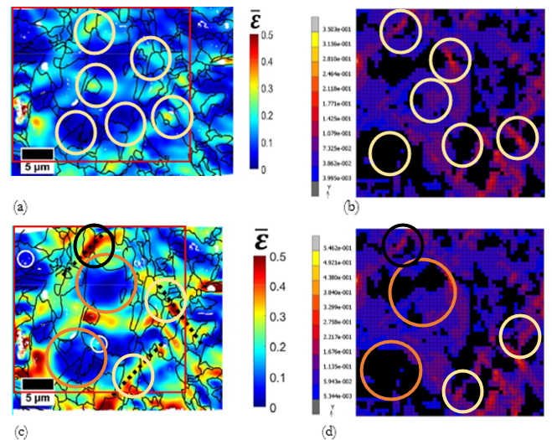

Figure R2. Strain localization and inhomogeneity reported in Ref. [28] in comparison with the CPFEM results (a) experimental strain distribution map at 10% elongation reported in Ref. [28], (b) our numerical result starting from an initial undeformed state under 10% elongation, (c) experimental reference strain distribution map at 15% elongation reported in Ref. [28], and (d) our numerical result for which the starting point was an undeformed initial state under 15% elongation. The red box in (a) and (c) shows the areal experimental distribution of strain which our CPFEM was implemented to and compared with. The CPFEM ran on the digititized phase distribution with random orientation approximation inside the phases provide results where the strain concentrations and almost zero-strain regions to a reasonable degree. The circles in both (a)-(c) and (b)-(d) denote the regions of low strain and concentrated strain regions that approximately appear in the experimental and the CPFEM results to highlight that the latter approximately follows the experiment.

The CoV value is calculated to be 0.6764 for the 15% applied strain case whose CPFEM simulated strain response is in Figure R2d. This data point is plotted in Figure 9 of the manuscript along with the MCF value (2.191).

