Association of sex steroid hormones and new bone formation rate after iliac onlay grafting: a prospective clinical pilot study
Victoria Constanze Landwehr¹, Tobias Fretwurst¹, Julia Heinen², Kirstin Vach³, Katja Nelson¹, Susanne Nahles², Gerhard Iglhaut¹
¹ Department of Oral and Maxillofacial Surgery, Center for Dental Medicine, Medical Center – University of Freiburg, Faculty of Medicine – University of Freiburg, Freiburg, Germany
² Department of Oral and Maxillofacial Surgery, Berlin Institute of Health, Corporate Member of Freie Universität Berlin, Charité – Universitätsmedizin Berlin, Humboldt-Universität zu Berlin, Berlin, Germany
^{3​} Institute of Medical Biometry and Statistics, Faculty of Medicine and Medical Center, University of Freiburg, Freiburg, Germany
Adresses:
Victoria Constanze Landwehr, Tobias Fretwurst, Katja Nelson and Gerhard Iglhaut
Department of Oral and Maxillofacial Surgery
Center for Dental Medicine
Hugstetter Straße 55
79106 Freiburg
Germany
Julia Heinen and Susanne Nahles
Department of Oral and Maxillofacial Surgery
Charité– Universitätsmedizin Berlin
Augustenburger Platz 1
13353 Berlin
Germany
Kirstin Vach
Institute of Medical Biometry and Statistics
Faculty of Medicine and Medical Center
Hebelstraße 11
79104 Freiburg
Germany

Corresponding author:
Victoria Constanze Landwehr
Department of Oral and Maxillofacial Surgery
Center for Dental Medicine
Medical Center – University of Freiburg
Faculty of Medicine – University of Freiburg
Freiburg – Germany

Telephone: 0049-761-270-49820
Fax: 0049-761-270-48010
Email: victoria.landwehr@uniklinik-freiburg.de

Supplement 1
Body mass index (BMI), 17β-estradiol, testosterone, sex hormone binding globulin and mean new bone formation (NBF) in female and male patients.
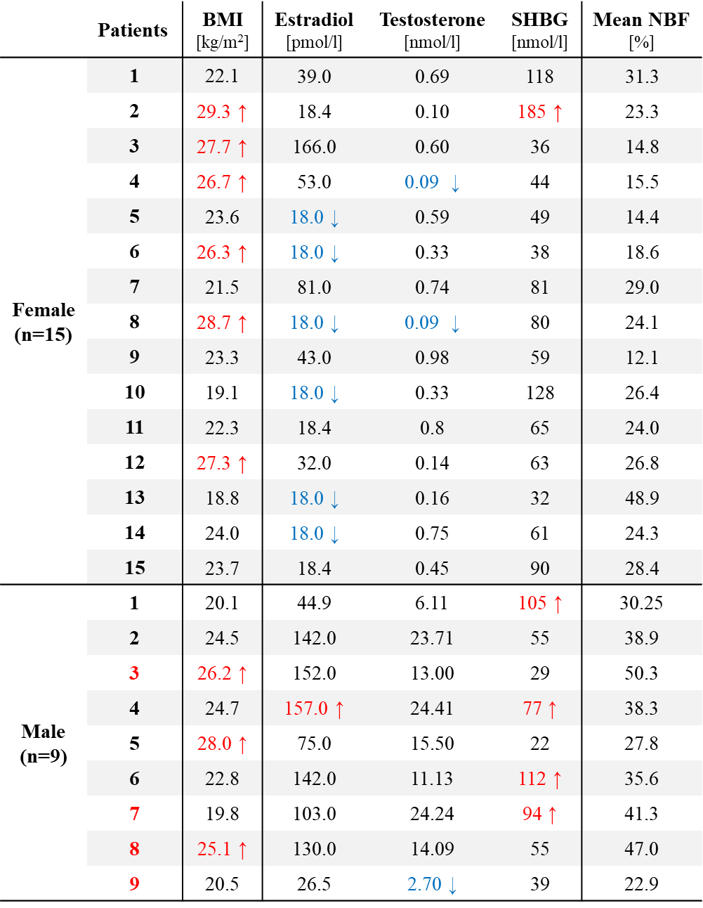
Values above the reference range and overweighted patients are colored red and marked with ↑, values below the reference range are colored blue and marked with ↓.

Supplement 2
Reference ranges (a) of the body mass index (BMI), according to the World Health Organization (WHO, 2000), regardless of gender and (b) of the sex steroid hormone serum concentrations according to the criteria of the Labor Berlin - Charité Vivantes GmbH.

Classification | BMI
Underweight | < 18.5
Normal weight | 18.5 - 24.9
Overweight or pre-obesity | 25 - 29.9
Obesity | ≥ 30

a
Gender | Estradiol serum concentration [pmol/l]
Female (postmenopausal) | 18.4 - 201
Men (> 21 years) | 28 - 156

Gender | Testosterone serum concentration [nmol/l]
Female (postmenopausal) | 0.1 - 1.6
Men (20 - 49 years) | 7.6 - 31.4
Men (> 50 years) | 4.6 - 30.9

Gender | SHBG serum concentration [nmol/l]
Female (postmenopausal) | 14.4 - 136
Men (13 - 49 years) | 10.6 - 72.3
Men (> 50 years) | 14.2 - 78.0

b

