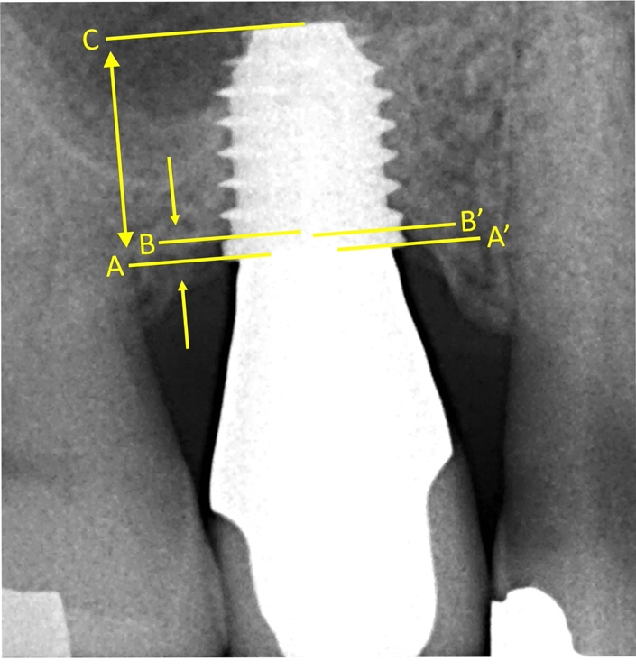

Supplementary figure 1. Measure of the marginal bone loss (MBLoss), obtained as the vertical distance between the implant shoulder and the most coronal bone-implant contact (A/B for distal MBLoss and A’/B’ for mesial MBLoss).

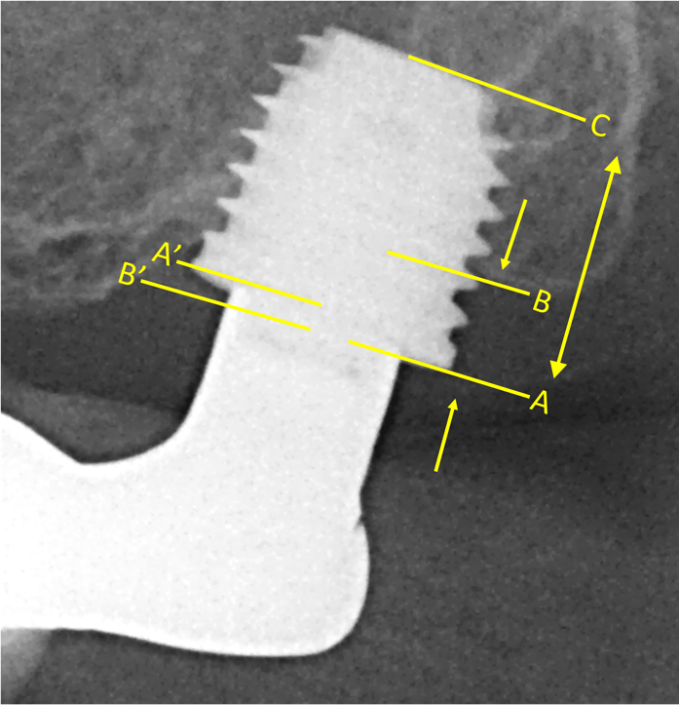

Supplementary figure 2. Measure of the marginal bone level (MBLevel), obtained as the vertical distance between the implant shoulder and the most coronal bone-implant contact (A/B for distal MBLevel and A’/B’ for mesial MBLevel). A positive value was assigned when the bone crest was coronal to the IS (A’/B’), whereas a negative value was assigned when the bone crest was apical to the IS (A/B).

