Supplementary Appendix

Page 2 Appendix Table 1 Electronic databases and search details
Page 3 Appendix Fig. 1 Forest plot for the result of sensitivity analysis of horizontal buccal bone loss by excluding non-randomized studies
Page 4 Appendix Fig. 2 Forest plot for the result of sensitivity analysis of pink aesthetic score by excluding non-randomized studies
Page 5 Appendix Fig. 3 Forest plot for the result of sensitivity analysis of implant success rate by excluding non-randomized studies
Page 6 Appendix Fig. 4 Forest plot for the result of sensitivity analysis of horizontal buccal bone loss by excluding studies with inconsistent bone grafting protocols
Page 7 Appendix Fig. 5 Forest plot for the result of sensitivity analysis of vertical buccal bone loss by excluding studies with inconsistent bone grafting protocols
Page 8 Appendix Fig. 6 Forest plot for the result of sensitivity analysis of implant stability quotient by excluding studies with inconsistent bone grafting protocols
Page 9 Appendix Fig. 7 Forest plot for the result of sensitivity analysis of pink aesthetic score by excluding studies with inconsistent bone grafting protocols
Page 10 Appendix Fig. 8 Forest plot for the result of sensitivity analysis of implant success rate by excluding studies with inconsistent bone grafting protocols
Page 11 Appendix Fig. 9 Funnel plot for (a) horizontal buccal bone loss, (b) pink aesthetic score, (c) implant success rate

Appendix Table 1 The utilized Search key terms for the electronic databases
Databases | Search key terms
PubMed | ("immediate dental implant loading" OR "immediate implant" OR "immediate implantation" OR "immediate implant placement" OR "immediate implant treatment" OR "post-extraction implant") AND ("socket shield technique" OR "socket shield" OR "root membrane technique" OR "root membrane" OR "partial root retention" OR "partial extraction")
Embase | #1: 'tooth implant':ti,ab,kw OR 'immediate dental implant loading':ti,ab,kw OR 'immediate implant':ti,ab,kw OR 'immediate implantation':ti,ab,kw OR 'immediate implant placement':ti,ab,kw OR 'post-extraction implant':ti,ab,kw OR 'immediate implant treatment':ti,ab,kw  #2: 'socket shield technique':ti,ab,kw OR 'socket shield':ti,ab,kw OR 'root membrane technique':ti,ab,kw OR 'root membrane':ti,ab,kw OR 'partial root retention':ti,ab,kw  #3: #1 AND #6
Cochrane | #1 immediate dental implant loading 664  #2 immediate implant 1841  #3 immediate implantation 1197  #4 immediate implant placement 938  #5 immediate implant treatment 988  #6 post-extraction implant 157  #7 #1 or #2 or #3 or #4 or #5 or #6 2427  #8 socket shield technique 50  #9 socket shield 56  #10 root membrane technique 162  #11 root membrane 536  #12 partial root retention 62  #13 partial extraction 2909  #14 #8 or #9 or #10 or #11 or #12 or #13 3476  #15 #7 and #14 171
Web of Science | (((((TS=(immediate dental implant loading)) OR TS=(immediate implant)) OR TS=(immediate implantation)) OR TS=(immediate implant placement)) OR TS=(immediate implant treatment)) OR TS=(post-extraction implant) and  (((((TS=(socket shield technique)) OR TS=(socket shield)) OR TS=(root membrane technique)) OR TS=(root membrane)) OR TS=(partial root retention)) OR TS=(partial extraction)
CNKI | SU=('盾构术'+'根盾术'+'根膜术'+'根片术'+‘根片屏障术’) AND SU=('即刻种植'+'即刻种植牙'+'即刻种植术')
VIP | 题名或关键词:(“盾构术” or “根盾术” or “根片术” or “根膜术” or “根片屏障术”) and 题名或关键词:(“即刻种植” or “即刻种植牙” or “即刻种植术”)
Wanfang | M=(盾构术 OR 根盾术 OR 根片术 OR 根膜术 OR 根片屏障术) AND M=(即刻种植 OR 即刻种植牙 OR 即刻种植术)

Appendix Fig. 1 Forest plot for the result of sensitivity analysis of horizontal buccal bone loss by excluding non-randomized studies
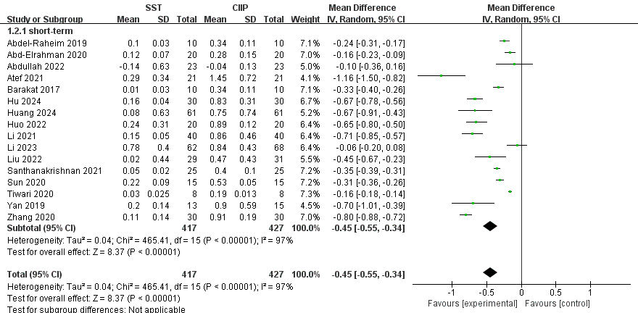

Appendix Fig. 2 Forest plot for the result of sensitivity analysis of pink aesthetic score by excluding non-randomized studies
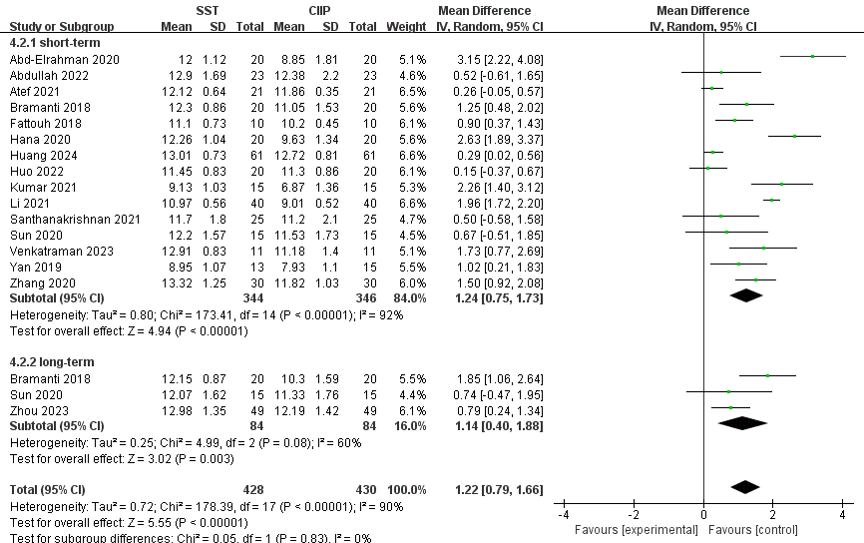

Appendix Fig. 3 Forest plot for the result of sensitivity analysis of implant success rate by excluding non-randomized studies
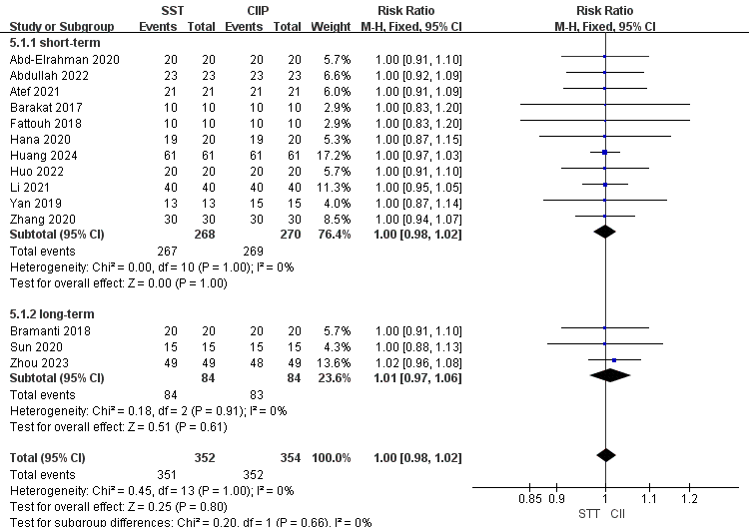
Appendix Fig. 4 Forest plot for the result of sensitivity analysis of horizontal buccal bone loss by excluding studies with inconsistent bone grafting protocols
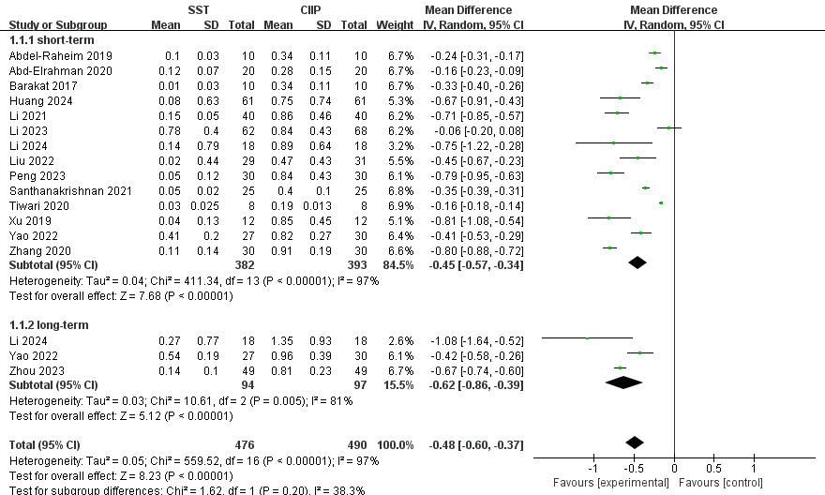
Appendix Fig. 5 Forest plot for the result of sensitivity analysis of vertical buccal bone loss by excluding studies with inconsistent bone grafting protocols
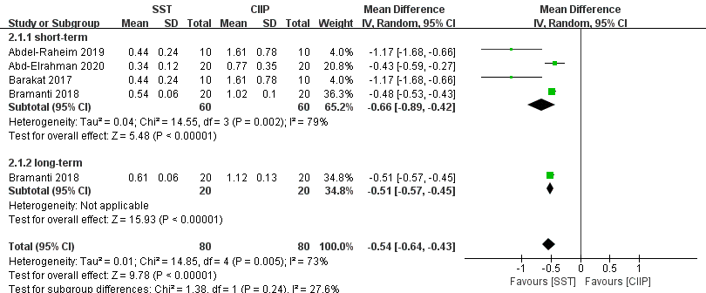
Appendix Fig. 6 Forest plot for the result of sensitivity analysis of implant stability quotient by excluding studies with inconsistent bone grafting protocols
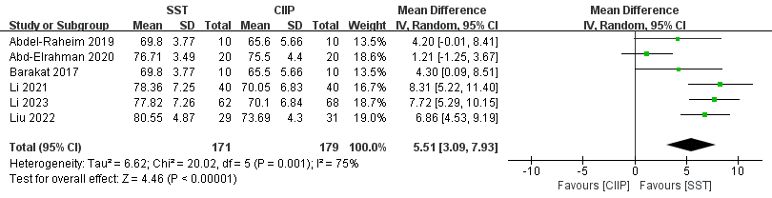
Appendix Fig. 7 Forest plot for the result of sensitivity analysis of pink aesthetic score by excluding studies with inconsistent bone grafting protocols
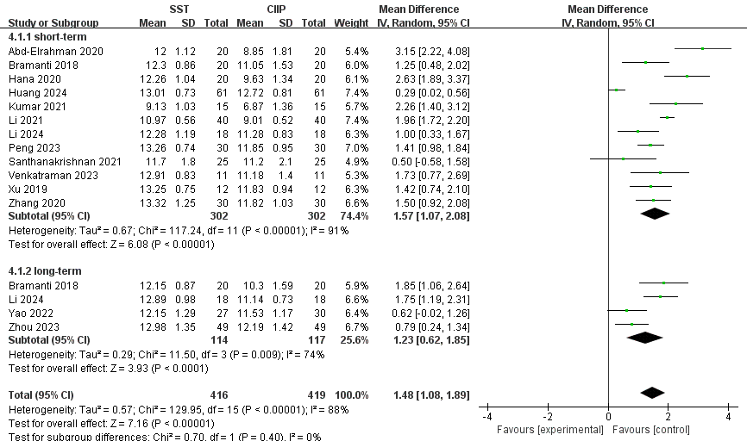
Appendix Fig. 8 Forest plot for the result of sensitivity analysis of implant success rate by excluding studies with inconsistent bone grafting protocols
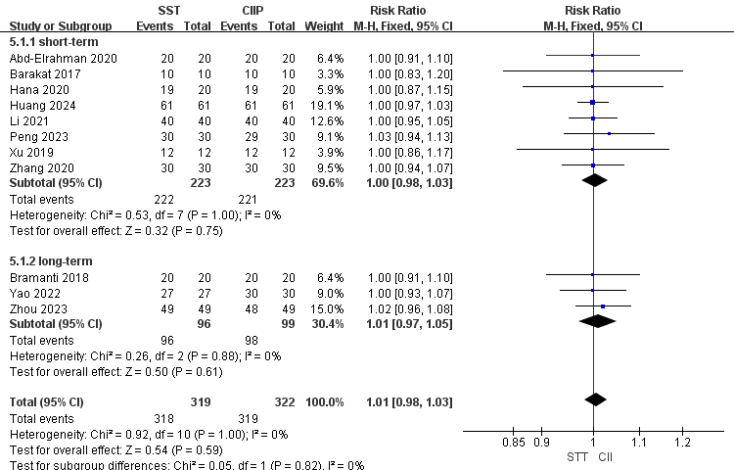
Appendix Fig. 9 Funnel plot for (a) horizontal buccal bone loss, (b) pink aesthetic score, (c) implant success rate
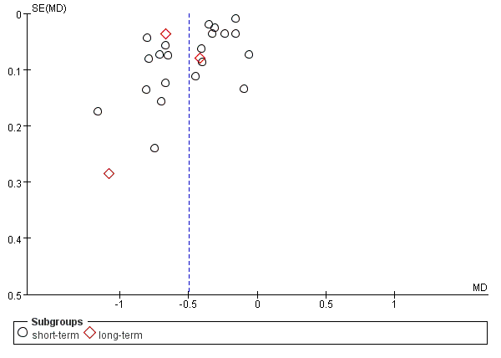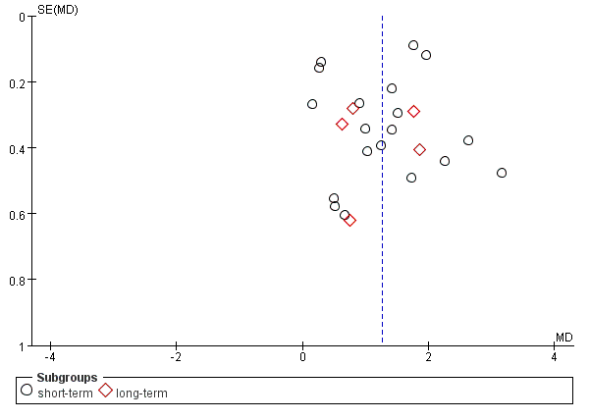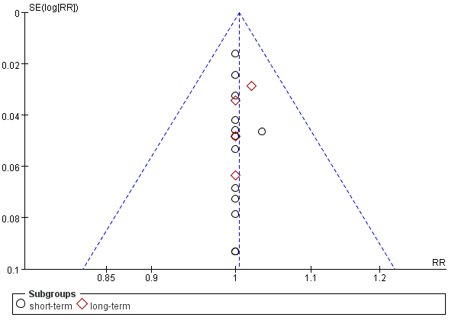
(a) (b) (c)

