Supplementary Information
Plant Description
Binomial name: Indigofera heterantha Wall. Ex.
Scientific classification
Kingdom Plantae, Angiosperms
Order Fabales
Family Fabaceae
Subfamily Faboideae
Genus Indigofera
Species Indigofera heterantha
Synonyms
Common name - Himalayan indigo
Urdu - Jangli mulethi
Kashmiri name - Keiche, Jand
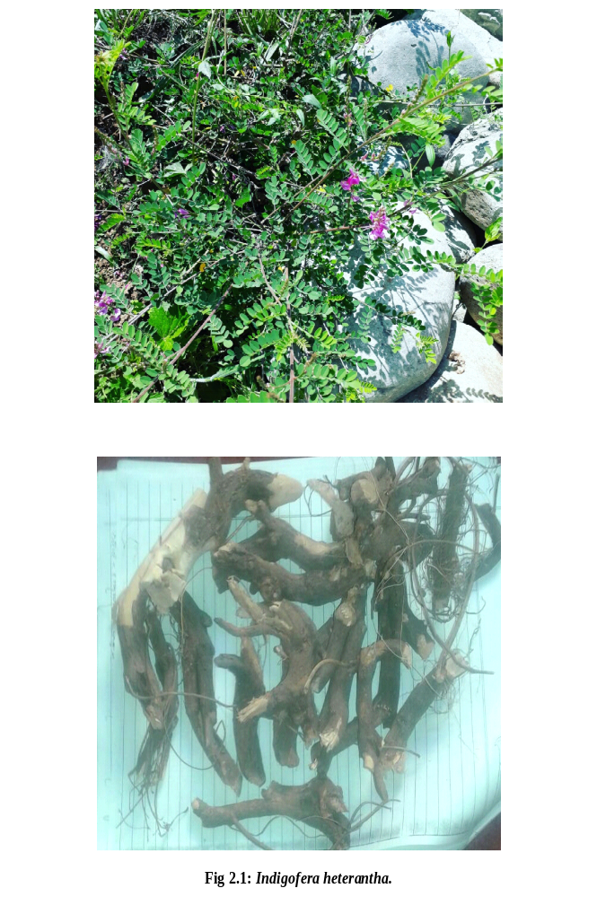
Fig S1: Parts of Indigofera heterantha
Parts investigated: Roots, Bark, Leaves, and Flowers
Table S1. Extraction of different parts of Indigofera heterantha
Plant part | Solvent | Theoretical yield | Practical yield | %yield
Leaves | Methanol  Water | 600g  300g | 81.82g  50.33g | 13.64%  16.77%
Roots | Methanol  Water | 600g  300g | 76.36g  46g | 12.73%  15.33%
Bark | Methanol  Water | 300g  200g | 31.22g  25.33g | 10.41%  12.66%
Flower | Methanol  Water | 300g  300g | 22.45g  27.66g | 7.48%  9.22%

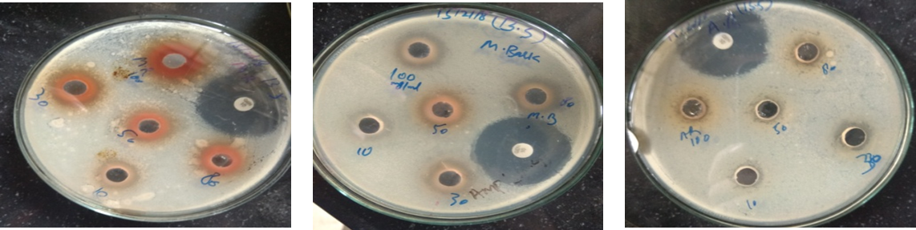
Figure S2. Representative Agar-well diffusion assay plates showing the anti-bacterial activity against Bacillus subtalis using different concentrations of the plant extractives and positive control.

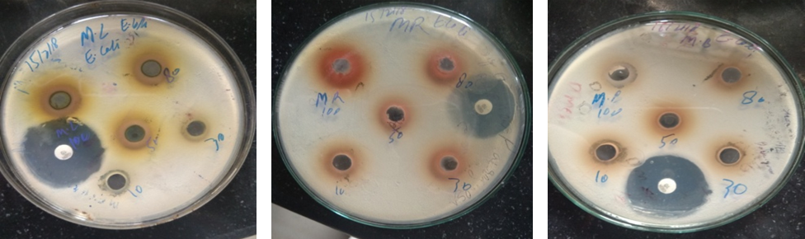
Figure S3. Representative Agar-well diffusion assay plates showing the anti-bacterial activity against E. coli using different concentrations of the plant extractives and positive control.

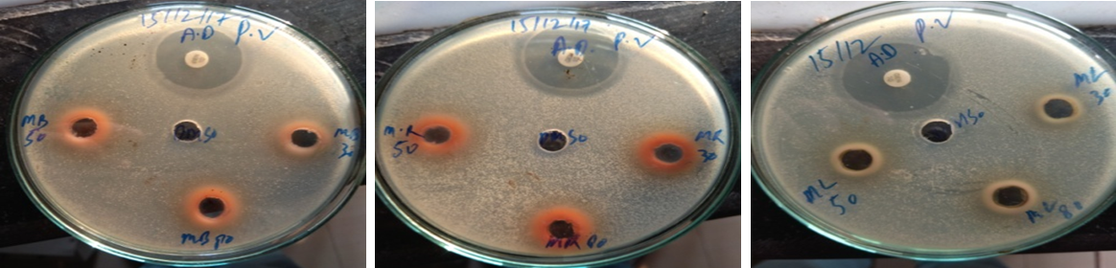
Figure S4. Representative Agar-well diffusion assay plates showing the anti-bacterial activity against Proteus vulgaris using different concentrations of the plant extractives and positive control.

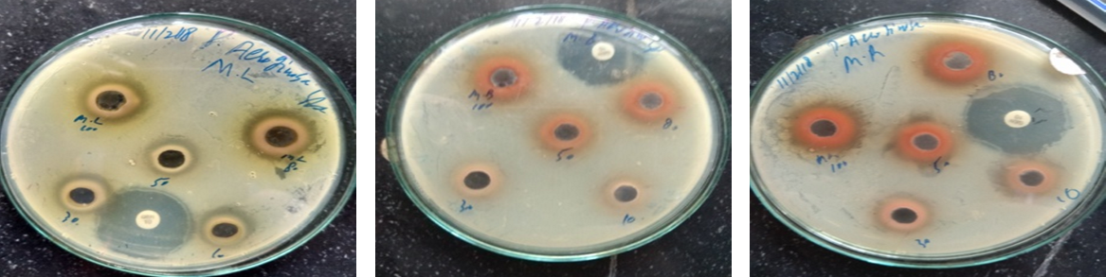
Figure S5. Representative Agar-well diffusion assay plates showing the anti-bacterial activity against Pseudomonas Aeruginosa using different concentrations of the plant extractives and positive control.
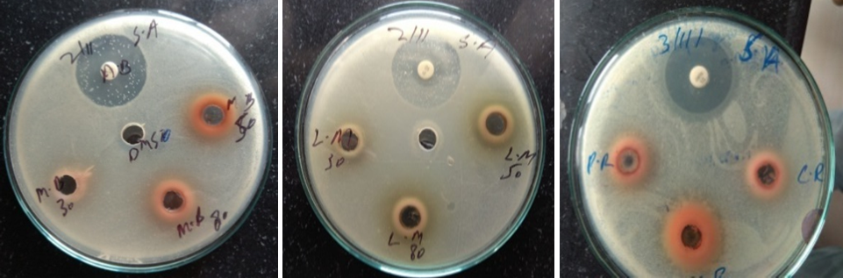
Figure S6. Representative Agar-well diffusion assay plates showing the anti-bacterial activity against Staphylococcus aureus using different concentrations of the plant extractives and positive control.
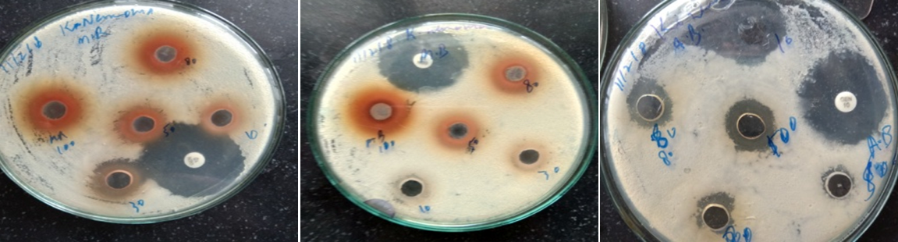
Figure S7. Representative Agar-well diffusion assay plates showing the anti-bacterial activity against Klebsiella Pneumoniae using different concentrations of the plant extractives and positive control.
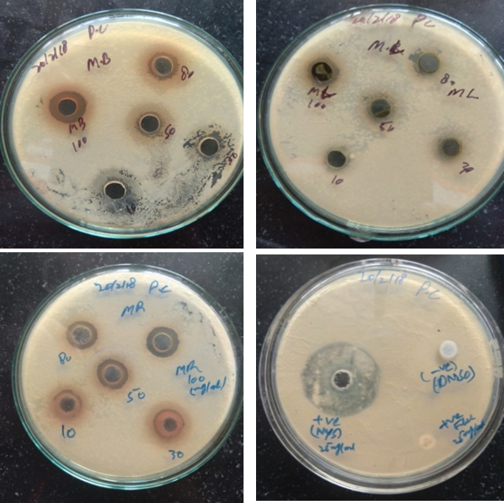
Figure S8. Representative Agar-well diffusion assay plates showing the anti-fungal activity against Penicillium chrysogenum using different concentrations of the plant extractives and positive control.

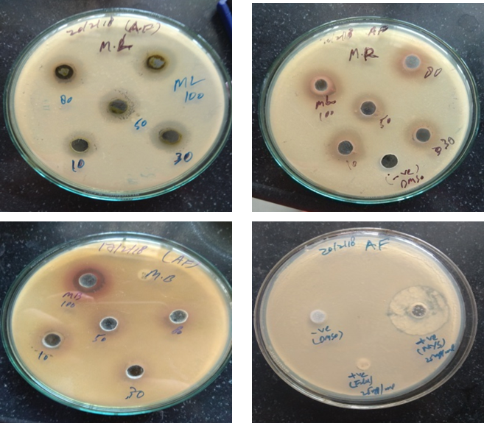
Figure S9. Representative Agar-well diffusion assay plates showing the anti-fungal activity against Aspergillus Fumigatus using different concentrations of the plant extractives and positive control.
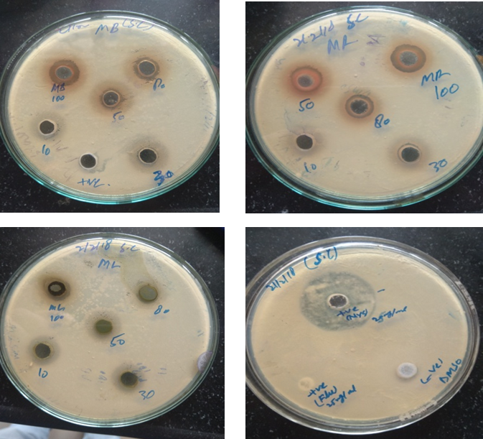
Figure S10. Representative Agar-well diffusion assay plates showing the anti-fungal activity against Saccharomyces Cerevisiae using different concentrations of the plant extractives and positive control.

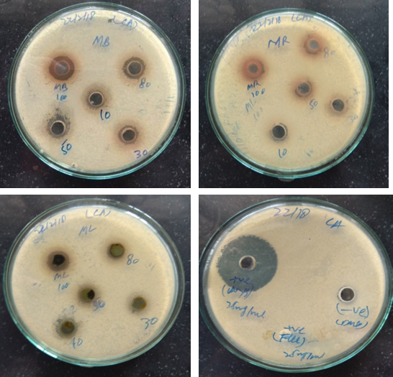
Figure S11. Representative Agar-well diffusion assay plates showing the anti-fungal activity against Candida Albicans using different concentrations of the plant extractives and positive control.
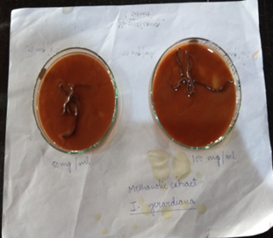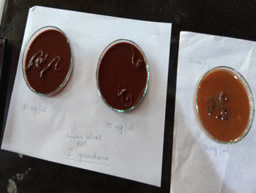
Figure S12. Representative Agar-well diffusion assay plates showing the anti-helminthic activity against Pheretima posthuma using different concentrations of the plant extractives and positive control.

