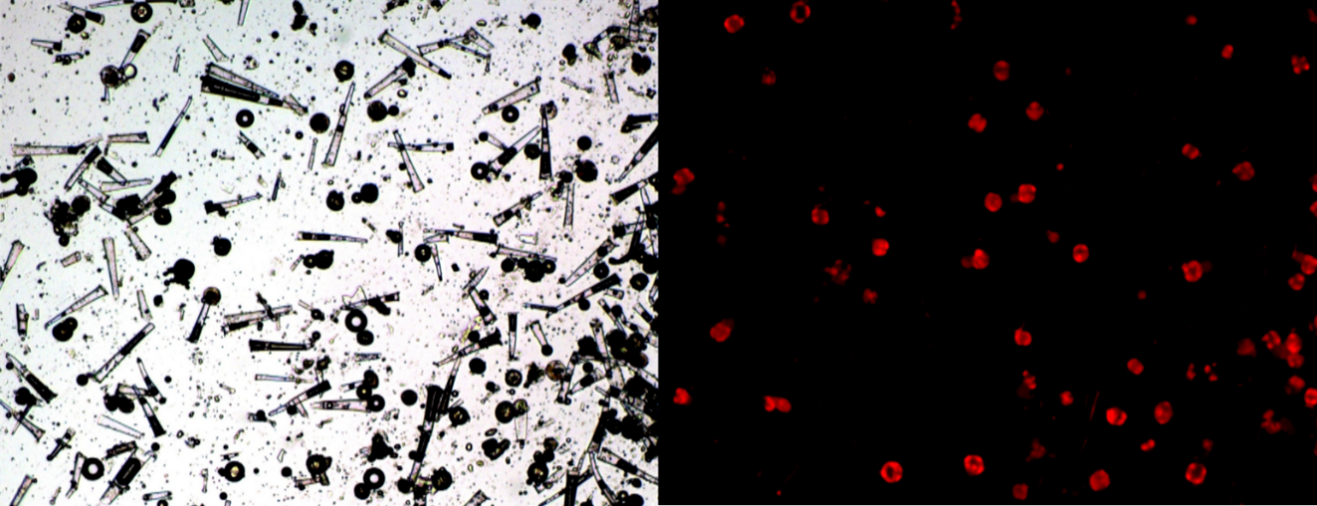
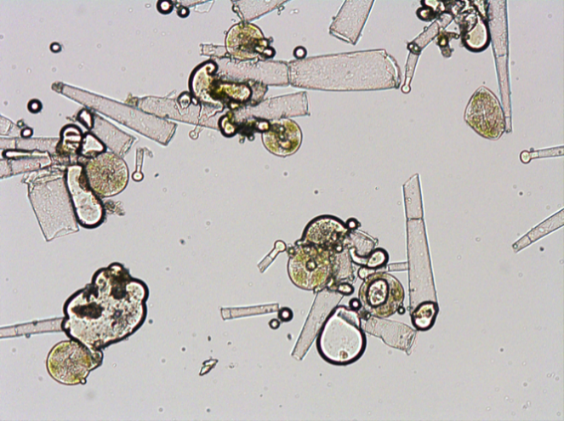
A
C
B
Additional Figure: Microscopic observation during trichome isolation. The panel (A) shows an overview of trichomes collected after harvest using a brush dipped in liquid nitrogen and sieving. The panel (B) is the same field but in autofluorescence of chlorophyll showing the heads of type VI trichomes. The panel (C) is a close-up view of the same sample. Pieces of trichomes stalks and trichome heads can be seen.

