Supplementary Material

Improved quantitative microbiome profiling for environmental antibiotic resistance surveillance

Amelie Ott¹, Marcos Quintela-Baluja¹, Andrew M. Zealand¹, Greg O'Donnell¹, Mohd Ridza Mohd Haniffah², and David W. Graham^{1*}

¹ Newcastle University, School of Engineering, Newcastle upon Tyne, NE1 7RU, UK
² Universiti Teknologi Malaysia, Jalan Iman, 81310 Skudai, Johor, Malaysia

*Corresponding author: Prof David W. Graham
School of Engineering
Cassie Building
Newcastle University
Newcastle upon Tyne
United Kingdom NE1 7RU
E-mail: david.graham@newcastle.ac.uk

Supplementary Figures
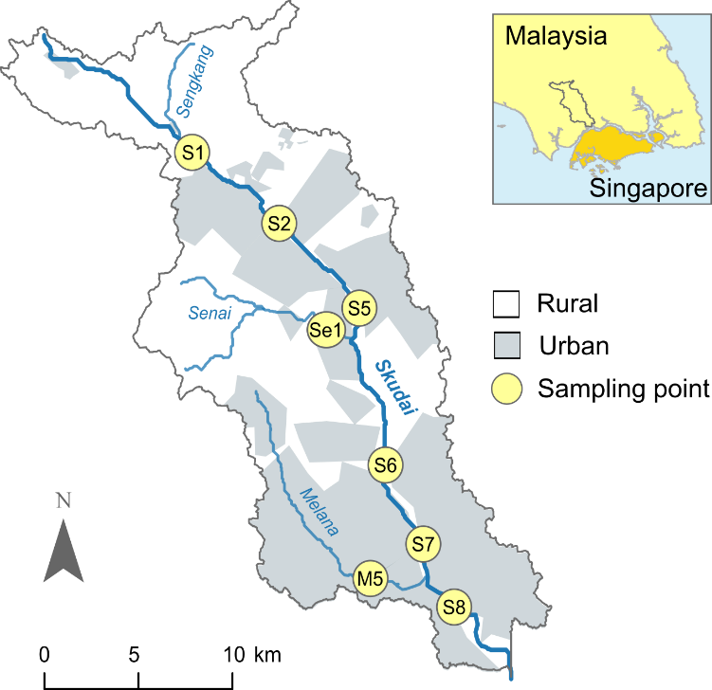
Additional file 1: Figure S1. Skudai catchment in Malaysia with sampling points.[1]
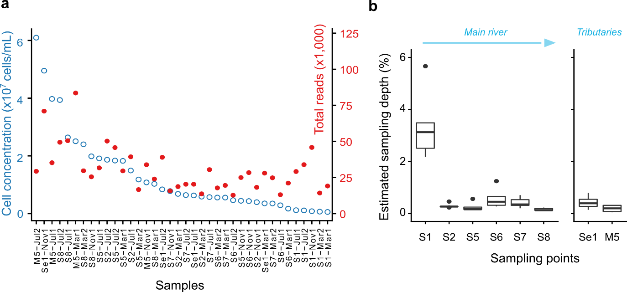
Additional file 1: Figure S2. Cell concentration and reads per sample (a) and sampling depth per sampling point (b). For (a), Samples ranked according to decreasing cell concentration. Cell concentration and reads per sample correlated moderately (n = 38, Spearman ρ = 0.52, P = 0.0007528). For sampling depth (b), reads per sample (=sequencing depth) was divided by cell concentration. Data represented is based on five biological replicates for the main river (S1, S2, S5, S6, S7, S8) and on four biological replicates for the tributaries (Se1, M5). Box-plot elements are defined as center line (median), box limits (upper and lower quartiles), whiskers (1.5x interquartile range) and points (outliers).
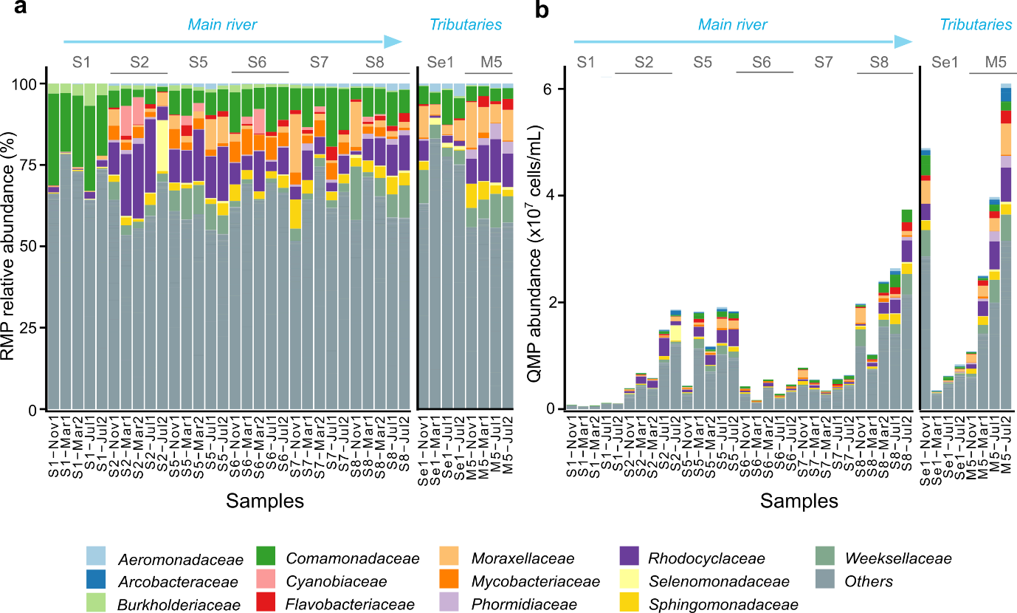
Additional file 1: Figure S3. Barplots showing the 20 most abundant ASVs grouped into families with remain pooled into 'Other' for the relative (RMP; a) and quantitative (QMP[2]; b) microbiome profiling approach. Data represented (n = 38) is based on five biological replicates for the main river (S1, S2, S5, S6, S7, S8) and on four biological replicates for the tributaries (Se1, M5).
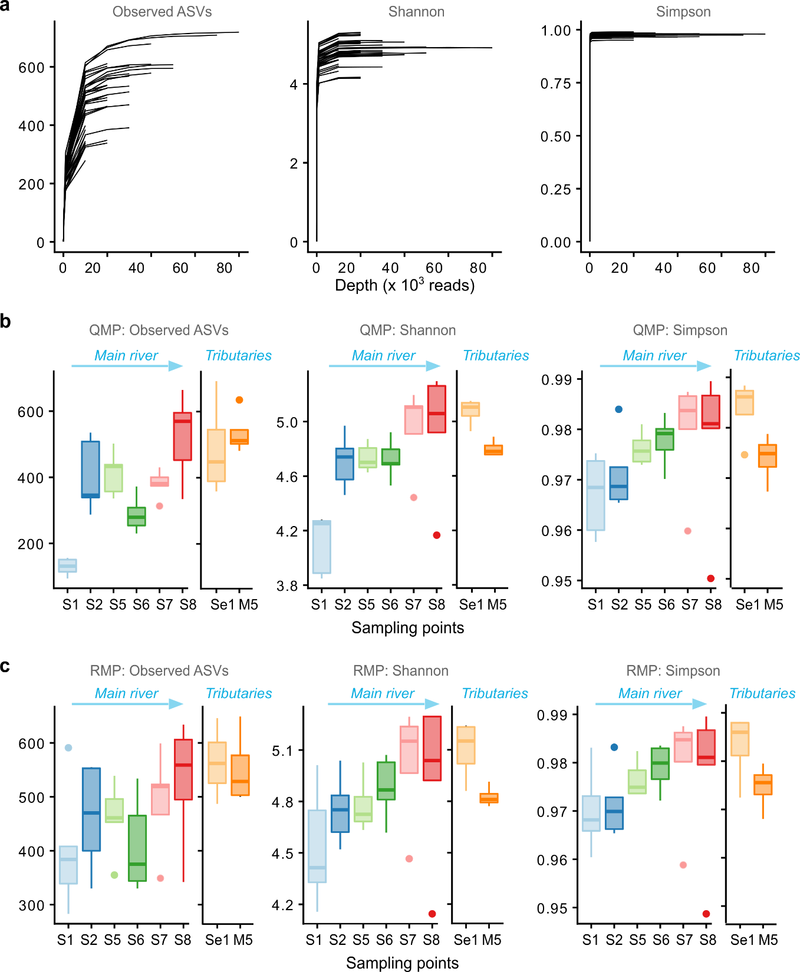
Additional file 1: Figure S4. Rarefaction curves (a) and alpha diversity indices (richness, Shannon index and Simpson index) for the QMP (b) and RMP (c) dataset. Data represented (n = 38) is based on five biological replicates for the main river (S1, S2, S5, S6, S7, S8) and on four biological replicates for the tributaries (Se1, M5). Box-plot elements are defined as center line (median), box limits (upper and lower quartiles), whiskers (1.5x interquartile range) and points (outliers).
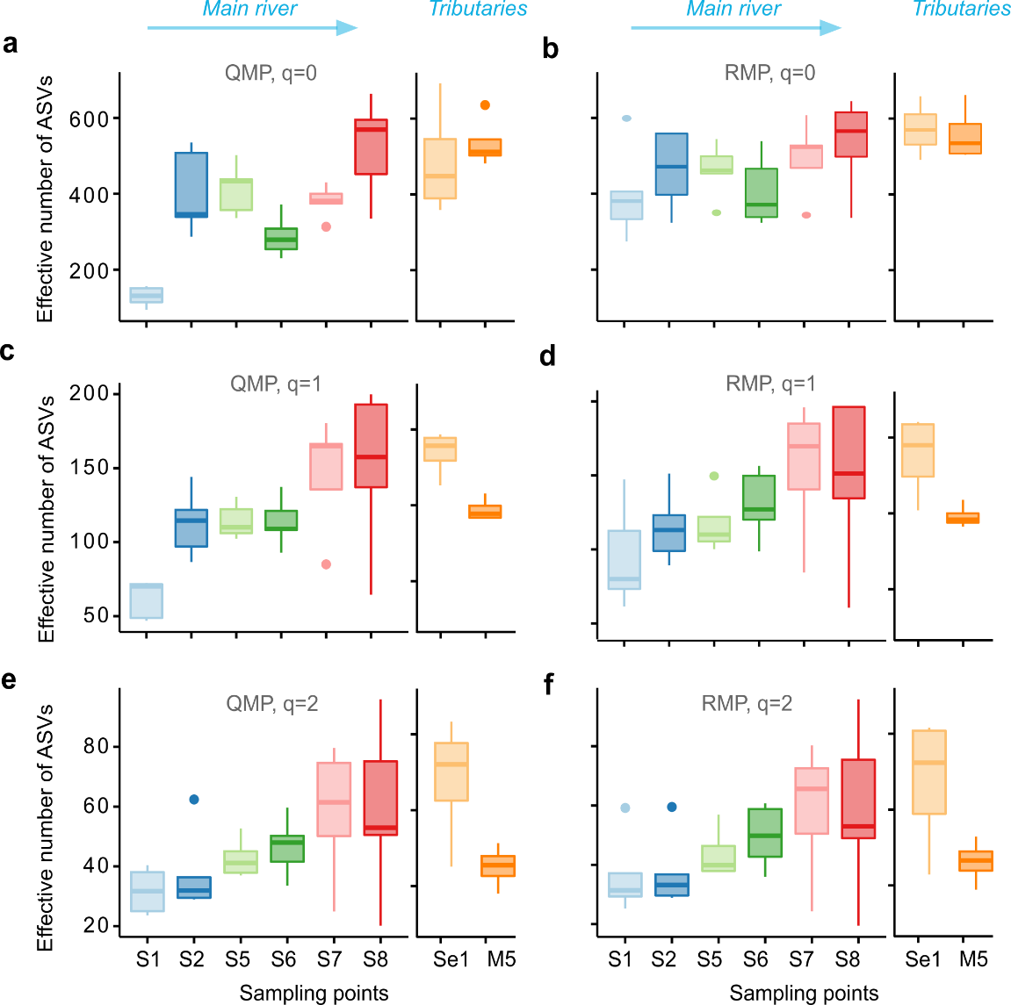
Additional file 1: Figure S5. Hill number α-diversities per sampling point for q = 0, q = 1 and q = 2 for the quantitative microbiome profiling (QMP) approach (a, c, e) and the relative microbiome profiling (RMP) approach (b, d, f) [3, 4]. Data represented (n = 38) is based on five biological replicates for the main river (S1, S2, S5, S6, S7, S8) and on four biological replicates for the tributaries (Se1, M5). Box-plot elements are defined as center line (median), box limits (upper and lower quartiles), whiskers (1.5x interquartile range) and points (outliers).
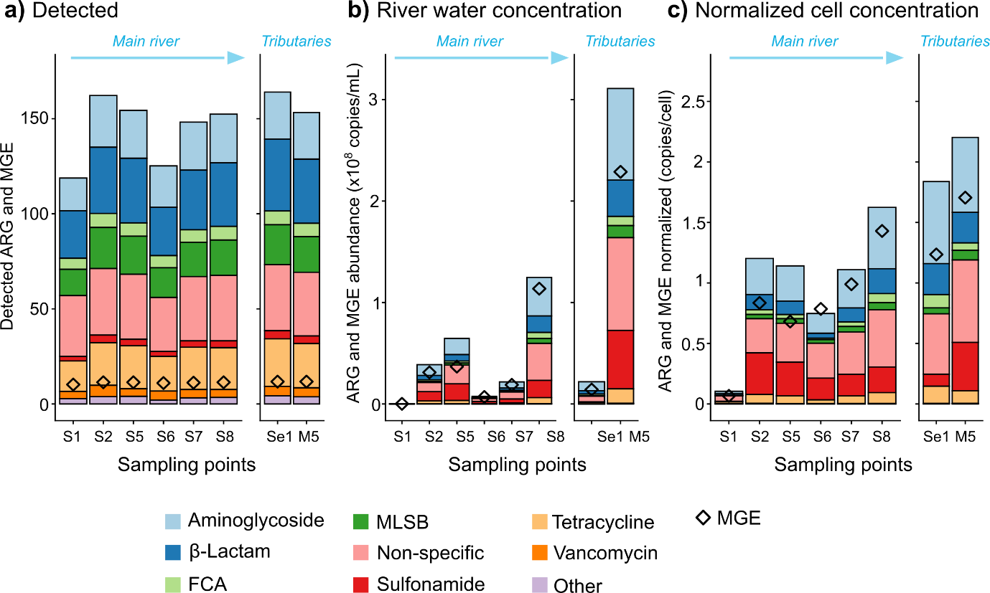
Additional file 1: Figure S6. ARG and MGE numbers (a), river water concentrations (b) and normalized cell concentration (c) detected with HT-qPCR per sampling point in the Skudai catchment. Mean data represented is based on five biological replicates for the main river (S1, S2, S5, S6, S7, S8) and on four biological replicates for the tributaries (Se1, M5).

Supplementary Tables
Additional file 1: Table S1. List of the 20 most abundant ASVs classified to genus level based on the QMP and RMP approach. For genus level, numbers in brackets were added to differentiate ASVs with the same genus. where grey colouring for the QMP or RMP listing highlights ASVs not present in the RMP or QMP listing, respectively. * indicates where ASV rank order is the same in the QMP and RMP listing. ND = not classified to genus level.
Top 20 ASVs based QMP approach
ASV | Phylum | Class | Order | Family | Genus
1 | Bacteroidota | Bacteroidia | Flavobacteriales | Weeksellaceae | Cloacibacterium (1)
2 | Proteobacteria | Gammaproteobacteria | Pseudomonadales | Moraxellaceae | Acinetobacter (1)
3 | Proteobacteria | Gammaproteobacteria | Burkholderiales | Rhodocyclaceae | C39 (1) *
4 | Proteobacteria | Gammaproteobacteria | Burkholderiales | Comamonadaceae | ND (1)
5 | Proteobacteria | Alphaproteobacteria | Sphingomonadales | Sphingomonadaceae | Novosphingobium (1)*
6 | Proteobacteria | Gammaproteobacteria | Burkholderiales | Rhodocyclaceae | C39 (2)*
7 | Proteobacteria | Gammaproteobacteria | Burkholderiales | Rhodocyclaceae | C39 (3)
8 | Bacteroidota | Bacteroidia | Flavobacteriales | Flavobacteriaceae | Flavobacterium (1)
9 | Proteobacteria | Gammaproteobacteria | Burkholderiales | Rhodocyclaceae | C39 (4)
10 | Cyanobacteria | Cyanobacteriia | Cyanobacteriales | Phormidiaceae | Planktothrix_NIVA-CYA_15 (1)
11 | Actinobacteriota | Actinobacteria | Corynebacteriales | Mycobacteriaceae | Mycobacterium (1)
12 | Proteobacteria | Gammaproteobacteria | Pseudomonadales | Moraxellaceae | Acinetobacter (2)
13 | Proteobacteria | Gammaproteobacteria | Burkholderiales | Comamonadaceae | ND (2)
14 | Proteobacteria | Gammaproteobacteria | Aeromonadales | Aeromonadaceae | Tolumonas (1)
15 | Firmicutes | Negativicutes | Veillonellales-Selenomonadales | Selenomonadaceae | ND (3)
16 | Campilobacterota | Campylobacteria | Campylobacterales | Arcobacteraceae | Arcobacter (1)
17 | Campilobacterota | Campylobacteria | Campylobacterales | Arcobacteraceae | Pseudarcobacter (1)
18 | Proteobacteria | Alphaproteobacteria | Sphingomonadales | Sphingomonadaceae | Novosphingobium (1)
19 | Proteobacteria | Gammaproteobacteria | Burkholderiales | Comamonadaceae | Aquabacterium (1)
20 | Bacteroidota | Bacteroidia | Flavobacteriales | Flavobacteriaceae | Flavobacterium (1)
Top 20 ASVs based RMP approach
ASV | Phylum | Class | Order | Family | Genus
1 | Proteobacteria | Gammaproteobacteria | Burkholderiales | Comamonadaceae | ND (1)
2 | Bacteroidota | Bacteroidia | Flavobacteriales | Weeksellaceae | Cloacibacterium (1)
3 | Proteobacteria | Gammaproteobacteria | Burkholderiales | Rhodocyclaceae | C39 (1)*
4 | Proteobacteria | Gammaproteobacteria | Pseudomonadales | Moraxellaceae | Acinetobacter (1)
5 | Proteobacteria | Alphaproteobacteria | Sphingomonadales | Sphingomonadaceae | Novosphingobium (1)*
6 | Proteobacteria | Gammaproteobacteria | Burkholderiales | Rhodocyclaceae | C39 (2)*
7 | Actinobacteriota | Actinobacteria | Corynebacteriales | Mycobacteriaceae | Mycobacterium (1)
8 | Proteobacteria | Gammaproteobacteria | Burkholderiales | Comamonadaceae | ND (4)
9 | Proteobacteria | Gammaproteobacteria | Burkholderiales | Comamonadaceae | ND (5)
10 | Proteobacteria | Gammaproteobacteria | Burkholderiales | Burkholderiaceae | Polynucleobacter (1)
11 | Proteobacteria | Gammaproteobacteria | Pseudomonadales | Moraxellaceae | Acinetobacter (2)
12 | Proteobacteria | Gammaproteobacteria | Burkholderiales | Comamonadaceae | ND (2)
13 | Proteobacteria | Gammaproteobacteria | Burkholderiales | Rhodocyclaceae | C39 (3)
14 | Bacteroidota | Bacteroidia | Flavobacteriales | Flavobacteriaceae | Flavobacterium (1)
15 | Cyanobacteria | Cyanobacteriia | Synechococcales | Cyanobiaceae | Cyanobium_PCC-6307 (1)
16 | Proteobacteria | Gammaproteobacteria | Burkholderiales | Rhodocyclaceae | C39 (4)
17 | Proteobacteria | Gammaproteobacteria | Aeromonadales | Aeromonadaceae | Tolumonas (1)
18 | Cyanobacteria | Cyanobacteriia | Cyanobacteriales | Phormidiaceae | Planktothrix_NIVA-CYA_15 (1)
19 | Proteobacteria | Gammaproteobacteria | Burkholderiales | Comamonadaceae | ND (6)
20 | Firmicutes | Negativicutes | Veillonellales-Selenomonadales | Selenomonadaceae | ND (3)

Additional file 1: Table S2. Results from the Welch’s t-test and Cohen’s D effect size calculations comparing Hill number diversities upstream (S1) and downstream (S8). Comparisons based on five biological replicates for each site. Statistical significance for P < 0.05 and large effect size for D < -0.8.
 | Welch’s t-test |  |  | Cohen’s D effect size
 | P value | Degrees of freedom | t value | Value | 95% confidence interval range
QMP q=0 | 0.0021 | 4.31 | -6.62 | -4.19 | -6.80 | -1.58
QMP q=1 | 0.0203 | 4.45 | -3.53 | -2.23 | -4.09 | -0.38
QMP q=2 | 0.0993 | 4.56 | -2.06 | -1.31 | -2.91 | 0.30
RMP q=0 | 0.1245 | 8.00 | -1.72 | -1.09 | -2.65 | 0.48
RMP q=1 | 0.1175 | 6.71 | -1.80 | -1.14 | -2.71 | 0.44
RMP q=2 | 0.1747 | 5.65 | -1.55 | -0.98 | -2.53 | 0.56

Additional file 1: Table S3. ARG and MGE numbers included in the HT-qPCR assay, detected in each river water sample and maximum amount detected.
 | Gene number included in HT-qPCR assay | Detected in each river water sample (n=38) |  | Maximum amount detected in catchment
 | Gene number included in HT-qPCR assay | Number | % of assay | Number | % of assay
ARGs | 283 | 70 | 25 | 211 | 75
- Aminoglycoside | 36 | 13 | 36 | 31 | 86
- β-Lactams | 52 | 14 | 27 | 45 | 87
- FCA | 9 | 4 | 44 | 9 | 100
- MLSB | 46 | 9 | 20 | 29 | 63
- Non-specific | 51 | 14 | 27 | 39 | 76
- Others | 11 | 1 | 9 | 8 | 73
- Sulfonamide | 7 | 1 | 14 | 6 | 86
- Tetracycline | 39 | 12 | 31 | 31 | 79
- Vancomycin | 32 | 2 | 6 | 13 | 41
MGEs | 12 | 9 | 75 | 12 | 100
- Integrons | 4 | 2 | 50 | 4 | 100
- Transposase | 8 | 7 | 88 | 8 | 100
ALL | 578 | 79 | 14 | 223 | 39

Additional file 1: Table S4. Results from the Welch’s t-test and Cohen’s D effect size calculations comparing log₁₀ ARG and MGE river water concentrations (gene copies/mL), ARG and MGE detected numbers, and ARG and MGE normalized cell concentrations for up-(S1) and downstream (S8). Comparisons based on five biological replicates for each site. Statistical significance for P < 0.05 and large effect size for D < -0.8.
 | Welch’s t-test |  |  | Cohens D effect size
 | P value | Degrees of freedom | t value | Exact value | 95% confidence interval range
ARG log₁₀ river water concentration (copies/mL) | <0.0001 | 6.91 | -11.75 | -7.43 | -11.53 | -3.33
MGE log₁₀ river water concentration (copies/mL) | <0.0001 | 7.19 | -12.07 | -7.63 | -11.83 | -3.44
Detected ARGs (number) | 0.0015 | 7.06 | -5.01 | -3.17 | -5.36 | -0.98
Detected MGEs (number) | 0.0057 | 7.69 | -3.79 | -2.40 | -4.31 | -0.49
ARG normalized cell concentration (copies/cell) | 0.0035 | 4.10 | -6.06 | -3.83 | -6.29 | -1.38
MGE normalized cell concentration (copies/cell) | 0.0071 | 4.03 | -5.06 | -3.20 | -5.40 | -1.00

Additional file 1: Table S5. ARG and MGE detected numbers, river water concentrations and normalized cell concentrations per sampling point in the Skudai catchment. Mean and standard deviations based on five biological replicates for the main river (S1, S2, S5, S6, S7, S8) and on four biological replicates for the tributaries (Se1, M5).
 | Detected (number) |  | River water concentration (copies/mL) |  | Normalized cell concentration (copies/cell)
 | ARGs | MGEs | ARGs | MGEs | ARGs | MGEs
S1 | 118.8 ± 12.4 | 10.2 ± 0.4 | (1.8 ± 1.5) x 10⁵ | (1.2 ± 1) x 10⁵ | 0.1 ± 0.06 | 0.07 ± 0.04
S2 | 162.2 ± 13.5 | 11.4 ± 0.5 | (3.4 ± 3.1) x 10⁷ | (2.6 ± 3.3) x 10⁷ | 1.2 ± 0.42 | 0.84 ± 0.61
S5 | 154.4 ± 6.2 | 11.4 ± 0.9 | (5.4 ± 2.6) x 10⁷ | (3.1 ± 1.5) x 10⁷ | 1.14 ± 0.14 | 0.68 ± 0.14
S6 | 125.2 ± 13.1 | 11.0 ± 0.0 | (8.6 ± 4.7) x 10⁶ | (8 ± 3.4) x 10⁶ | 0.75 ± 0.14 | 0.79 ± 0.19
S7 | 148.2 ± 8.6 | 11.2 ± 0.4 | (2.2 ± 0.6) x 10⁷ | (2.1 ± 0.9) x 10⁷ | 1.11 ± 0.19 | 0.99 ± 0.28
S8 | 152.4 ± 8.4 | 11.4 ± 0.5 | (1.1 ± 0.8) x 10⁸ | (1 ± 0.8) x 10⁸ | 1.62 ± 0.56 | 1.43 ± 0.6
Se1 | 164.0 ± 3.7 | 11.8 ± 0.5 | (5.7 ± 7) x 10⁷ | (3.9 ± 5.1) x 10⁷ | 1.84 ± 0.57 | 1.24 ± 0.27
M5 | 153.3 ± 9.3 | 11.8 ± 0.5 | (2.4 ± 2.5) x 10⁸ | (1.8 ± 1.9) x 10⁸ | 2.2 ± 1.22 | 1.7 ± 0.89

Additional file 1: Table S6. Ten most abundant ARGs in the Skudai catchment based on the mean river water concentration (n = 38).
Gene name | Classification | Mechanism | Mean ARG copies/mL | Standard deviation ARG copies/mL
sul2 | Sulfonamide | Cellular protection | 1.1 x 10⁷ | 1.8 x 10⁷
qacEdelta1_02 | Non-specific | Efflux pump | 7.2 x 10⁶ | 1.3 x 10⁷
qacEdelta1_01 | Non-specific | Efflux pump | 7 x 10⁶ | 1.3 x 10⁷
aadA2_03 | Aminoglycoside | Antibiotic deactivate | 4.2 x 10⁶ | 8.1 x 10⁶
aadA1 | Aminoglycoside | Antibiotic deactivate | 3.2 x 10⁶ | 6 x 10⁶
qacH_02 | Non-specific | Efflux pump | 2.3 x 10⁶ | 3.6 x 10⁶
aadA2_01 | Aminoglycoside | Antibiotic deactivate | 2.1 x 10⁶ | 4.5 x 10⁶
aadA2_02 | Aminoglycoside | Antibiotic deactivate | 2. x 10⁶ | 4.4 x 10⁶
blaOXA10_01 | β-Lactam | Antibiotic deactivate | 2. x 10⁶ | 3.6 x 10⁶
blaOXA10_02 | β-Lactam | Antibiotic deactivate | 1.7 x 10⁶ | 2.9 x 10⁶

Additional file 1: Table S7. Properties for the ARG, MGE and taxa (order level) networks based on the relative microbiome profiling (RMP) approach (see Figure 1-7a) and quantitative microbiome profiling (QMP) approach (see Figure 1-7b). Only nodes with at least three other connections are shown.
 | RMP | QMP
Nodes | 153 | 176
- ARGs | 130 | 130
- Transposase | 7 | 7
- Integrons | 3 | 3
- Taxa | 13 | 36
Edges | 7690 | 9455
Network diameter (maximum distance between edges) | 5 | 3
Average path length | 1.4 | 1.37
Average degree (node connectivity) | 100.523 | 107.443
Graph density | 0.661 | 0.614
Modularity index | 0.072 | 0.094

Additional file 1: Table S8. HT-qPCR primers.[5, 6] FCA = (flor)/(chlor)/(am)phenicol. MLSB = macrolides, lincosamides and streptogramin B.
Assay ID | Forward Primer | Reverse Primer | Classification | Mechanism
16S rRNA | GGGTTGCGCTCGTTGC | ATGGYTGTCGTCAGCTCGTG
catA1 | GGGTGAGTTTCACCAGTTTTGATT | CACCTTGTCGCCTTGCGTATA | FCA | deactivate
catB3 | GCACTCGATGCCTTCCAAAA | AGAGCCGATCCAAACGTCAT | FCA | deactivate
catB8 | CACTCGACGCCTTCCAAAG | CCGAGCCTATCCAGACATCATT | FCA | deactivate
cfr | GCAAAATTCAGAGCAAGTTACGAA | AAAATGACTCCCAACCTGCTTTAT | FCA | deactivate
cmlA1-01 | TAGGAAGCATCGGAACGTTGAT | CAGACCGAGCACGACTGTTG | FCA | efflux
cmlA1-02 | AGGAAGCATCGGAACGTTGA | ACAGACCGAGCACGACTGTTG | FCA | efflux
cmx(A) | GCGATCGCCATCCTCTGT | TCGACACGGAGCCTTGGT | FCA | efflux
floR | ATTGTCTTCACGGTGTCCGTTA | CCGCGATGTCGTCGAACT | FCA | efflux
qnrA | AGGATTTCTCACGCCAGGATT | CCGCTTTCAATGAAACTGCAA | FCA | unknown
aac | CCCTGCGTTGTGGCTATGT | TTGGCCACGCCAATCC | Amino- glycoside | deactivate
aac(6')I1 | GACCGGATTAAGGCCGATG | CTTGCCTTGATATTCAGTTTTTATAACCA | Amino- glycoside | deactivate
aac(6')-Ib(aka aacA4)-02 | CGTCGCCGAGCAACTTG | CGGTACCTTGCCTCTCAAACC | Amino- glycoside | deactivate
aac(6')-Ib(aka aacA4)-01 | GTTTGAGAGGCAAGGTACCGTAA | GAATGCCTGGCGTGTTTGA | Amino- glycoside | deactivate
aac(6')-Ib(aka aacA4)-03 | AGAAGCACGCCCGACACTT | GCTCTCCATTCAGCATTGCA | Amino- glycoside | deactivate
aac(6')-II | CGACCCGACTCCGAACAA | GCACGAATCCTGCCTTCTCA | Amino- glycoside | deactivate
aac(6')-Iy | GCTTTGCGGATGCCTCAAT | GGAGAACAAAAATACCTTCAAGGAAA | Amino- glycoside | deactivate
aacA/aphD | AGAGCCTTGGGAAGATGAAGTTT | TTGATCCATACCATAGACTATCTCATCA | Amino- glycoside | deactivate
aacC | CGTCACTTATTCGATGCCCTTAC | GTCGGGCGCGGCATA | Amino- glycoside | deactivate
aacC1 | GGTCGTGAGTTCGGAGACGTA | GCAAGTTCCCGAGGTAATCG | Amino- glycoside | deactivate
aacC2 | ACGGCATTCTCGATTGCTTT | CCGAGCTTCACGTAAGCATTT | Amino- glycoside | deactivate
aacC4 | CGGCGTGGGACACGAT | AGGGAACCTTTGCCATCAACT | Amino- glycoside | deactivate
aadA-01 | GTTGTGCACGACGACATCATT | GGCTCGAAGATACCTGCAAGAA | Amino- glycoside | deactivate
aadA-02 | CGAGATTCTCCGCGCTGTA | GCTGCCATTCTCCAAATTGC | Amino- glycoside | deactivate
aadA1 | AGCTAAGCGCGAACTGCAAT | TGGCTCGAAGATACCTGCAA | Amino- glycoside | deactivate
aadA-1-01 | AAAAGCCCGAAGAGGAACTTG | CATCTTTCACAAAGATGTTGCTGTCT | Amino- glycoside | deactivate
aadA-1-02 | CGGAATTGAAAAAACTGATCGAA | ATACCGGCTGTCCGTCATTT | Amino- glycoside | deactivate
aadA2-01 | ACGGCTCCGCAGTGGAT | GGCCACAGTAACCAACAAATCA | Amino- glycoside | deactivate
aadA2-02 | CTTGTCGTGCATGACGACATC | TCGAAGATACCCGCAAGAATG | Amino- glycoside | deactivate
aadA2-03 | CAATGACATTCTTGCGGGTATC | GACCTACCAAGGCAACGCTATG | Amino- glycoside | deactivate
aadA5-01 | ATCACGATCTTGCGATTTTGCT | CTGCGGATGGGCCTAGAAG | Amino- glycoside | deactivate
aadA5-02 | GTTCTTGCTCTTGCTCGCATT | GATGCTCGGCAGGCAAAC | Amino- glycoside | deactivate
aadA9-01 | CGCGGCAAGCCTATCTTG | CAAATCAGCGACCGCAGACT | Amino- glycoside | deactivate
aadA9-02 | GGATGCACGCTTGGATGAA | CCTCTAGCGGCCGGAGTATT | Amino- glycoside | deactivate
aadD | CCGACAACATTTCTACCATCCTT | ACCGAAGCGCTCGTCGTATA | Amino- glycoside | deactivate
aadE | TACCTTATTGCCCTTGGAAGAGTTA | GGAACTATGTCCCTTTTAATTCTACAATCT | Amino- glycoside | deactivate
aph | TTTCAGCAAGTGGATCATGTTAAAAT | CCAAGCTGTTTCCACTGTTTTTC | Amino- glycoside | deactivate
aph(2')-Id-02 | TAAGGATATACCGACAGTTTTGGAAA | TTTAATCCCTCTTCATACCAATCCATA | Amino- glycoside | deactivate
aph(2')-Id-01 | TGAGCAGTATCATAAGTTGAGTGAAAAG | GACAGAACAATCAATCTCTATGGAATG | Amino- glycoside | deactivate
aph6ia | CCCATCCCATGTGTAAGGAAA | GCCACCGCTTCTGCTGTAC | Amino- glycoside | deactivate
aphA1(aka kanR) | TGAACAAGTCTGGAAAGAAATGCA | CCTATTAATTTCCCCTCGTCAAAAA | Amino- glycoside | deactivate
spcN-01 | AAAAGTTCGATGAAACACGCCTAT | TCCAGTGGTAGTCCCCGAATC | Amino- glycoside | deactivate
spcN-02 | CAGAATCTTCCTGAAAAGTTTGATGAA | CGCAGACACGCCGAATC | Amino- glycoside | deactivate
str | AATGAGTTTTGGAGTGTCTCAACGTA | AATCAAAACCCCTATTAAAGCCAAT | Amino- glycoside | deactivate
strA | CCGGTGGCATTTGAGAAAAA | GTGGCTCAACCTGCGAAAAG | Amino- glycoside | deactivate
strB | GCTCGGTCGTGAGAACAATCT | CAATTTCGGTCGCCTGGTAGT | Amino- glycoside | deactivate
ampC/blaDHA | TGGCCGCAGCAGAAAGA | CCGTTTTATGCACCCAGGAA | β-Lactam | deactivate
ampC-01 | TGGCGTATCGGGTCAATGT | CTCCACGGGCCAGTTGAG | β-Lactam | deactivate
ampC-02 | GCAGCACGCCCCGTAA | TGTACCCATGATGCGCGTACT | β-Lactam | deactivate
ampC-04 | TCCGGTGACGCGACAGA | CAGCACGCCGGTGAAAGT | β-Lactam | deactivate
ampC-05 | CTGTTCGAGCTGGGTTCTATAAGTAAA | CAGTATCTGGTCACCGGATCGT | β-Lactam | deactivate
ampC-06 | CCGCTCAAGCTGGACCATAC | CCATATCCTGCACGTTGGTTT | β-Lactam | deactivate
ampC-07 | CCGCCCAGAGCAAGGACTA | GCTCGACTTCACGCCGTAAG | β-Lactam | deactivate
ampC-09 | CAGCCGCTGATGAAAAAATATG | CAGCGAGCCCACTTCGA | β-Lactam | deactivate
bla1 | GCAAGTTGAAGCGAAAGAAAAGA | TACCAGTATCAATCGCATATACACCTAA | β-Lactam | deactivate
bla-ACC-1 | CACACAGCTGATGGCTTATCTAAAA | AATAAACGCGATGGGTTCCA | β-Lactam | deactivate
blaCMY | CCGCGGCGAAATTAAGC | GCCACTGTTTGCCTGTCAGTT | β-Lactam | deactivate
blaCMY2-01 | AAAGCCTCATGGGTGCATAAA | ATAGCTTTTGTTTGCCAGCATCA | β-Lactam | deactivate
blaCMY2-02 | GCGAGCAGCCTGAAGCA | CGGATGGGCTTGTCCTCTT | β-Lactam | deactivate
blaCTX-M-04 | CTTGGCGTTGCGCTGAT | CGTTCATCGGCACGGTAGA | β-Lactam | deactivate
blaCTX-M-01 | GGAGGCGTGACGGCTTTT | TTCAGTGCGATCCAGACGAA | β-Lactam | deactivate
blaCTX-M-02 | GCCGCGGTGCTGAAGA | ATCGGATTATAGTTAACCAGGTCAGATTT | β-Lactam | deactivate
blaCTX-M-03 | CGATACCACCACGCCGTTA | GCATTGCCCAACGTCAGATT | β-Lactam | deactivate
blaCTX-M-05 | GCGATAACGTGGCGATGAAT | GTCGAGACGGAACGTTTCGT | β-Lactam | deactivate
blaCTX-M-06 | CACAGTTGGTGACGTGGCTTAA | CTCCGCTGCCGGTTTTATC | β-Lactam | deactivate
blaGES | GCAATGTGCTCAACGTTCAAG | GTGCCTGAGTCAATTCTTTCAAAG | β-Lactam | deactivate
bla-L1 | CACCGGGTTACCAGCTGAAG | GCGAAGCTGCGCTTGTAGTC | β-Lactam | deactivate
blaMOX/blaCMY | CTATGTCAATGTGCCGAAGCA | GGCTTGTCCTCTTTCGAATAGC | β-Lactam | deactivate
blaIMP-02 | AAGGCAGCATTTCCTCTCATTTT | GGATAGATCGAGAATTAAGCCACTCT | β-Lactam | deactivate
blaIMP-01 | AACACGGTTTGGTGGTTCTTGTA | GCGCTCCACAAACCAATTG | β-Lactam | deactivate
blaOCH | GGCGACTTGCGCCGTAT | TTTTCTGCTCGGCCATGAG | β-Lactam | deactivate
blaOKP | GCCGCCATCACCATGAG | GGTGACGTTGTCACCGATCTG | β-Lactam | deactivate
blaOXA1/blaOXA30 | CGGATGGTTTGAAGGGTTTATTAT | TCTTGGCTTTTATGCTTGATGTTAA | β-Lactam | deactivate
blaOXA10-01 | CGCAATTATCGGCCTAGAAACT | TTGGCTTTCCGTCCCATTT | β-Lactam | deactivate
blaOXA10-02 | CGCAATTATCGGCCTAGAAACT | TTGGCTTTCCGTCCCATTT | β-Lactam | deactivate
blaOXY | CGTTCAGGCGGCAGGTT | GCCGCGATATAAGATTTGAGAATT | β-Lactam | deactivate
blaPAO | CGCCGTACAACCGGTGAT | GAAGTAATGCGGTTCTCCTTTCA | β-Lactam | deactivate
blaPER | TGCTGGTTGCTGTTTTTGTGA | CCTGCGCAATGATAGCTTCAT | β-Lactam | deactivate
blaPSE | TTGTGACCTATTCCCCTGTAATAGAA | TGCGAAGCACGCATCATC | β-Lactam | deactivate
blaROB | GCAAAGGCATGACGATTGC | CGCGCTGTTGTCGCTAAA | β-Lactam | deactivate
blaSFO | CCGCCGCCATCCAGTA | GGGCCGCCAAGATGCT | β-Lactam | deactivate
blaSHV-01 | TCCCATGATGAGCACCTTTAAA | TTCGTCACCGGCATCCA | β-Lactam | deactivate
blaSHV-02 | CTTTCCCATGATGAGCACCTTT | TCCTGCTGGCGATAGTGGAT | β-Lactam | deactivate
blaTEM | AGCATCTTACGGATGGCATGA | TCCTCCGATCGTTGTCAGAAGT | β-Lactam | deactivate
blaTLA | ACACTTTGCCATTGCTGTTTATGT | TGCAAATTTCGGCAATAATCTTT | β-Lactam | deactivate
blaVEB | CCCGATGCAAAGCGTTATG | GAAAGATTCCCTTTATCTATCTCAGACAA | β-Lactam | deactivate
blaVIM | GCACTTCTCGCGGAGATTG | CGACGGTGATGCGTACGTT | β-Lactam | deactivate
blaZ | GGAGATAAAGTAACAAATCCAGTTAGATATGA | TGCTTAATTTTCCATTTGCGATAAG | β-Lactam | deactivate
cepA | AGTTGCGCAGAACAGTCCTCTT | TCGTATCTTGCCCGTCGATAAT | β-Lactam | deactivate
cfiA | GCAGCGTTGCTGGACACA | GTTCGGGATAAACGTGGTGACT | β-Lactam | deactivate
cfxA | TCATTCCTCGTTCAAGTTTTCAGA | TGCAGCACCAAGAGGAGATGT | β-Lactam | deactivate
cphA-01 | GCGAGCTGCACAAGCTGAT | CGGCCCAGTCGCTCTTC | β-Lactam | deactivate
cphA-02 | GTGCTGATGGCGAGTTTCTG | GGTGTGGTAGTTGGTGTTGATCAC | β-Lactam | deactivate
fox5 | GGTTTGCCGCTGCAGTTC | GCGGCCAGGTGACCAA | β-Lactam | deactivate
mecA | GGTTACGGACAAGGTGAAATACTGAT | TGTCTTTTAATAAGTGAGGTGCGTTAATA | β-Lactam | protection
NDM1 | ATTAGCCGCTGCATTGAT | CATGTCGAGATAGGAAGTG | β-Lactam | deactivate
pbp | CCGGTGCCATTGGTTTAGA | AAAATAGCCGCCCCAAGATT | β-Lactam | protection
pbp2x | TTTCATAAGTATCTGGACATGGAAGAA | CCAAAGGAAACTTGCTTGAGATTAG | β-Lactam | protection
Pbp5 | GGCGAACTTCTAATTAATCCTATCCA | CGCCGATGACATTCTTCTTATCTT | β-Lactam | protection
penA | AGACGGTAACGTATAACTTTTTGAAAGA | GCGTGTAGCCGGCAATG | β-Lactam | protection
intI-1(clinic) = clint1 | CGAACGAGTGGCGGAGGGTG | TACCCGAGAGCTTGGCACCCA | MGEs:  Integron | integrase
intI-1LC | GGCATCCAAGCAGCAAG | AAGCAGACTTGACCTGA | MGEs:  Integron | integrase
intI2 | TGCTTTTCCCACCCTTACC | GACGGCTACCCTCTGTTATCTC | MGEs:  Integron | integrase
intI3 | GCCACCACTTGTTTGAGGA | GGATGTCTGTGCCTGCTTG | MGEs:  Integron | integrase
IS613 | AGGTTCGGACTCAATGCAACA | TTCAGCACATACCGCCTTGAT | MGEs: Transposase | transposase
tnpA-01 | CATCATCGGACGGACAGAATT | GTCGGAGATGTGGGTGTAGAAAGT | MGEs: Transposase | transposase
tnpA-02 | GGGCGGGTCGATTGAAA | GTGGGCGGGATCTGCTT | MGEs: Transposase | transposase
tnpA-03 | AATTGATGCGGACGGCTTAA | TCACCAAACTGTTTATGGAGTCGTT | MGEs: Transposase | transposase
tnpA-04 | CCGATCACGGAAAGCTCAAG | GGCTCGCATGACTTCGAATC | MGEs: Transposase | transposase
tnpA-05 | GCCGCACTGTCGATTTTTATC | GCGGGATCTGCCACTTCTT | MGEs: Transposase | transposase
tnpA-07 | GAAACCGATGCTACAATATCCAATTT | CAGCACCGTTTGCAGTGTAAG | MGEs: Transposase | transposase
Tp614 | GGAAATCAACGGCATCCAGTT | CATCCATGCGCTTTTGTCTCT | MGEs: Transposase | transposase
carB | GGAGTGAGGCTGACCGTAGAAG | ATCGGCGAAACGCACAAA | MLSB | efflux
ereA | CCTGTGGTACGGAGAATTCATGT | ACCGCATTCGCTTTGCTT | MLSB | deactivate
ereB | GCTTTATTTCAGGAGGCGGAAT | TTTTAAATGCCACAGCACAGAATC | MLSB | deactivate
erm(34) | GCGCGTTGACGACGATTT | TGGTCATACTCGACGGCTAGAAC | MLSB | protection
erm(35) | TTGAAAACGATGTTGCATTAAGTCA | TCTATAATCACAACTAACCACTTGAACGT | MLSB | protection
erm(36) | GGCGGACCGACTTGCAT | TCTGCGTTGACGACGGTTAC | MLSB | protection
ermA | TTGAGAAGGGATTTGCGAAAAG | ATATCCATCTCCACCATTAATAGTAAACC | MLSB | protection
ermA/ermTR | ACATTTTACCAAGGAACTTGTGGAA | GTGGCATGACATAAACCTTCATCA | MLSB | protection
ermB | TAAAGGGCATTTAACGACGAAACT | TTTATACCTCTGTTTGTTAGGGAATTGAA | MLSB | protection
ermC | TTTGAAATCGGCTCAGGAAAA | ATGGTCTATTTCAATGGCAGTTACG | MLSB | protection
ermF | CAGCTTTGGTTGAACATTTACGAA | AAATTCCTAAAATCACAACCGACAA | MLSB | protection
ermJ/ermD | GGACTCGGCAATGGTCAGAA | CCCCGAAACGCAATATAATGTT | MLSB | protection
ermK-01 | GTTTGATATTGGCATTGTCAGAGAAA | ACCATTGCCGAGTCCACTTT | MLSB | protection
ermK-02 | GAGCCGCAAGCCCCTTT | GTGTTTCATTTGACGCGGAGTAA | MLSB | protection
ermT-01 | GTTCACTAGCACTATTTTTAATGACAGAAGT | GAAGGGTGTCTTTTTAATACAATTAACGA | MLSB | protection
ermT-02 | GTAAAATCCCTAGAGAATACTTTCATCCA | TGAGTGATATTTTTGAAGGGTGTCTT | MLSB | protection
ermX | GCTCAGTGGTCCCCATGGT | ATCCCCCCGTCAACGTTT | MLSB | protection
ermY | TTGTCTTTGAAAGTGAAGCAACAGT | TAACGCTAGAGAACGATTTGTATTGAG | MLSB | protection
ImrA-01 | TCGACGTGACCGTAGTGAACA | CGTGACTACCCAGGTGAGTTGA | MLSB | efflux
lnuA-01 | TGACGCTCAACACACTCAAAAA | TTCATGCTTAAGTTCCATACGTGAA | MLSB | deactivate
lnuB-01 | TGAACATAATCCCCTCGTTTAAAGAT | TAATTGCCCTGTTTCATCGTAAATAA | MLSB | deactivate
lnuB-02 | AAAGGAGAAGGTGACCAATACTCTGA | GGAGCTACGTCAAACAACCAGTT | MLSB | deactivate
lnuC | TGGTCAATATAACAGATGTAAACCAGATTT | CACCCCAGCCACCATCAA | MLSB | deactivate
matA/mel | TAGTAGGCAAGCTCGGTGTTGA | CCTGTGCTATTTTAAGCCTTGTTTCT | MLSB | efflux
mdtA | CCTAACGGGCGTGACTTCA | TTCACCTGTTTCAAGGGTCAAA | MLSB | efflux
mefA | CCGTAGCATTGGAACAGCTTTT | AAACGGAGTATAAGAGTGCTGCAA | MLSB | efflux
mphA-01 | CTGACGCGCTCCGTGTT | GGTGGTGCATGGCGATCT | MLSB | deactivate
mphA-02 | TGATGACCCTGCCATCGA | TTCGCGAGCCCCTCTTC | MLSB | deactivate
mphB | CGCAGCGCTTGATCTTGTAG | TTACTGCATCCATACGCTGCTT | MLSB | deactivate
mphC | CGTTTGAAGTACCGAATTGGAAA | GCTGCGGGTTTGCCTGTA | MLSB | deactivate
msrA-01 | CTGCTAACACAAGTACGATTCCAAAT | TCAAGTAAAGTTGTCTTACCTACACCATT | MLSB | efflux
msrC-01 | TCAGACCGGATCGGTTGTC | CCTATTTTTTGGAGTCTTCTCTCTAATGTT | MLSB | efflux
oleC | CCCGGAGTCGATGTTCGA | GCCGAAGACGTACACGAACAG | MLSB | efflux
pikR1 | TCGACATGCGTGACGAGATT | CCGCGAATTAGGCCAGAA | MLSB | protection
pikR2 | TCGTGGGCCAGGTGAAGA | TTCCCCTTGCCGGTGAA | MLSB | protection
vatB-01 | GGAAAAAGCAACTCCATCTCTTGA | TCCTGGCATAACAGTAACATTCTGA | MLSB | deactivate
vatB-02 | TTGGGAAAAAGCAACTCCATCT | CAATCCACACATCATTTCCAACA | MLSB | deactivate
vatC-01 | CGGAAATTGGGAACGATGTT | GCAATAATAGCCCCGTTTCCTA | MLSB | deactivate
vatC-02 | CGATGTTTGGATTGGACGAGAT | GCTGCAATAATAGCCCCGTTT | MLSB | deactivate
vatE-01 | GGTGCCATTATCGGAGCAAAT | TTGGATTGCCACCGACAAT | MLSB | deactivate
vatE-02 | GACCGTCCTACCAGGCGTAA | TTGGATTGCCACCGACAATT | MLSB | deactivate
vgaA-01 | CGAGTATTGTGGAAAGCAGCTAGTT | CCCGTACCGTTAGAGCCGATA | MLSB | efflux
vgaA-02 | GACGGGTATTGTGGAAAGCAA | TTTCCTGTACCATTAGATCCGATAATT | MLSB | efflux
vgb-01 | AGGGAGGGTATCCATGCAGAT | ACCAAATGCGCCCGTTT | MLSB | deactivate
vgbB-01 | CAGCCGGATTCTGGTCCTT | TACGATCTCCATTCAATTGGGTAAA | MLSB | efflux
vgbB-02 | ATACGAGCTGCCTAATAAAGGATCTT | TGTGAACCACAGGGCATTATCA | MLSB | deactivate
acrA-01 | CAACGATCGGACGGGTTTC | TGGCGATGCCACCGTACT | Non-specific | efflux
acrA-02 | GGTCTATCACCCTACGCGCTATC | GCGCGCACGAACATACC | Non-specific | efflux
acrA-03 | CAGACCCGCATCGCATATT | CGACAATTTCGCGCTCATG | Non-specific | efflux
acrA-04 | TACTTTGCGCGCCATCTTC | CGTGCGCGAACGAACAT | Non-specific | efflux
acrB-01 | AGTCGGTGTTCGCCGTTAAC | CAAGGAAACGAACGCAATACC | Non-specific | efflux
acrR-01 | GCGCTGGAGACACGACAAC | GCCTTGCTGCGAGAACAAA | Non-specific | efflux
acrR-02 | GATGATACCCCCTGCTGTGAGA | ACCAAACAAGAAGCGCAAGAA | Non-specific | efflux
adeA | CAGTTCGAGCGCCTATTTCTG | CGCCCTGACCGACCAAT | Non-specific | efflux
acrA-05 | CGTGCGCGAACGAACA | ACTTTGCGCGCCATCTTC | Non-specific | efflux
acrF | GCGGCCAGGCACAAAA | TACGCTCTTCCCACGGTTTC | Non-specific | efflux
ceoA | ATCAACACGGACCAGGACAAG | GGAAAGTCCGCTCACGATGA | Non-specific | efflux
cmeA | GCAGCAAAGAAGAAGCACCAA | AGCAGGGTAAGTAAAACTAAGTGGTAAATCT | Non-specific | efflux
cmr | CGGCATCGTCAGTGGAATT | CGGTTCCGAAAAAGATGGAA | Non-specific | efflux
emrD | CTCAGCAGTATGGTGGTAAGCATT | ACCAGGCGCCGAAGAAC | Non-specific | efflux
marR-01 | GCGGCGTACTGGTGAAGCTA | TGCCCTGGTCGTTGATGA | Non-specific | efflux
mdetl1 | ATACAGCAGTGGATATTGGTTTAATTGT | TGCATAAGGTGAATGTTCCATGA | Non-specific | efflux
mdtE/yhiU | CGTCGGCGCACTCGTT | TCCAGACGTTGTACGGTAACCA | Non-specific | efflux
mepA | ATCGGTCGCTCTTCGTTCAC | ATAAATAGGATCGAGCTGCTGGAT | Non-specific | efflux
mexA | AGGACAACGCTATGCAACGAA | CCGGAAAGGGCCGAAAT | Non-specific | efflux
mexD | TTGCCACTGGCTTTCATGAG | CACTGCGGAGAACTGTCTGTAGA | Non-specific | efflux
mexE | GGTCAGCACCGACAAGGTCTAC | AGCTCGACGTACTTGAGGAACAC | Non-specific | efflux
mexF | CCGCGAGAAGGCCAAGA | TTGAGTTCGGCGGTGATGA | Non-specific | efflux
mtrC-01 | GGACGGGAAGATGGTCCAA | CGTAGCGTTCCGGTTCGAT | Non-specific | efflux
mtrC-02 | CGGAGTCCATCGACCATTTG | ATCGTCGGCAAGGAGAATCA | Non-specific | efflux
mtrD-02 | GGTCGGCACGCTCTTGTC | TGAAGAATTTGCGCACCACTAC | Non-specific | efflux
mtrD-03 | CCGCCAAGCCGATATAGACA | GGCCGGGTTGCCAAA | Non-specific | efflux
oprD | ATGAAGTGGAGCGCCATTG | GGCCACGGCGAACTGA | Non-specific | efflux
oprJ | ACGAGAGTGGCGTCGACAA | AAGGCGATCTCGTTGAGGAA | Non-specific | efflux
pmrA | TTTGCAGGTTTTGTTCCTAATGC | GCAGAGCCTGATTTCTCCTTTG | Non-specific | efflux
putative multidrug | AATTTTGCCGATTATTGCTGAAA | GATTGTCATCATTCGTTTATCACCAA | Non-specific | efflux
qac | CAATAATAACCGAAATAATAGGGACAAGTT | AATAAGTGTTCCTAGTGTTGGCCATAG | Non-specific | efflux
qacA | TGGCAATAGGAGCTATGGTGTTT | AAGGTAACACTATTTTCGGTCCAAATC | Non-specific | efflux
qacA/qacB | TTTAGGCAGCCTCGCTTCA | CCGAATCCAAATAAAACCCAATAA | Non-specific | efflux
qacEdelta1-01 | TCGCAACATCCGCATTAAAA | ATGGATTTCAGAACCAGAGAAAGAAA | Non-specific | efflux
qacEdelta1-02 | CCCCTTCCGCCGTTGT | CGACCAGACTGCATAAGCAACA | Non-specific | efflux
qacH-01 | GTGGCAGCTATCGCTTGGAT | CCAACGAACGCCCACAA | Non-specific | efflux
qacH-02 | CATCGTGCTTGTGGCAGCTA | TGAACGCCCAGAAGTCTAGTTTT | Non-specific | efflux
rarD-02 | TGACGCATCGCGTGATCT | AAATTTTCTGTGGCGTCTGAATC | Non-specific | efflux
sdeB | CACTACCGCTTCCGCACTTAA | TGAAAAAACGGGAAAAGTCCAT | Non-specific | efflux
tolC-01 | GGCCGAGAACCTGATGCA | AGACTTACGCAATTCCGGGTTA | Non-specific | efflux
tolC-02 | CAGGCAGAGAACCTGATGCA | CGCAATTCCGGGTTGCT | Non-specific | efflux
tolC-03 | GCCAGGCAGAGAACCTGATG | CGCAATTCCGGGTTGCT | Non-specific | efflux
ttgA | ACGCCAATGCCAAACGATT | GTCACGGCGCAGCTTGA | Non-specific | efflux
ttgB | TCGCCCTGGATGTACACCTT | ACCATTGCCGACATCAACAAC | Non-specific | efflux
yceE/mdtG-01 | TGGCACAAAATATCTGGCAGTT | TTGTGTGGCGATAAGAGCATTAG | Non-specific | efflux
yceE/mdtG-02 | TTATCTGTTTTCTGCTCACCTTCTTTT | GCGTGGTGACAAACAGGCTTA | Non-specific | efflux
yceL/mdtH-01 | TCGGGATGGTGGGCAAT | CGATAACCGAGCCGATGTAGA | Non-specific | efflux
yceL/mdtH-02 | CGCGTGAAACCTTAAGTGCTT | AGACGGCTAAACCCCATATAGCT | Non-specific | efflux
yceL/mdtH-03 | CTGCCGTTAAATGGATGTATGC | ACTCCAGCGGGCGATAGG | Non-specific | efflux
yidY/mdtL-01 | GCAGTTGCATATCGCCTTCTC | CTTCCCGGCAAACAGCAT | Non-specific | efflux
yidY/mdtL-02 | TGCTGATCGGGATTCTGATTG | CAGGCGCGACGAACATAAT | Non-specific | efflux
fabK | TTTCAGCTCAGCACTTTGGTCAT | AAGGCATCTTTTTCAGCCAGTTC | Other | deactivate
imiR | CCGGACTAGAGCTTCATGTAAGC | CCCACGCGGTACTCTTGTAAA | Other | unknown
nisB | GGGAGAGTTGCCGATGTTGTA | AGCCACTCGTTAAAGGGCAAT | Other | unknown
speA | GCAAGAGGTATTTGCTCAACAAGA | CAGGGTCACCCTCATAAAGAAAA | Other | unknown
bacA-01 | CGGCTTCGTGACCTCGTT | ACAATGCGATACCAGGCAAAT | Other | deactivate
bacA-02 | TTCCACGACACGATTAAGTCATTG | CGGCTCTTTCGGCTTCAG | Other | deactivate
fosB | TCACTGTAACTAATGAAGCATTAGACCAT | CCATCTGGATCTGTAAAGTAAAGAGATC | Other | deactivate
fosX | GATTAAGCCATATCACTTTAATTGTGAAAG | TCTCCTTCCATAATGCAAATCCA | Other | deactivate
nimE | TGCGCCAAGATAGGGCATA | GTCGTGAATTCGGCAGGTTTA | Other | unknown
pncA | GCAATCGAGGCGGTGTTC | TTGCCGCAGCCAATTCA | Other | unknown
sat4 | GAATGGGCAAAGCATAAAAACTTG | CCGATTTTGAAACCACAATTATGATA | Other | deactivate
dfrA1 | GGAATGGCCCTGATATTCCA | AGTCTTGCGTCCAACCAACAG | Sulfonamide | deactivate
dfrA12 | CCTCTACCGAACCGTCACACA | GCGACAGCGTTGAAACAACTAC | Sulfonamide | deactivate
folA | CGAGCAGTTCCTGCCAAAG | CCCAGTCATCCGGTTCATAATC | Sulfonamide | deactivate
sul1 | CAGCGCTATGCGCTCAAG | ATCCCGCTGCGCTGAGT | Sulfonamide | protection
sul2 | TCATCTGCCAAACTCGTCGTTA | GTCAAAGAACGCCGCAATGT | Sulfonamide | protection
sulA/folP-01 | CAGGCTCGTAAATTGATAGCAGAAG | CTTTCCTTGCGAATCGCTTT | Sulfonamide | protection
sulA/folP-03 | CACGGCTTCGGCTCATGT | TGCCATCCTGTGACTAGCTACGT | Sulfonamide | protection
tet(32) | CCATTACTTCGGACAACGGTAGA | CAATCTCTGTGAGGGCATTTAACA | Tetracycline | protection
tet(34) | CTTAGCGCAAACAGCAATCAGT | CGGTGATACAGCGCGTAAACT | Tetracycline | unknown
tet(35) | ACCCCATGACGTACCTGTAGAGA | CAACCCACACTGGCTACCAGTT | Tetracycline | unknown
tet(36) | AGAATACTCAGCAGAGGTCAGTTCCT | TGGTAGGTCGATAACCCGAAAAT | Tetracycline | protection
tet(36) | TGCAGGAAAGACCTCCATTACAG | CTTTGTCCACACTTCCACGTACTATG | Tetracycline | protection
tet(37) | GAGAACGTTGAAAAGGTGGTGAA | AACCAAGCCTGGATCAGTCTCA | Tetracycline | unknown
tetA-01 | GCTGTTTGTTCTGCCGGAAA | GGTTAAGTTCCTTGAACGCAAACT | Tetracycline | efflux
tetA-02 | CTCACCAGCCTGACCTCGAT | CACGTTGTTATAGAAGCCGCATAG | Tetracycline | efflux
tetB-01 | AGTGCGCTTTGGATGCTGTA | AGCCCCAGTAGCTCCTGTGA | Tetracycline | efflux
tetB-02 | GCCCAGTGCTGTTGTTGTCAT | TGAAAGCAAACGGCCTAAATACA | Tetracycline | efflux
tetC-01 | CATATCGCAATACATGCGAAAAA | AAAGCCGCGGTAAATAGCAA | Tetracycline | efflux
tetC-02 | ACTGGTAAGGTAAACGCCATTGTC | ATGCATAAACCAGCCATTGAGTAAG | Tetracycline | efflux
tetD-01 | TGCCGCGTTTGATTACACA | CACCAGTGATCCCGGAGATAA | Tetracycline | efflux
tetD-02 | TGTCATCGCGCTGGTGATT | CATCCGCTTCCGGGAGAT | Tetracycline | efflux
tetE | TTGGCGCTGTATGCAATGAT | CGACGACCTATGCGATCTGA | Tetracycline | efflux
tetG-01 | TCAACCATTGCCGATTCGA | TGGCCCGGCAATCATG | Tetracycline | efflux
tetG-02 | CATCAGCGCCGGTCTTATG | CCCCATGTAGCCGAACCA | Tetracycline | efflux
tetH | TTTGGGTCATCTTACCAGCATTAA | TTGCGCATTATCATCGACAGA | Tetracycline | efflux
tetJ | GGGTGCCGCATTAGATTACCT | TCGTCCAATGTAGAGCATCCATA | Tetracycline | efflux
tetK | CAGCAGTCATTGGAAAATTATCTGATTATA | CCTTGTACTAACCTACCAAAAATCAAAATA | Tetracycline | efflux
tetL-01 | AGCCCGATTTATTCAAGGAATTG | CAAATGCTTTCCCCCTGTTCT | Tetracycline | efflux
tetL-02 | ATGGTTGTAGTTGCGCGCTATAT | ATCGCTGGACCGACTCCTT | Tetracycline | efflux
tetM-01 | CATCATAGACACGCCAGGACATAT | CGCCATCTTTTGCAGAAATCA | Tetracycline | protection
tetM-02 | TAATATTGGAGTTTTAGCTCATGTTGATG | CCTCTCTGACGTTCTAAAAGCGTATTAT | Tetracycline | protection
tetO-01 | ATGTGGATACTACAACGCATGAGATT | TGCCTCCACATGATATTTTTCCT | Tetracycline | protection
tetW-01 | ATGAACATTCCCACCGTTATCTTT | ATATCGGCGGAGAGCTTATCC | Tetracycline | protection
tetPA | AGTTGCAGATGTGTATAGTCGTAAACTATCTATT | TGCTACAAGTACGAAAACAAAACTAGAA | Tetracycline | efflux
tetPB-01 | ACACCTGGACACGCTGATTTT | ACCGTCTAGAACGCGGAATG | Tetracycline | protection
tetPB-02 | TGATACACCTGGACACGCTGAT | CGTCCAAAACGCGGAATG | Tetracycline | protection
tetPB-03 | TGGGCGACAGTAGGCTTAGAA | TGACCCTACTGAAACATTAGAAATATACCT | Tetracycline | protection
tetPB-05 | CTGAAGTGGAGCGATCATTCC | CCCTCAACGGCAGAAATAACTAA | Tetracycline | protection
tetQ | CGCCTCAGAAGTAAGTTCATACACTAAG | TCGTTCATGCGGATATTATCAGAAT | Tetracycline | protection
tetR-02 | CGCGATAGACGCCTTCGA | TCCTGACAACGAGCCTCCTT | Tetracycline | efflux
tetR-03 | CGCGATGGAGCAAAAGTACAT | AGTGAAAAACCTTGTTGGCATAAAA | Tetracycline | efflux
tetS | TTAAGGACAAACTTTCTGACGACATC | TGTCTCCCATTGTTCTGGTTCA | Tetracycline | protection
tetT | CCATATAGAGGTTCCACCAAATCC | TGACCCTATTGGTAGTGGTTCTATTG | Tetracycline | protection
tetU-01 | GTGGCAAAGCAACGGATTG | TGCGGGCTTGCAAAACTATC | Tetracycline | unknown
tetV | GCGGGAACGACGATGTATATC | CCGCTATCTCACGACCATGAT | Tetracycline | efflux
tetX | AAATTTGTTACCGACACGGAAGTT | CATAGCTGAAAAAATCCAGGACAGTT | Tetracycline | unknown
vanA | AAAAGGCTCTGAAAACGCAGTTAT | CGGCCGTTATCTTGTAAAAACAT | Vancomycin | protection
vanB-01 | TTGTCGGCGAAGTGGATCA | AGCCTTTTTCCGGCTCGTT | Vancomycin | protection
vanC-01 | ACAGGGATTGGCTATGAACCAT | TGACTGGCGATGATTTGACTATG | Vancomycin | protection
vanC-02 | CCTGCCACAATCGATCGTT | CGGCTTCATTCGGCTTGATA | Vancomycin | protection
vanC-03 | AAATCAATACTATGCCGGGCTTT | CCGACCGCTGCCATCA | Vancomycin | protection
vanC1 | AGGCGATAGCGGGTATTGAA | CAATCGTCAATTGCTCATTTCC | Vancomycin | protection
vanC2/vanC3 | TTTGACTGTCGGTGCTTGTGA | TCAATCGTTTCAGGCAATGG | Vancomycin | protection
vanG | ATTTGAATTGGCAGGTATACAGGTTA | TGATTTGTCTTTGTCCATACATAATGC | Vancomycin | protection
vanHB | GAGGTTTCCGAGGCGACAA | CTCTCGGCGGCAGTCGTAT | Vancomycin | protection
vanHD | GTGGCCGATTATACCGTCATG | CGCAGGTCATTCAGGCAAT | Vancomycin | protection
vanRA-01 | CCCTTACTCCCACCGAGTTTT | TTCGTCGCCCCATATCTCAT | Vancomycin | protection
vanRA-02 | CCACTCCGGCCTTGTCATT | GCTAACCACATTCCCCTTGTTTT | Vancomycin | protection
vanRB | GCCCTGTCGGATGACGAA | TTACATAGTCGTCTGCCTCTGCAT | Vancomycin | protection
vanRC | TGCGGGAAAAACTGAACGA | CCCCCCATACGGTTTTGATTA | Vancomycin | protection
vanRC4 | AGTGCTTTGGCTTATCTCGAAAA | TCCGGCAGCATCACATCTAA | Vancomycin | protection
vanRD | TTATAATGGCAAGGATGCACTAAAGT | CGTCTACATCCGGAAGCATGA | Vancomycin | protection
vanSA | CGCGTCATGCTTTCAAAATTC | TCCGCAGAAAGCTCAATTTGTT | Vancomycin | protection
vanSB | GCGCGGCAAATGACAAC | TTTGCCATTTTATTCGCACTGT | Vancomycin | protection
vanSC-01 | ATCAACTGCGGGAGAAAAGTCT | TCCGCTGTTCCGCTTCTT | Vancomycin | protection
vanSC-02 | GCCATCAGCGAGTCTGATGA | CAGCTGGGATCGTTTTTCCTT | Vancomycin | protection
vanTC-01 | CACACGCATTTTTTCCCATCTAG | CAGCCAACAGATCATCAAAACAA | Vancomycin | protection
vanTC-02 | ACAGTTGCCGCTGGTGAAG | CGTGGCTGGTCGATCAAAA | Vancomycin | protection
vanTE | GTGGTGCCAAGGAAGTTGCT | CGTAGCCACCGCAAAAAAAT | Vancomycin | protection
vanTG | CGTGTAGCCGTTCCGTTCTT | CGGCATTACAGGTATATCTGGAAA | Vancomycin | protection
vanWB | CGGACAAAGATACCCCCTATAAAG | AAATAGTAAATTGCTCATCTGGCACAT | Vancomycin | protection
vanWG | ACATTTTCATTTTGGCAGCTTGTAC | CCGCCATAAGAGCCTACAATCT | Vancomycin | protection
vanXA | CGCTAAATATGCCACTTGGGATA | TCAAAAGCGATTCAGCCAACT | Vancomycin | protection
vanXB | AGGCACAAAATCGAAGATGCTT | GGGTATGGCTCATCAATCAACTT | Vancomycin | protection
vanXD | TAAACCGTGTTATGGGAACGAA | GCGATAGCCGTCCCATAAGA | Vancomycin | protection
vanYB | GGCTAAAGCGGAAGCAGAAA | GATATCCACAGCAAGACCAAGCT | Vancomycin | protection
vanYD-01 | AAGGCGATACCCTGACTGTCA | ATTGCCGGACGGAAGCA | Vancomycin | protection
vanYD-02 | CAAACGGAAGAGAGGTCACTTACA | CGGACGGTAATAGGGACTGTTC | Vancomycin | protection

References
1. Ott A, O’Donnell G, Tran NH, Haniffah MRBM, Su J-Q, Zealand AM, et al. Developing surrogate markers for predicting antibiotic resistance “hot spots” in rivers where limited data are available. Environ Sci Technol. 2021;55:7466–78.
2. Vandeputte D, Kathagen G, D’Hoe K, Vieira-Silva S, Valles-Colomer M, Sabino J, et al. Quantitative microbiome profiling links gut community variation to microbial load. Nature. 2017;551:507–11. doi:10.1038/nature24460.
3. Alberdi A, Gilbert MTP. A guide to the application of Hill numbers to DNA-based diversity analyses. Mol Ecol Resour. 2019;19:804–17.
4. Alberdi A, Gilbert MTP. hilldiv: an R package for the integral analysis of diversity based on Hill numbers. bioRxiv. 2019;1 February:545665. doi:10.1101/545665.
5. Zhu YG, Johnson TA, Su JQ, Qiao M, Guo GX, Stedtfeld RD, et al. Diverse and abundant antibiotic resistance genes in Chinese swine farms. Proc Natl Acad Sci U S A. 2013;110:3435–40.
6. Zhu YG, Zhao Y, Li B, Huang CL, Zhang SY, Yu S, et al. Continental-scale pollution of estuaries with antibiotic resistance genes. Nat Microbiol. 2017;2 January.

