In-situ sequencing reveals the effect of storage on sediment microbiome demographics and functionality.

Supplementary Information

Richard K. Tennant¹, Ann L. Power¹, Norman Sinclair², Sara K. Burton¹, David A. Parker¹, Rob Lee¹, Richard T. Jones³ and John Love¹

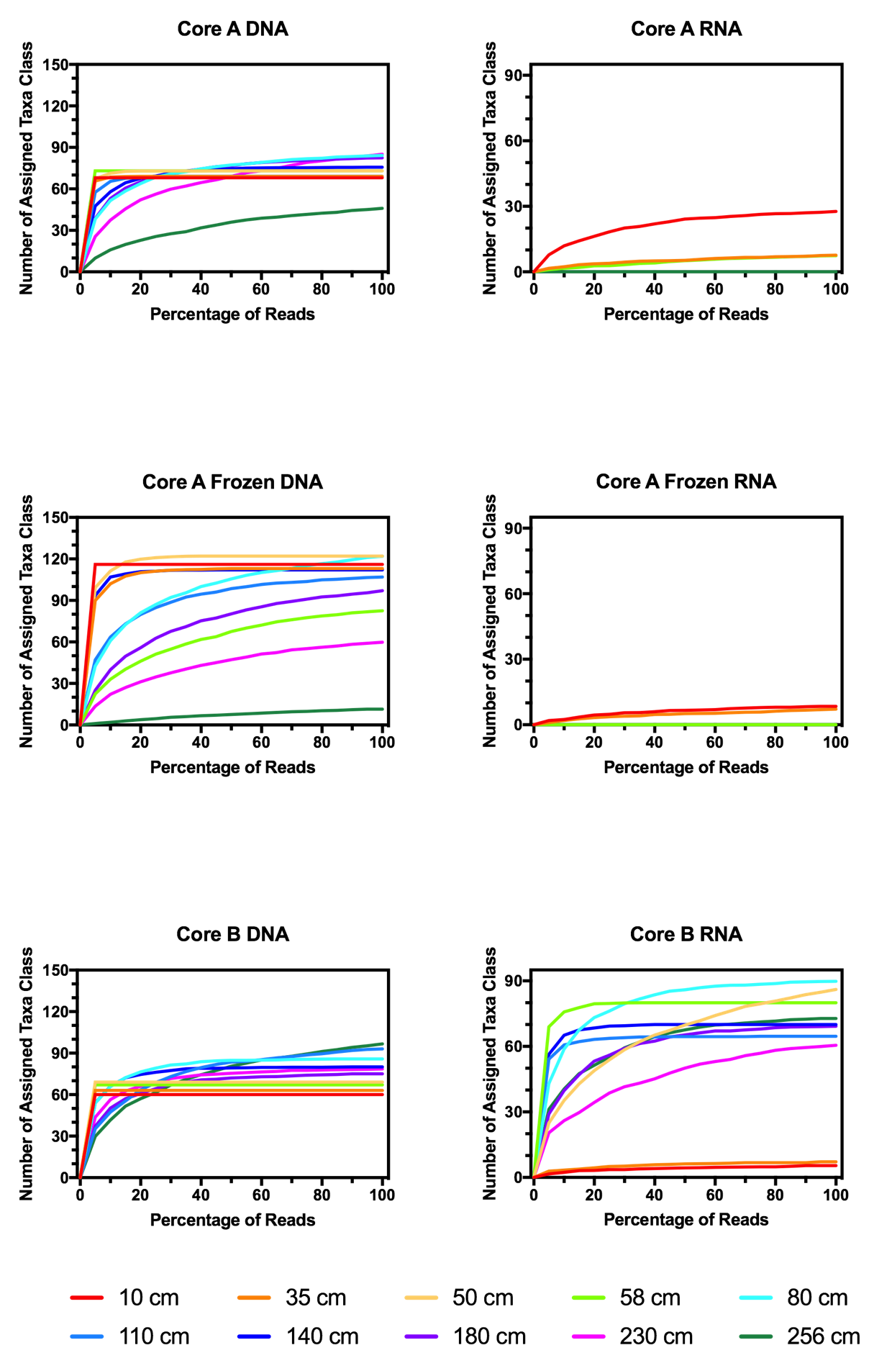
Supplementary Figure 1 – Rarefaction Analysis of sedDNA and sedRNA sequence data at Class taxonomic level for each of the storage conditions.

Supplementary Table 1 - Change in abundance between conditions As, Af and B for sedDNA analysis.
Displaying percentage classifications for the 15 most abundant taxa identified in condition As.
Column 1. Percentage abundance identified at each sampled sediment depth.
Column 2. Change in percentage abundance for condition Af.
Column 3. Change in percentage abundance for condition B.
Red number/red background indicates percentages that are greater than 4 % lower than condition As. Red number/white background indicates percentages that are between 0 and 4 % lower than condition As. Green number/green background indicates percentages that are greater than a 4 % increase from condition As. Green number/white background indicates percentages that are between 0 and 4 % higher than condition As.

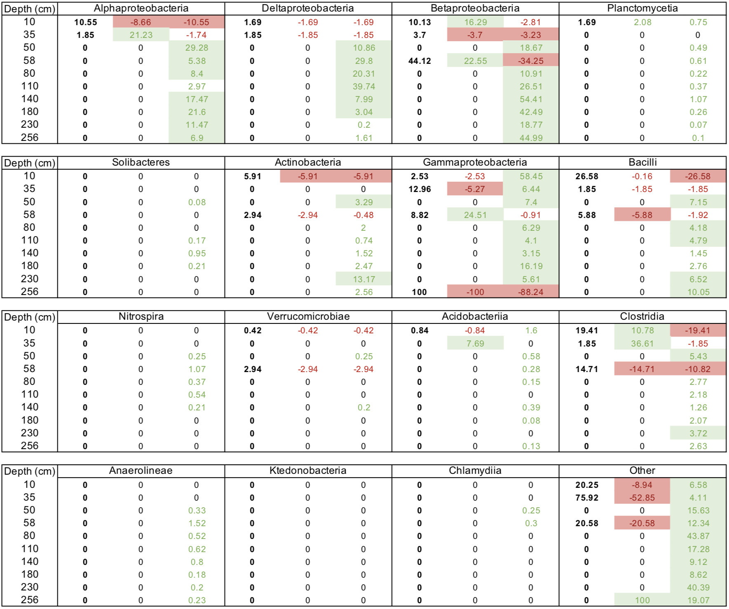
Supplementary Table 2 - Change in abundance between conditions As, Af and B for sedRNA analysis.
Displaying percentage classifications for the 15 most abundant taxa identified in condition As.
Column 1. Percentage abundance identified at each sampled sediment depth.
Column 2. Change in percentage abundance for condition Af.
Column 3. Change in percentage abundance for condition B.
Red number/red background indicates percentages that are greater than 4 % lower than condition As. Red number/white background indicates percentages that are between 0 and 4 % lower than condition As. Green number/green background indicates percentages that are greater than a 4 % increase from condition As. Green number/white background indicates percentages that are between 0 and 4 % higher than condition As.

