Supplementary information

Soil microbial communities following 20 years of fertilization and crop rotation practices in the Czech Republic
Martina Kracmarova¹, Ondrej Uhlik¹, Michal Strejcek¹, Jirina Szakova², Jindrich Cerny², Jiri Balik², Pavel Tlustos², Petr Kohout^{3, 4}, Katerina Demnerova¹, Hana Stiborova¹
¹University of Chemistry and Technology, Prague, Faculty of Food and Biochemical Technology, Department of Biochemistry and Microbiology, Technicka 3, 166 28 Prague 6, Czech Republic
²Czech University of Life Sciences Prague, Faculty of Agrobiology, Food and Natural Resources, Department of Agro-Environmental Chemistry and Plant Nutrition, Kamycka 129, Prague – Suchdol, 165 21, Czech Republic
³Laboratory of Environmental Microbiology, Institute of Microbiology of the CAS, Videnska 1083, 142 20, Praha 4, Czech Republic
⁴Department of Experimental Plant Biology, Faculty of Science, Charles University, Vinicna 5, 128 44 Praha 2, Czech Republic
Corresponding authors: University of Chemistry and Technology, Prague, Technicka 3, 166 28 Prague 6, Czech Republic. Phone: +420 220 44 5204; emails: hana.stiborova@vscht.cz; kracma.mk@gmail.com

Fig. S1. Scatter plot of each pair of physicochemical parameters showing Pearson’s correlation coefficients, histograms and bivariate scatter plots.
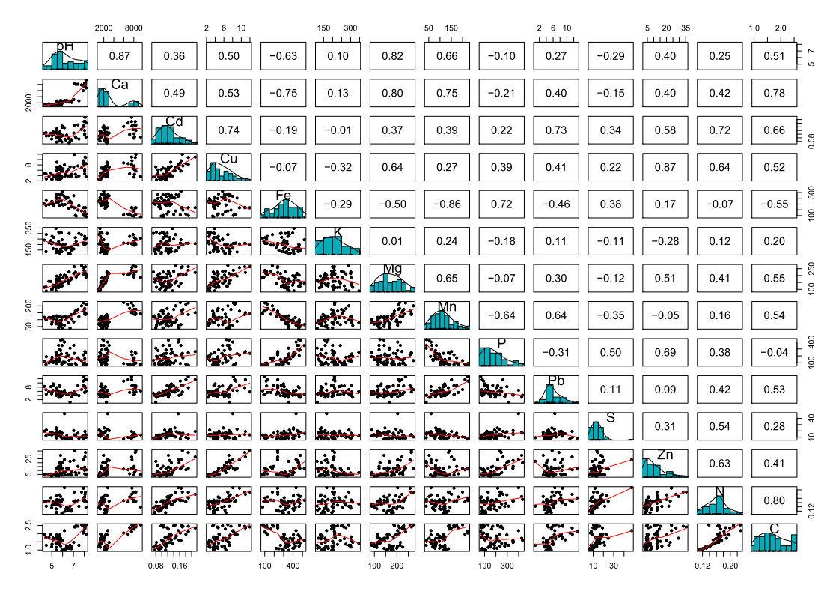
Table S1 Physicochemical parameters of soils in the experimental fields.
Sample ID | crop | fertilizer | location | pH | Ca [mg/kg] | Cd [mg/kg] | Cu [mg/kg] | Fe [mg/kg] | K [mg/kg] | Mg [mg/kg] | Mn [mg/kg] | P [mg/kg] | Pb [mg/kg] | S [mg/kg] | Zn [mg/kg] | N [mg/kg] | C [mg/kg]
HB_1 | potato | contr | Humpolec | 5.13 | 1495 | 0.132 | 3.98 | 299 | 163 | 131 | 121 | 103.5 | 9.54 | 15.5 | 4.5 | 0.1505 | 1.6235
HB_2 | potato | sludge | Humpolec | 5.42 | 2068 | 0.144 | 5.86 | 405 | 138 | 147 | 81 | 212.8 | 5.62 | 24.7 | 11.82 | 0.1665 | 1.72
HB_3 | potato | sludge3 | Humpolec | 6.17 | 2790 | 0.155 | 8.05 | 432 | 167 | 203 | 60 | 399.5 | 6.49 | 47.4 | 23.9 | 0.2300 | 2.1845
HB_4 | potato | manure | Humpolec | 5.68 | 1660 | 0.118 | 3.68 | 274 | 303 | 184 | 123 | 123.5 | 8.74 | 16.3 | 4.39 | 0.1720 | 1.802
HB_5 | potato | NPK | Humpolec | 5.17 | 1440 | 0.127 | 3.78 | 279 | 265 | 125 | 114 | 116.5 | 8.59 | 15.3 | 4.22 | 0.1590 | 1.6945
HJ_1 | barley | contr | Humpolec | 5.50 | 1852 | 0.124 | 4.49 | 331 | 135 | 143 | 112 | 109.3 | 6.71 | 16.1 | 5.39 | 0.1580 | 1.683
HJ_2 | barley | sludge | Humpolec | 5.73 | 2136 | 0.122 | 6.30 | 370 | 121 | 158 | 92 | 152.7 | 5.09 | 16.9 | 9.37 | 0.1640 | 1.7215
HJ_3 | barley | sludge3 | Humpolec | 5.47 | 2631 | 0.130 | 9.02 | 404 | 132 | 196 | 88 | 231.4 | 6.35 | 22.8 | 12.67 | 0.1930 | 1.942
HJ_4 | barley | manure | Humpolec | 4.74 | 1722 | 0.111 | 3.60 | 291 | 214 | 158 | 116 | 98.8 | 5.77 | 14.2 | 4.94 | 0.1685 | 1.7645
HJ_5 | barley | NPK | Humpolec | 5.11 | 1369 | 0.116 | 4.17 | 305 | 214 | 113 | 104 | 112.9 | 6.53 | 16.4 | 4.8 | 0.1645 | 1.7385
HP_1 | wheat | contr | Humpolec | 4.47 | 1625 | 0.128 | 4.61 | 279 | 135 | 117 | 101 | 75.3 | 6.71 | 12.2 | 5.05 | 0.1655 | 1.778
HP_2 | wheat | sludge | Humpolec | 5.45 | 2239 | 0.149 | 7.21 | 465 | 143 | 158 | 98 | 203.7 | 7.72 | 18.6 | 13.36 | 0.1735 | 1.8535
HP_3 | wheat | sludge3 | Humpolec | 5.74 | 2335 | 0.132 | 7.46 | 455 | 136 | 166 | 60 | 297 | 8.23 | 18.8 | 20.05 | 0.1965 | 1.924
HP_4 | wheat | manure | Humpolec | 4.91 | 1534 | 0.125 | 4.95 | 306 | 235 | 157 | 115 | 127.7 | 8.22 | 17.5 | 5.58 | 0.1830 | 1.946
HP_5 | wheat | NPK | Humpolec | 4.31 | 1335 | 0.125 | 4.86 | 304 | 240 | 115 | 117 | 120.2 | 8.35 | 19.5 | 4.85 | 0.1670 | 1.967
LB_1 | potato | contr | Lukavec | 5.63 | 1370 | 0.117 | 2.50 | 335 | 227 | 113 | 79 | 157.5 | 6.04 | 12.9 | 3.07 | 0.1480 | 1.3425
LB_2 | potato | sludge | Lukavec | 5.95 | 1994 | 0.164 | 5.69 | 519 | 243 | 144 | 64 | 350.5 | 4.53 | 16.1 | 12.73 | 0.1715 | 1.583
LB_3 | potato | sludge3 | Lukavec | 5.96 | 1830 | 0.158 | 6.58 | 459 | 175 | 125 | 40 | 434.5 | 4.10 | 16.4 | 20.05 | 0.1750 | 1.599
LB_4 | potato | manure | Lukavec | 5.71 | 1341 | 0.100 | 2.67 | 396 | 305 | 130 | 77 | 202.7 | 4.09 | 13.7 | 4.8 | 0.1690 | 1.595
LB_5 | potato | NPK | Lukavec | 5.39 | 1250 | 0.136 | 3.84 | 409 | 346 | 89 | 78 | 251 | 5.94 | 12.1 | 7.4 | 0.1535 | 1.4045
LJ_1 | barley | contr | Lukavec | 4.99 | 1030 | 0.093 | 2.61 | 341 | 206 | 100 | 68 | 147 | 4.79 | 13.6 | 2.75 | 0.1355 | 1.205
LJ_2 | barley | sludge | Lukavec | 5.42 | 1472 | 0.105 | 3.45 | 319 | 206 | 127 | 84 | 151.3 | 4.06 | 13.7 | 6.03 | 0.1550 | 1.44
LJ_3 | barley | sludge3 | Lukavec | 5.63 | 1500 | 0.104 | 6.80 | 461 | 200 | 121 | 40 | 352 | 4.12 | 14.6 | 15.4 | 0.1660 | 1.531
LJ_4 | barley | manure | Lukavec | 5.65 | 1256 | 0.082 | 2.34 | 348 | 312 | 115 | 58 | 193.1 | 3.13 | 13 | 4.43 | 0.1620 | 1.467
LJ_5 | barley | NPK | Lukavec | 5.03 | 1305 | 0.113 | 2.57 | 346 | 274 | 98 | 82 | 179.5 | 5.72 | 13.9 | 4.13 | 0.1485 | 1.3585
LP_1 | wheat | contr | Lukavec | 5.41 | 1300 | 0.099 | 2.8 | 324 | 127 | 111 | 70 | 134 | 4.92 | 11.2 | 3.34 | 0.1305 | 1.1615
LP_2 | wheat | sludge | Lukavec | 5.74 | 1605 | 0.114 | 4.76 | 472 | 140 | 121 | 62 | 287 | 4.38 | 16.8 | 12.6 | 0.1565 | 1.411
LP_3 | wheat | sludge3 | Lukavec | 5.81 | 1960 | 0.122 | 7.13 | 477 | 158 | 143 | 52 | 427 | 3.12 | 17.5 | 29.35 | 0.1890 | 1.7225
LP_4 | wheat | manure | Lukavec | 5.88 | 1425 | 0.107 | 2.99 | 355 | 307 | 147 | 97 | 228.5 | 5.79 | 14.4 | 5.38 | 0.1640 | 1.537
LP_5 | wheat | NPK | Lukavec | 4.49 | 1095 | 0.110 | 2.73 | 361 | 291 | 88 | 99 | 188.3 | 4.64 | 21.3 | 4.58 | 0.1430 | 1.287
SB_1 | potato | contr | Suchdol | 8.17 | 6864 | 0.181 | 8.48 | 126 | 211 | 207 | 211 | 80.4 | 11.6 | 9.6 | 10.95 | 0.1640 | 1.9585
SB_2 | potato | sludge | Suchdol | 7.42 | 8068 | 0.171 | 7.62 | 195 | 194 | 206 | 174 | 172.3 | 8.78 | 16.4 | 15.28 | 0.1695 | 2.4565
SB_3 | potato | sludge3 | Suchdol | 8.07 | 7560 | 0.212 | 10.95 | 238 | 208 | 222 | 151 | 262.5 | 11.55 | 19.1 | 27.4 | 0.1990 | 2.3485
SB_4 | potato | manure | Suchdol | 8.03 | 8405 | 0.140 | 5.69 | 120 | 249 | 230 | 174 | 96.8 | 8.57 | 11.8 | 10.4 | 0.1670 | 2.4895
SB_5 | potato | NPK | Suchdol | 8.16 | 9355 | 0.104 | 3.62 | 77 | 256 | 187 | 144 | 77.6 | 6.17 | 13.6 | 4.97 | 0.1385 | 2.5365
SJ_1 | barley | contr | Suchdol | 7.91 | 5970 | 0.162 | 8.75 | 114 | 213 | 212 | 224 | 90.4 | 10.9 | 7.4 | 11.8 | 0.1695 | 2.0405
SJ_2 | barley | sludge | Suchdol | 8.05 | 8040 | 0.122 | 6.32 | 164 | 195 | 232 | 140 | 161.5 | 5.50 | 11.7 | 14.4 | 0.1720 | 2.282
SJ_3 | barley | sludge3 | Suchdol | 7.08 | 8409 | 0.169 | 11.95 | 236 | 200 | 264 | 143 | 237.2 | 5.71 | 13.7 | 35.4 | 0.2100 | 2.4125
SJ_4 | barley | manure | Suchdol | 7.18 | 8131 | 0.105 | 4.48 | 104 | 262 | 225 | 163 | 92.7 | 4.60 | 13.6 | 7.55 | 0.1690 | 2.4105
SJ_5 | barley | NPK | Suchdol | 7.25 | 8034 | 0.098 | 3.42 | 91 | 228 | 189 | 162 | 73.3 | 4.38 | 11.2 | 4.38 | 0.1645 | 2.4795
SP_1 | wheat | contr | Suchdol | 7.98 | 7540 | 0.189 | 8.17 | 103 | 210 | 238 | 221 | 66.7 | 12.98 | 8.2 | 12.8 | 0.1820 | 2.128
SP_2 | wheat | sludge | Suchdol | 7.93 | 7640 | 0.165 | 9.58 | 236 | 205 | 258 | 162 | 215.5 | 8.72 | 11.9 | 23.9 | 0.2280 | 2.5135
SP_3 | wheat | sludge3 | Suchdol | 8.11 | 8295 | 0.189 | 10.8 | 238 | 211 | 264 | 137 | 246.3 | 7.70 | 14.2 | 33.07 | 0.2090 | 2.457
SP_4 | wheat | manure | Suchdol | 7.75 | 7852 | 0.146 | 6.91 | 181 | 290 | 273 | 200 | 131.9 | 6.82 | 10.4 | 12.61 | 0.2095 | 2.5445
SP_5 | wheat | NPK | Suchdol | 8.04 | 7165 | 0.118 | 4.69 | 129 | 274 | 212 | 181 | 72.9 | 5.46 | 9.8 | 5.84 | 0.1865 | 2.3645
VB_1 | potato | contr | Hněvčeves | 6.80 | 2575 | 0.090 | 3.57 | 250 | 147 | 179 | 137 | 78.5 | 5.20 | 9.1 | 4.33 | 0.1200 | 1.079
VB_2 | potato | sludge | Hněvčeves | 6.38 | 2795 | 0.115 | 5.55 | 424 | 163 | 185 | 115 | 237.2 | 4.29 | 12.3 | 12.9 | 0.1380 | 1.236
VB_3 | potato | sludge3 | Hněvčeves | 7.03 | 3065 | 0.126 | 7.18 | 444 | 159 | 215 | 84 | 352 | 4.47 | 20.5 | 22.95 | 0.1665 | 1.4615
VB_4 | potato | manure | Hněvčeves | 7.51 | 2665 | 0.093 | 3.86 | 267 | 300 | 214 | 122 | 147.9 | 3.94 | 7.9 | 6.9 | 0.1425 | 1.2865
VB_5 | potato | NPK | Hněvčeves | 6.58 | 2290 | 0.095 | 3.91 | 223 | 176 | 143 | 120 | 82.1 | 4.78 | 6.9 | 4.55 | 0.1230 | 1.097
VJ_1 | barley | contr | Hněvčeves | 5.93 | 2420 | 0.077 | 3.57 | 297 | 136 | 153 | 117 | 80.1 | 3.96 | 8.2 | 3.93 | 0.1100 | 0.9915
VJ_2 | barley | sludge | Hněvčeves | 6.51 | 2385 | 0.098 | 6.25 | 408 | 116 | 165 | 78 | 209 | 4.58 | 8 | 12.6 | 0.1245 | 1.1145
VJ_3 | barley | sludge3 | Hněvčeves | 6.69 | 2534 | 0.080 | 7.26 | 352 | 114 | 166 | 39 | 311.7 | 0.83 | 9.1 | 21.76 | 0.1435 | 1.2885
VJ_4 | barley | manure | Hněvčeves | 6.84 | 2170 | 0.084 | 4.49 | 314 | 175 | 176 | 106 | 154.8 | 3.54 | 8.2 | 8.19 | 0.1280 | 1.1815
VJ_5 | barley | NPK | Hněvčeves | 6.05 | 2200 | 0.113 | 6.46 | 284 | 196 | 184 | 118 | 110 | 5.46 | 9 | 7.17 | 0.1125 | 0.9955
VP_1 | wheat | contr | Hněvčeves | 5.44 | 2483 | 0.076 | 3.79 | 354 | 156 | 175 | 128 | 91.6 | 4.27 | 8.9 | 3.49 | 0.1140 | 0.9805
VP_2 | wheat | sludge | Hněvčeves | 6.31 | 2665 | 0.087 | 4.58 | 398 | 153 | 199 | 98 | 185.5 | 4.88 | 8.5 | 8.38 | 0.1310 | 1.1115
VP_3 | wheat | sludge3 | Hněvčeves | 5.82 | 2824 | 0.087 | 6.12 | 464 | 197 | 203 | 80 | 278.2 | 3.44 | 10.7 | 16.42 | 0.1420 | 1.236
VP_4 | wheat | manure | Hněvčeves | 6.60 | 2625 | 0.072 | 3.54 | 318 | 301 | 226 | 122 | 135 | 5.00 | 8.3 | 5.11 | 0.1340 | 1.1785
VP_5 | wheat | NPK | Hněvčeves | 6.22 | 2380 | 0.091 | 3.77 | 292 | 202 | 158 | 126 | 107.5 | 5.33 | 7.1 | 4.45 | 0.1195 | 1.018

Table S2 The influence of location, soil type, fertilization and crop rotation on soil chemical properties analysed with Kruskal-Wallis test. Significant p-values after FDR correction (p_{adj} < 0.05) are underlined.
 | p_{adj} - values
 | pH | Ca | Cd | Cu | Fe | K | Mg | Mn | P | Pb | S | Zn | N | C
Location | < 0.001 | < 0.001 | < 0.001 | < 0.001 | < 0.001 | < 0.001 | < 0.001 | < 0.001 | < 0.05 | < 0.001 | < 0.001 | 0.08 | < 0.001 | < 0.001
Soil type | < 0.001 | < 0.001 | < 0.001 | < 0.05 | < 0.001 | < 0.05 | < 0.001 | < 0.001 | 0.06 | < 0.001 | < 0.001 | < 0.05 | < 0.001 | < 0.001
Fertilization | 0.57 | 0.25 | 0.15 | < 0.001 | < 0.05 | < 0.001 | 0.06 | 0.06 | < 0.001 | 0.48 | < 0.05 | < 0.001 | < 0.05 | 0.48
Crop rotation | 0.42 | 0.85 | < 0.05 | 0.84 | 0.67 | 0.38 | 0.83 | 0.78 | 0.76 | 0.12 | 0.46 | 0.80 | 0.55 | 0.85

